Rolls Royce Phantom

**Chairman of the Board**

***01 November 1994***

He was Chairman of the Board of a huge company

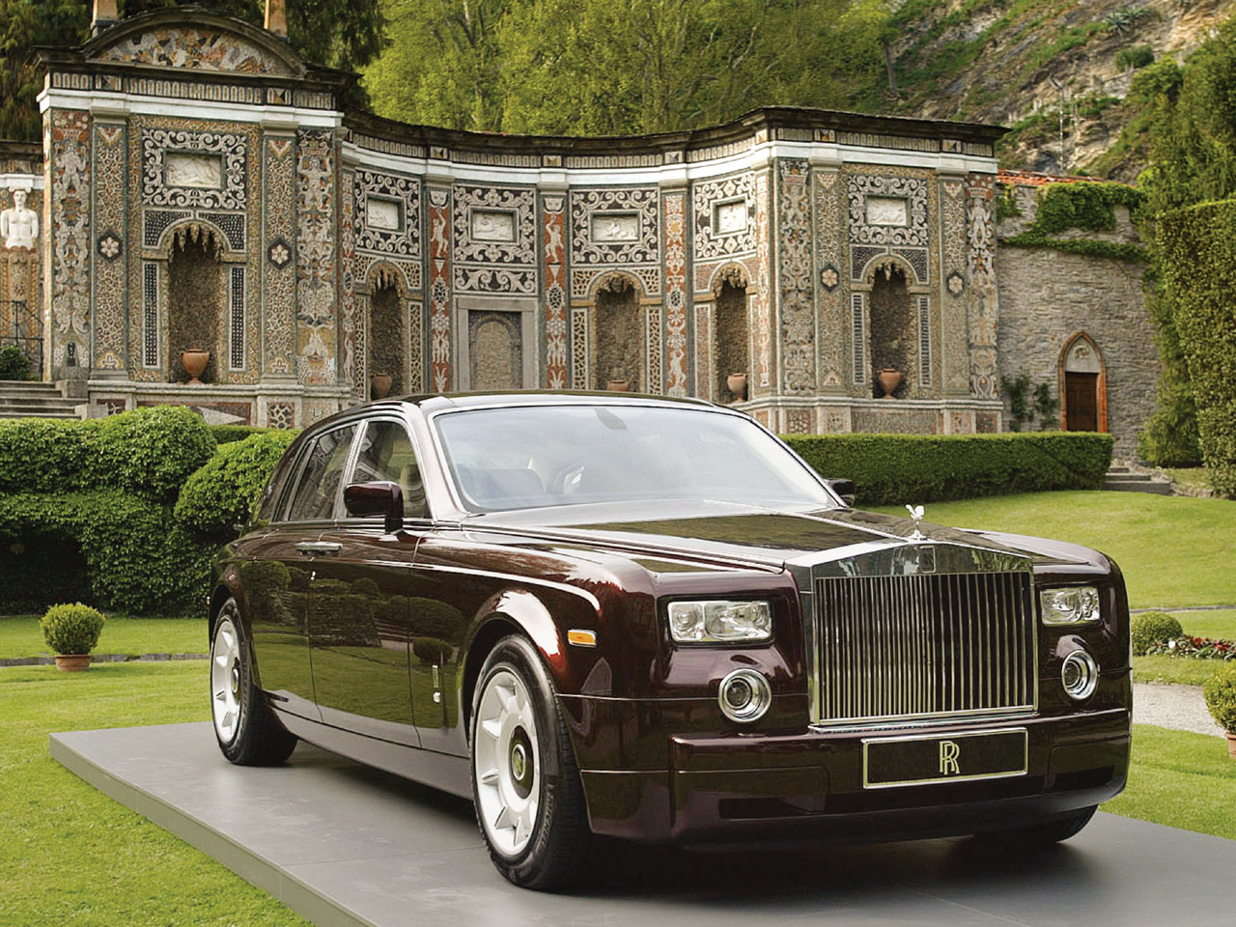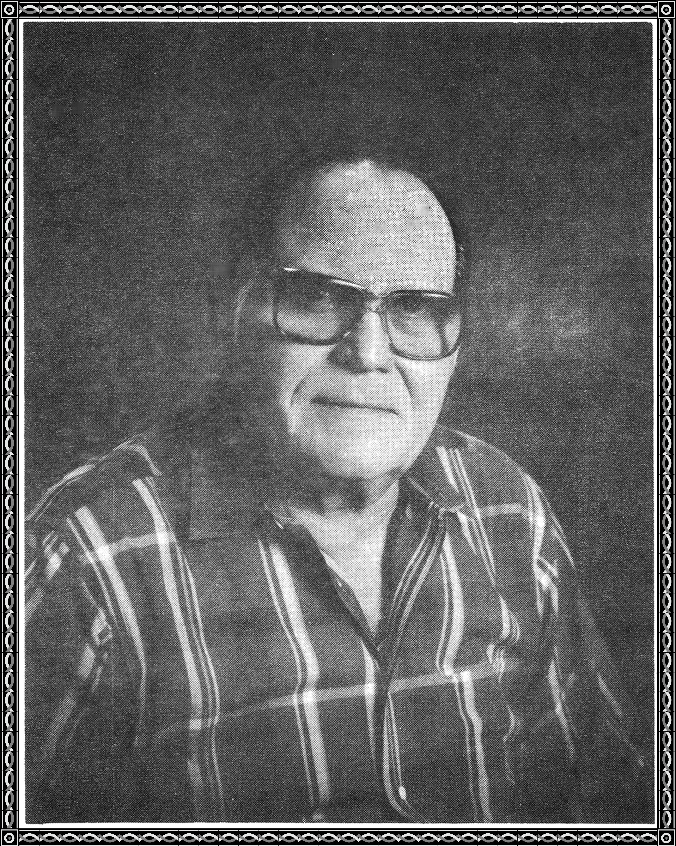

He had 35 years experience in his field

People jumped at his command

He lived in a lordly fashion

Every luxury and convenience came his way

He was the epitome of American success

He was very proud and had a large ego.

He made several huge decisions all at once

He bought out a competitor

He introduced new products

He became heavily indebted

Sometimes he fretted

But not enough

He thought he had the stuff.

Whamo! The banks failed,

Sales declined,

Debts could not be paid.

Japanese came to his rescue

They bailed him out on cue,

But he still had to few

and the Japanese threw him out without further ado.