**Watch Some TV**

***01 October 1994***

Nick and Dot were man and wife.

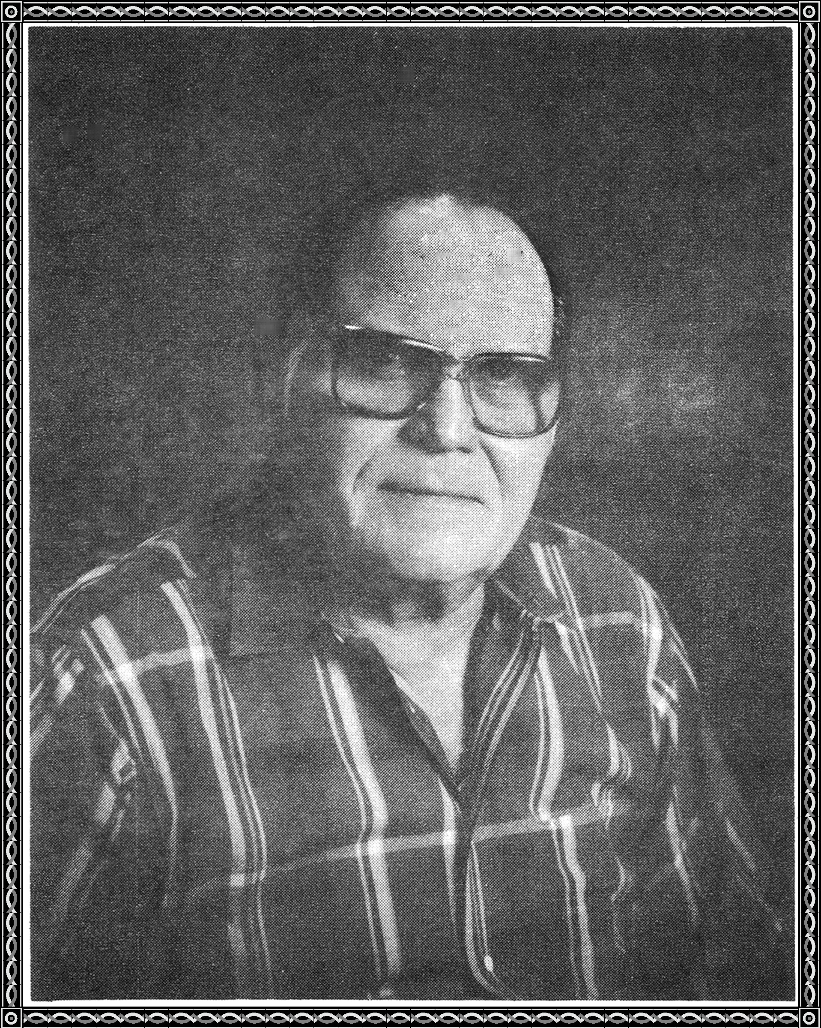

They had reached middle age.

They had been married 31 years.

Their life together had a minimum of tears.

Many struggles reduced their fears.

They were mostly happy through the years.

Time passed from stage to stage.

Over the years romance declined.

Their countenance was more refined.

Though, they did no wrong,

passion was there, but not as strong.

As it was when they were younger,

they still lived on a street named Munger.

At home, they did not always slumber.

One cold night they retired early.

They both were feeling squirrelly.

Nude they did get,

under the covers they went.

Nick tried to no avail.

"What are you doing," Dot wailed.

"I'm going to watch some TV," he said.

