**Read**

***01 September 1994***

Yea, to those who read

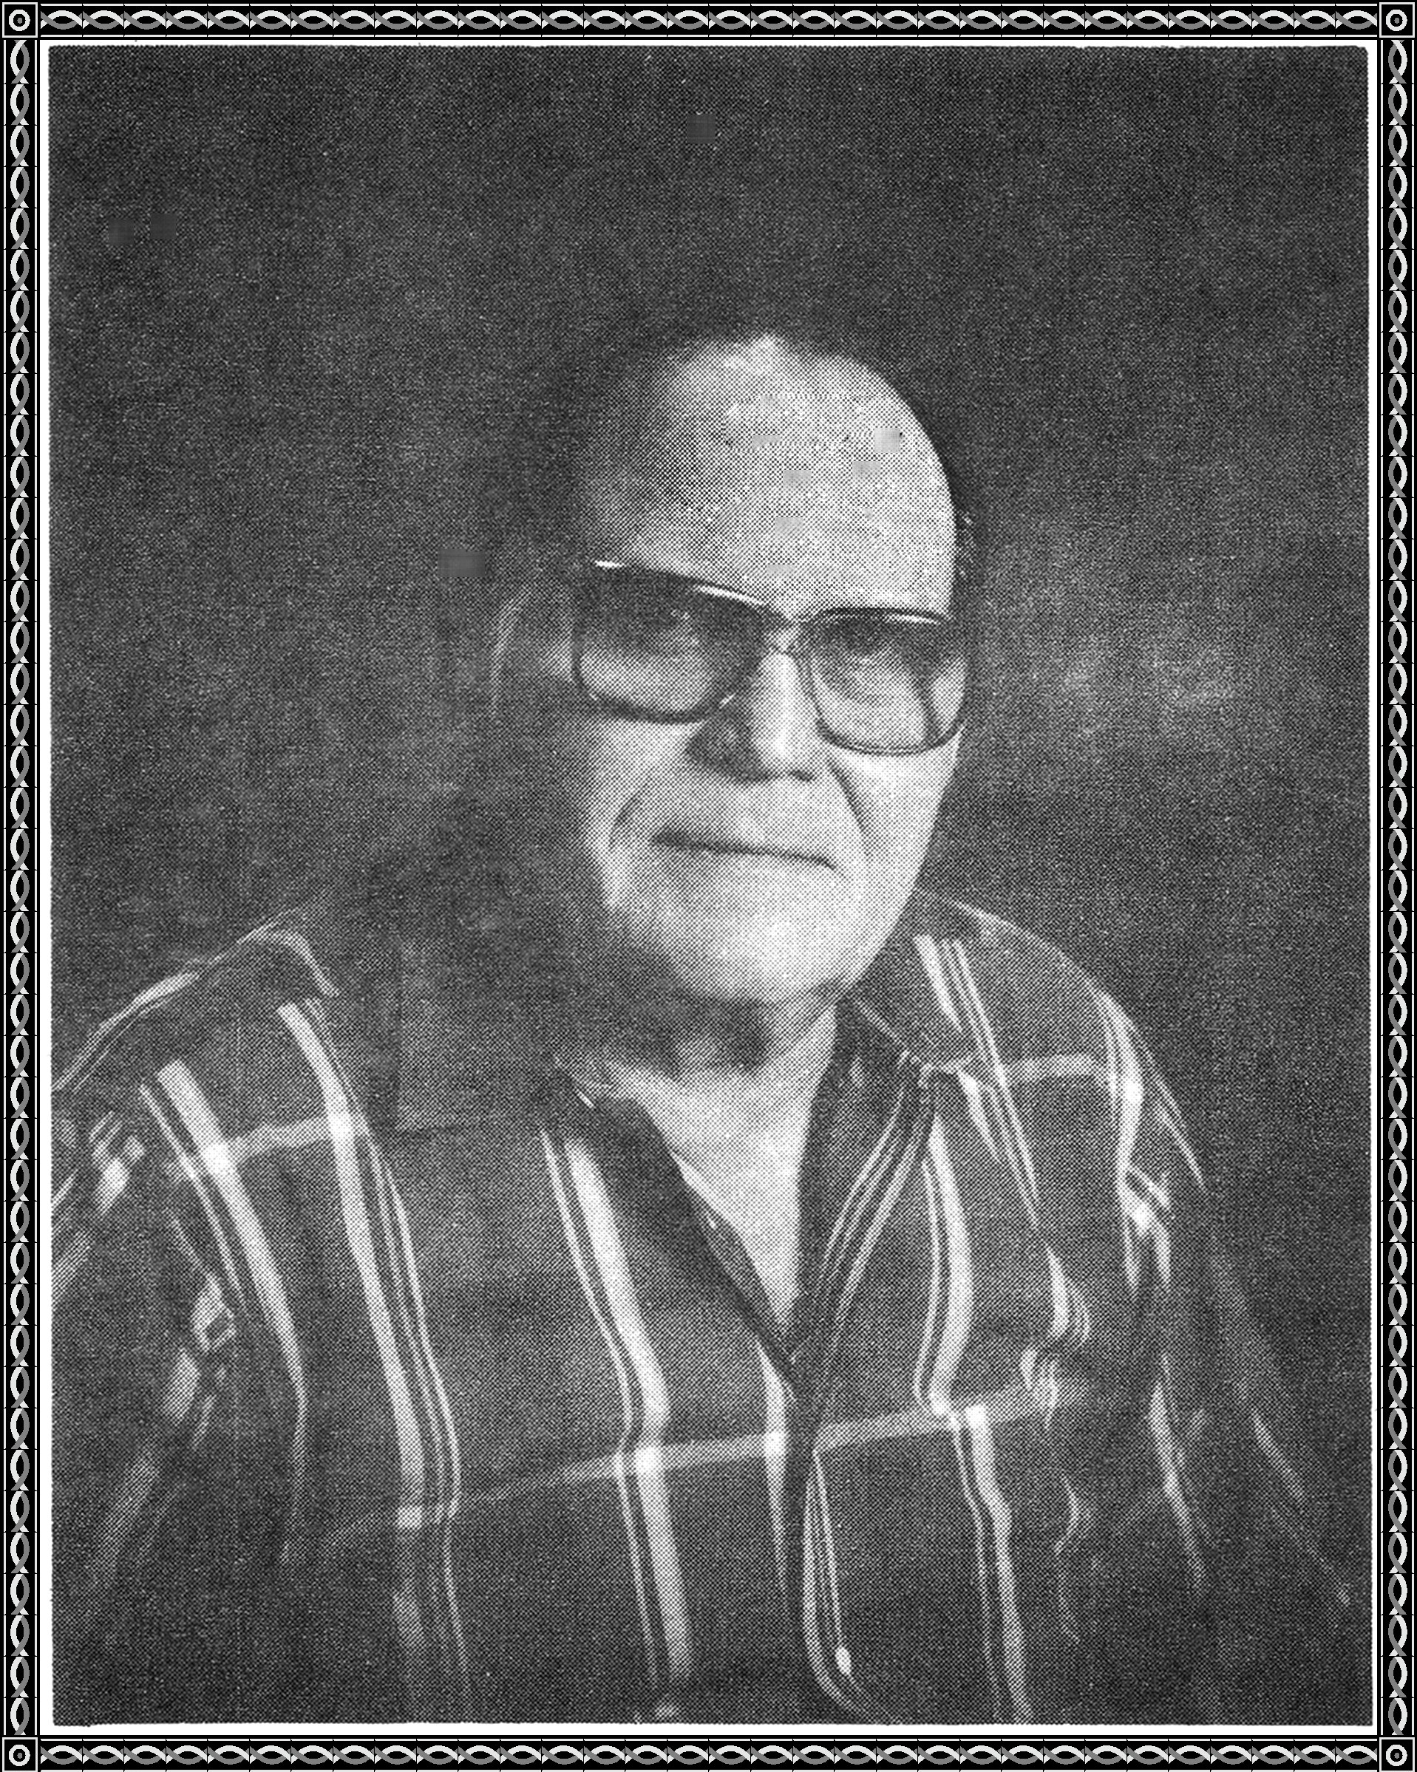

The rest of the world,

They shall feed.

You will supply the feed

to saturate their greed

You shall help those in need

Yea, to those who read

Yea, to those who read

You'll cry for the coon, treed

You'll cry for the bird in a bead

You'll cry for the dog of a bad breed

These actions shall be considered a good deed

Tis better than being upon, Peed

Yea, to those who read.

