**Homeless Veteran**

***01 July 1994***

The homeless Veteran

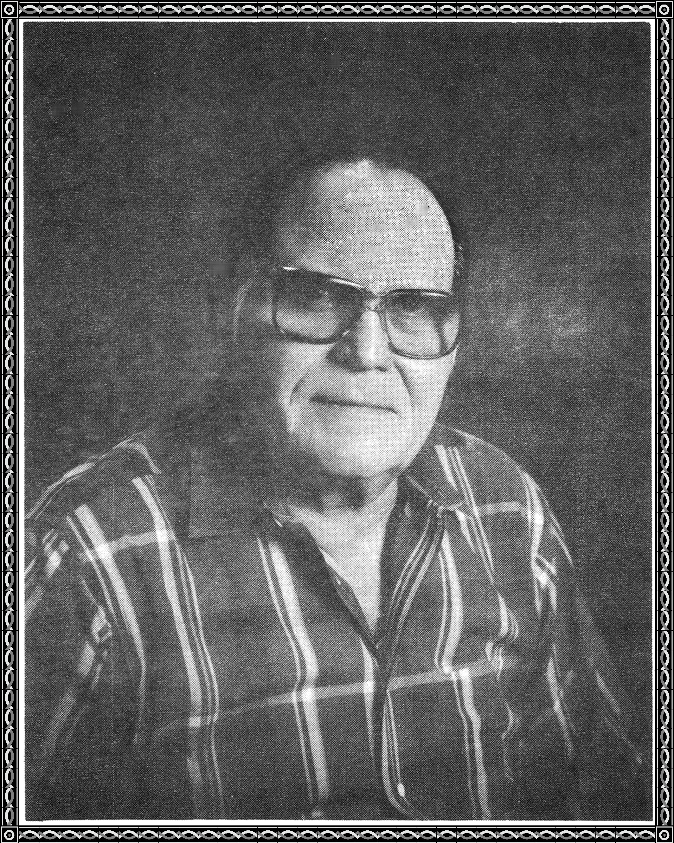

Stood under an overpass

The concrete was cold

He shivered from the wetness of his ass

His stomach growled from being empty

His mind was filled with despair

Mr. President, he cried, "Please help me."

But the president did not hear

He was too busy bugging his foes

He was too busy giving away the Panama Canal

He was too busy cutting the VA benefits

He was too busy quitting Desert Storm too soon

He was too busy forgiving debts

He was too busy appointing alleged

Perverts to the Supreme Court

He was too busy supporting the world

The Homeless Veteran stood

under the overpass and cried.

