**Factory Worker**

***01 June 1994***

There was a farmer in Missouri

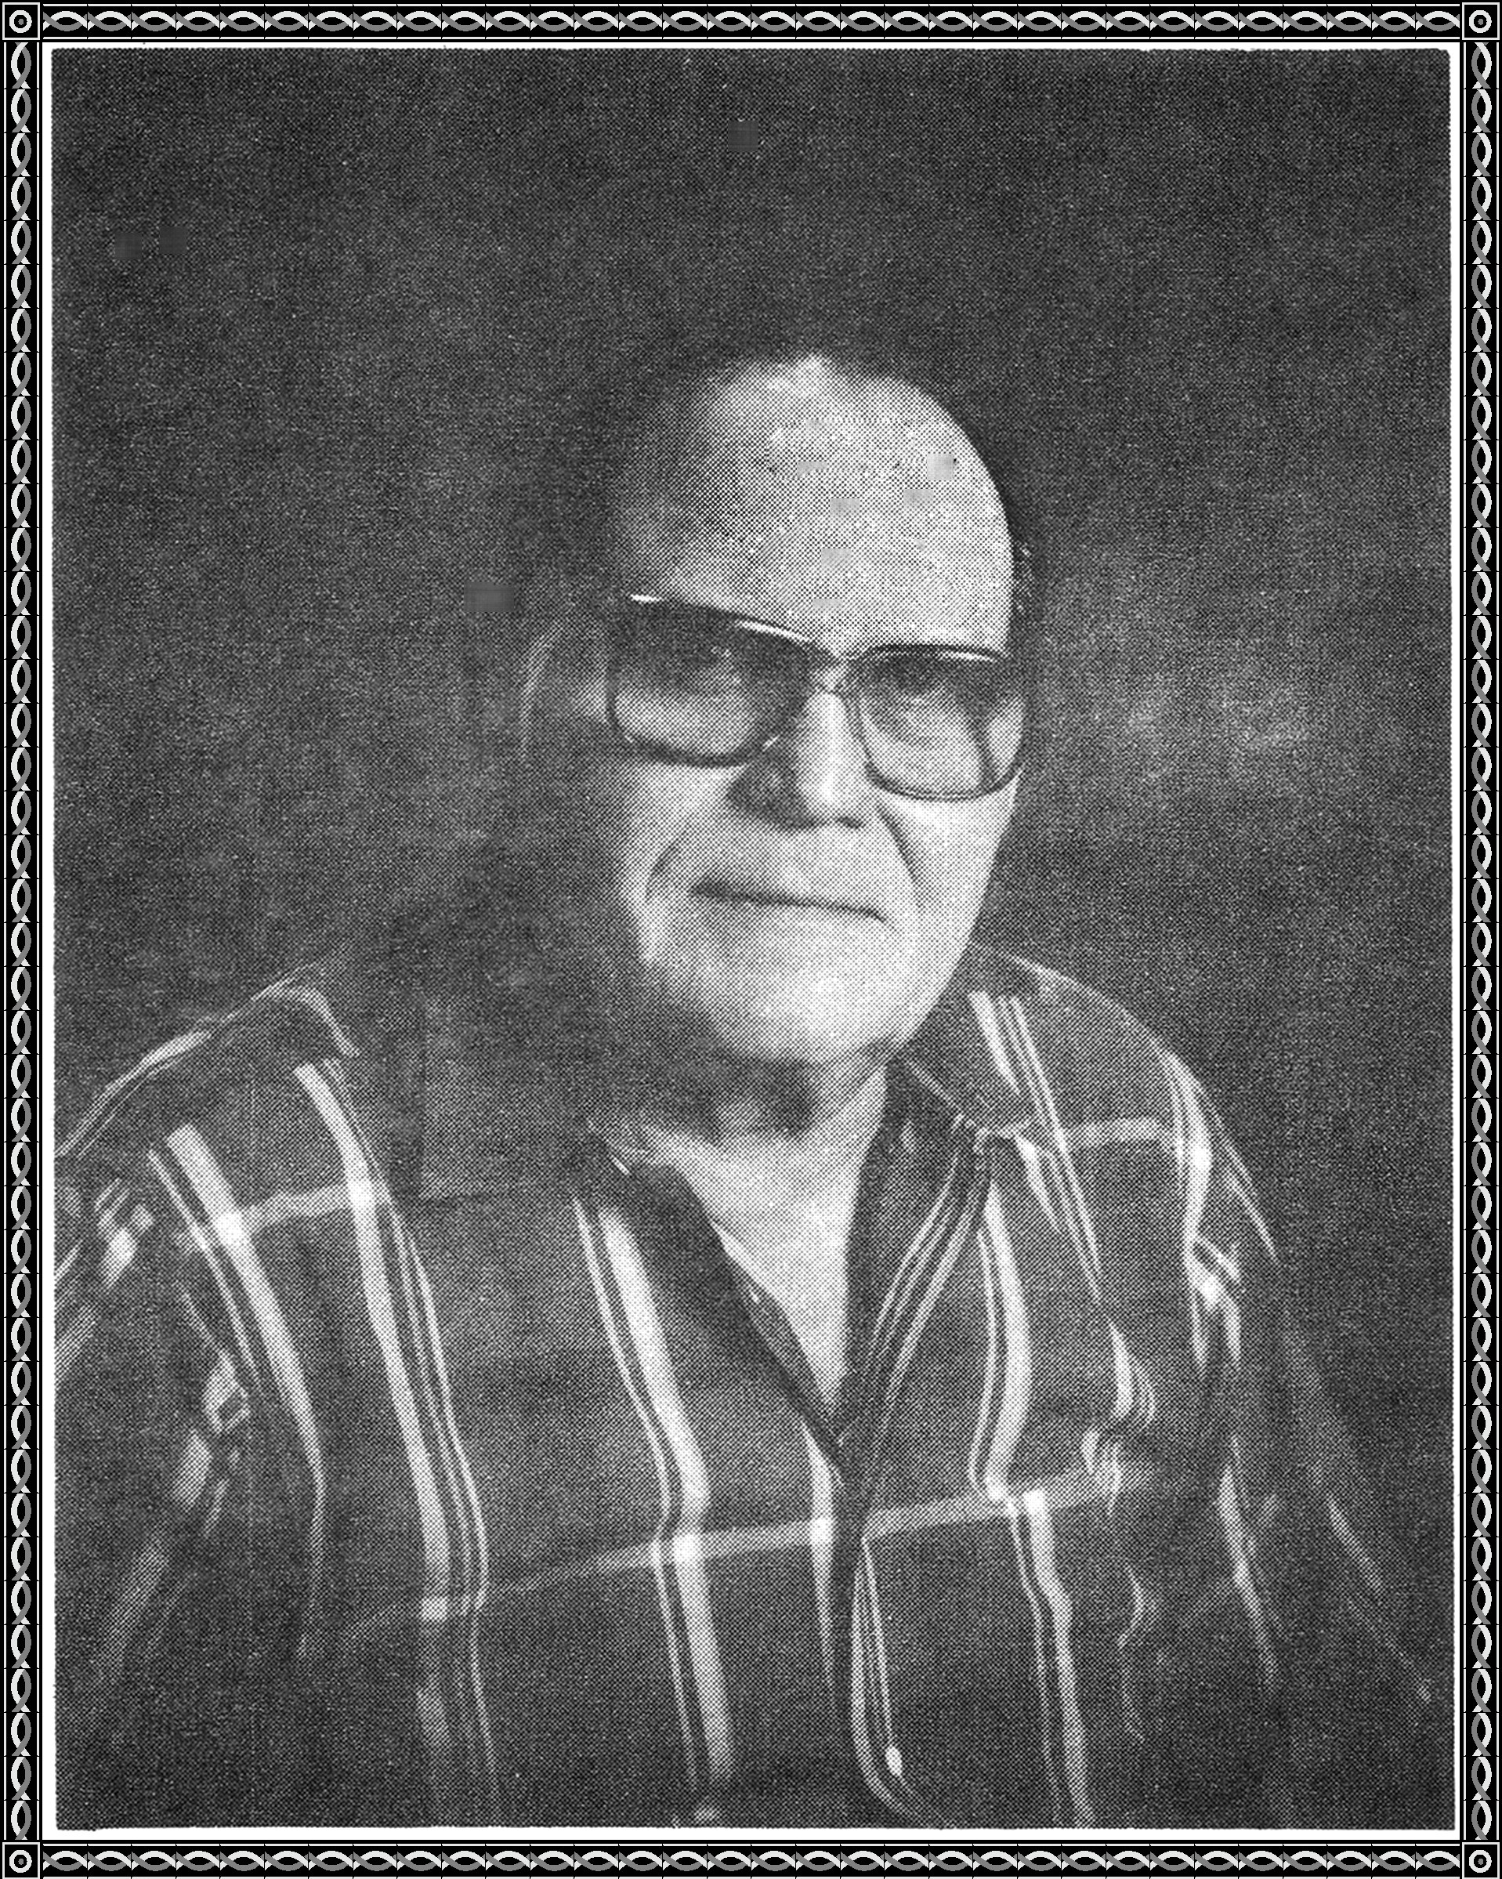

Who was tired of following a mule

So he sold his farm and went to trade school

He then went to Detroit

And got a job in an automobile plant

As the engine rolled by

He was to tighten a nut.

He soon got a promotion.

He was to tighten two nuts

This made him work a little harder

And just more money in the larder

Lo! and behold! he got another promotion

He was to tighten three nuts

He went home and told his wife the news.

Time went on and eventually he

became a four nut man, and then five.

He jumped for joy and bought a new car.

He couldn't see the danger from afar.

The depression hit and he was laid off

He then got in his new Toyota

and went to the unemployment office.

1942 Ford Pickup ¾ Ton

