**Banana Pudding**

***01 April 1994***

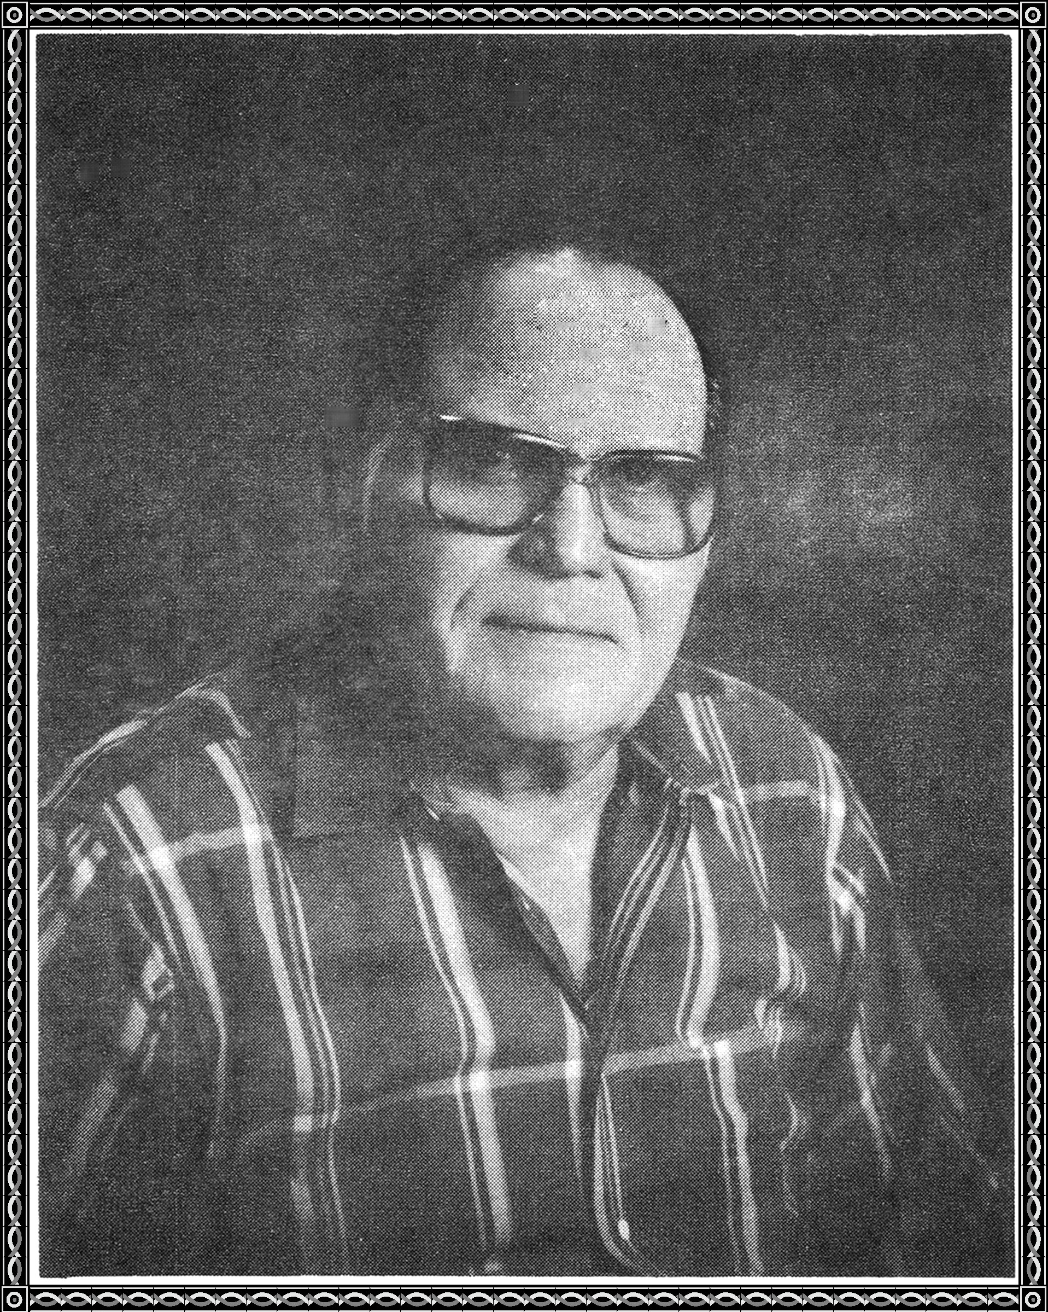

He was ten and taking his Saturday night bath,

tomorrow they would all go to Church.

After Church, dinner would be served.

Many dishes would be on the tables,

displaying the skill of those able.

Connoisseurs would stalk the tables,

making their choices of the dishes.

Of deserts, there were many,

but banana pudding was the favorite.

They were on one table at the end.

The center one was a beauty,

of banana pudding, he had never had his fill.

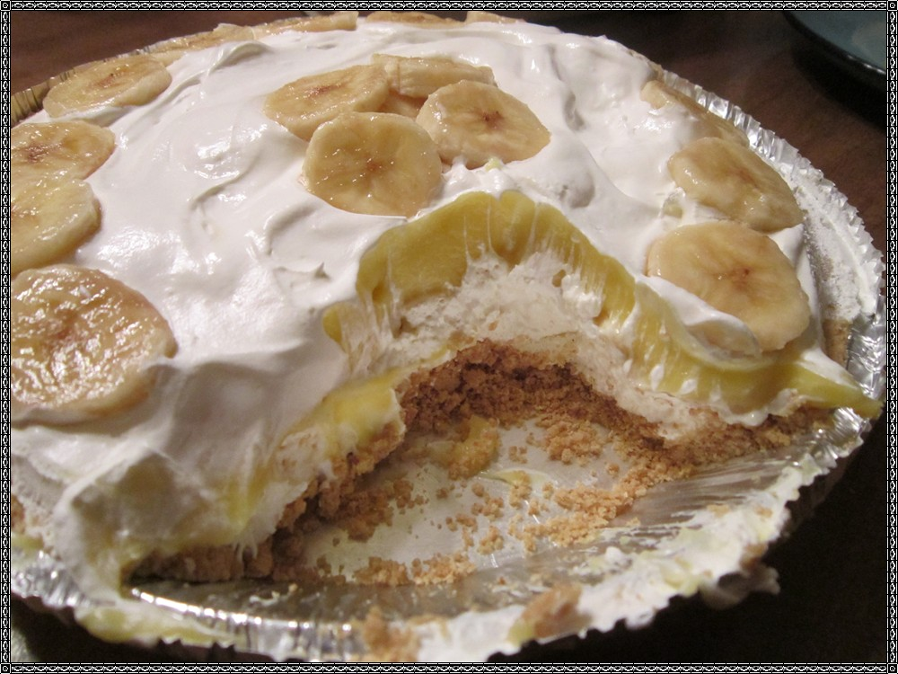

He placed a big spoon in his pocket,

for this was one time he would satiate his desire.

When the preacher had finished grace,

he had already taken his place.

He grabbed the center pudding and began to run,

across the road and into the woods he went.

He sat under a tree and began to eat,

till his desire for banana pudding was spent.

He lay under the tree and gave a sigh of content.