**Plane Crash**

***01 February 1994***

Above the jungle, the plane flew,

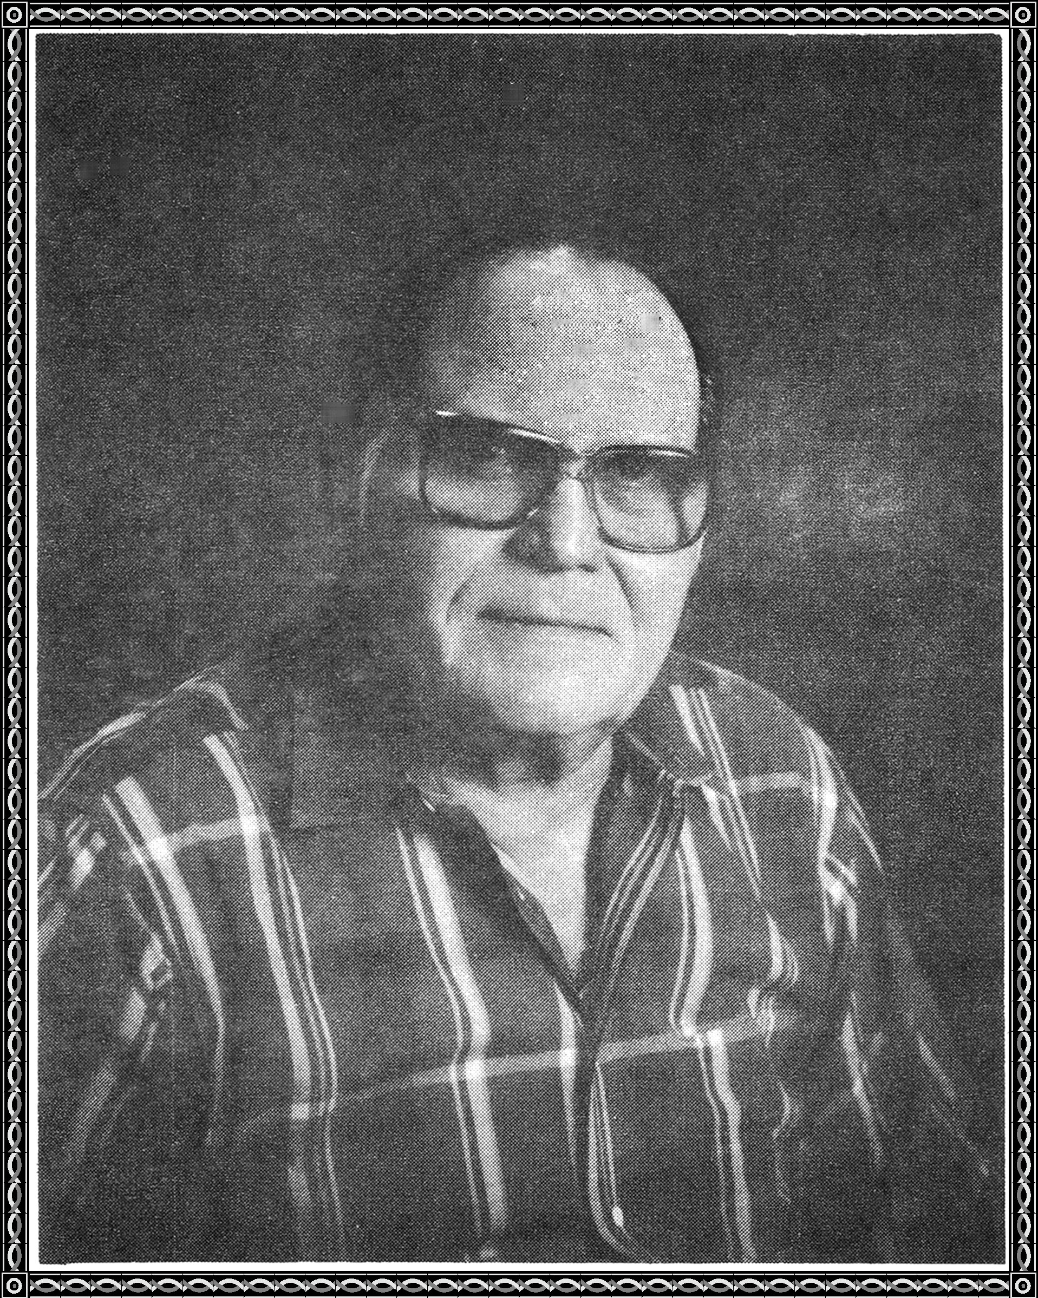

searching for the drop target/by the crew.

Suddenly, small arms fire cracked the plane's skin,

The plane's pilot looked for a place to land.

The plane skidded to a stop in an open space.

The crew began the urgent pace,

to escape the enemy and Join the guerrillas.

The guerrillas found the crew first,

and took them to their camp.

They bestowed their hospitality upon them,

food and drink were in abundance.

A young boy was assigned to each crew member,

to keep him supplied with food and drink,

till some began to show signs of over-indulgence.

One crewman had too much tuba.

He wandered forth in the camp. inebriated,

till he came to a huge tree,

under which a water buffalo lay asleep.

The crewman lay down,

placing his head on the water buffalo's stomach,

and joined this noble beast, in peaceful sleep.

