**Hangover**

***01 January 1994***

He awakened with a start

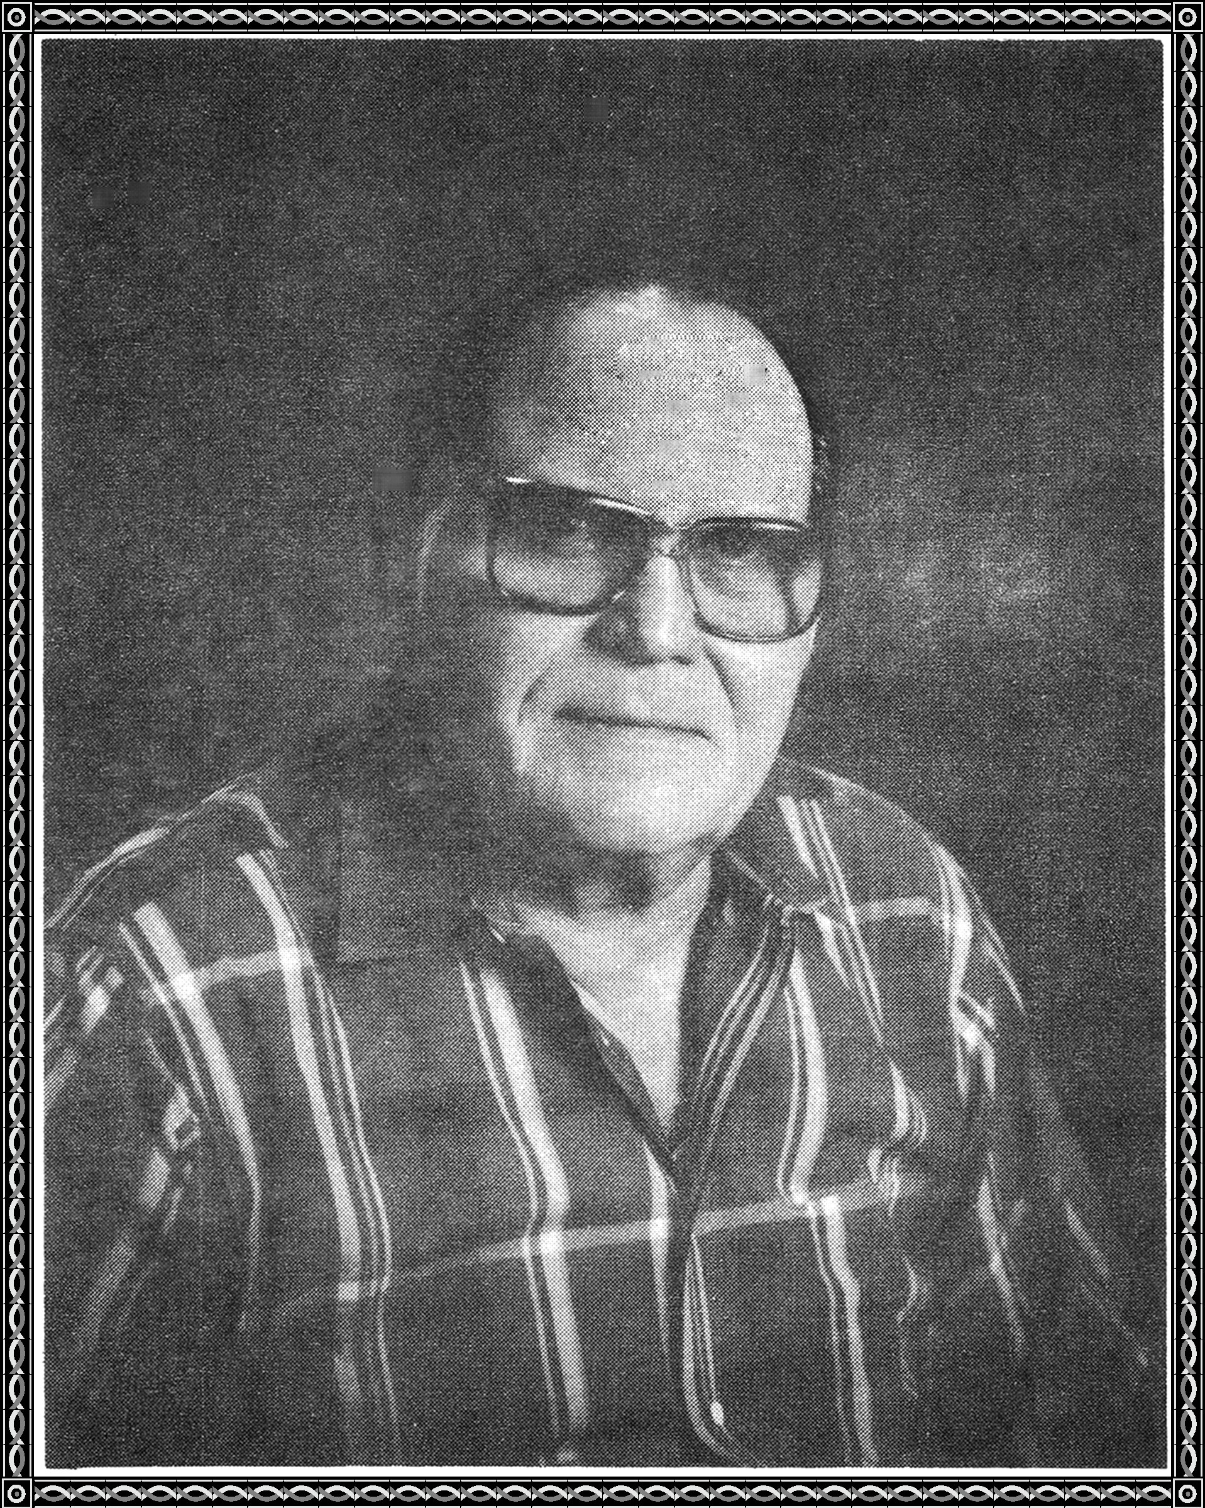

It didn't take him long

to realize something was wrong.

His head was throbbing like a pump

His mouth tasted like sump

He began to mentally kick his own rump.

For he realized that his problem was a hangover deluxe

His wife came into the room

"How do you feel?" she asked.

I feel like a barrel of worms in a bucket

I'll fix you, she replied.

She injected him with poison

He sighed and passed over the divide

She looked at him and never cried.

The state employee injected her with poison

She sighed and passed over the divide

She spotted him riding on a cloud

He was drunk on heavenly nectar

She joined him on a cloud

Suddenly, he fell off the cloud

She too, fell off the cloud

They fell down to the depths of Hell



Somewhere up above, God smiled.