**My Brothers Who Stayed**

***01 October 1993***

Basic training camp was where we met,

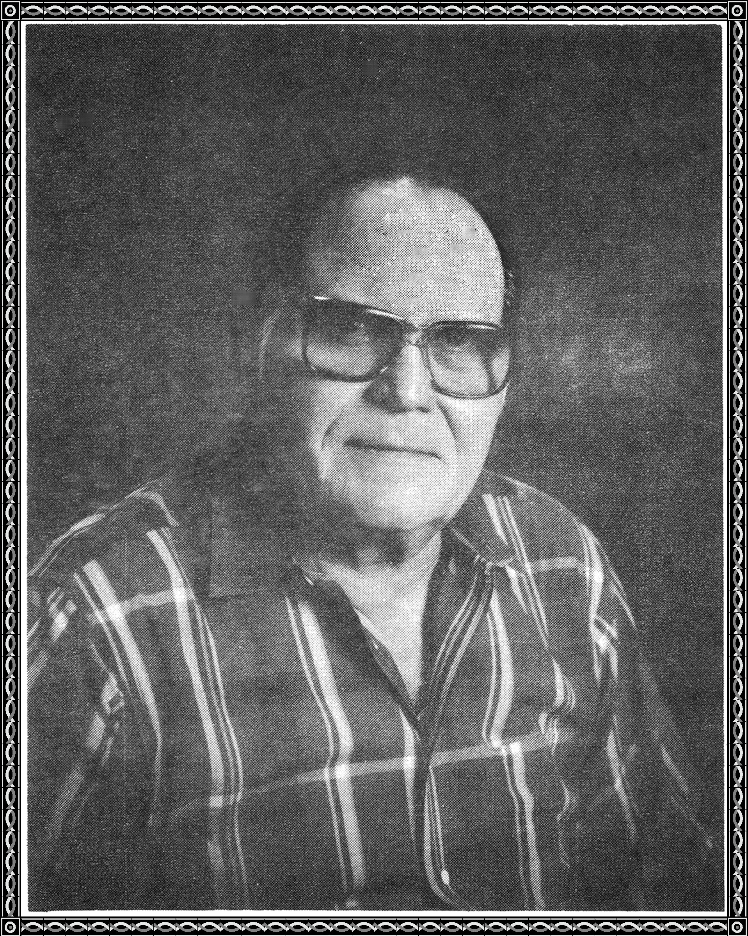

the six of us who became so close.

From all over the country we came,

to serve our country was our aim.

Youthful exuberance was our game,

wills enthusiasm we trained.

Soon our training came to an end.



After a short leave, we returned to our base,

and joined together on a troop train,

across the country we went.

On a ship we were loaded,

for many days we sailed,

till at last we landed on an island,

and prepared for the invasion.

The day came and we fought bravely,



till one by one we began to fall.

A month went by and one was left.

He felt lucky to survive.

And finally at home he did arrive.

To the chapel he went and prayed,

for his brothers who stayed.