**The Hunter**

***01 July 1993***

Stepping softly, he moved through the woods,

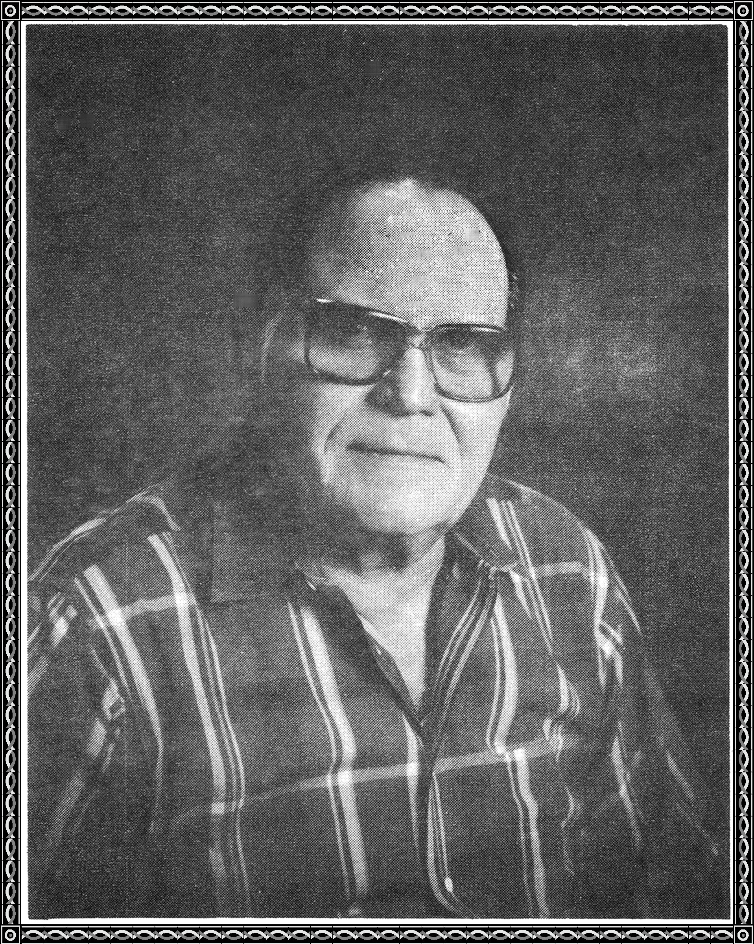

blending into the foliage as best he could.

For he was after the big buck, whose tracks

he could see.

Suddenly, he stopped next to a big tree,

straining his eyes, so that he could see.

Into a circle of sunlight, the big buck stepped,

he stood there grandly, listening for a sound.

The hunter slowly took aim and pressed with

his finger.

There was a click, and the buck bounded away.

The hunter smiled triumphantly and looked at his camera.

For this big buck would live to another day.

**WON GOLDEN POET AWARD -1990**

