**Triangle**

***01 June 1993***

Jack and Lorraine were man and wife,

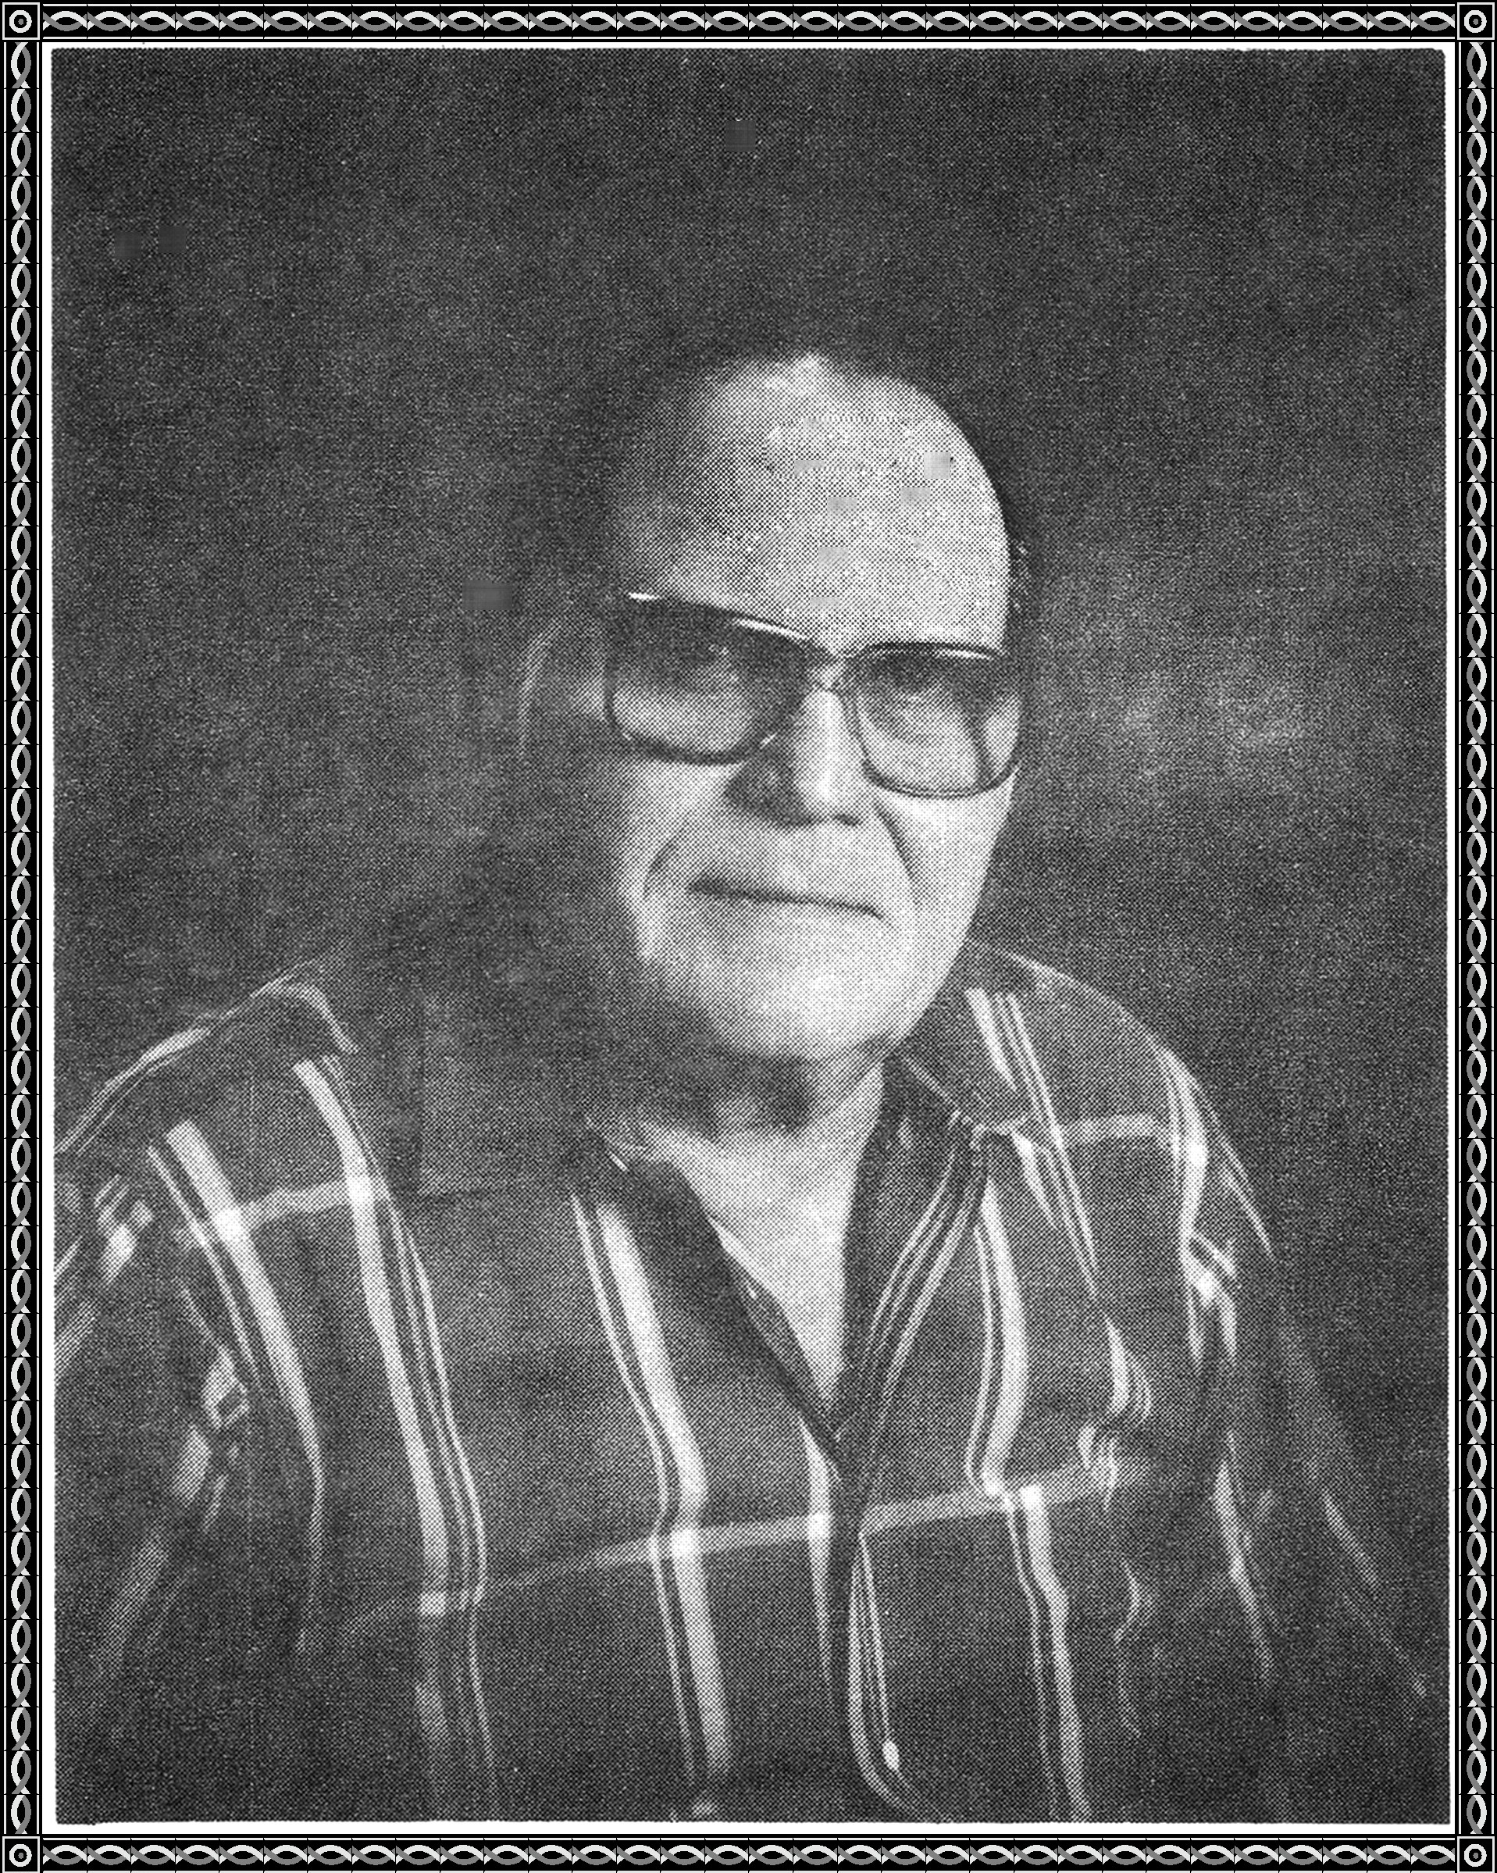

though their marriage sometimes was in strife.

A rooming house was their abode, and there,

Jack sometimes returned with quite a load.

Joe, too, was a roomer here,

and he thought Lorraine was a dear.

He longed for her to be near.

One day, Jack got angry and split,

Lorraine was left alone and sad.

Joe approached her as a friend.

They started keeping company, in the end.

To dinner and the movies they would go.

till eventually, lovers they became.

The gossip about them increased their fame.



One night, Joe was alone in his bed.

A car pulled up to his window and stopped.

"Joe", Jack called out, "I've come to kill you."

"Jack", Joe answered, "come in and have a drink.

"Cheers", said Joe. "Cheers", said Jack, and downed

the booze.

From Jack's eyes tears oozed.

**WON GOLDEN POET AWARD - 1991**