**Letter from Eddie-Lou Cole**

**Poetry Editor**

***01 April 1993***



CONGRATULATIONS! World of Poetry is scheduled to honor you as a Golden Poet for 1992 on Sunday, September 6 at 8 P.M., at the luxurious San Francisco Hilton and Towers, during our Eighth Annual Poetry Convention. Please see exciting details below

.

June 10, 1992

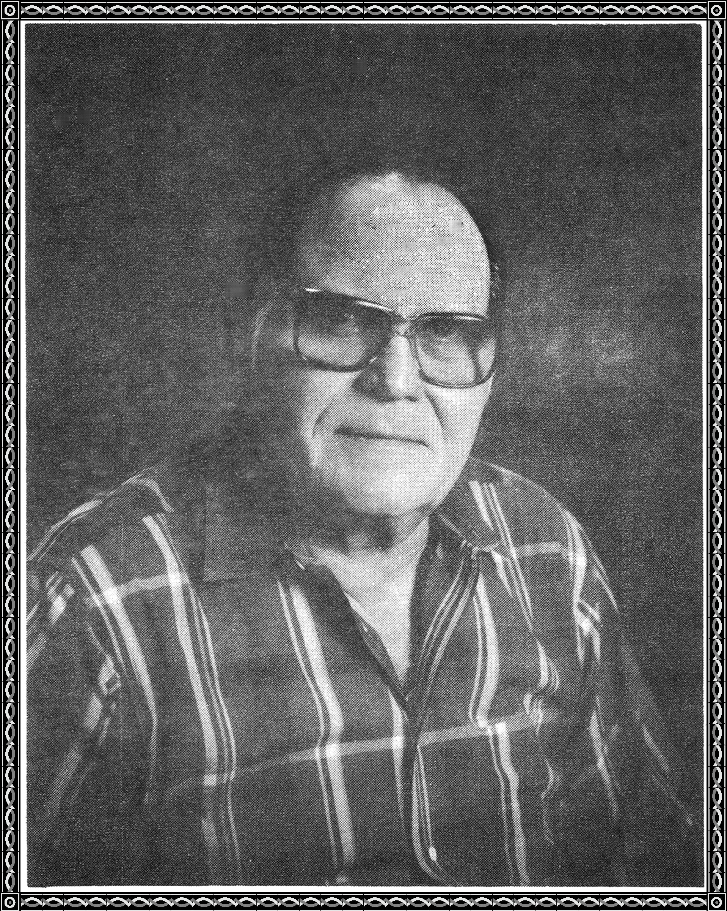

GERALD O MERRITT V.I.P. 1108095

2954 HOUSLEY DR

DALLAS, TX 75228-1708

Dear Golden Poet,

The Executive Committee of our distinguished Board of Directors has chosen your poem POKER GAME from those submitted to us during the past year to be eligible for a presentation at our convention. You will be honored as a Golden Poet and receive a beautiful Golden Poet Trophy. I am so happy for you!

Formal presentations are scheduled to take place at the San Francisco Hilton in San Francisco, Sunday evening, September 6 at 8 P.M., during our Golden Poets' Round-Robin and Medal of Honor Presentation. After you have read your poem aloud, you will be presented with your beautiful Golden Poet Trophy and inducted into the prestigious Homer Honor Society of International Poets. The Academy Awards limits recipients to one minute. We allow you more time because we want your audience to hear the poem for which you have been honored. Indeed, your presentation will be videotaped live so it may be presented later on our television series, "Poetryland - The Wonderful World of Poetry," during one of our "Poet's Corner" segments.

Many poets will be attending alone; many with guests. Either way, we can accommodate you. I have enclosed a copy of our newsletter which outlines the exciting details of our convention. It even includes notes on how to make hotel and airline reservations. After all, this is the first time many poets have traveled to San Francisco, so we want to be helpful in every way. You may be proud of yourself, as fewer than four percent of our worldwide constituency are eligible for a presentation at our conference. Naturally, with the mega-star celebrities and poets in attendance this year, we expect media coverage like we have had in the past - "Entertainment Tonight," "USA Today," etc. So please be prepared to talk about yourself in the event you are interviewed.

Due to my age and health this may be in all likelihood the last convention I am able to attend, and I do so want you to be there for our biggest and best event ever. I want you to sign my autograph book, and take pictures with me for World of Poetry's archives. Indeed. I will take you and your guests to lunch on the afternoon of September 6, during our Master Workshop Series lunch break, as my personal guests. In the event you are unable to attend our conference, I will send you a certificate acknowledging you as a Golden Poet for 1992 by the end of October.

Poetically yours,

Eddie-Lou Cole, Poetry Editor



P.S. It would do my 85-year-YOUNG heart good to see you win our $20,000.00 Convention Contest and be crowned our Poet Laureate for 1992 by Milton Berle!