**Family Origin and Coat of Arms**

***01 February 1993***

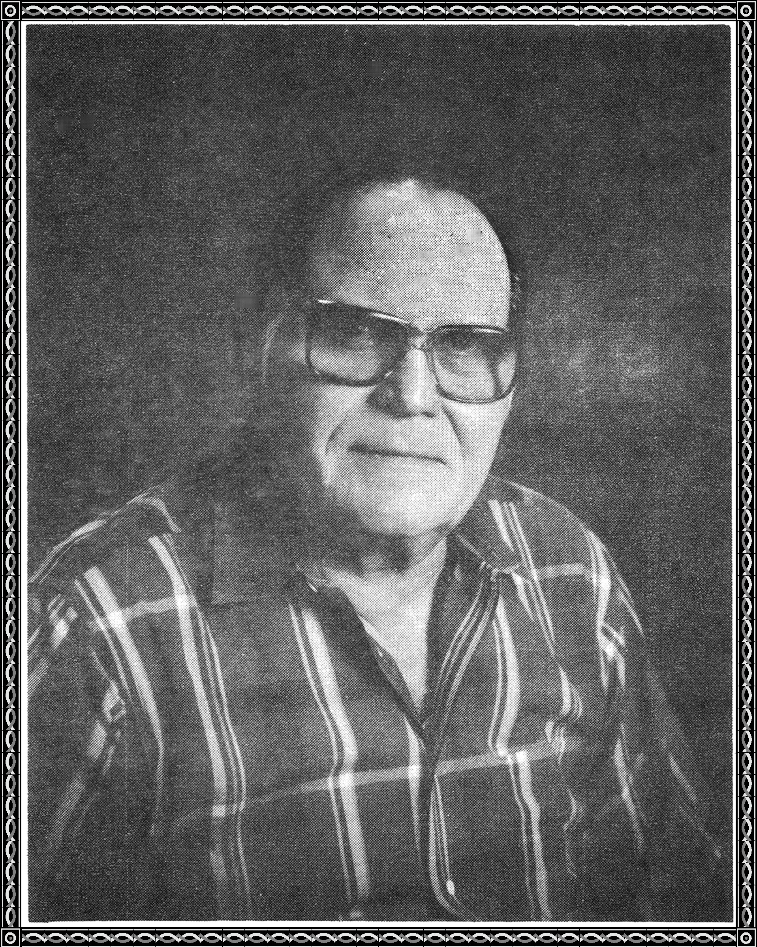

**Gerald Otto Merritt**