**Letter from Eddie-Lou Cole**

**Poetry Editor**

***01 May 1993***

May 22, 1991

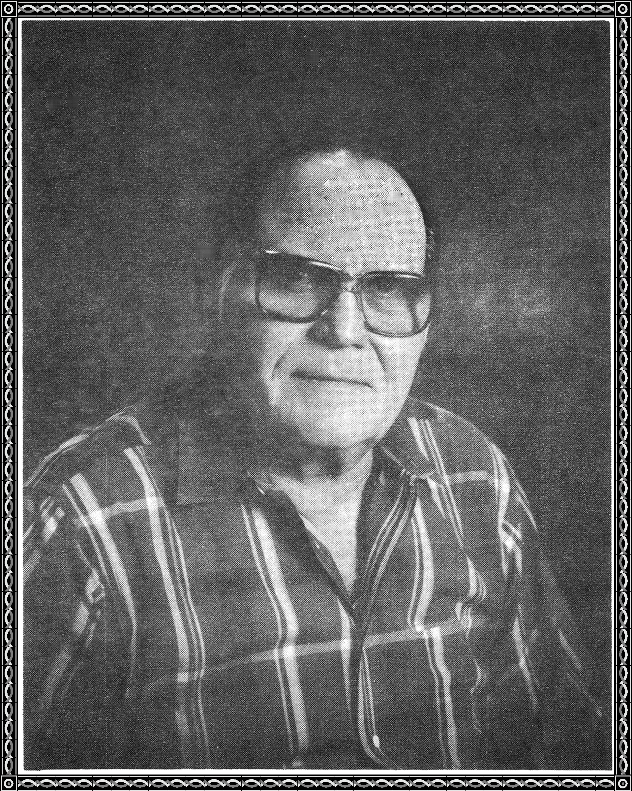

GERALD O MERRITT V.I.P. 1108095

2954 HOUSLEY DR

DALLAS, TX 75228-1708

Dear Golden Poet,

The Executive Committee of our distinguished Board of Directors has chosen your poem TRIANGLE from those submitted to us during the past year to be eligible for a presentation at our convention. You will be honored as a Golden Poet and receive a beautiful Golden Poet Trophy. I am so happy for you!

Formal presentations are scheduled to take place at the Marriott Marquis in New ork City, Monday, September 2, at one o'clock, during our Golden Poets' Round-Robin Presentation. After you have read your beautiful poem, you will be presented with your trophy. The Academy Awards limits recipients to one minute. We allow you more time because we want your audience to hear the poem for which you have been honored. (And don't worry about being nervous—everybody is. You'll love being a celebrity!)

Many poets will be attending alone; many with guests. Either way, we can accommodate you. I have enclosed a copy of our newsletter which outlines the exciting details of our convention. It even includes notes on how to make hotel and airline reservations. After all, this is the first time many poets have traveled to New York, so we want to be helpful in every way.

You may be proud of yourself, as fewer than ten percent of our worldwide constituency have poems eligible for a presentation at our conference. Naturally, with the mega-star celebrities and poets in attendance this year, there will again be the television crews from local, national, and international media outlets. Last year we were on "Entertainment Tonight," among other major media. So please be prepared to talk about yourself and your poetry in the event you are interviewed.

It would do my 84-year young heart good to see you win our $20,000.00 Convention Contest and be crowned our Poet Laureate for 1991. You can see I believe in you! On behalf of John Campbell and the wonderful World of Poetry, I look forward with all my heart to honoring you in New York. In the event you are unable to attend, a certificate acknowledging you as a Golden Poet for 1991 will be sent to you within one month following our convention.

Poetically yours,

Eddie-Lou Cole, Poetry Editor



P.S. How exciting! John Campbell just informed me he wants you to appear on his television show "Poetryland—The Wonderful World of Poetry," reading from your poetry. When you check in at the convention we will schedule a time for you to be videotaped live, as our TV studio will run 24-hours a day during the convention.