**Christmas Eve**

***24 December 1992***

Christmas Eve is our favorite night of the year.

Its traditions to us are quite dear.

It's the night for an open house,

and friends and relatives are invited,

to join with us in celebration.

The dining table is laden with a buffet,

the kitchen counter is laden with drinks.

The house is all decorated.

Of Christmas trees, there are two,

one in the living room and one in the den.

If you can't get the spirit here,

you're in trouble, friend.

We get together to talk and laugh,

and we all partake of the fatted calf.

The evening progresses,

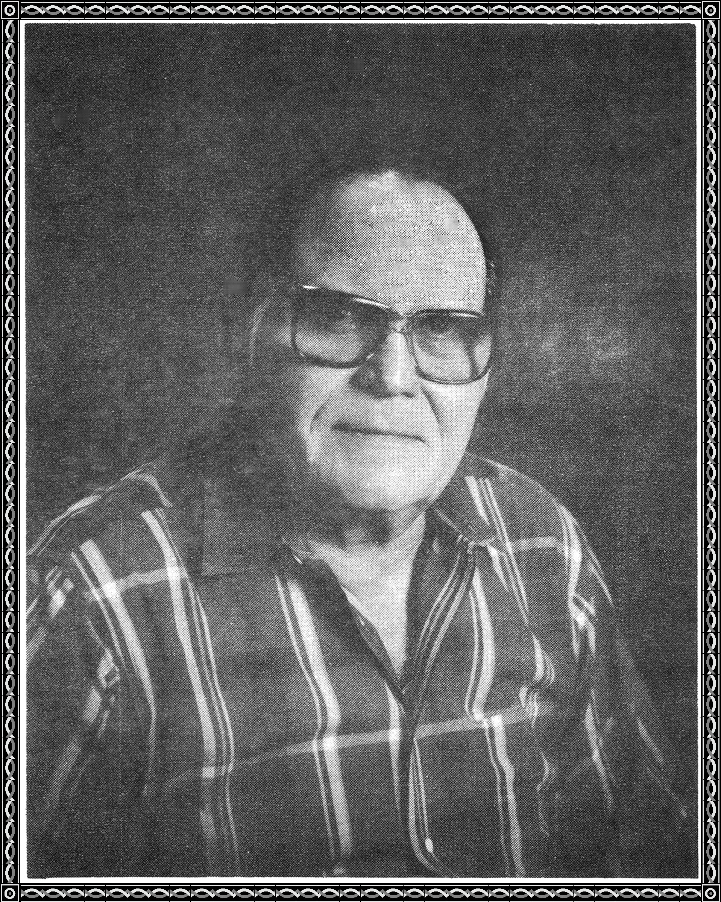

the spirit of the party heightens.

Jokes are told, songs are sung.

Pictures are taken, to record the evening,

alas, the evening comes to a close.

The people depart with a cheer,

shouting, "Merry Christmas, till next year."

