**Who Sold Me This House?**

***01 November 1992***



I bought this house eleven years ago,

I can't remember who sold it to me,

but i wish I could.

This is a house that always has some rotten wood,

it always needs painting,

The lights blink,

the switchbox smokes.

The pipes groan,

the air conditioning leaks.

The water heater was hooked up wrong,

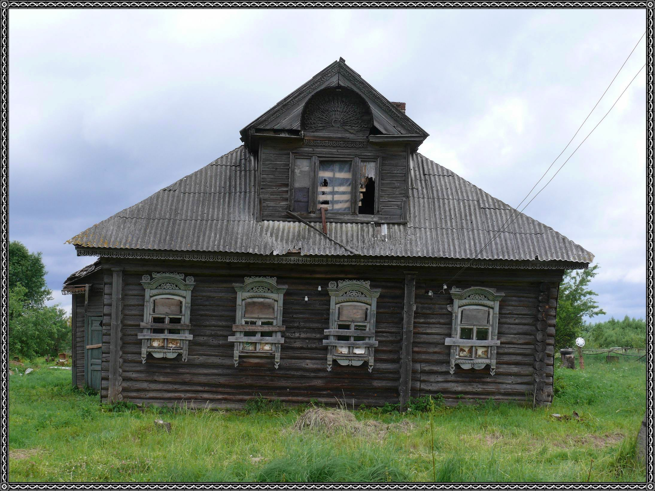

the kitchen sink becomes unglued.

The roof leaks,

the patio roof is rotten,

and now we come to the yard.

The yard always needs mowing.

the weeds just keep growing.

It always needs to be sprayed for bugs,

the shrubs need trimming.

I wish I could remember who sold me this house,

for I would like to thank him.

for I love it and will never move.