**Catfish**

***01 September 1992***



He was thirteen, and he lived with his

grandparents on a farm, near a small lake,

where a rowboat was kept.

He spent many hours swimming and rowing here,

he conquered this lake without fear.

An older man lived nearby,

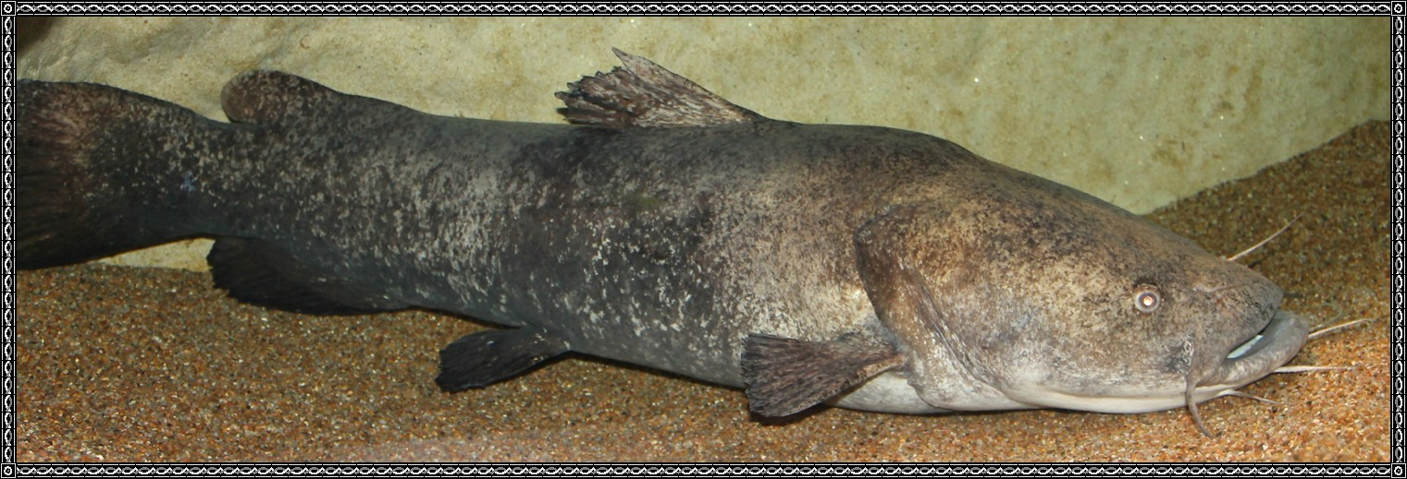

And he longed for some fish to fry.

He loaned the boy his trotline,

for half the fish he caught.

The boy set the line between two trees,

and baited it with P&G soap,

and he hurried home to wait with hope,

for the fish to bite,

for he knew that he was right.

The next morning he rowed out to the line,

he felt something heavy tugging hard.

It was a large channel cat!

He took it home and it was cleaned and cooked,

they ate it all for supper.

The old man across the road got none.

for this the boy felt shame.

