**Mother-In-Law**

***01 July 1992***

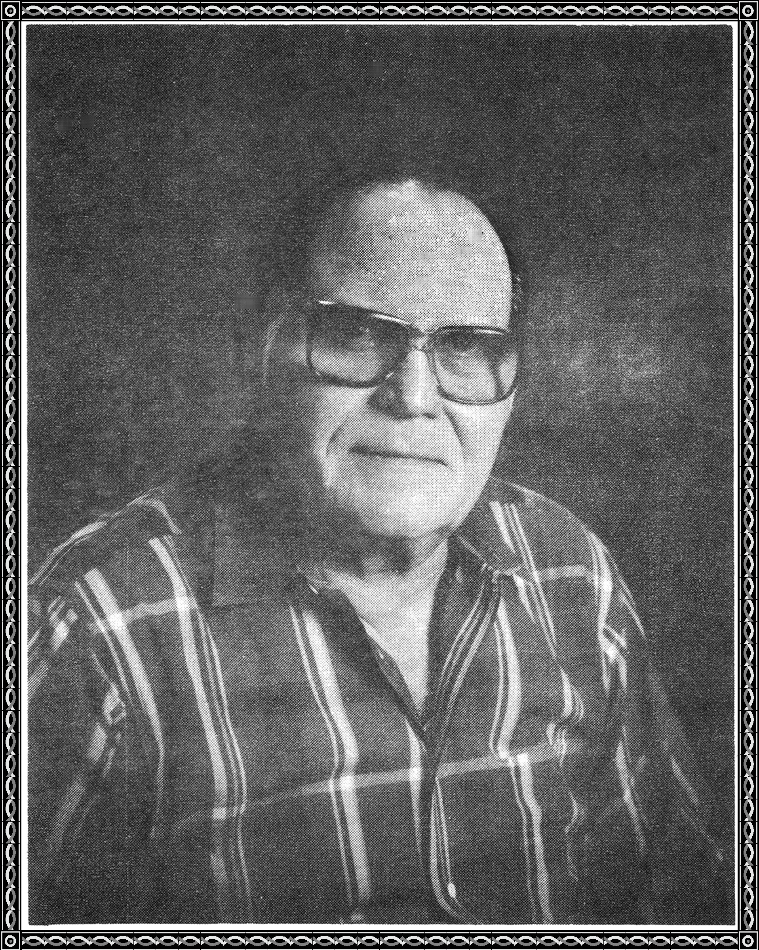

The purpose of this tale

is to set aside the common wail,

about one's Mother-In-Law,

for I have the best you ever saw.

If you have a knot to gnaw

about your Mother-In-Law,

then proceed to where the ice will thaw.

My Mother-In-Law will stand behind you,



like a rock, she will be.

She will help you be trouble free.

She will discourage a spending spree.

A friend to you, she will be,

so do not bother me with the yoke,

of a poorly Mother-in-Law joke.

The time has come to set the record straight,

for she is as a piece of eight,

solid gold through and through.

Dear one, if you only knew,

what I really think of you,

then we would have a good time or two.