**Aunt Flo**

***01 June 1992***

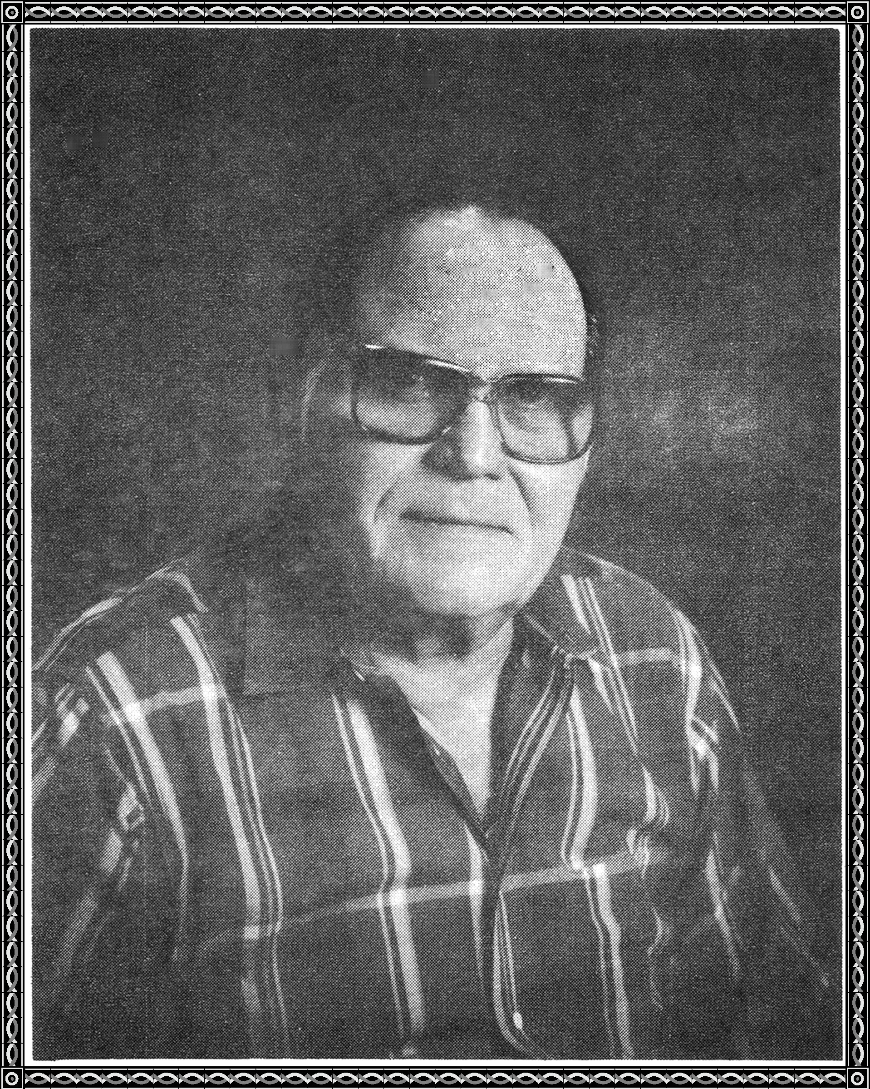

Christmas has come and gone,

Aunt Flo at 97, is with us still,

that's because she has the will,

to do what has to be done,

and still have some fun.

Aunt Flo has a goal,

and that is to reach 101,



for all, that will be fun,

for her, she will know she has won,

the glory of being 101.

The tide of time looses it's ebb,

but Aunt Flo dodges its web.

The radiance of her being

spreads to her friends,

caressing them lovingly as the winds.