**Poker Game**

***01 May 1992***

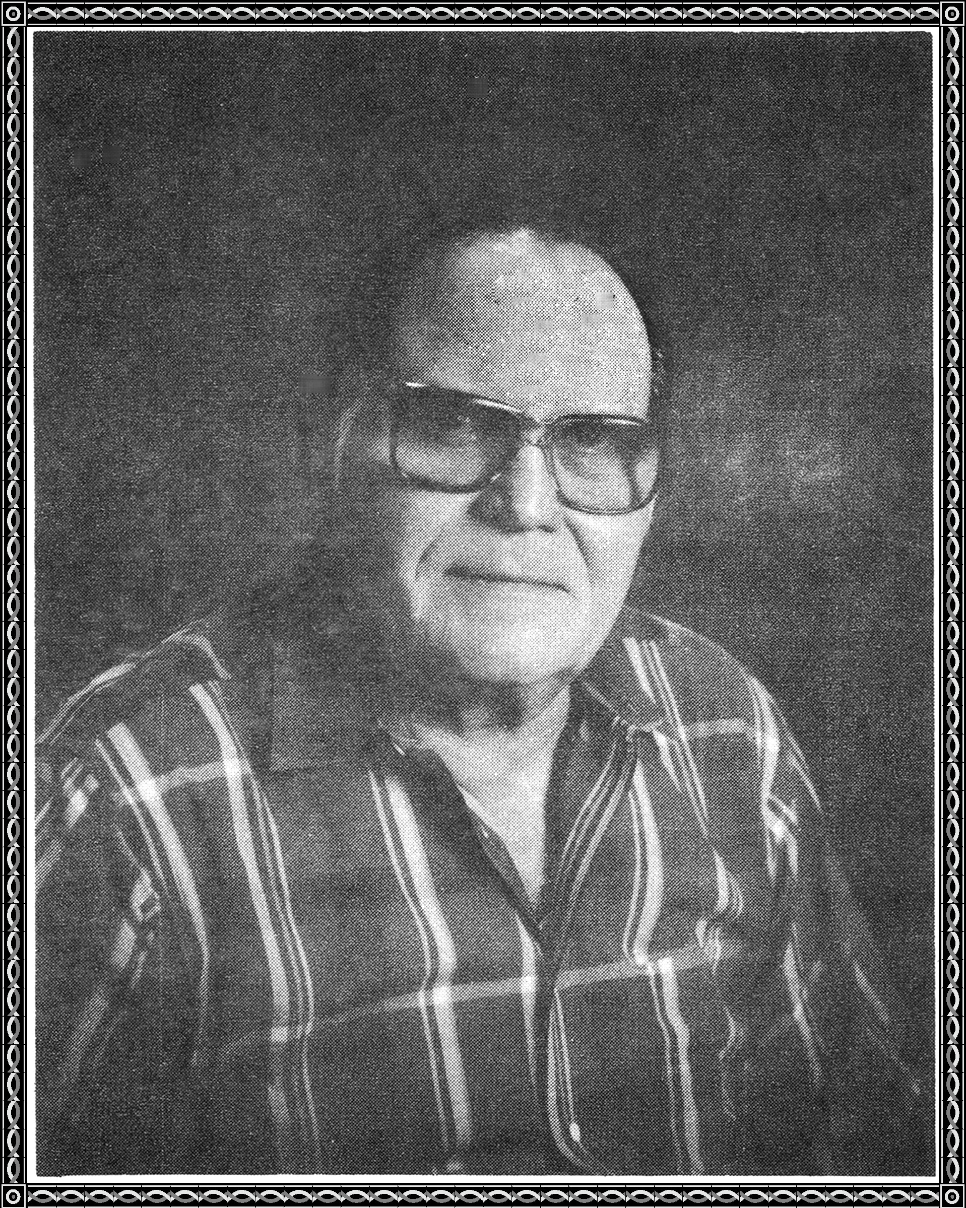

He was walking along the college campus,

minding his own business,

when someone called out, "Hey Joel

Want to go play some poker?"

"Sure, why not?" he replied, and joined the group.

They went downtown on the bus,

and rented a hotel room.

There were seven players around the table.

The game was no limit and all were able.

Seven card stud was the game,

and to win was the aim.

Joe won the first hand with three aces.

He won the second hand with a straight.

The third one came with a flush.

Joe was so lucky, his face began to blush.

He won the fourth hand with a full house.

He won three more hands for seven straight,

the others arose, for their leave to take.

"I'll pay for the room," Joe said as they left,

Joe felt so good, he called down for a girl.

When she arrived, she was from his history class.

**Won Golden Poet Award - 1992**

