**The Love of Two Dogs**

***01 April 1992***



My back yard and patio is the home of two dogs,

one is dark blue and four years old,

one is white with brown spots and ten.

This one is not too thin.

The dark one is named Aussie.

The white one is Gigi.

They often have a playful spree.

These dogs' love for each other is plain to see,

they can communicate with each other.

They share each others' food,

they protect each other from danger.

The bond of love between them is as a ray of sun,

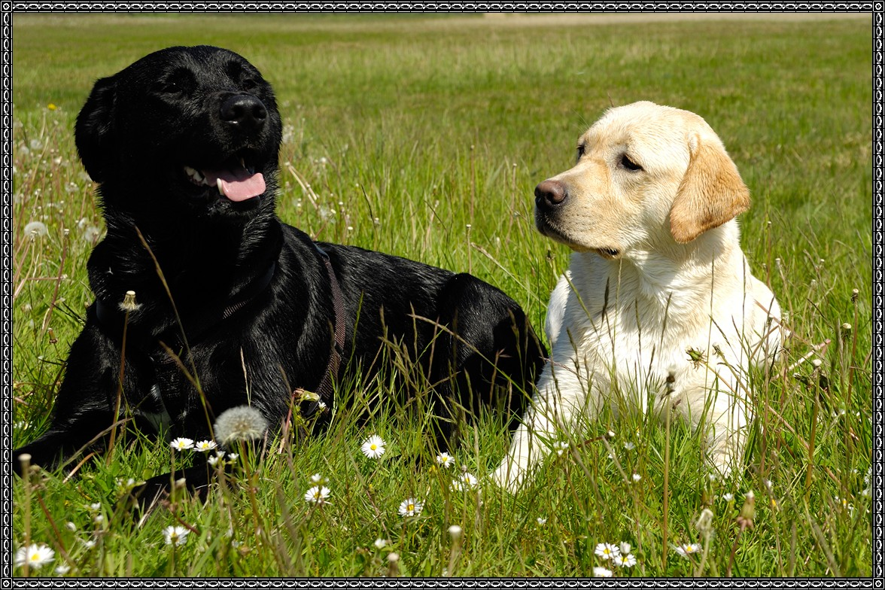

they play together and have some fun.

They are competitive, but each has won.

Their days are spent sleeping and playing.

At night they maintain a vigilance.

They bark and keep on top of things,

they never fail to warn of anything wrong.

They will bark and sing their song.

O'Lord, if the peoples of this world could love

like these dogs, there would be no strife.