**Otis**

***01 March 1992***

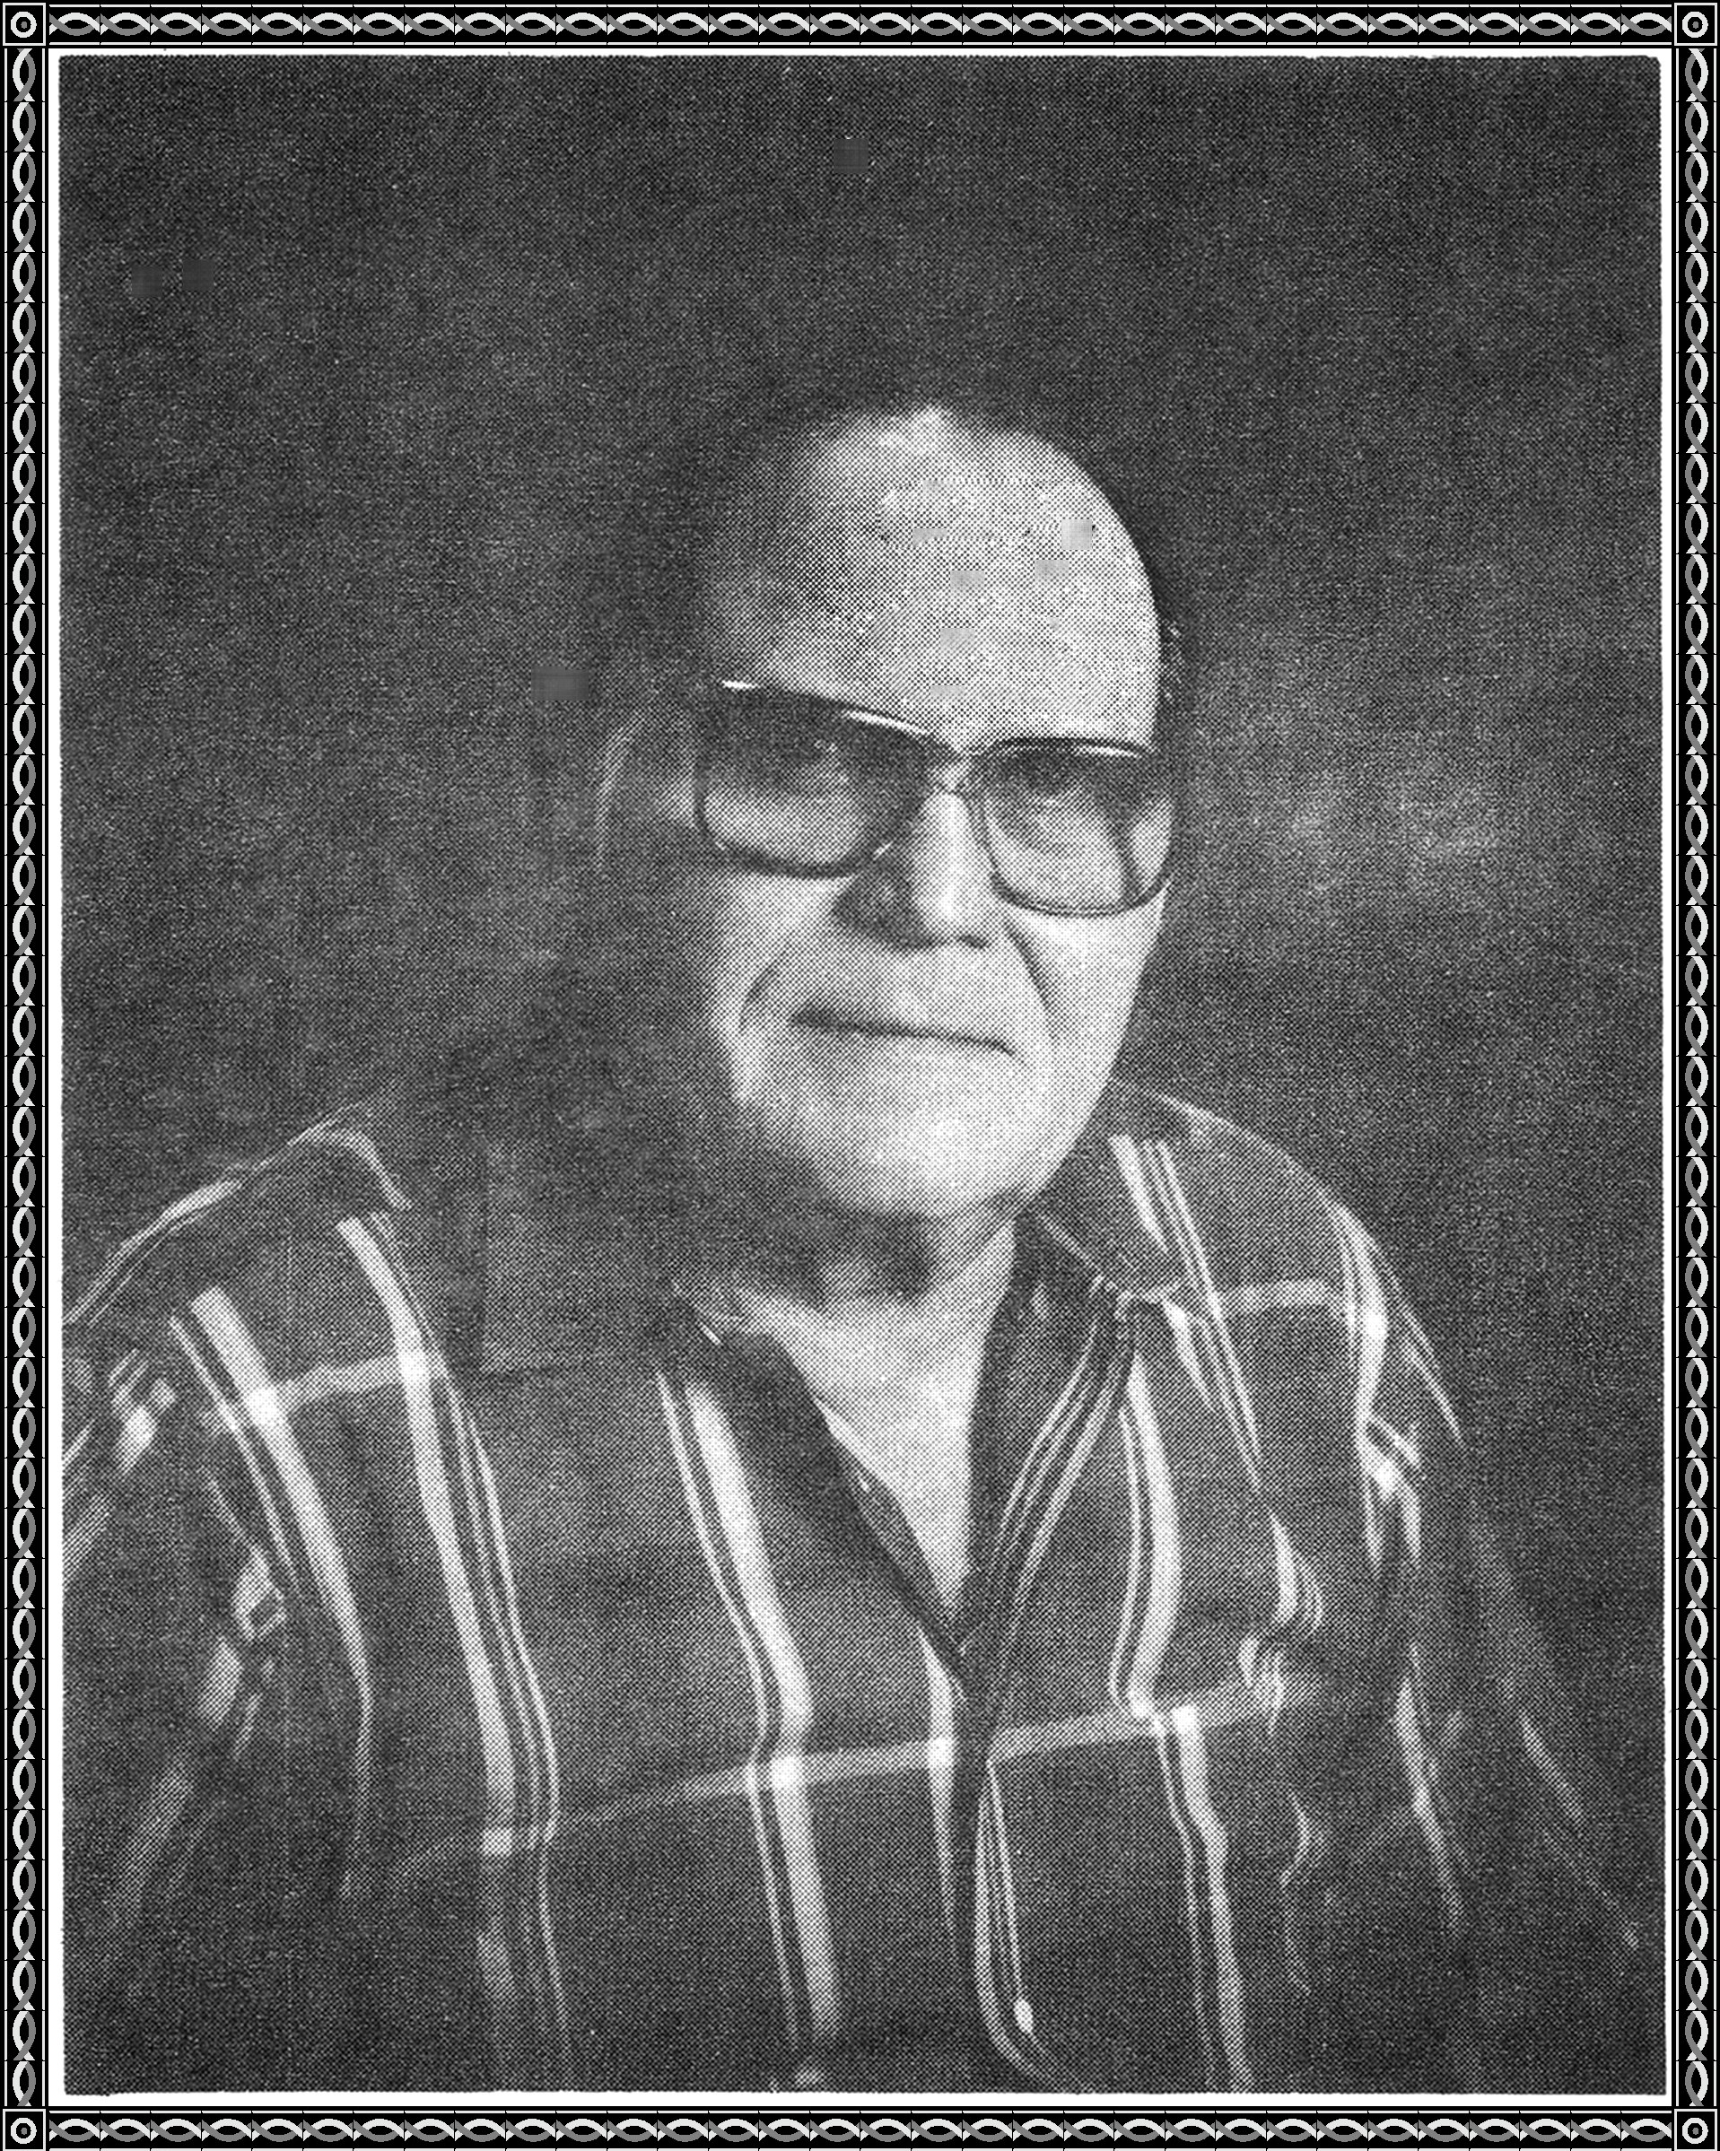

Otis was my friend, it's as simple as that.

The bond of friendship between us began to grow,

50 years ago.

It grew like a well-nourished plant

Continuously, it never stopped to pant.

Somehow we were born on the same wave length,

In the same mode,

We lived by the same code,

Apart or in the same abode.

Otis and I walked many different roads together -

We walked high roads and low roads.

We walked rough roads and smooth roads.

We walked dirty roads and clean roads.

But, whatever roads we walked, we walked them

together.

Apart or together, the bond was always there,

And we both knew that we would always care.

Otis, I wish you well on your Journey,

For you are walking a new road

For me to follow, it won't be long.

The bond between us continues to grow,

To follow this bond is all I need to know.

And I will reach you at the end

And we'll walk together again, my Friend.

