**Crazy**

***01 February 1992***

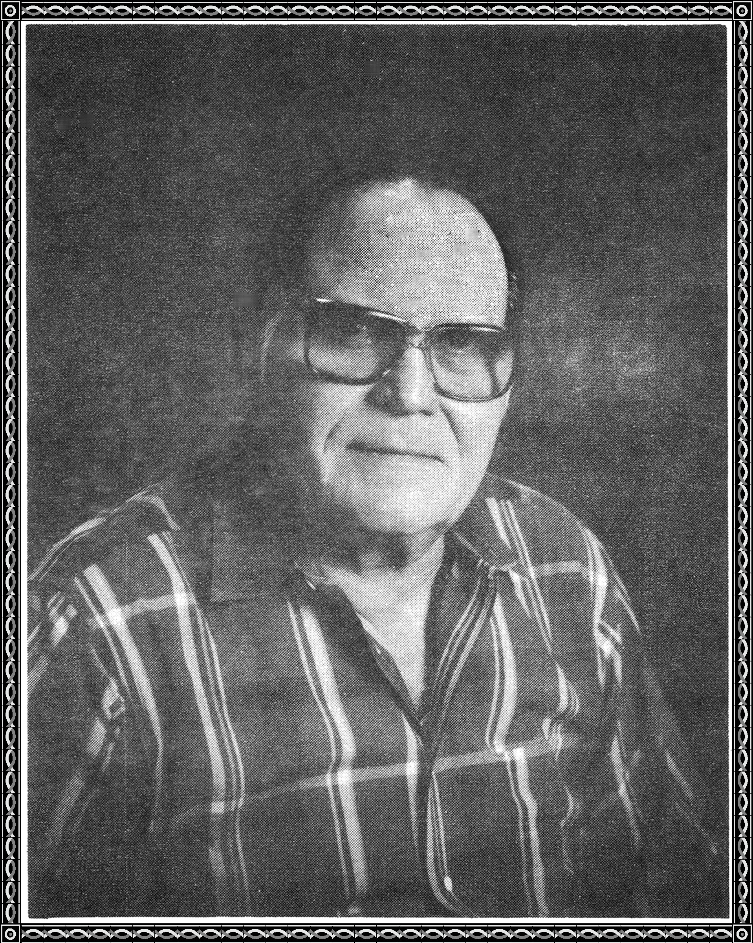

He grabbed his pistol with his hand,

down the company street he went,

waving his pistol wildly about,

threatening everyone he could see.

The men scattered in all directions,

Except for the sergeant, who stood his ground.

He walked up and grabbed the pistol away.

He was put on a ship,

and returned to the states,

and given a section eight discharge.

He was now a free man,

and could go where he wished.

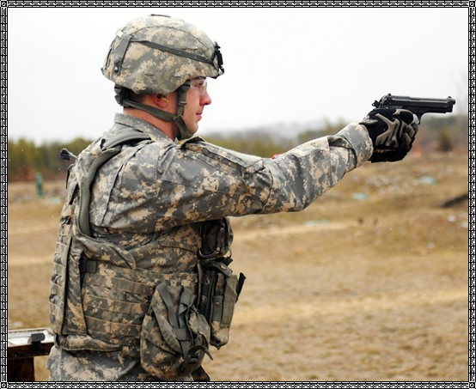

Somehow he wound up here,

with an arrogant altitude.

He went forth to seek a job,

everywhere he went was to no avail.

He began to feel unwanted.

He came home one day and said.

"I think everybody out there is crazy, and I am too.

But at least I have the papers to prove it."