**Cornbread**

***01 January 1992***



If I were to be stranded on an isle,

per chance, or for evil deeds,

without a telephone to dial,

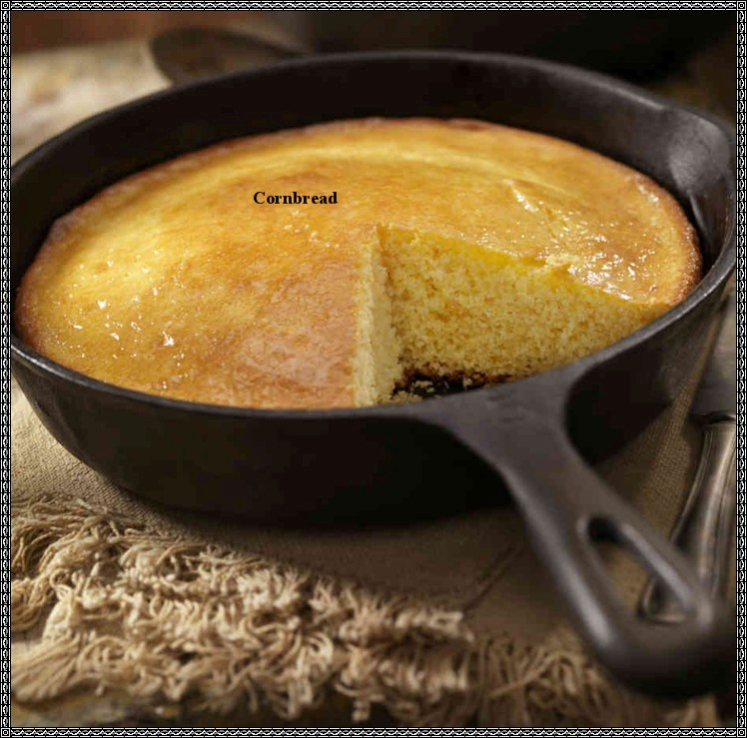

the choice of food to take,

would be an ample supply of cornbread to bake.

For this is the most noble of all breads,

it will satiate your hunger and keep you fed.

Take cornbread and a bowl of chili,

tis enough to drive you nilly-willy.

Take cornbread and a bowl of stew,

tis enough to make you want more than a few.

Take cornbread and a bowl of peas,

tis enough to make you say, "More please."

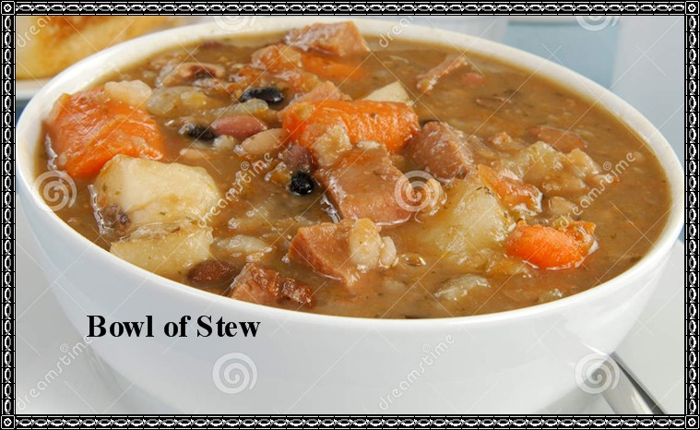

I must go and bake some cornbread.

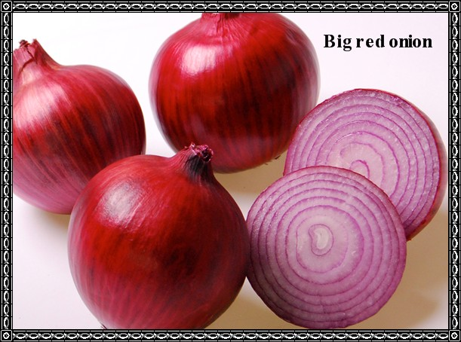

Take cornbread and a plate of greens,

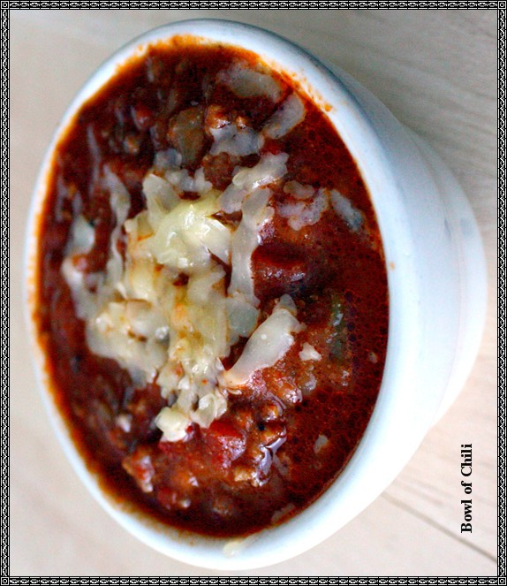

seek out a big red onion,

get a glass of cold buttermilk,

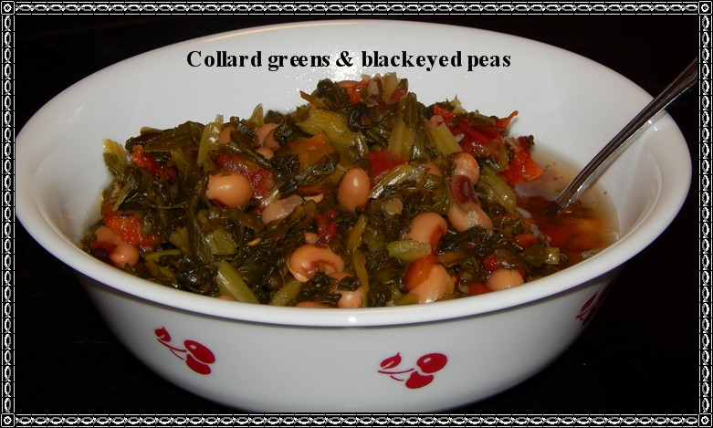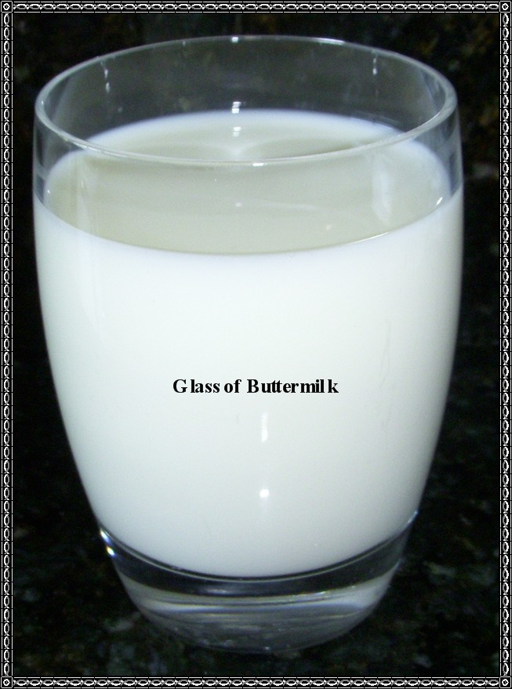

tis enough said, I can't stand it.

But for the ultimate of them all,

cook some collard greens with hog jowl,

for this with cornbread, is the land of ecstasy.