JOHN HENSON - farmer of Vine Prairie Township was born in Saline County, Arkansas, in 1853, and is a son of the Rev. Jeremiah J. and Margaret Hopper Henson, natives of North Carolina, where they were reared and married. In 1853 they came to Arkansas, living first in Saline and Garland County and in 1859 came to Crawford County, Arkansas, their deaths occurring here in January 1977 ***[Editor's note: 1877???]*** and 1882, respectively. He was married twice, his last wife being the mother of our subject. Both belonged to the Methodist Church, in which for many years Mr. Henson was engaged as a local preacher. He was captain of a company of militia at the commencement of the war. He was of Irish-Spanish and Scotch descent. John Henson was the eldest of four children, and his education was received in the common schools of Crawford County and at Cane Hill College, which he attended five months; he afterward taught several months; in 1875 he married Eliza J. Wigley daughter of Richard Wigley, who came here from Georgia soon after the war. They were the parents of eight children, five of whom are still living. Mr. Henson began life a poor man, but is now comfortably fixed, and is one of the enterprising and worthy citizens of the township. He is a Democrat, cast his first presidential vote for Tilden in 1876, and for two years was a township constable. Himself and wife are Methodist, and he is a member of the Producers' Trade Union. He has some Cherokee Indian-blood.

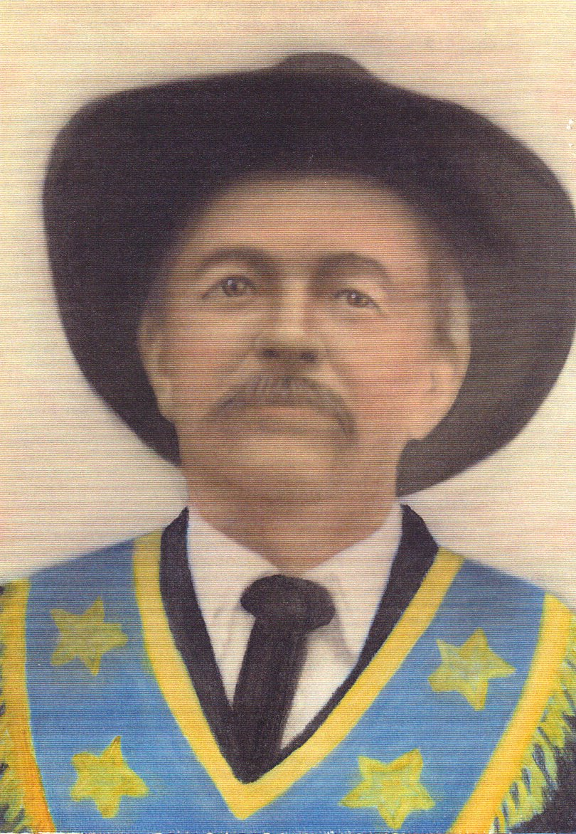

—Goodspeed's History of Northwest Arkansas

***[Editor's note: The photo of John Henson was found on the internet, compliments of Tom Gamel, at this web site:***

**http://trees.ancestry.com/tree/19876736/person/5134862188/photo/535d1926-9844-4cd5-8fbd-61aba9d449f5?src=search End.]**

***Filename: WeRememberDyer post-1986 Book 03, 144-144 ~ John Henson***