**Concluding Reflections**

While reflecting on the past, we are thankful for the Pioneer spirit that led our forefathers to this wilderness which became our home town, for their perseverance, their honesty, for in those days a man's word was good for a loan at the bank.

For the Christian influence that helped mold our town and our lives as we grew up here, for their Community spirit that was always seeking improvements to a better life of which we today enjoy the benefits of their struggles and labors of love and concern for this community.

They were ever concerned for the entertainment of the people in planning for Literaries at the school on Friday nights, plays, picnics, baseball games, making arrangements for Lyceum programs to come every few months that we might have the opportunity to hear good music, book reviews, Hawaiian music, etc, giving permission for the Circus to camp at the Depot square and having a parade of the morning before the night show, medicine shows where there would be a little entertainment and a lot of selling Elixirs that could cure anything from mange to cancer.

And some can recall the late twenties (Roaring Twenties) but don't think it roared much around Dyer. When you passed a home and saw a washing machine sitting on the front or back porch (We did not have utility rooms in those days). Those were still the horse and buggy days, for cars were just coming into their own around then (some of the buggies even had fringe on top); and my, wasn't those long summer afternoon days with all the family in the Surry fun, especially when Mother put in a sack of cookies to snack on as father drove in the bottoms to see how the crops were growing or stopped somewhere on the drive to see a neighbor.

The status symbol then was the beautiful span of horses owned by a man and today its how many cars are sitting on the driveway or perhaps a boat if one can afford one. In the Twenties we were happy to have an Atwater Kent Radio> sitting on a table in the living room where one could listen to Lum and Abner, Amos and Andy, and once in awhile, hear ball game. But today we have progressed to a TV. aerial up on every house and shanty, and we know what is happening in the world as it happens as well as hear some good entertainment as well as some that is not so good.

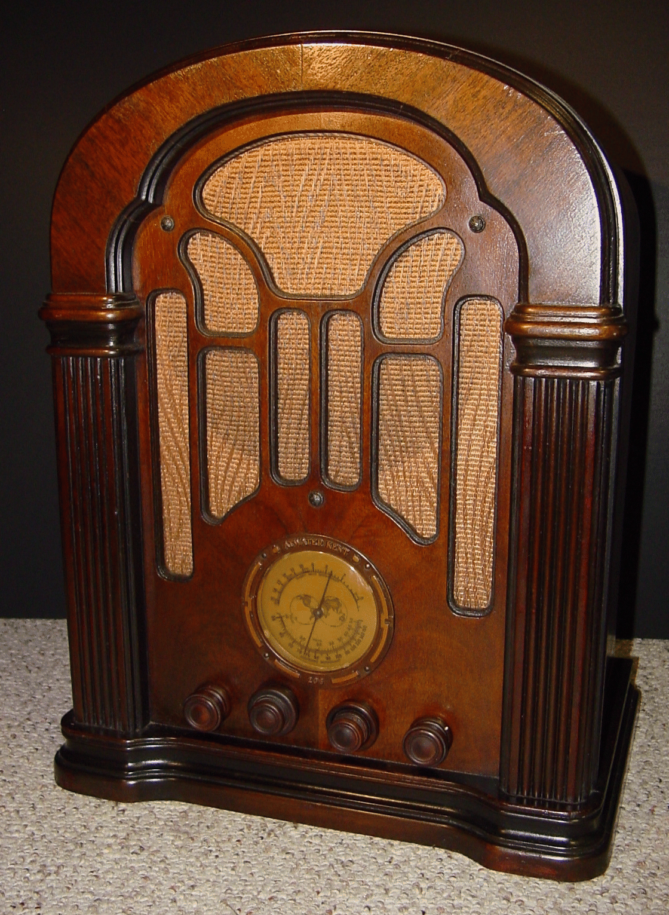

Well, I could rattle on and on but as we glance over our shoulders at our past, we also look hopefully to the future and pray there will be more and better improvements, but most of all may we be able to pass on to those who follow us some of the inspiration and love of Christ that has been handed down to us.

This story is not ended; there will be no end to our story, for each birth, each graduate, marriage, death, events, and progress will be making history. Its been a good 200 years for our nation and one hundred thirty eight years for our community, and we hope, when someone writes the next one hundred years for the Tricentennial in 2076, that this data may help you.

With God's blessing, we are the Bicentennial Committee :

Mayor Ernest Cottrell Martha Bowlin Chitwood

Alma Lorena Moss Lancaster Lois Chitwood Williams

Virginia Kamm Rhodes Luvenia Whitlock Aldridge

Wanda Hurd Aldridge Wanda Porter Dyer

Mary Loy Thomas Kelly Mrs. Jess Howard

Irene Morse Hurd

***Filename: LookingBackAtDyer 1838-1976 Book 01, 180-180 ~ bicentennial committee review***