**LETTER FROM JOEL DYER TO HIS DAUGHTER, CLEMENTINE**

My Dear Clemmie:

Notwithstanding the many and diversified ills incident to this life, the many vicissitudes of fortune, and the deplorable fact that a blighting curse hangs over our race, still God manifests His goodness and mercy toward us in this; that He hath blessed some of us, at least, with parental and filial affection, with an ardent love for our children, and which we fondly trust is reciprocated by them. Love is a Divine principle, it is a spark of celestial fire, emanating from the throne of the Eternal and is conferred upon us by the munificent hand of our merciful Creator, for the purpose of, partially at least, assuaging the ills, and exacting the thorns that pervade life's devious pathway to the grave.

O Clem. What a dark night of sorrow would life be, deprived of the blissful illumination of love, but blessed with the smiles of affection, the wheels of life goes rattling on with a cheerful glee.

But here a sad reflection comes over me. I am writing this as a memento. I am aiming to admonish my Clemmie, my first born, that I must so die, that ere long we must be separated for all time, never to see each other until the great resurrection morn. And, therefore, I wish to perpetuate my memory.

Dear Clemmie, will these lines call to mind your old father when his gray hairs lie mouldering in the tomb?

Will they cause you to try to meet me in Heaven?

Then let this suffice:

May all your path be strewed with flowers;

And grace light up your darkest hours.

May you and I, again unite,

Beyond the grave - in realms of light.

(signed) Joel Dyer

**TRIBUTE TO A HUSBAND**

by Truman Wright

When Senator Dale Bumper's father was pastor of the Dyer Methodist Church, Thad Johnson was Superintendent of the Sunday School. Mr. Thad was one of my boyhood heroes. He had the cleanest fields, the neatest barn, garden, and lawn, the most pleasant home...and a house full of beautiful daughters.

Then as now, nothing made a boy more popular than a pretty sister, not even a pony. Wendall Johnson, who was my age and one of my best friends was well blessed with pretty sisters. Lucille who married Merwin Hamilton and lives in Louisville, Kentucky. Zeil married Orvall Selby and lives in Corpus Christi, Texas. Marue married Dyer Meadors and lives in Fort Smith and if Wendall's twin sister, Wilma, hadn't married Bill Cauld, of Corpus Christi, Texas, I might have been a Methodist preacher today.

The Johnson family lived on Main Street. The principle street is Washington, one block east of Main. Their home was once a hotel built by Floyd Loomis, the father of Mrs. Florence Bennett of Campbell, California, for John W. Moss, father of Mr Tom Moss and Mr. Charley Moss. Mr Tom and Mrs. Dora, parents of Lorena Moss Lancaster, was born in the hotel. Mrs. Dora was one of my all time favorite teachers. She taught me the love of books, that happiness is found in knowledge. The Dora Moss Library was named for her. She was 95 years of age and enjoyed every minute of it.

So far as I know the Johnson house was the only place with gas lights A carbide tank out back supplied the gas that was piped to overhead mantle in all the rooms.

The site is now the home of Mayor and Mrs. Ernest Cottrell, across the railroad tracks. East across Main Street was depot square where the Circus, Wild West shows, and carnivals set up. In 1926 the railroad built a spur onto the square to stockpile material to pave Highway 64. The spur was later removed.

Hester's gristmill was on the southeast corner. Spencer's blacksmith shop faced North on the square. The Spencers lived where Mr. and Mrs. Ray Aldridge lived now. Orville Coulter's house presently occupies the site where the Widow Sweeney lived.

There was a huge sweet gum tree on the northwest corner of the square under which Uncle Jake Well held court in the hot summer time. He was the only Justice of the Peace I knew to ever issue a Writ of Habeas Corpus. Deputy Sheriff J. O. Stephenson (Speck) executed the order. Speck still lives at the intersection of Hwy 64 and Dyer Cemetery Road. He is 95 years.

I once sat on the ground in Uncle Jake's Court under the tree and heard him try a transient for robbery, convict the man and sentence him to a year in the penitentiary. Shades of Judge Roy Bean, the law West of the Pecos.

The Dyer jail (Hoosegow) was on the northwest corner of our place behind the mule barn. The jail and part of the old barn are still standing on Kuykendall Street. Daddy and my older brother built that barn in 1916 of native oak sawed off the Graphis place where I live now.

During the summer I made one of my infrequent visits back to the old hometown. Driving down Main street I saw Mrs. Fila Johnson sitting on a swing on the North porch and I stopped to talk with her. After greetings I inquired about Mr. Thad. She told me that he had died a few month ago.

I was embarrassed. I never know the proper thing to say under such circumstances but managed to mumble my regrets and mentioned that he had been an inspiration to me. She put her arms around me and said, "Truman, I was married to Thad Johnson for 35 years and there was never a day I didn't think he was the finest man that ever lived."

I asked her if she told him that and her reply was barely audible, "Yes, every day." This was the best tribute to a husband I ever heard.

**State of Arkansas Marriage License County of Crawford**

**Van Buren Court House for Crawford County**

**Book A 1877**

**To Any Known Authorized To Solemnize Marriage:**

You are hereby commanded to solemnize the rites and publish the bans of matrimony between J. N. Patton of the County of Clay and State of Texas, age 40, and Miss Rebecca Dyer of Crawford County, Arkansas, age 32 years.

According to law and you do officially sign and return the license to parties herein named.

Witnessed my hand and seal

September 14, 1880

L. H. Southmayd, D. C.

**https://familysearch.org/pal:/MM9.3.1/TH-267-11583-62029-9?cc=1417439**

***[Editor's note: Via Google, I tracked down a copy of the marriage license issued by the County of Crawford, Van Buren, Arkansas, for the marriage of Rebecca Dyer of Crawford County, Arkansas, to J. N. Patton of Texas.***

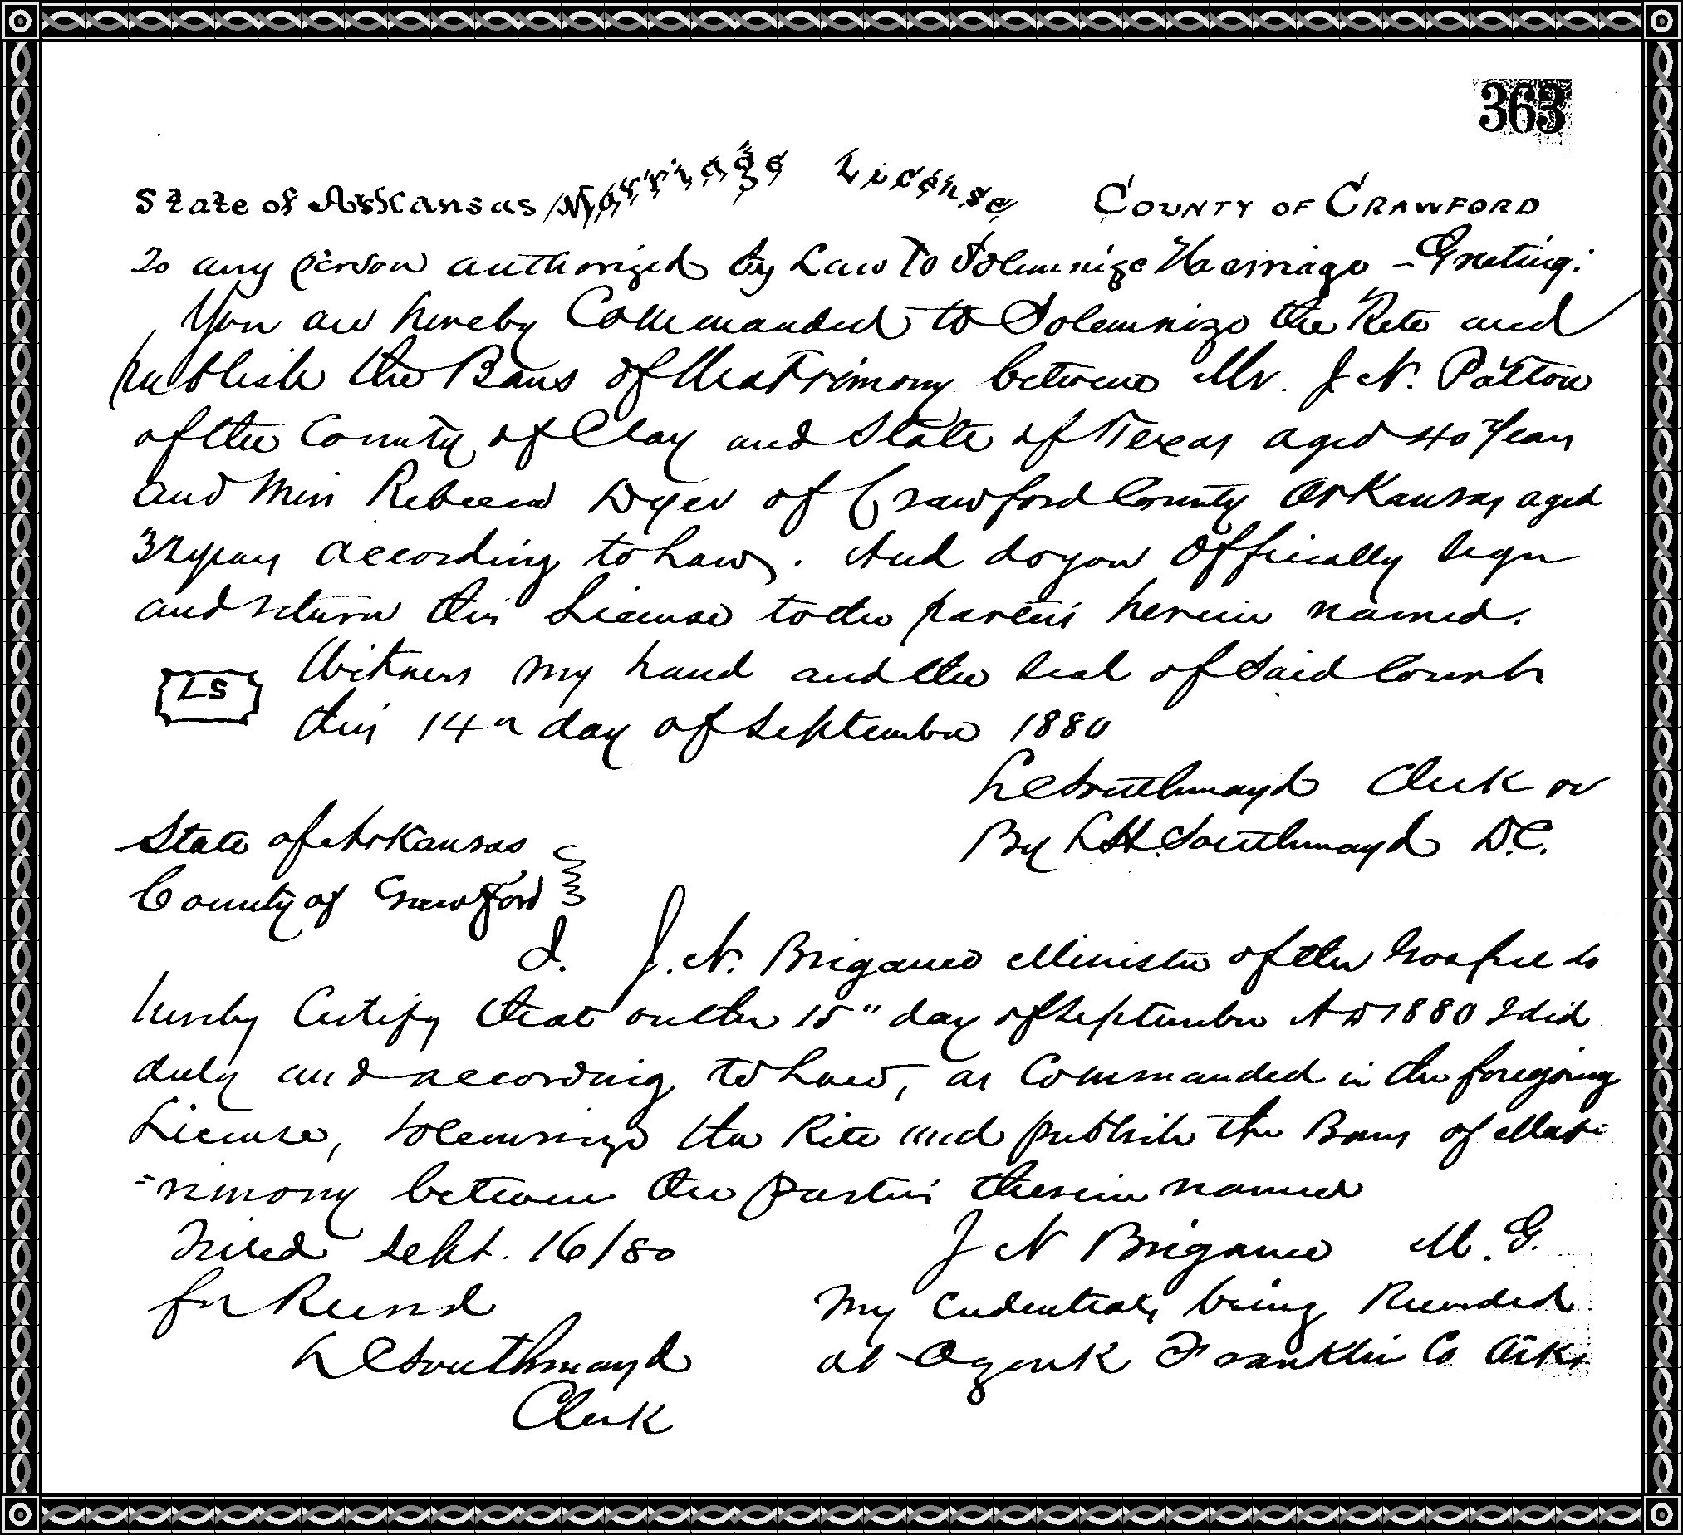

***Filename: LookingBackAtDyer 1838-1976 Book 01, 058-062 ~ letter, tribute, marriage license***