**The Women's Club**

The Women's Club held a Hostage Day on Saturday, January 26, at the City Hall. The ladies converted the city hall into a "JAIL," and their Deputy force picked up area citizens and business representatives and brought them before a "mock" judge who assessed fines for trumped up charges ranging from "wife beating" to parking violations. Those convicted were fined and confined to "JAIL" until their penalties were paid. Prisoners were treated well while in jail and were served refreshments while their friends and/or employees raised donations for their fines. Over $600.00 was raised for civic improvements. At the end of the day, the Ladies's Club sponsored a pie supper at the Community Building at 7 PM and raised an additional $200.00.

**March 30, 1985:**

The Dyer Women's Club will sponsor a "Poor Boy's Supper" from 5 PM until the food is gone. The menu will include Beans, Fried Potatoes, Cole Slaw, Pie, and drink: price $2.50. Proceeds will go to the Fire Station.

**Mother's Day Contest Held May 11, 1985:**

A lot of interest was taken in this project sponsored by the Women's Club. Lucy Thomas was awarded prize for being the oldest entrée. She was 83 years of age.

Myrtle Shelton was the youngest in age.

Runner up was Nellie Hankins.

Myrtle Shelton won the contest and became the queen and led the field by far with 10,000 votes and became Dyer's Mother's Day Queen. $1,482.25 dollars was raised in the contest.

**Candidates:**

Myrtle Shelton 62 10,000

Nellie Hankins 80 3,340

Lucy Thomas 88 3,490

Laura Nixon 67 3,200

Ola Morse 84 3,020

Bessie Kincy 80 2,025

Sula Kamm 88 90 26 years in Dyer ***[??? ~ per the original document]***

Nita Wagner 80 781

Myrtle Gregory 79 260

Martha Hatley 66 180

Nerva Moore 76 ***[??? ~ it appears as though the alignment slipped]***

**August 13, 1985:**

Members of the Dyer Women's Club attended an awards .and recognition ceremony held by Governor Clinton August 13, 1985, in Little Rock in the State Capitol Building. Those making the trip were Club Leader Naomi Hatley and Sue Morse, Lugenia Whitlock, Goldie Pollock, Irene Hurd, Dean Kincy, Debbie Coulter, and Kathy Koiser. The ladies went on an organized tour of the capitol, meeting the Governor and Bill McCuen, Secretary of the State, Arkansas.

**1986: Members of the Town Council**

Mayor: Fayette Peevy

Recorder: W. N. Brasher Ex-Recorder: Joe Kincy

Aldermen: Wi1liam Gregory Claude Hatley

Movle McCabe Quentin Stephens

Tommy Thrift Hershel Whitlock

**Vessel Draws Large Crowd**

600 people, two bus loads from Lavaca Public School, showed up at Dam 13, near Barling, Thursday, to get a look at what may be the largest ship ever to travel the Arkansas River. The Sea-going vessel from Hamburg, Germany, called the M-V Frauke, is on its way to the Port of Catoosa near Tulsa, Oklahoma, to pick up equipment to build oil rigs and then head for Egypt. When it passed by Kelly Park in Fort Smith, near the Garrison Avenue Bridge, there were about 50 people lined up on the Arkansas River bank.

The ship has a crew of ten, plus the Captain and his wife, and a river pilot from Oklahoma. This ship has been called the first International sea-going vessel to travel the Arkansas River as far inland as Tulsa, Oklahoma, under its own power. The depth water is only nine feet in some parts of the channel, so few ships can navigate the channel. This vessel came through on the **16th of January 1986**.

***[Editor's note: See******WRD post-1986 Book 03, 168-170 ~ MV Frauke, ocean vessel******for more information and photo of the MV Frauke].***

**Belt buckle is limited edition**

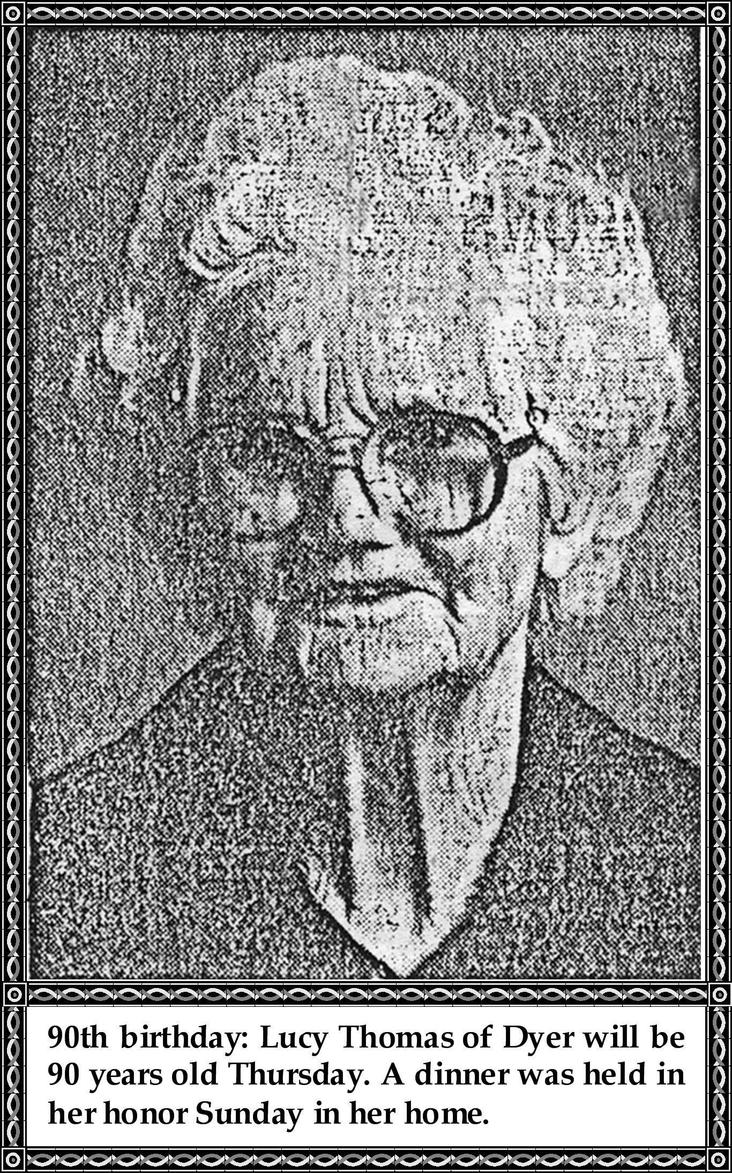

***Depicts past 150 years of historical events***

In observance of the Arkansas Sesquicentennial celebration planned in Dyer on May 17, the Dyer Sesquicentennial committee is casting a solid pewter belt buckle in a limited edition depicting historical events of the past 150 years.

The buckle is being designed by local artist Tonia Holleman and a limited number will be available for purchase from the committee.

All reservations must be made by February 25 for delivery in May. Each buckle will be individually numbered and after the order is made and the buckles cast, the mold will be destroyed.

The buckles will be $20 each, payable in advance.

January 22, 1986

**Mulberry, Dyer list joint projects**

By Linda Seubold

SWTR Staff Writer

DYER—About 30 residents of neighboring Mulberry and Dyer met Tuesday night in Dyer's community hall and compiled a list of projects they can jointly participate in and benefit from.

After breaking into six informal discussion groups to identify mutual wants and needs, the group came up with 12 major areas of concern:

□ Sewer expansion for Mulberry and installation for Dyer.

□ Connecting Dyer and Mulberry water systems.

□ Joint police protection for the two cities.

□ Implementing a neighborhood watch program for Mulberry and strengthening Dyer's program, which has been in place for about two years.

□ Extending cooperative fire protection for the two cities and eventually establishing a station somewhere near the Dyer exit on Interstate 40 between Mulberry and Dyer.

□ Improving police and ambulance dispatching services.

□ Obtaining private telephone lines for all 997-prefix residents in both cities.

□ Upgrading railroad crossings in the area.

□ "Getting rid of the gap" between Mulberry and Dyer—the area outside of and between both cities's taxing boundaries, so that city services and taxes can be implemented to benefit residents of both communities.

□ Investigating the possibility of having an ambulance service specifically for eastern Crawford County.

□ Banding together to obtain better cable television service.

□ Securing docking facilities somewhere between the two cities for anticipated industrial development.

Mulberry Mayor Arnold Feller and Dyer Mayor Fayette Peevy agreed the list will form a good base for both long and short range joint goals for the two cities. Rick Fivekiller of Western Arkansas Planning and Development District advised that, due to anticipated federal budget cuts resulting from the Gramm-Ruddman bill, a sewer project would probably be too costly for the cities at this time. But he said he would help the group if possible and encouraged them to pursue their goals. Feller said the Alma Area Chamber of Commerce had also offered to assist in the joint projects.

**Gym and City Hall and Fire Station**

