**Council Meetings**

**1971 Councilmen:**

Mayor: Morris Herring Recorder: John Harness Treasurer: George Weese

Councilmen: Hershell Whitlock, Thurman Hurd, Jerry McAdoo, Fayette Peevy

**1973 Councilmen:**

Mayor: Irl Scott Lancaster Recorder: Virgil Kamm Treasurer: George Weese

Councilmen: Thurman Hurd, Hershell Whitlock, Jerry McAdoo, Fayette Peevy, Morris Herring

**October 9** a mass meeting to discuss plans for water system. Water tank serves two purposes:

1: Absorb the excess pressure

2: A needed reservoir

Gate installed and locked at "Dump" except on Saturdays, opening on Saturdays and only to people in Dyer.

Program of expenditures will be continued for Revenue Sharing:

10% to Dora Moss Library,

10% to recreation,

20% to City Dump,

60% to street repairs.

A "No Loafing" sign installed to safe guard public safety and welfare of citizens.

**July 1973**: Revenue Sharing check distributed:

$798 for street repairs,

$236 for city landfill,

$118 for Library in November in shelving,

$118 used for city park. .

**November 5, 1974**: 13 men seeking membership on Board of Aldermen and two running for Mayor.

Those elected: Ernest Cottrell as Mayor, Aldermen: Neil Coleman, Bill Coulter, Jerry McAdoo, Willard Blevins.

**March 1977: Ordinance no 2-1977:**

No disturbing noise from 10 P.M to 7 A.M

No vehicle shall stand within intersection of any street.

No vehicle shall park on right of way for more than 24 hours.

No vehicle backed up to a curb longer than for loading or unloading.

No vehicle shall stand stalled or wrecked, more than two hours where it congests traffic.

Unlawful to park any vehicle on East side of Washington between hours of 7 AM and 7 PM.

Dyer was certified to be a second class city in **1981.**

Mayor: Fayette Peevy Recorder: Joe Kincy Treasurer: George Weese

Aldermen: Kenneth Morse, William Gregory, Quinton Stephens, Jim Moore, Moval McCabe.

Soon there will be six Councilmen.

**January 3, 1983:**

Old Council reported that street signs for the city due in January. The City owns the following: Tractor with a bush hog, mower, radar gun, radio base station, and a patrol car.

Mr. Weaver asked that his resignation be accepted for sanitation: Accepted.

A motion was made that Mr. Land and Mrs. Goff be retained as employees and Mrs Leakey continue to assist in reading water meters.

May asked that Ben Leakey be contacted to see if he is interested in the sanitation job vacated by Mr. Weaver.

Speed limit for vehicles in city limits is 30 MPH.

**January 10, 1983**: Sammy Whitlock was elected Assistant Fire Chief and Quinton Stephens was appointed training officer.

A "Hidden Entrance" sign installed near Bank entrance.

**Appointment made:**

McCabe: Water Department Stephens: Fire Department

Morse: City Dump Gregory: Streets

Ronnie Hatley: Gym

**March 7, 1983**: Motion made for fencing around compound back of City Hall.

All city monies now in interest bearing accounts.

A bulletin board, purchased for outside City Hall.

Motion that "One Hour" parking limit signs be removed from Washington Street. "No Parking" from here to corner on South side of City Hall.

**April 4, 1983:** A petition with 163 signatures urging support of an ordinance regulating distribution of handbills

**June 1983**: A Fourth of July Picnic will be held at the Gym.

**July 1983**: Ordinance on fireworks temporarily suspended to allow fireworks on school ground on the Fourth of July.

**September 5, 1983**: Plans to build a tool shed behind City Hall.

**September 26, 1983:** a meeting to discuss a crime watch for the town.

**October 3, 1983**: 100 chairs to be bought for the Gym.

Paneling and paint to repair Gym.

**November 1983**: Town mapped out and block captains appointed for CRIME WATCH.

**January 1984**: Maps for city from state now on file.

**Destruction of 1908 stores, site for new Fire Station**

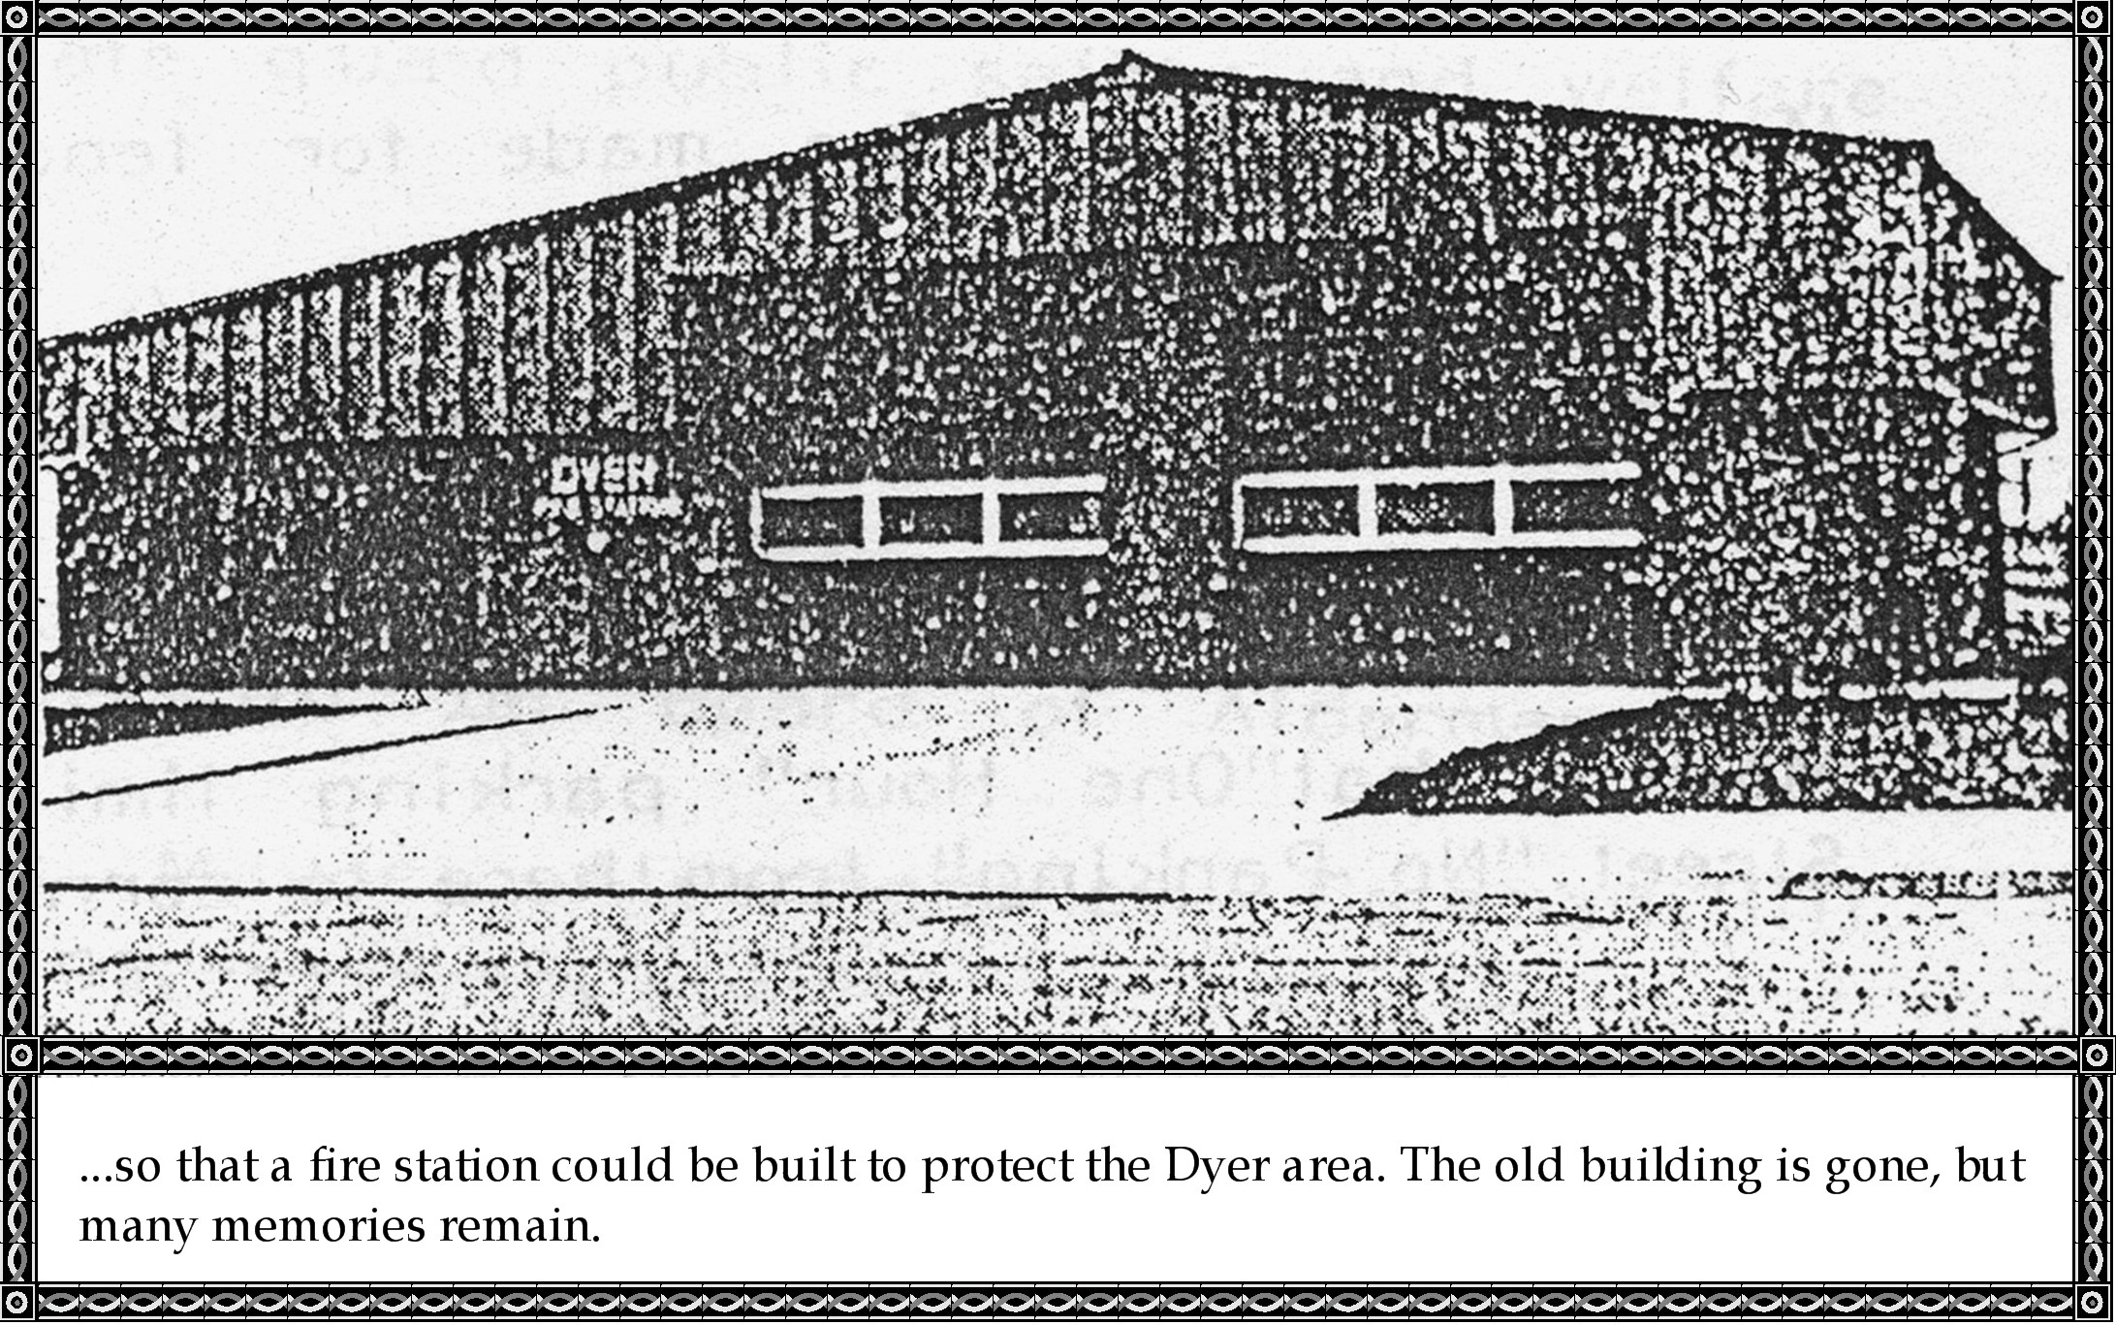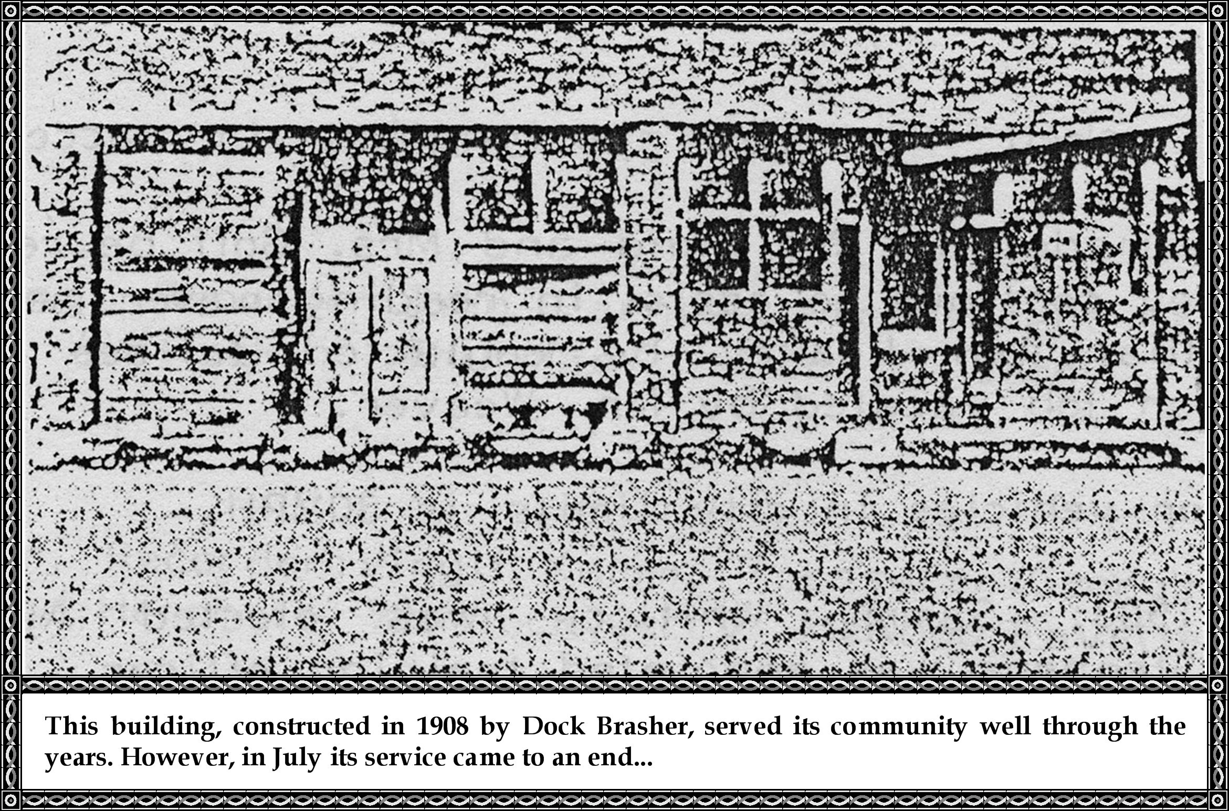

**Fire Station Replaces Two Old Building**

**By Joe Kincy**

Back in the old days the town of Dyer was a beehive of activity. The two block area along Washington Street were filled with such businesses as grocery, hardware, furniture, merchant, harness, leather goods, drug, confectionery, and creamery stores. Also cafes, Doctor offices, blacksmith shop, wagon sales, ice house, bank, Post Office, barber shop, shoe repair, and furniture repair shop.

Dyer was the trade center for an eight square mile area. People from Georgia Ridge and the mountains to the North brought strawberries and produce to Dyer to be shipped. Folk from Arbuckle Island crossed the Arkansas River on Dick Leakey's ferry to do their trading and have cotton ginned and sold. The Missouri Pacific Railroad ran through the heart of town and the Depot was always a busy place. At times, the long loading platform located between Main and Washington Streets would be filled with cotton or produce to be shipped. Trains stopped frequently to switch cars on and off the siding, and the local or "Dinky" made two stops daily.

Most of the people were farmers; using horse or mule teams, they raised mainly cotton on 10 to 15 acre plots in the fertile river bottoms that border the town on the South. When cotton prices fell, small farms gave way to larger mechanized operations, forcing people to find work in other areas. A lot moved to California, Michigan, Texas, and other states. Those who remained found work in trades and factories in Van Buren and Fort Smith.

In July of this year, the old buildings constructed by Dock Brasher in 1908 came to an end after 77 years of service. In one day's time heavy equipment leveled the buildings, hauled away the debris, and restored the land to its original condition to make way for construction of a FIRE STATION.

Although several businesses are scattered throughout the city, Rhodes General Store and the Country Corner Craft Shop are the only commercial ventures remaining in what was once a bustling business district.

The old buildings are gone, but many memories of their history remain. Roe Cottrell operated a Barber Shop there from 1965 until his retirement in 1981, and since then the buildings remained vacant. Roe's shop was a popular gathering place where in the winter you could warm by his open flame asbestos-backed gas heater and hear a friendly argument on about any topic. Haircuts were a dollar until 1979, and then, to keep up with inflation, Roe doubled his price.

Many old timers will fondly recall when the two-part old building housed the following: Shibley and Heard clothing store; Terrell Rhodes Post Office; Offices of Doctor Rankin, Dr. Haney, and Dr. Hunt; Guy Gray Drug Store; John Cecil harness shop; Fletcher Chitwood; Bayliss Kelly; Morset Bennett; and Oliver Thomas; cafe or confectionaries; Norris Johnson; Monroe Nelson; and Mr. Bernard Barber Shops; Tom James grocery and wagon sales; Amos Fleaner and Elzie Harris shoe repair shops; Thurman Rhodes grocery, creamery, and shoe repair; Frank Selby ice house and grocery; Randolph Shropshire furniture manufacturing and repair; and Debs Peevy beer parlor. Also there were grocery and general merchandise stores ran by Thomas William Moss, Mr. McKeal, Charles Fines, Seth Davidson, Buck Davidson, Carl Heger, Joe Teague, Sam Stewart, Ray Babb, Susie Holcombe, Joe Mullins, Hays Hurd, Dick Wells, Ira Griffin, Jewell Harris, Jess Cole, Avery Morse, and Ernest Wells.

Yes, a part of the past is gone but has been replaced by the modern fire station. The soon-to-be dedicated station was built by Meadors Construction Company of Alma. The all steel and masonry 40 x 60 foot building will house two fire trucks and has classroom, office, rest room, and kitchen facilities. Construction of the station, purchase of " a . new mini-pumper fire truck, land acquisition, architectural and administrative fees were provided by a $213,000 AIDC grant from the state.

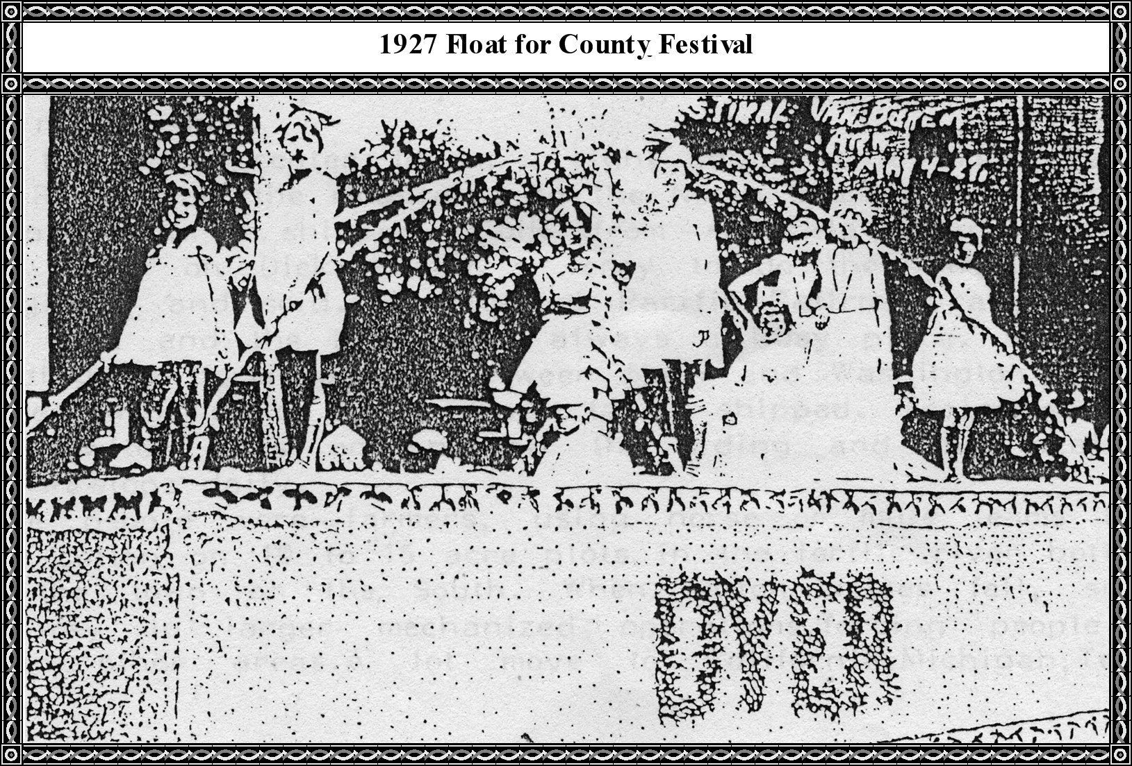

***[Editor's note: I found this photo of the Dyer Fire Station on Facebook and have inserted it into this document, found at this Facebook web site:***

**https://www.facebook.com/108316295915957/photos/pb.108316295915957.-2207520000.1432069002./343895705691347/?type=3&theater**

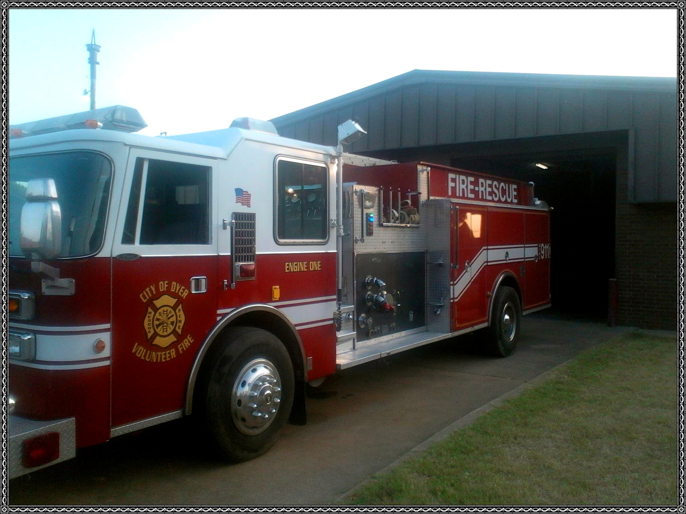

***[End.]***