**Brush Arbor**

**Old-Time Revival Now Underway**

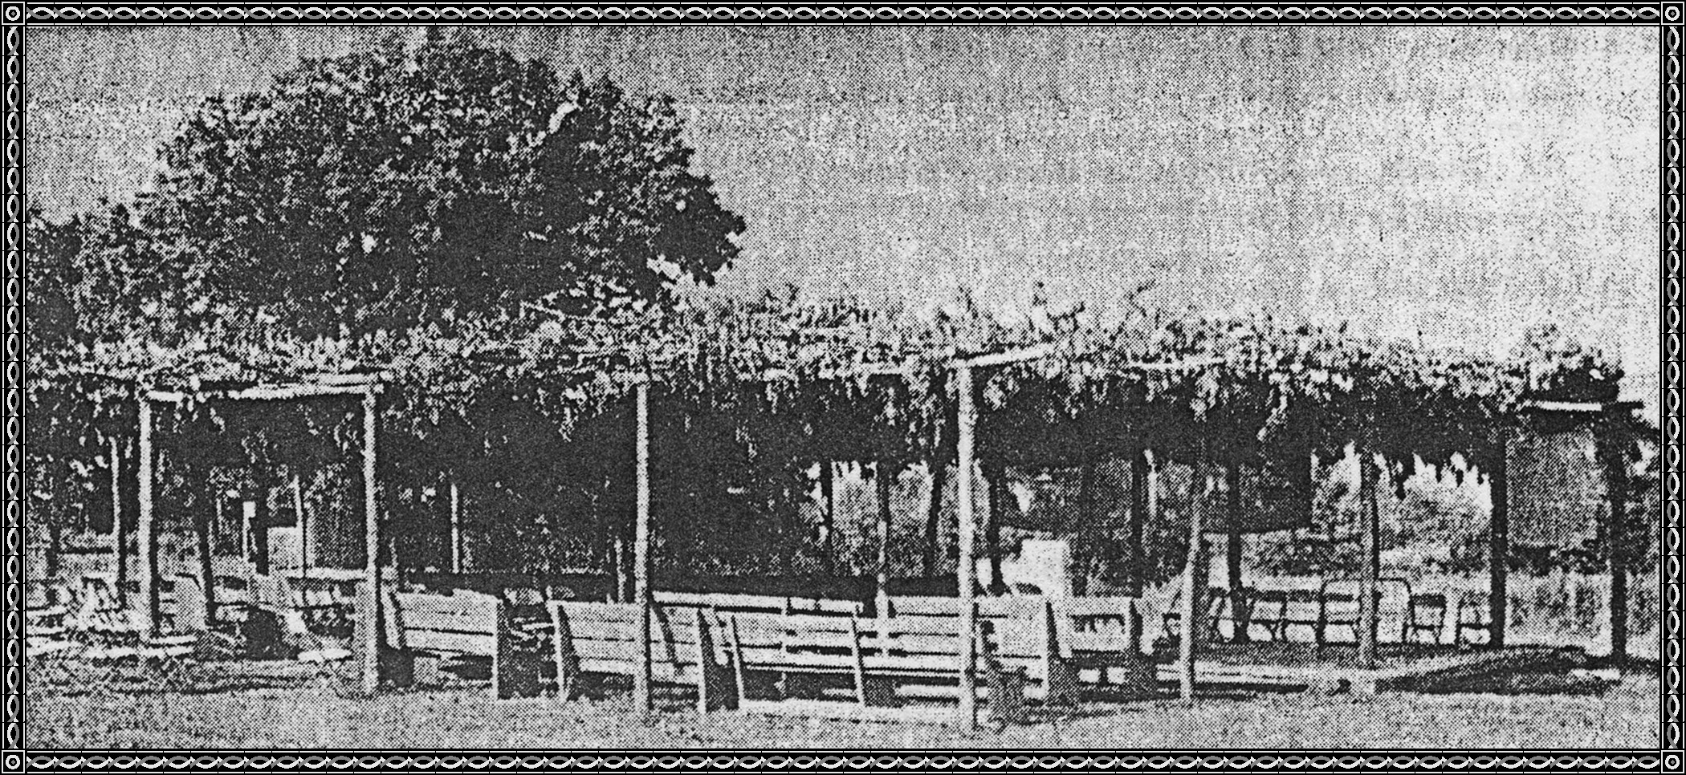

This brush arbor, constructed about four miles east of Ozark on Highway 64, is the setting for an old-time revival which got underway Friday night. Services are being held nightly at 7:30, with Barry Flanagan as the evangelist.

This picture was cut from the newspaper when it brought back memories of the days of our youth when Revivals were held almost continuously during the summer after one Church started a revival. After the crops were laid by, the men of the Church would go to the woods and cut down some small trees to use in the frame work for the arbor. Also limbs would be cut to lay over the top of the arbor to keep out the sun for a day service and also the rain. The "why fore" that it was called a brush arbor. After the closing of a three weeks revival then another Church would come in and put fresh brush and start another revival. Sometimes you would get so tired and worn out that you would have to take a rest for a few nights. There was a lot of visiting as well as many finding that God was an important factor in their daily living.

This picture looks like the brush arbors that we had services in back in our youth.

**The Weaning House**

I don't recall of Dyer having a weaning house but read about this and thought it might be of interest. A smaller house was built near the parents house and the "Newlyweds" lived in the small house or the Weaning House until they were weaned away from home.

**A Dog Trot**

A hall built between rooms and the dogs would trot through the hall, hence the name "DOG TROT."

***[Editor's note: this dog trot log home has been added to this document: web site URL:***

[**http://misspreservation.files.wordpress.com/2010/12/meador.jpg**](http://misspreservation.files.wordpress.com/2010/12/meador.jpg)

Constructed in 1885, the Meador Homestead is double-pen dog-trot log cabin with two massive end fireplaces. The house was constructed of massive hand-hewn pine logs joined with dove-tail notches. The open center dog-trot is 8 feet wide and 16 feet long and the house has wide covered porches on both the front and back. These features allowed optimal use of outdoor living space.

***[End of attachment.]***

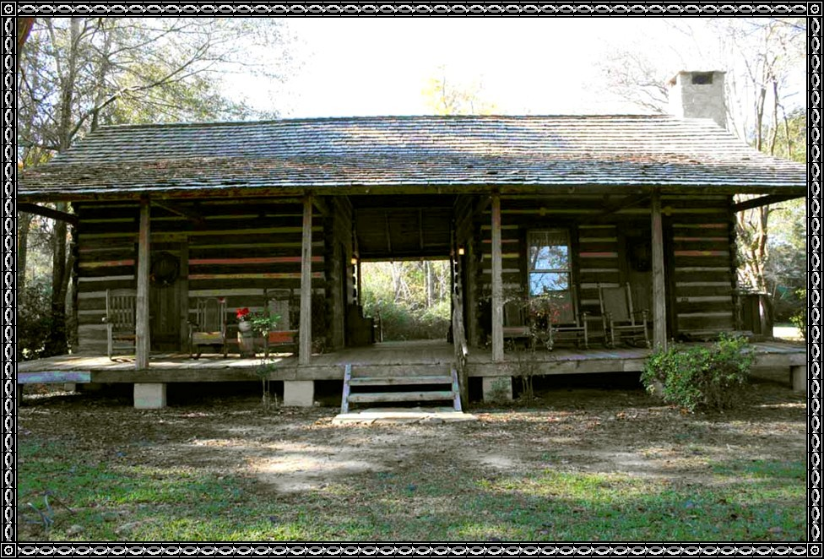

**Deed To South Side Of Cemetery**

**Grant, Bargain, Sell, And Convey:**

Running from the Northeast corner of the Northwest Quarter of the Southeast Quarter of Section 36 in Township 10, Range 30 West, North twenty eight rods, thence West 264.5 feet for a place of beginning, running North 300 feet, thence West 200 feet, thence South 300, then East 200 feet to place of beginning, containing 135 lots 20 by 20 feet with two streets 10 feet wide running North and South.

The above describes land to be used for a public burying ground.

Signatures: W. H. Dyer Younger Neal

Laura Dyer Mattie F. Neal

**Deed To North Side Of Cemetery**

February 20, 1940

Warranty deed with relinquishment of dower filed May 24, 1940.

Consideration $25.00

**J. R. Chastain And Alice Chastain, His Wife**

**to**

**Raymond Koiser, Tom Morse, And E. C. Wright**

Trustees of the Odd Fellow Lodge of Dyer, Arkansas

Book 149 Page 615

**Grant, Bargain, Sell, and Convey:**

Convey the following described property in Crawford County, Arkansas beginning at an oak tree 52 rods West and 15 rods and ten feet South of the center of the North East A Quarter of Section 36, Township 10, North, Range 30 West, running South 18 rods and 6 feet, thence East 35 rods and 10 feet to the Branch, thence Northwest 39 rods and 6 feet to the place of beginning. Also a road 2 rods wide from point of beginning to the Old Wire Road containing in all 2¼ acres more or less.

This deed is given for the use and purpose of a burial ground as an addition to the present Dyer Cemetery.

Release and relinquish

J. R. Chastain

Alice Chastain

**Real Estate Transfer:**

JAMES SHETTLEWORTH et ux JEWEL CHITWOOD et al Trustees of Dyer Cemetery Pt W¼ NE¼ 36 10 30.

The land for the Dyer Community Cemetery was donated by Mr. Steven Dyer. Uncle Mack Dyer's first wife was the first to be buried therein in 1888. They had two children, Susie Dyer Bennett Tomlinson and Cyrus Dyer. Cyrus was a tiny baby and Aunt Betty and Uncle Steve Dyer took them and kept them until Uncle Mack married again.

It seemed from all accounts that anyone went to the Cemetery and picked out the lots they wanted.

When the land was purchased from the Jordons on the North side of the Cemetery and the lots were sold for $10 per lot to raise money to pay for this part of Cemetery. The Odd Fellows Lodge bought this section of ground according to the deed.

**Old Twelve Corner Cemetery**

**May 28, 1981**: Mrs. Edward Wilson of Dyer expressed concern of the condition of the old Twelve Corner Cemetery in that area. The old Country road that provided entrance to the old school house and Church as well as the Cemetery in the 1800 hundreds has been closed to the public by a property owner whose land lies South of the Cemetery. It has become a pasture with cattle grazing and bedding down with the fence removed from around the Cemetery.

Mrs. Wilson's grandfather born 1847 whom she understands attended the twelve Corner School and he set out twin pine trees that stand at the front part of the Cemetery today, which is over 100 years later.

Many old residents from Riverside Community and Dyer are buried in this Cemetery also.