**Games**

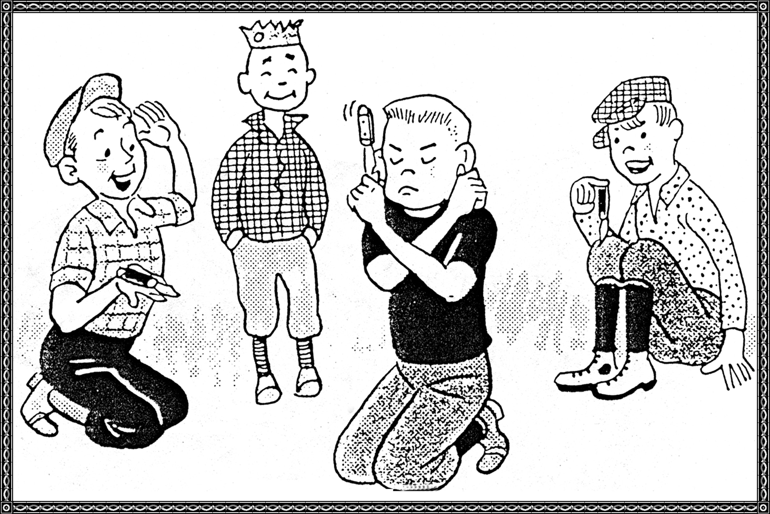

**Mumblety Peg**

I am wondering if the youth of today know how to play **Mumblety-Peg**; in the summer time we spent many afternoon with this game. It was played with a jack knife that had to be tossed from a variety of positions and had to land upright with the blade sticking in the ground. And the loser had to draw a peg driven in the ground with his teeth.

You played in a crouched position and placed the knife on the palm of your right hand with the blade pointing toward you. So you flipped your hand upward so the knife made one revolution in the air and land with point of knife in ground. Then you placed knife on back of your hand and went through the same maneuvers. Then did the same with the left hand. There were many moves to the game as I said; one could play all afternoon.

Making a "**Spider Web**" with twine by wrapping it just so and then two people could seesaw the string around your fingers

And how many hours did you spend playing in your Mother's **button box**? My, some of the buttons were so pretty and some would have a story behind them especially grandmother's buttons. Perhaps one from a Civil War army coat and another from her wedding dress and her first baby. And you could string all the pretty colored buttons with a needle and twine and make a necklace or you could just put a big button on the string and make a "Whiz" that would sing as you pulled the strings.

No matter how many dolls a little girl had, she liked to go to the corn field and pull an ear of corn with long tassels and plait the beard for hair and play with these dolls.

Mothers would spend Saturday morning or night wrapping the little daughter's hair in long strips of rags so their little darlings could have curls for Sunday.

And some I remember cut up tin cans and wrapped their hair in these strips to make curls.

Boys made "scooters" out of orange crates. They played with yo-yos. Caught fireflies and put them in jars.

**Choke It, Albert**

The Miller family lived across the pasture from us when the family was young. There were two boys, one named Albert and one named "Splash." The boys and Charlie and Bob Moss were always working on some "Hoopty" trying to get it to run and finding out what made it run or rather WHAT would make it run. The boys would buy a gallon of gas at a time for that would be all the money they could scrape up between them and then drive the old hoopty around the Miller pasture until it ran out of gas and usually spent more time on repairing than driving. Albert was the driver and Splash would do a lot of pushing the car. Once they got it as far as the railroad in town, and they saw a train approaching and Splash yelled at Albert, "Choke it, Albert," but they had to jump out and push the car off the tracks.

**Sugar And Cream**

A family named Henshaw, father, mother, and small daughter lived back of us. Mr. Henshaw was working on the road with several other men from Dyer, and they were talking about what they had for breakfast. Asa Dyer said, "Dish up a big bowl of hot oats and you have a fine breakfast." The next day while eating lunch Mr. Henshaw remarked, "Last night on the way home I bought a box of OATS, and my wife cooked some this morning but we didn't like them." Asa said, "My, my, a hot bowl of oats, and add sugar and cream." Henshaw said, "I guess so, sugar and cream." This became a favorite saying around Dyer and it was carried out to California we know.

**Be Sure Your Sins Will Find You Out**

Olin Selby was in Thomas W. Moss's store one day. In those days wieners came in a box linked together and you cut them apart as to how many were wanted by the customer. A Dyer teenager grab a wiener and stuck it in his pocket and started out of the store in a hurry with the string of wieners "tagging along" behind him when Daddy said, "Wait,___, and I'll cut off a wiener for you."

**A Fire**

The old "Bucket Brigade" was used when there was a fire in Dyer. I remember when Vance Moss's barn caught fire and all the neighbors were drawing water and tossing it on the fire but that barn burned up in a very short time. Someone said, "Where are Stacy Moss and Velta Fern Wells?" They had been playing in the barn. Later they were found under the bed and they had decided to start a little fire in the barn and boil them an egg.

**Somebody Moved The Well**

Charley McCain and his boys lived about where the Assembly of God Church stands today. After supper they all went out to town to "gas" with the men. When they returned home he would go by the well to get him a drink before retiring. One night the boys beat Charley home from town and they removed the curbing from around the well so when Charley went to get his drink he fell into the well and caught on the side of the well. The boys pulled him out and replaced the curbing, and Charley said, "Someone moved the well!"

**Remembering**

**Jennie Rhodes:**

After I married I went back to school and took up nursing. I look back now and I can see that my Grandmother Shaver influenced me more than I thought to be a Christian. When I was a little girl

she would tell me the stories from the Bible. She never went to school a day in her life but she could read the Bible. Grandfather was a Methodist Circuit Rider until he died about 60 years ago (1977), and after his death Grandmother lived with her children: Aunt Belle in Joplin, Missouri; Aunt Oma in Muskogee, Oklahoma; Aunt Era in Atoka, Oklahoma; Daddy and Aunt Ethel in Dyer. Uncle Frank never married but she would live with him sometimes.

**Lois Chitwood Williams:**

Remembers the Sweet Gum with a five pack. Every weekend her Daddy would buy gum and that night give each of them a pack and that left one on Wednesday night would divide out the last pack to "Sweeten" up their gum. ***[Huh?]***

**Velma Burrough Kincy:**

I remember going down to play with Lorena Moss, and Mrs. Dora would make us a tea party. Set us up a small table and make peanut butter sandwiches with either lemonade or milk to drink. And I also recall spending the night with Lorena and one night we kids were playing Hide and Seek in the house and Lorena and I stood up on the window sill behind the blind and only our toes were sticking out. Tom was the hunter and his mother told him he could not peek behind the blind to see which one we were, and we both had a hole in the same stocking.

**Lillian Tomlinson Moss:**

That she and her sister, Hazel, would come over to play with me. I had a play house that Daddy had built for me back of the smokehouse and put in an old pug stove that I could cook on so we would cook us a meal of fried potatoes with onions, fried apples, and get bread and milk from mother's kitchen.

**Lorena Moss Lancaster:**

I have done a lot of research and reading these past ten years preparing for this observance. Rummaged through some of Mother's boxes of "JUNK" and found some Saving Stamp that we children had purchased at school to help win the war. Also found some postage stamps such as one and two and three cent postage stamps. Think I will place these in the CAPSULE. And can you remember ARBUCKLE COFFEE? How many cups of coffee have been made since then. By saving the strips on the side of a package of coffee one could remit and get all kinds of goodies. And how about the Mothers Rolled Oats? When you opened the package there would be aluminum measuring cups, measuring spoons, and also china was stored in the packages.

And **Mr. Allie Jean** was called "Marrying Sam" because he married so many couples in our community.

And did you know that once there was an alligator here in our Community? **Garland Ayres** kept one in the cellar when he lived where John Moore lives today.