**Outhouses**

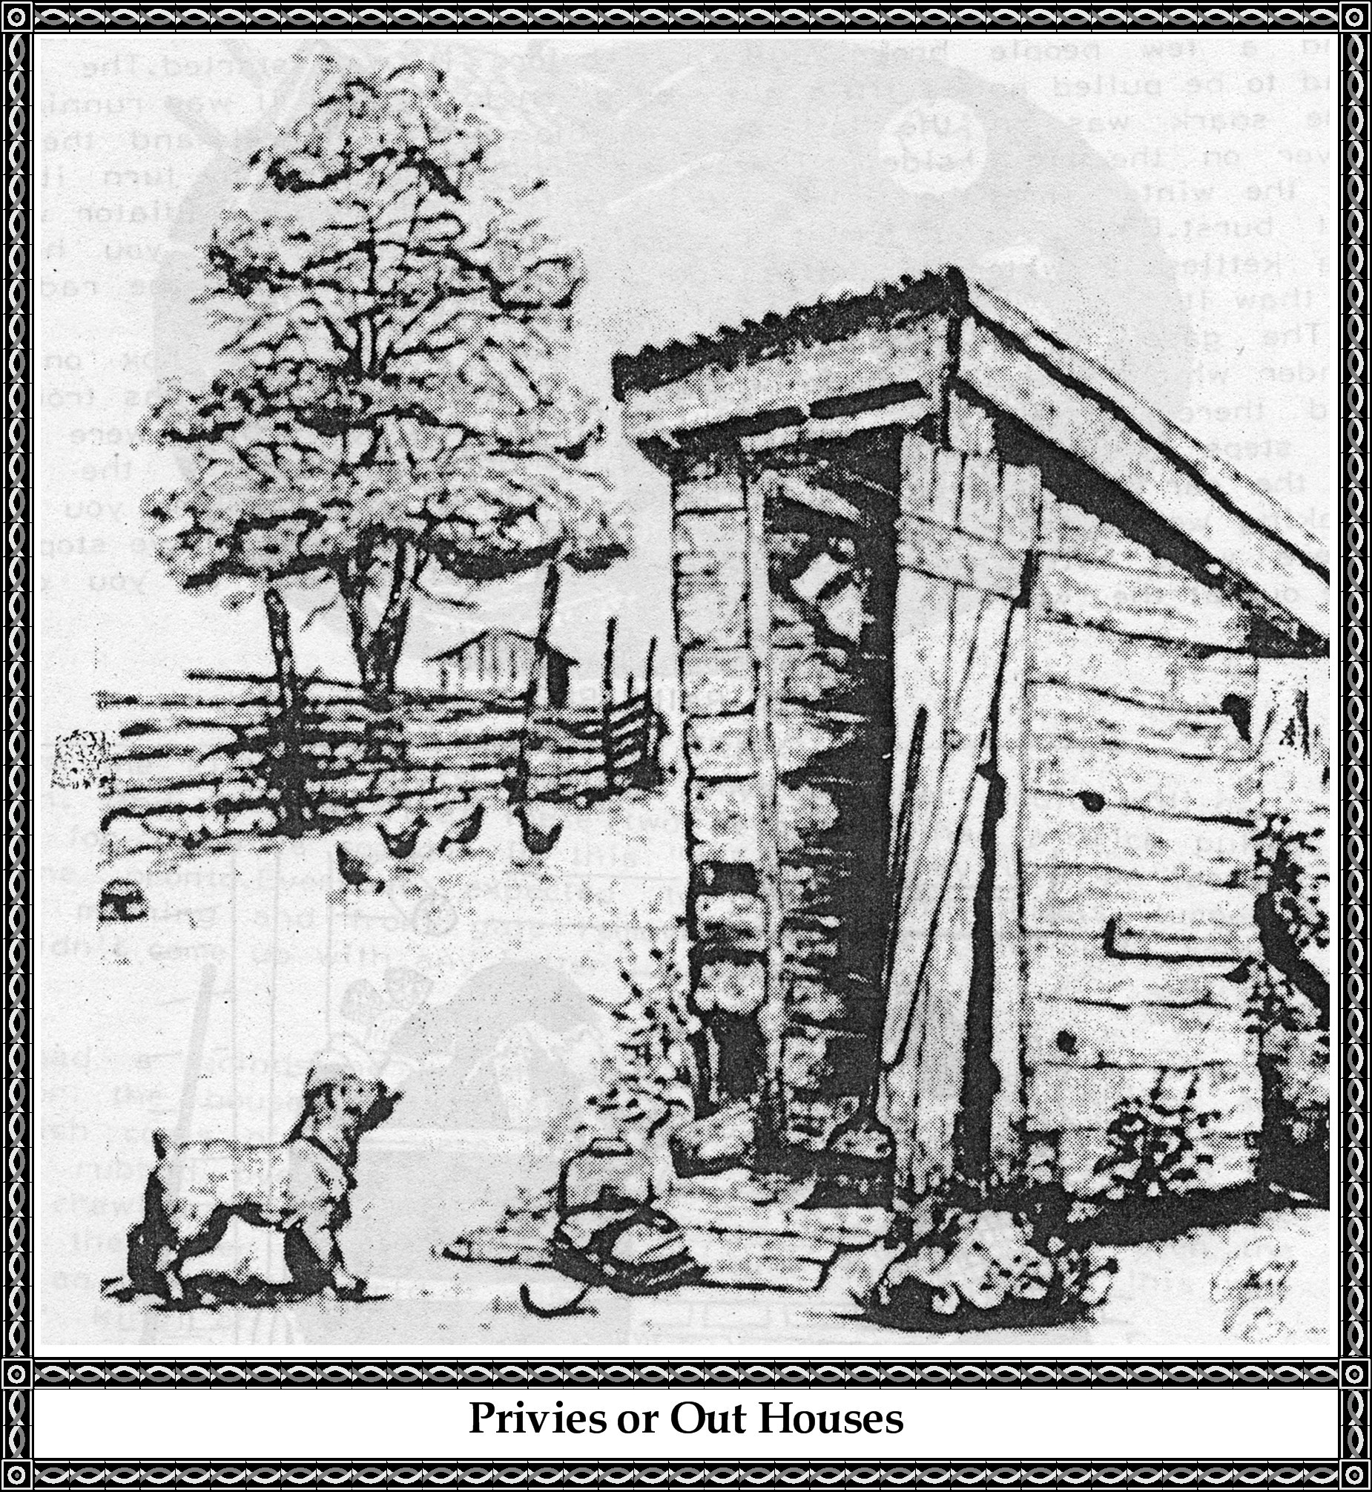

Not long ago there was a page in the SouthWest Times Record Review Edition so I cut out one of the pictures which I have used on this page for most of us grew up with "THE NECESSITY" in our back yard.

"The Privy is very noticeable today because they are becoming a rarity. These structures that once sat in the back yard on every home site have disappeared from the landscape."

There are a few still in Dyer. Must be the people don't want to forget their "raisin." There were little crescents cut in the side of the building to ventilate. There was also one at the train station east of the depot. Schools had them with a blind placed around them. In some Church yards, Cemeteries, and parks. Today workmen use portable privies set up for a work project on a construction site.

So this page WAS ADDED "lest we forget."

**The Model "T" Ford ~ *See page 166 below***

A model "T" Ford cost about $395 dollars in the early 1920s. To start it one must crank it, and sometimes it was very stubborn about starting, and a few people broke an arm before it was started. The choke had to be pulled and a little gas was given to it until it was running.

The spark was on the left side of the steering wheel and the gas lever on the right side. There was no ignition key to turn it on. In the winter time the water had to drained so the radiator would not burst. But if you forgot to drain the radiator, then you heated tea kettles of water to boiling point and poured this into the radiator to thaw it.

The gasoline tank was under the front seat and a box on the fender which held tools to work on the car when there was trouble. And there were fenders on both sides of the car which were used as steps to get into the car and curtains that fit on the sides of the car to keep out the rain, though usually by the time you were soaking wet and had the curtains in place the rain would have stopped. There were little pieces of isinglass in the curtains so you could see out at the world.

**Whatever Happened To Rain Barrels?**

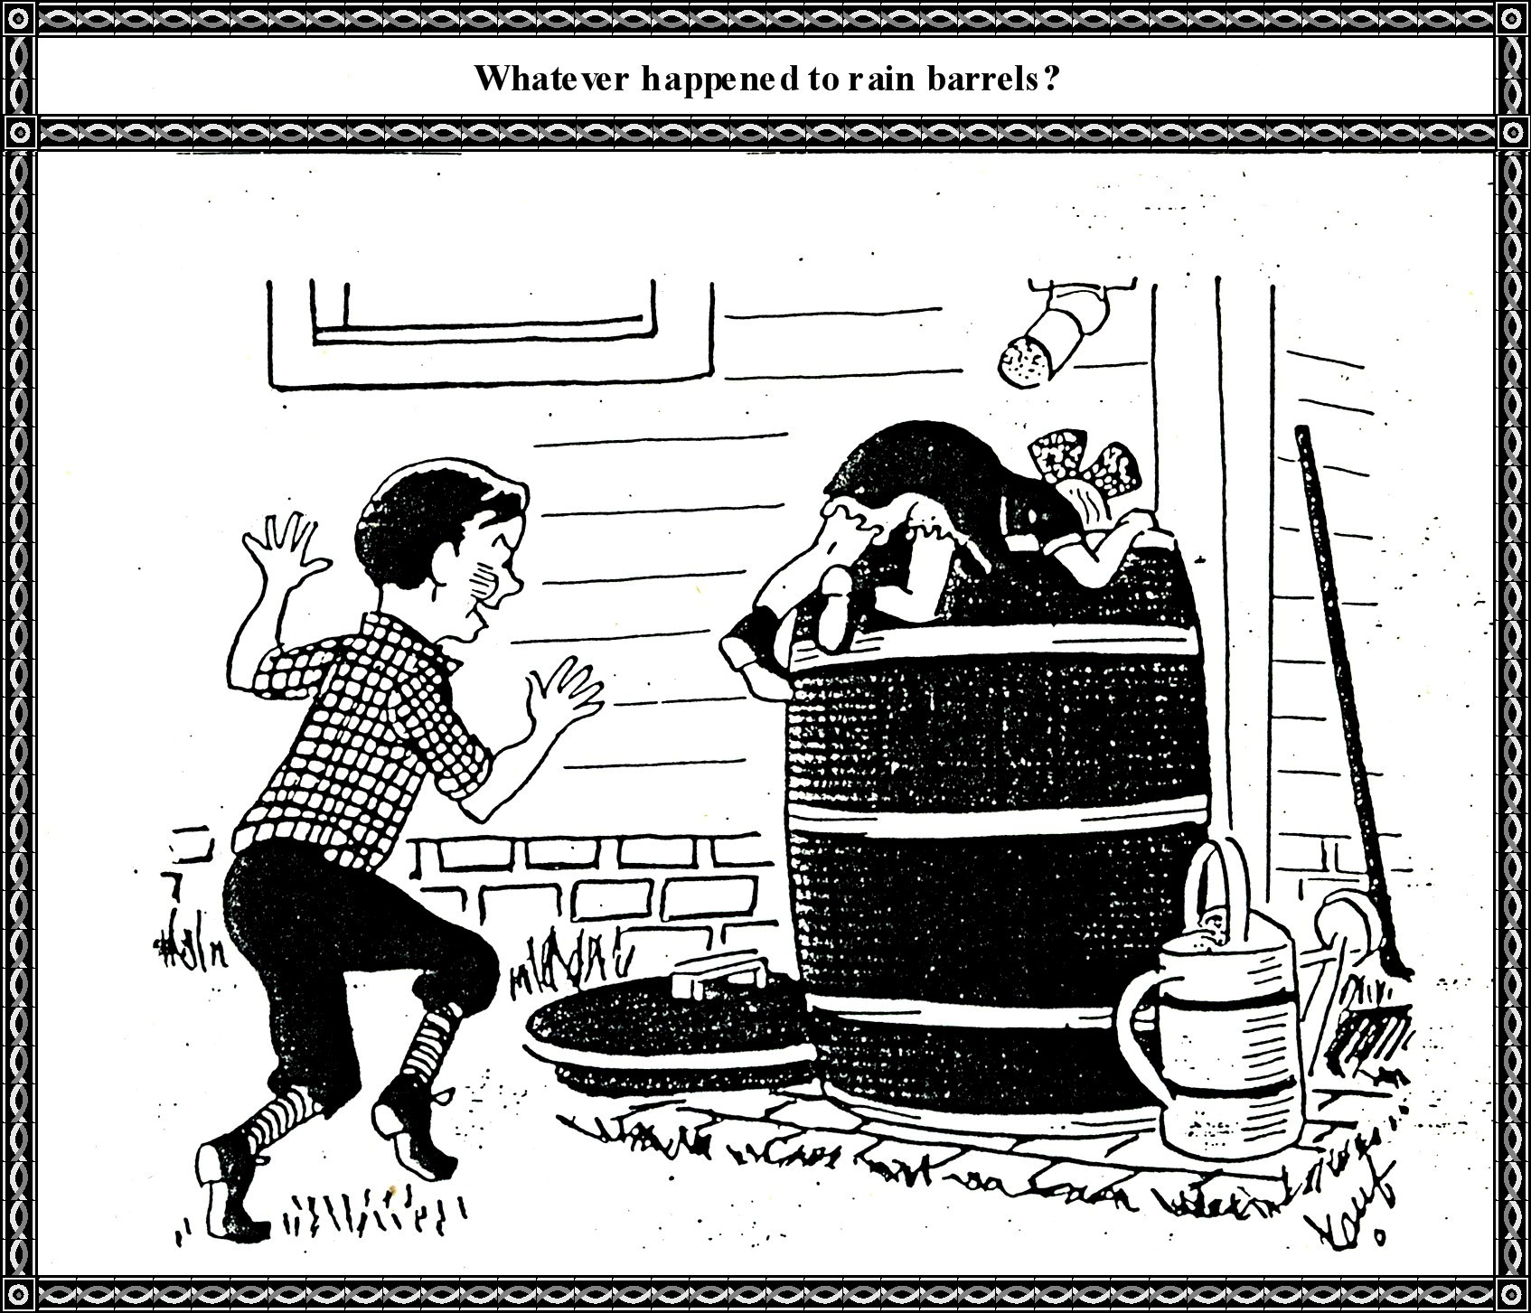

…that we liked to holler down in. "You can't holler down my rain barrel" so goes the song. Almost every family had one that sat under the downspout of the house. The water was used to wash clothes and your hair in for it was soft.

You could yell "Hoo-hooing" sounds and your voice would come back with a strange deep timbre.

**A Halloween Trick**

**A Halloween Trick**

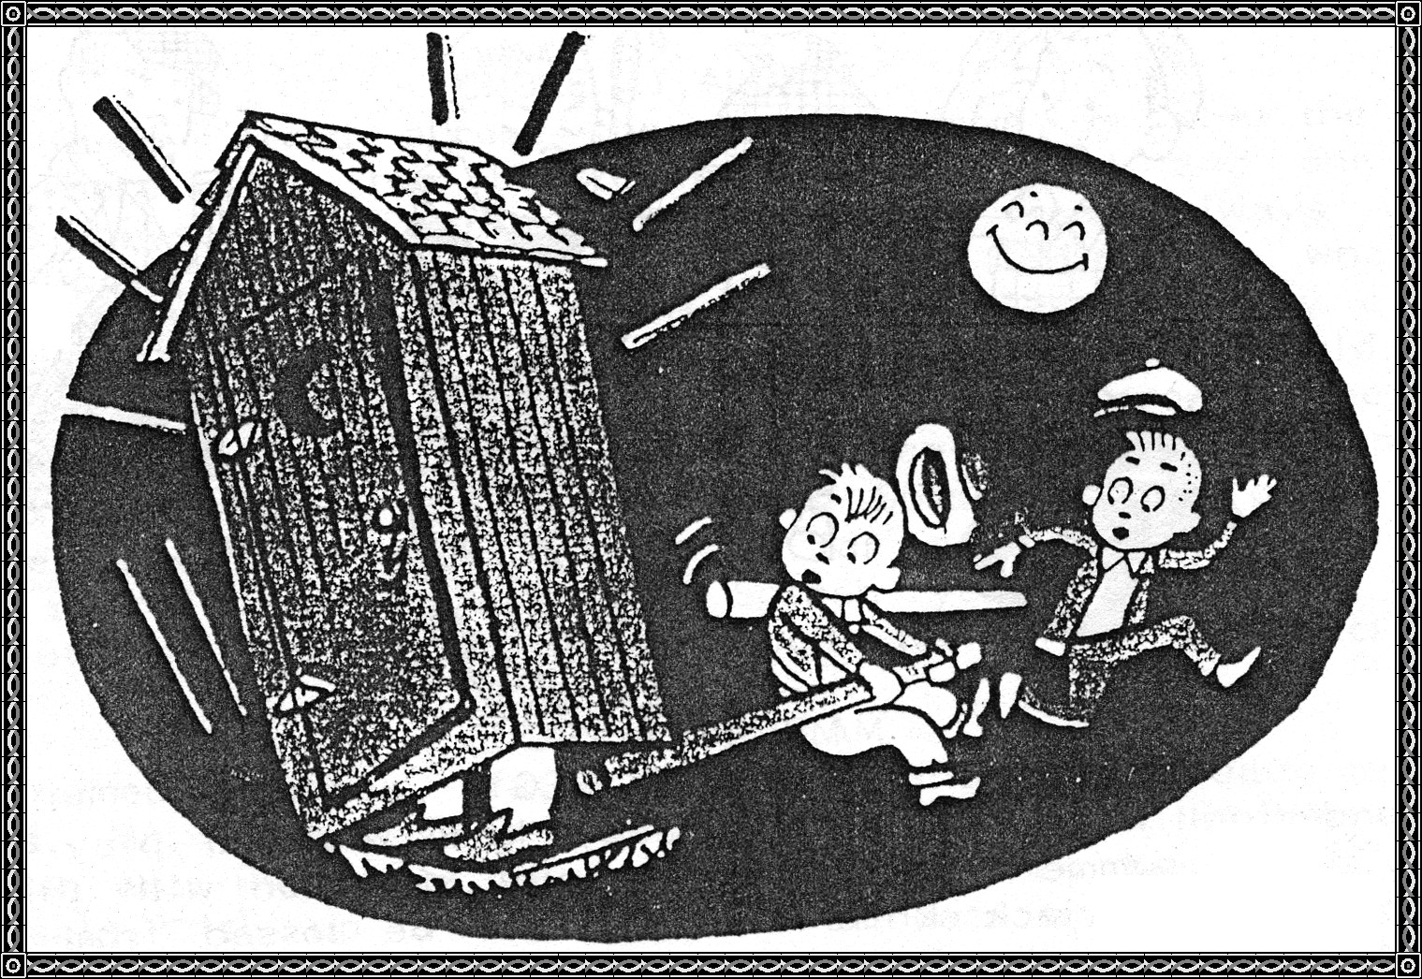

This was the kind of tricks that the boys of Dyer would pull on Halloween. And it seems that these two boys have had a trick pulled on them for there is someone in this "privy" so they will be leaving the scene pronto. Everyone expected to find their toilets turned over the next morning and the front gate removed from the gate post. Seemed they couldn't come up with any better ideas or tricks.

People had a grindstone to sharpen tools and kitchen knives and scissors for the household. And before our day they used "winnowing pans" ***[more accurately known as bed pan warmers]*** which coals of fire were placed in the pan and carried to the bed and rubbed over the sheets to take away the cold before the children crawled into bed on a cold winter night. We have seen the water in the water bucket frozen solid inside the house so this will give you an idea of how cold it was.

Another kind of winnowing was when they winnowed the beans or peas that had dried that would be stored for winter use. There were no freezer in those days so they had to save the food in some manner.

And who can forget the night "chores" such as feeding the stock, piling wood on the porch for that night and next day, hunting the eggs so they would not freeze during the cold night, drawing water for the water trough for the stock, cutting kindling to start the fire in the morning, milking, and all those things that small boys do not have to do these days.

The spring was for plowing the fields and preparing them for planting when the weather was warmer. In the fall when crops were gathered and the truck from the gardens was harvested, the turnips and sweet potatoes were stored in a hill out in the garden so they would not freeze and they tasted real good too. And how good the yams smelled when baking and tasted better than they smelled. Add a big pot of turnips cooked with a lot of backbone with some dried fruit and hot cornbread.

***[Editor's note: This image of six Model Ts was found at this web site:***

***http://www.neaktuality.cz/wp-content/uploads/1911-Ford-Model-T-line-up-ad-lg1.jpg***

**A Complete Line of Model Ts to Choose From**

***[End.]***

