**Holidays**

In our youth we had a party nearly every Friday night so that the young people could get together for we were not allowed to have a date when ever we wanted. The boys did not get the girls to take them to an event, but they were allowed to walk home with us afterwards. While the McNutts were here, we had a lot of parties at the school buildings with decoration according to the season of either Valentine, Washington's Birthday or Lincoln's, St. Patrick's, Easter, Fourth of July was usually a neighborhood celebration on the creek, Halloween, Thanksgiving or Christmas, and a New Years party.

When **Valentine** time came around, can you recall making a valentine to give to that "special one" and making up little verses such as "Roses are red, Violets are blue, Sugar is sweet, and so are you?"

**Easter**: Making a nest so the Easter Rabbit would leave some candy eggs in it.

**Fourth of July**: The family would bring out the ice cream freezer and buy a big block of ice and wrap it in papers and an old quilt to keep it from melting before you were ready to make the ice cream. In early days there would be a fish fry down on the Dyer Lake which has since been drained. The Community started having a Fourth of July picnic at the Gym, and they have several freezers of Ice cream and drinks as well as a picnic lunch.

**The Second Fourth of July Picnic**

The second Old-fashioned Fourth of July Picnic and Reunion begins at noon. The celebration will feature a gigantic picnic complete with home-made ice cream and all the trimmings. The program for the afternoon and evening is as follows:

Posting of the Colors

Patriotic address

Picnic and visiting

Bingo

Drawing for "Sue doll"

Prizes for Oldest, Youngest and one traveling farthest

Games and contest for children

Horseshoe pitching for the "old Pros"

Pictorial Display

Square Dancing

Country & Western Band

Close out the day with Fireworks display.

**The Third Fourth of July Picnic**

The flag-lined streets leading from Highway 64 to Dyer's Community Building set a festive and patriotic atmosphere for more than 500 people as they arrived . The crowd included people from Arizona, California, Florida, Kansas, Louisiana, Michigan, Missouri, New Mexico, Ohio, Oklahoma, Texas.

Posting of the Colors by an honor Guard led by Carl Manuel, a former boy born at Dyer. The audience joined Cindy Kelly Jones in singing the National Anthem accompanied by Bonnie Rhea Henson Wright, a local teacher for 44 years. Ronnie Hatley gave the Invocation and Joe Kincy introduced the keynote speaker, Charles Moss, former Alma School Superintendent and retired educator living in Little Rock. Moss traced his family history back to the original settlement of Dyer and related several humorous incidents that occurred while he grew up in Dyer.

***[Editor's note: Charles George Moss and Alma Lorena Moss Lancaster are brother and sister.]***

**Stewart Porter, Charles Moss, Yvonne Nelson Darling**

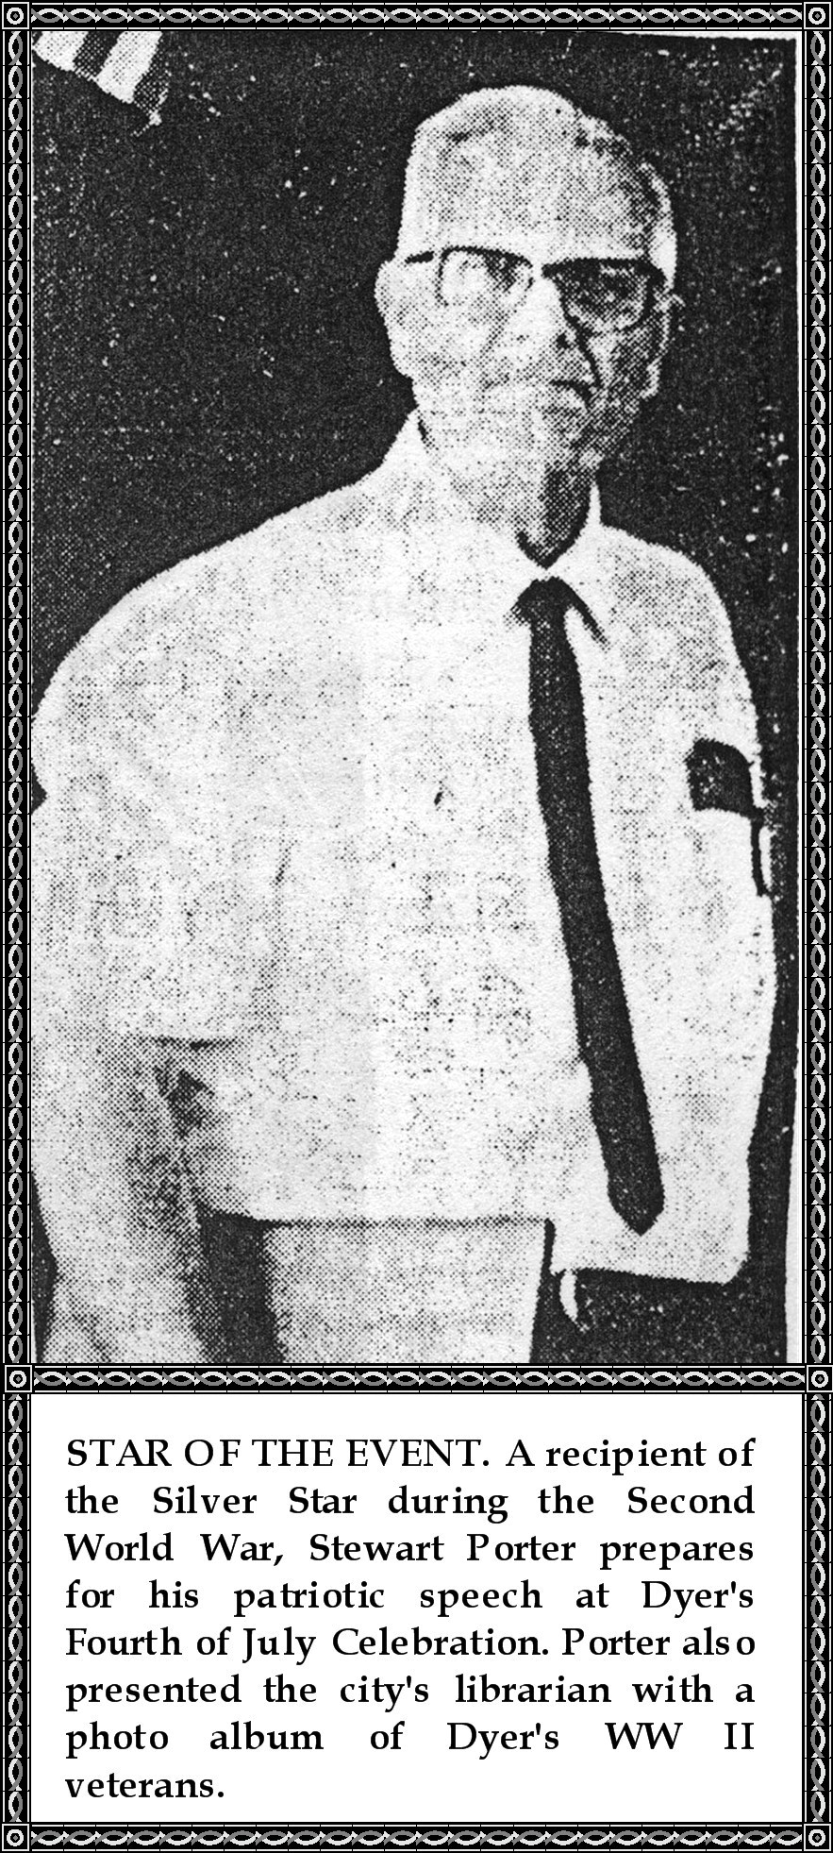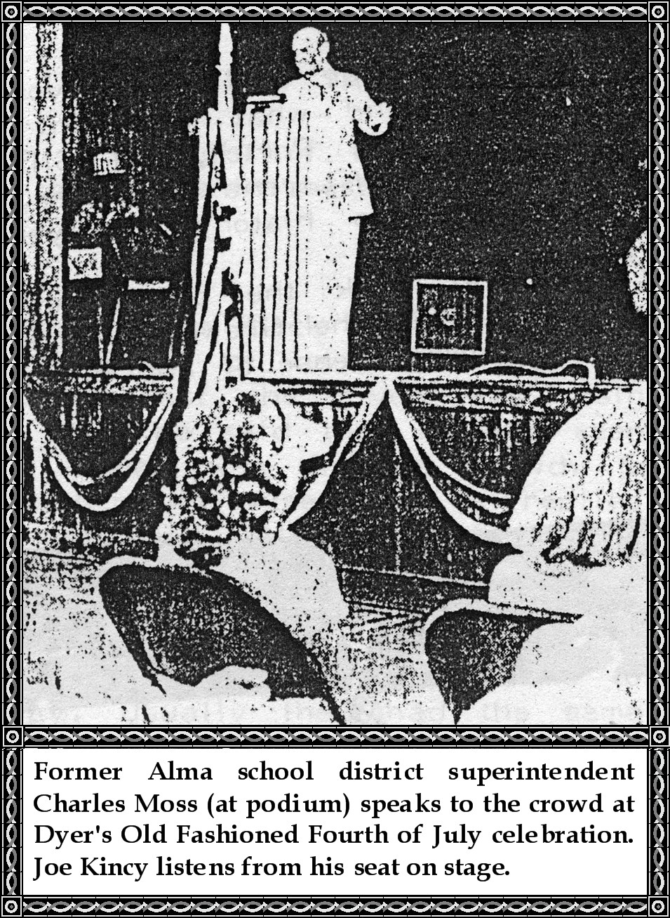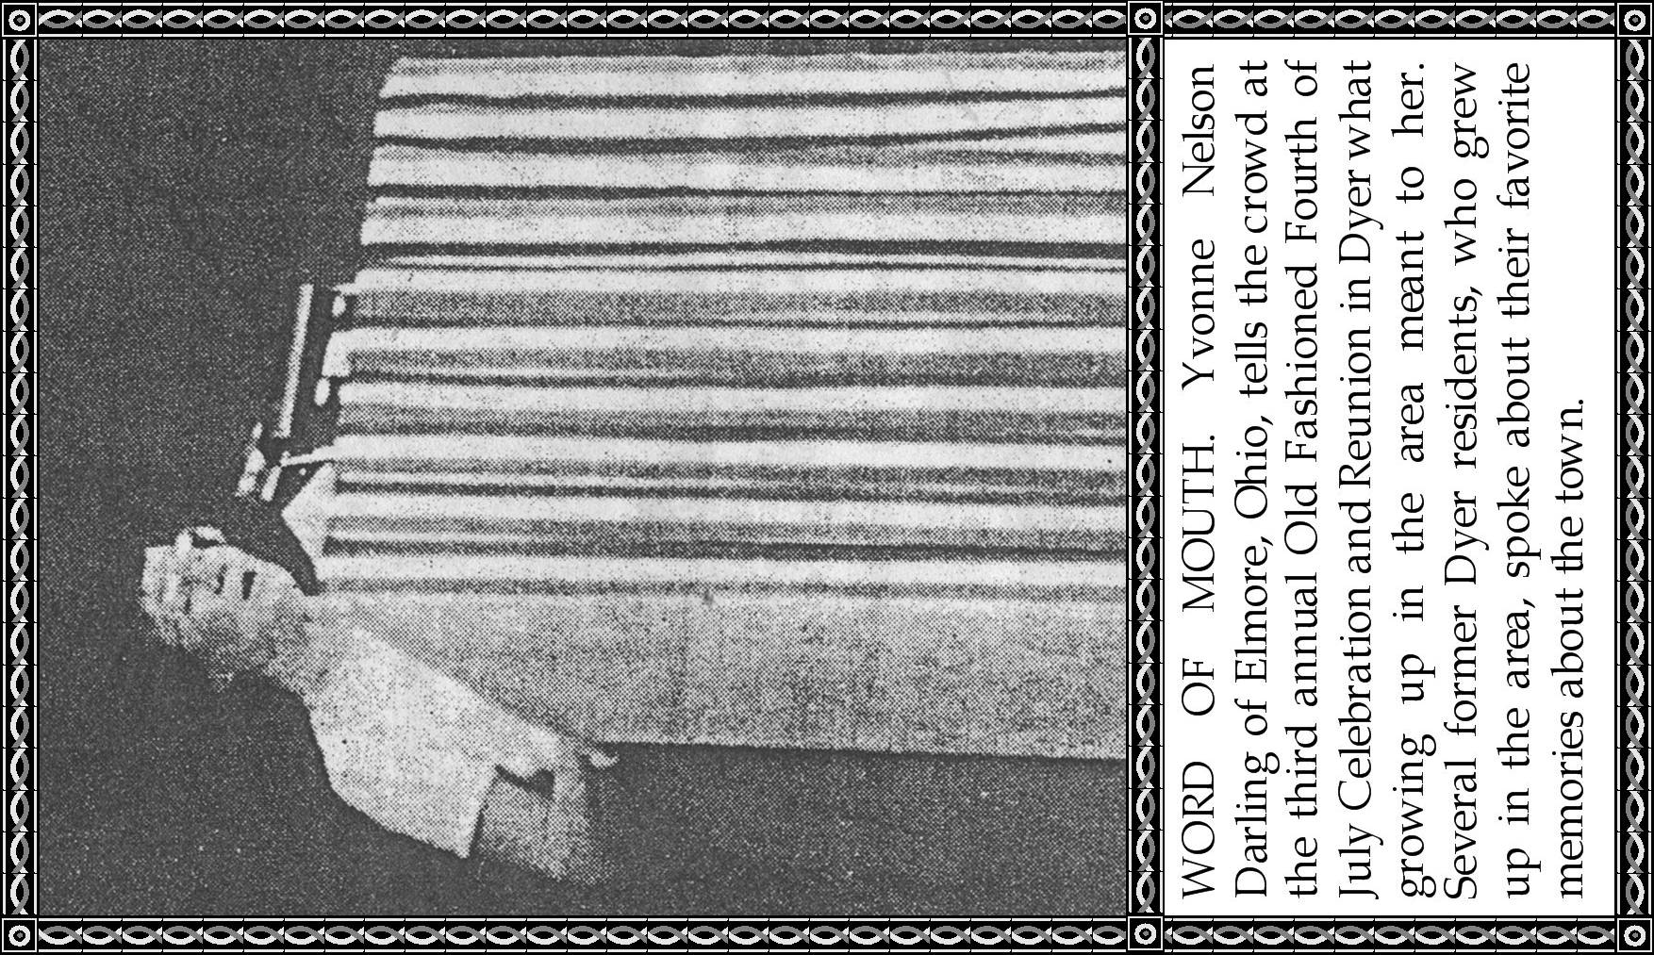

After lunch with all the home-made ice cream one could eat, Yvonne Nelson Darling spoke of her childhood years and what it meant to grow up in Dyer. She was followed by Stewart Porter, WWII Silver Star recipient, who gave a patriotic address and presented Lorena Lancaster, the city librarian, with a recently completed photo history of Dyer's WWII Veterans.

Games were played in the afternoon. At dusk the crowd moved outside to enjoy the Catcher Country Band until the fireworks began. A tired but happy crowd departed with a renewed sense of appreciation for our freedom.

