**From Tom Blake's Corner**

February 24, 1982

**ENJOYMENT IS....**

Dropping by the home of Dyer Mayor Ernest Cottrell and wife, Madge, to chat. Apologies for waking the Mayor from an early afternoon nap. He deserves respite after toiling hard on his farm, driving an Alma school bus twice daily, and trying to put Dyer on the map.

**The Mayor discloses:**

Dyer was not necessarily larger in the good old days, as suspected, and the current population of 608 is about tops.

Down town used to face South and be contiguous to the railroad but was moved after the fire destroyed several buildings in 1909.

Dyer was once an agricultural center. Twenty-six train carloads of strawberries were shipped once from Dyer to Kansas City. The berries were brought in by wagon which lined the road from

the rail siding to the river bottoms.

Cottrell was born in what is now Dyer's oldest house. It has been remodeled and is lived in.

Don't call it jealousy, but Cottrell is disappointed that other towns, some smaller, received more federal monies for new facilities the past few years. Dyer's only visible inroad to the federal treasury are a couple of tennis courts but Dyer has not asked for much. Cottrell said Mulberry Mayor Arnold Feller explained to Cottrell this is the way it is done; "Ask for everything and get something."

|  |  |
| --- | --- |
| **1977: Names Of Dyer's 80 Year Oldsters** | |
| Sidney Swafford  Flossie Thornburg  Johnny Johnson  Myrtle Morse  Tennie Porter  Maurice Howard  Sula Blalock  Willie Gregory  Lillie Gregory | 19 Jul 1893  12 Apr 1894  08 Aug 1896  03 Feb 1881  08 Dec 1882  08 Jan 1896  19 Apr 1890  01 Nov 1894  15 Jan 1895 |

All of the above have died.

**These Signed The Guest Register At The Bi-Centennial** but will not be present at the Sesquicentennial Observance:

|  |  |
| --- | --- |
| Susie Tomlinson  Hays Hurd  Robert Hankins  Lucy Stephens  Mae Isaac  Roy Porter  Red Cranford  Leonard Yates  T. J. James  Fannie Brown  John Burrough  Thelma Roden  Carl Chitwood | Claude Meadors  Edward Wilson  Otis Powell  Viola Wells  Ruth Carroll  Dow Manuel  Edna Cupp  Orville Coulter  Ray McAdoo  Earl Morse  June Dyer Steele  Reggie Chitwood |

**Bicentennial Photos**

Bicentennial

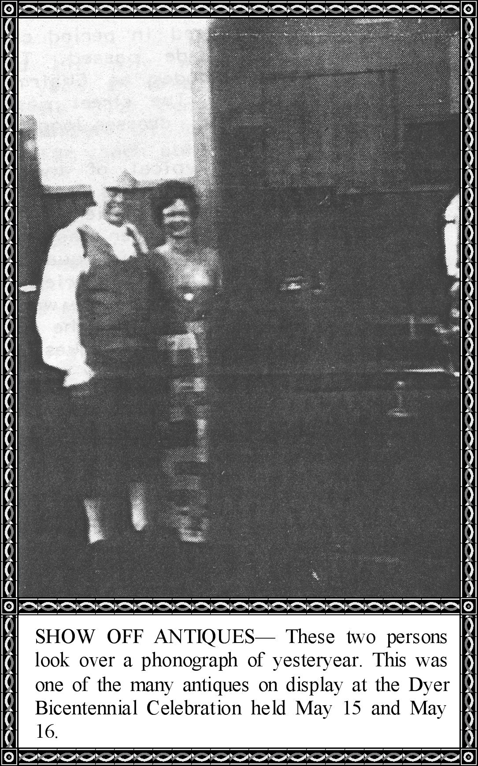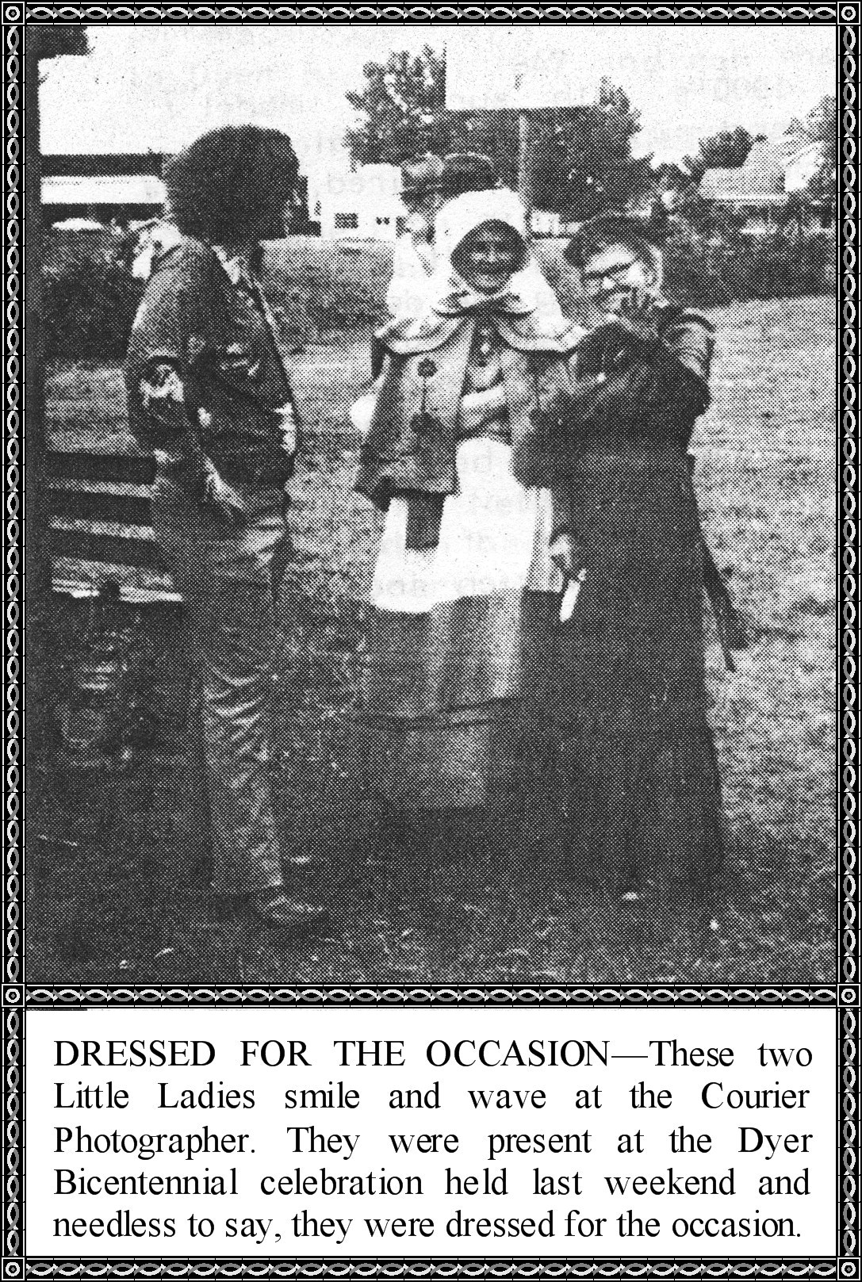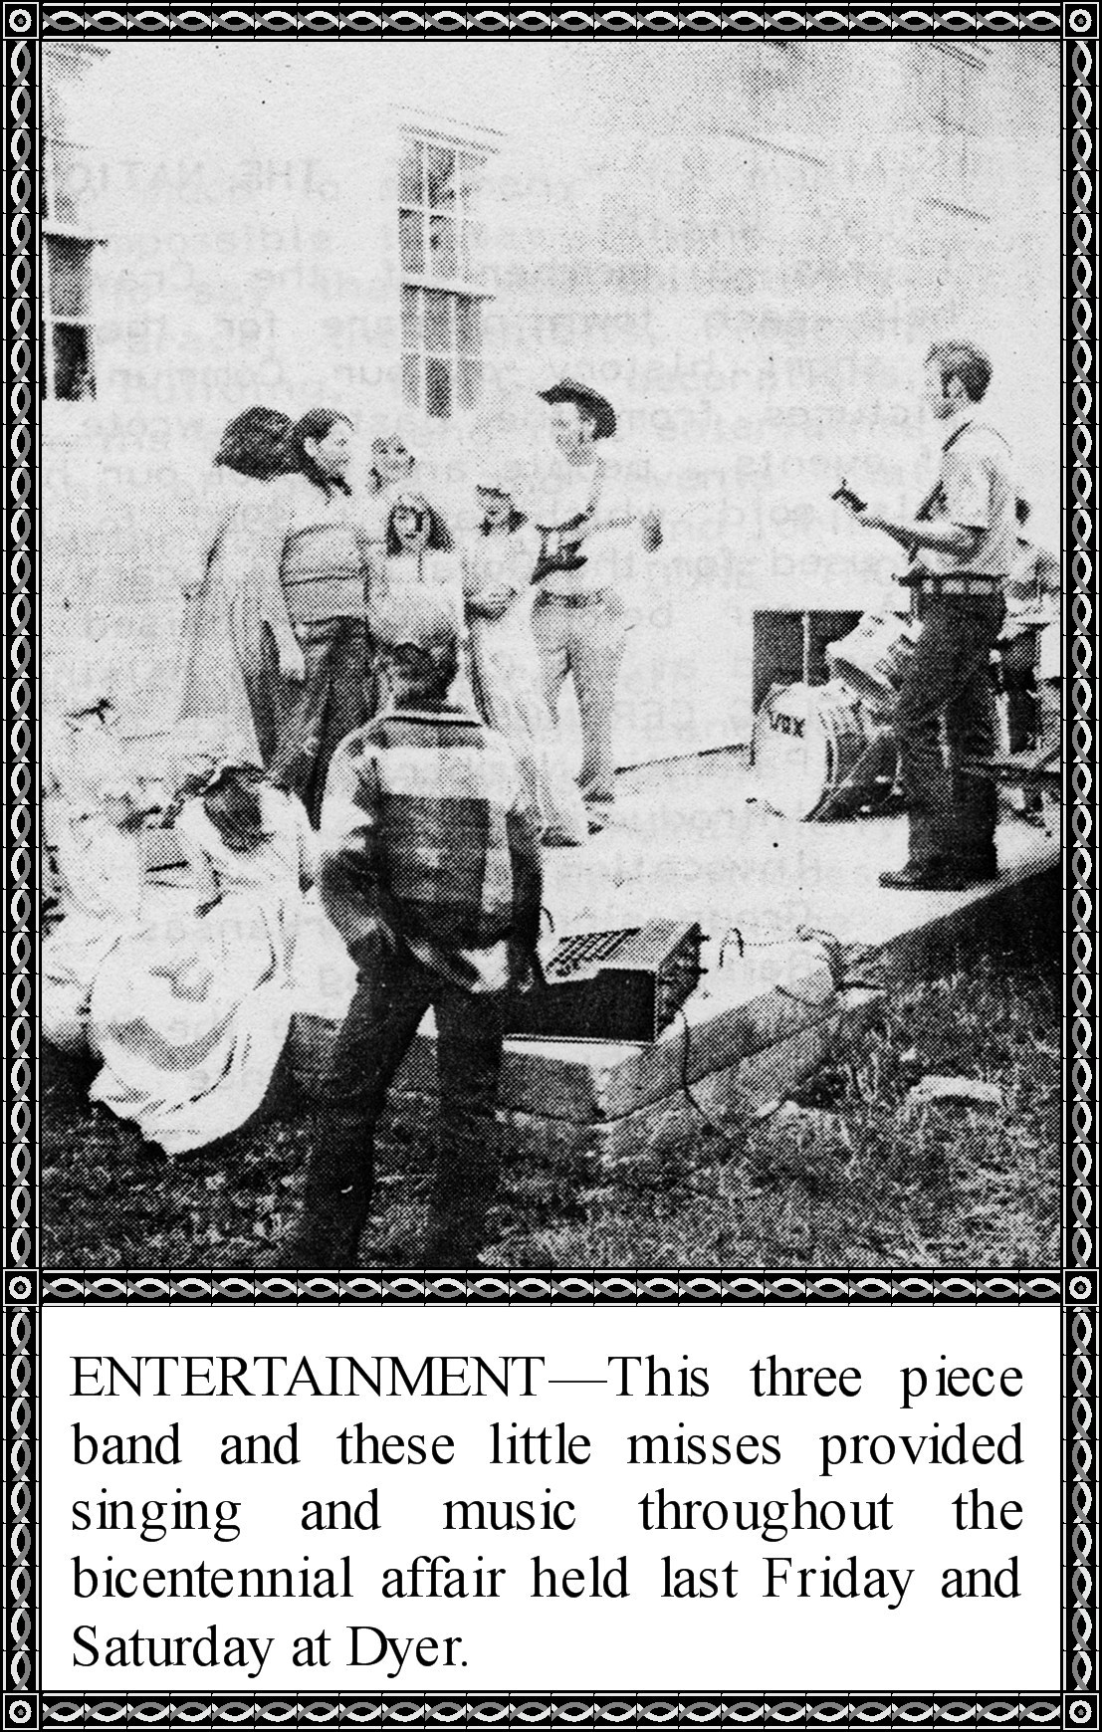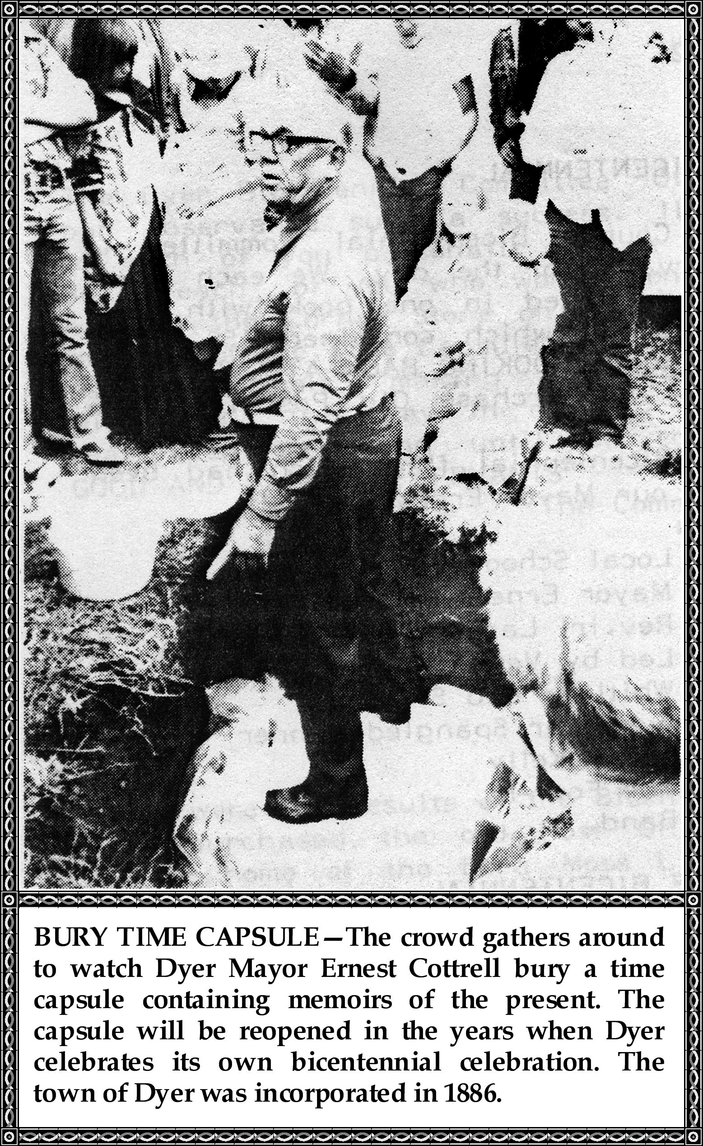

Photos