**Dyer Baptist Church, Dyer, Crawford County, Arkansas**

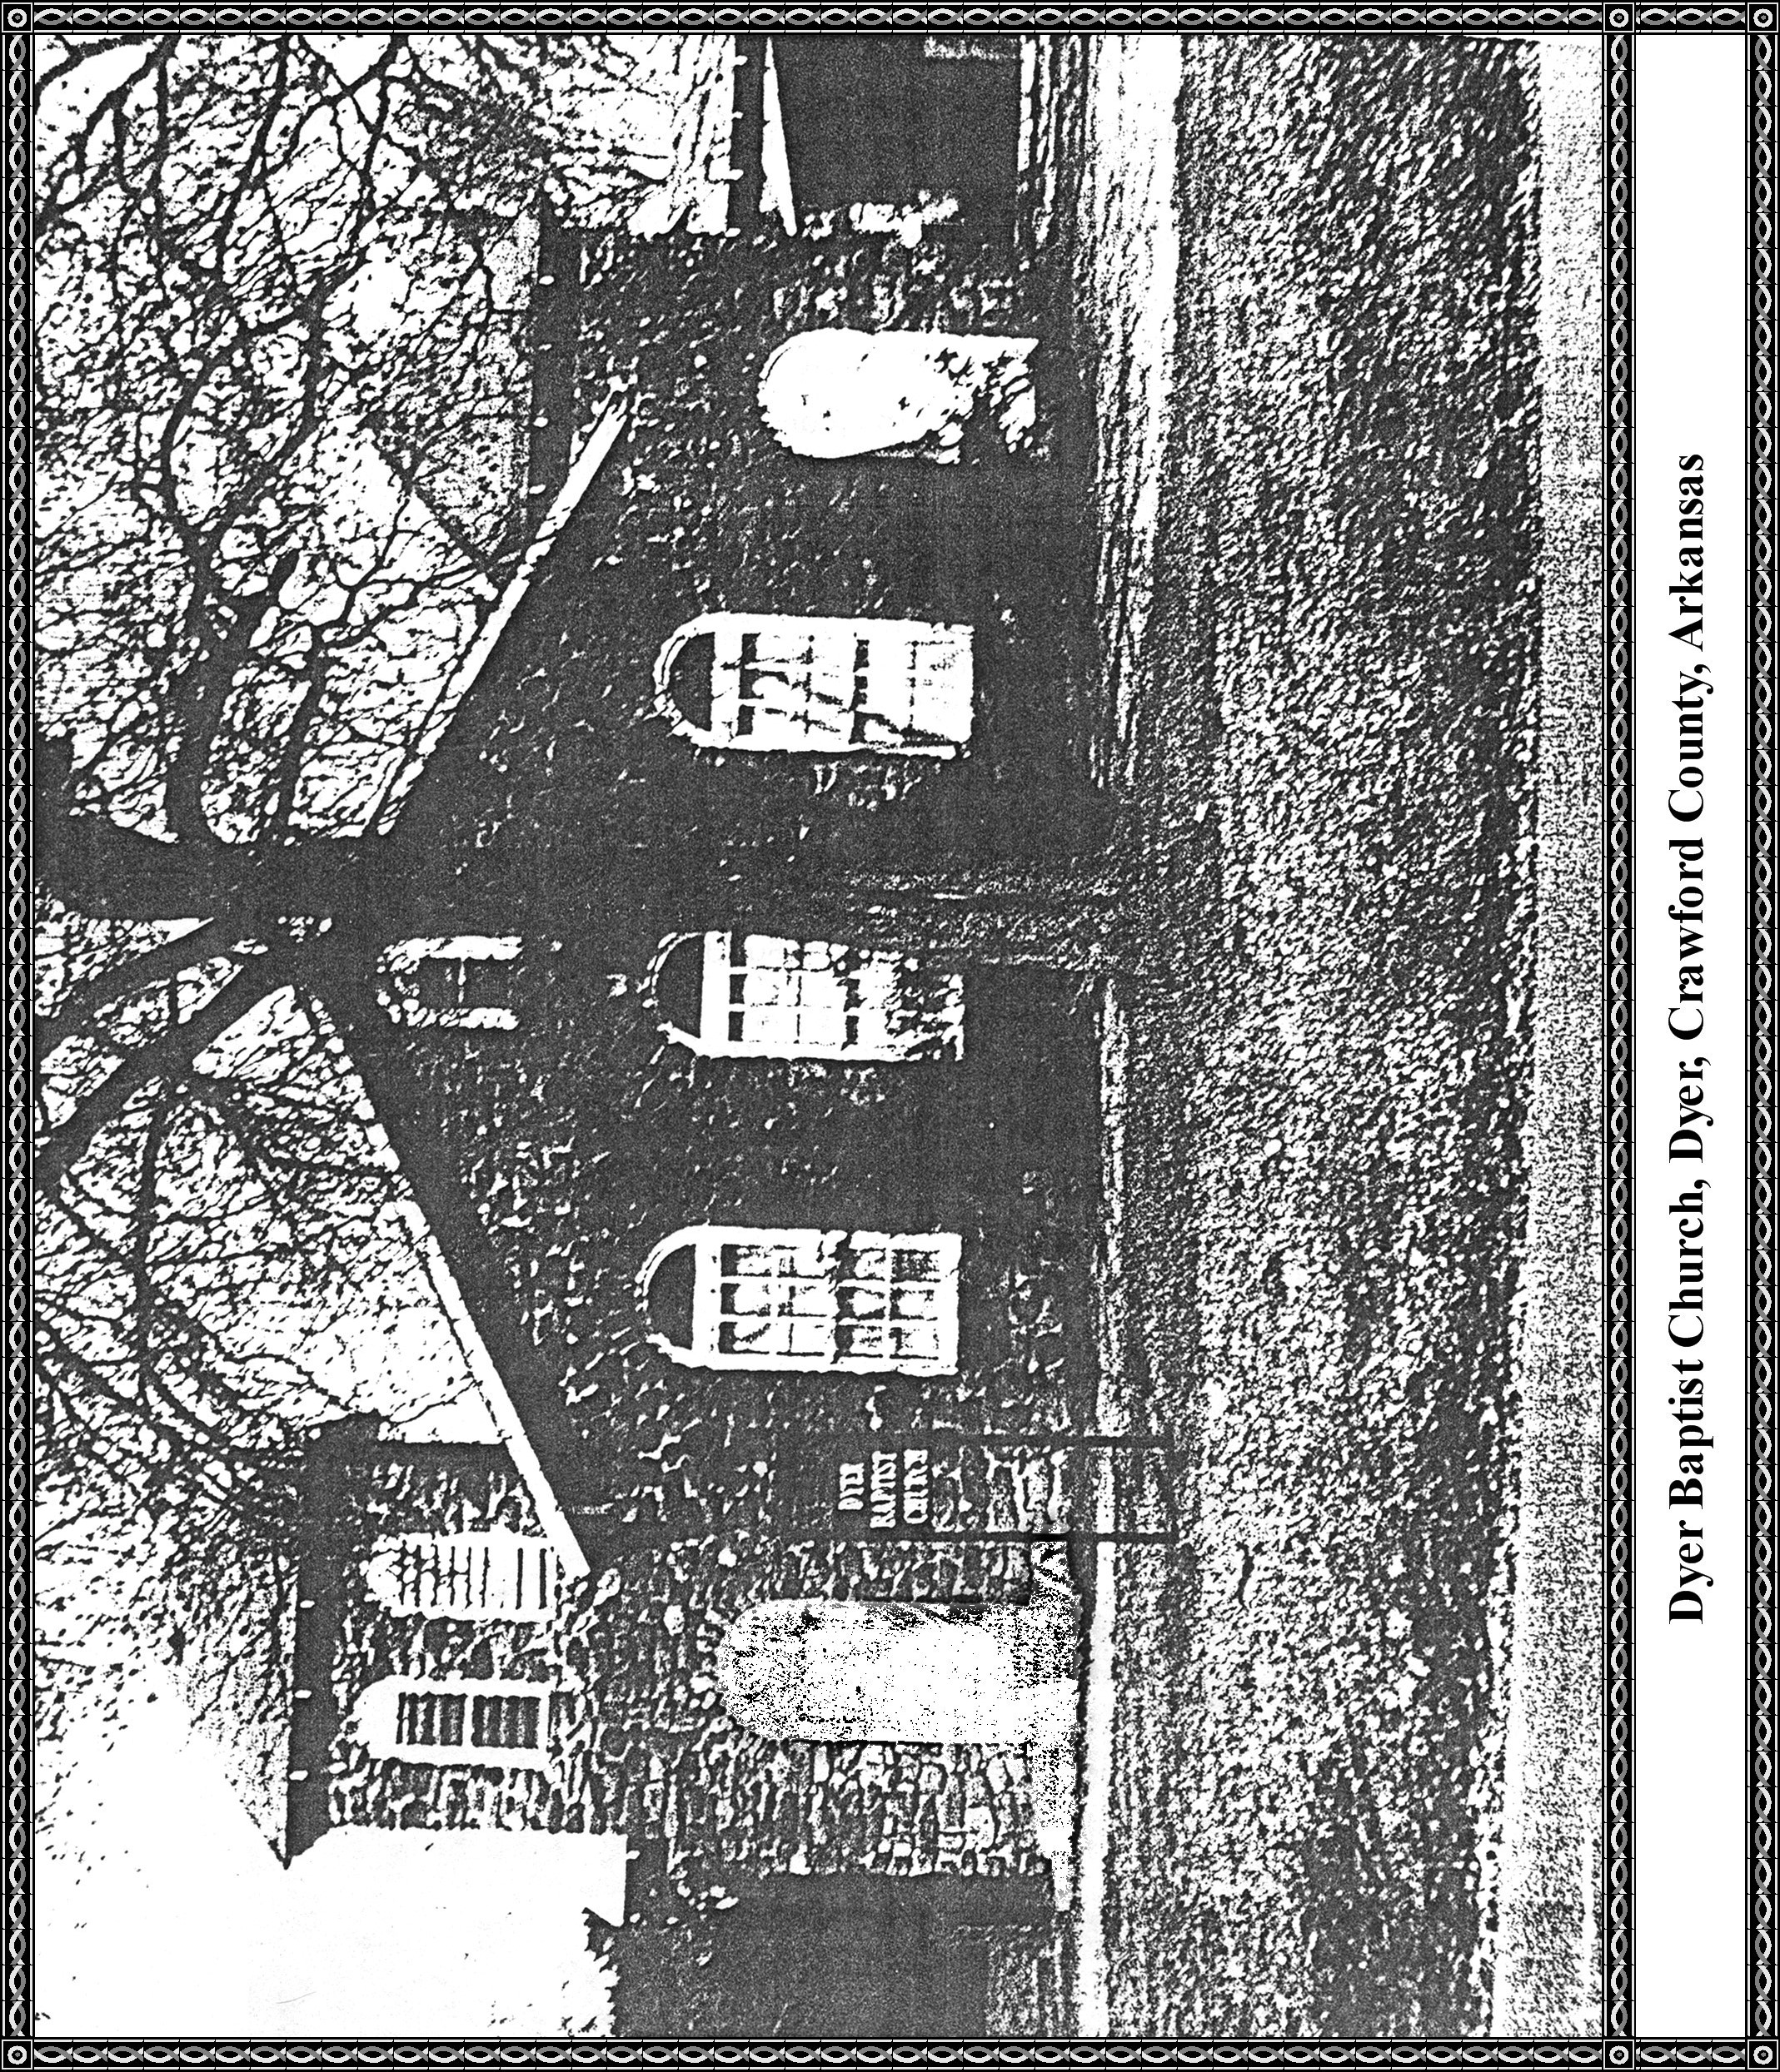

**DYER BAPTIST CHURCH**

1986

by Nita Dyer

These events and happenings have occurred in the Baptist Church in the past ten years.

**New Baptistery**

New Baptistery was built and dedicated on June 16, 1985, as a Memorial to H. L. Tucker, the husband of Marie James Tucker.

Marie was a daughter of Bill and Callie Patton James. She was born at Dyer and lived here until she entered college and after that she began teaching.

The Education Building was given a new face lift by giving it a coat of paint.

The Church installed a speaker for Curley Frazier. He is unable to attend Church.

**There have been two wedding in our Church since 1976:**

Shelia House and Kevin Kelton.

Patricia House and Gary Hall.

Our Pastor is Brother Floyd Vineyard.

The organist is Sue Vineyard

The pianist is Jeff Swafford.

**Deaths have been:**

Callie Patton James

Carson Morse

**We have purchased these:**

New Cook Stove

Microwave Oven

**In the Pastor's study:**

Desk and Chair

One Easy Chair

Installed a telephone