**Church of Christ, Dyer, Crawford County, Arkansas**

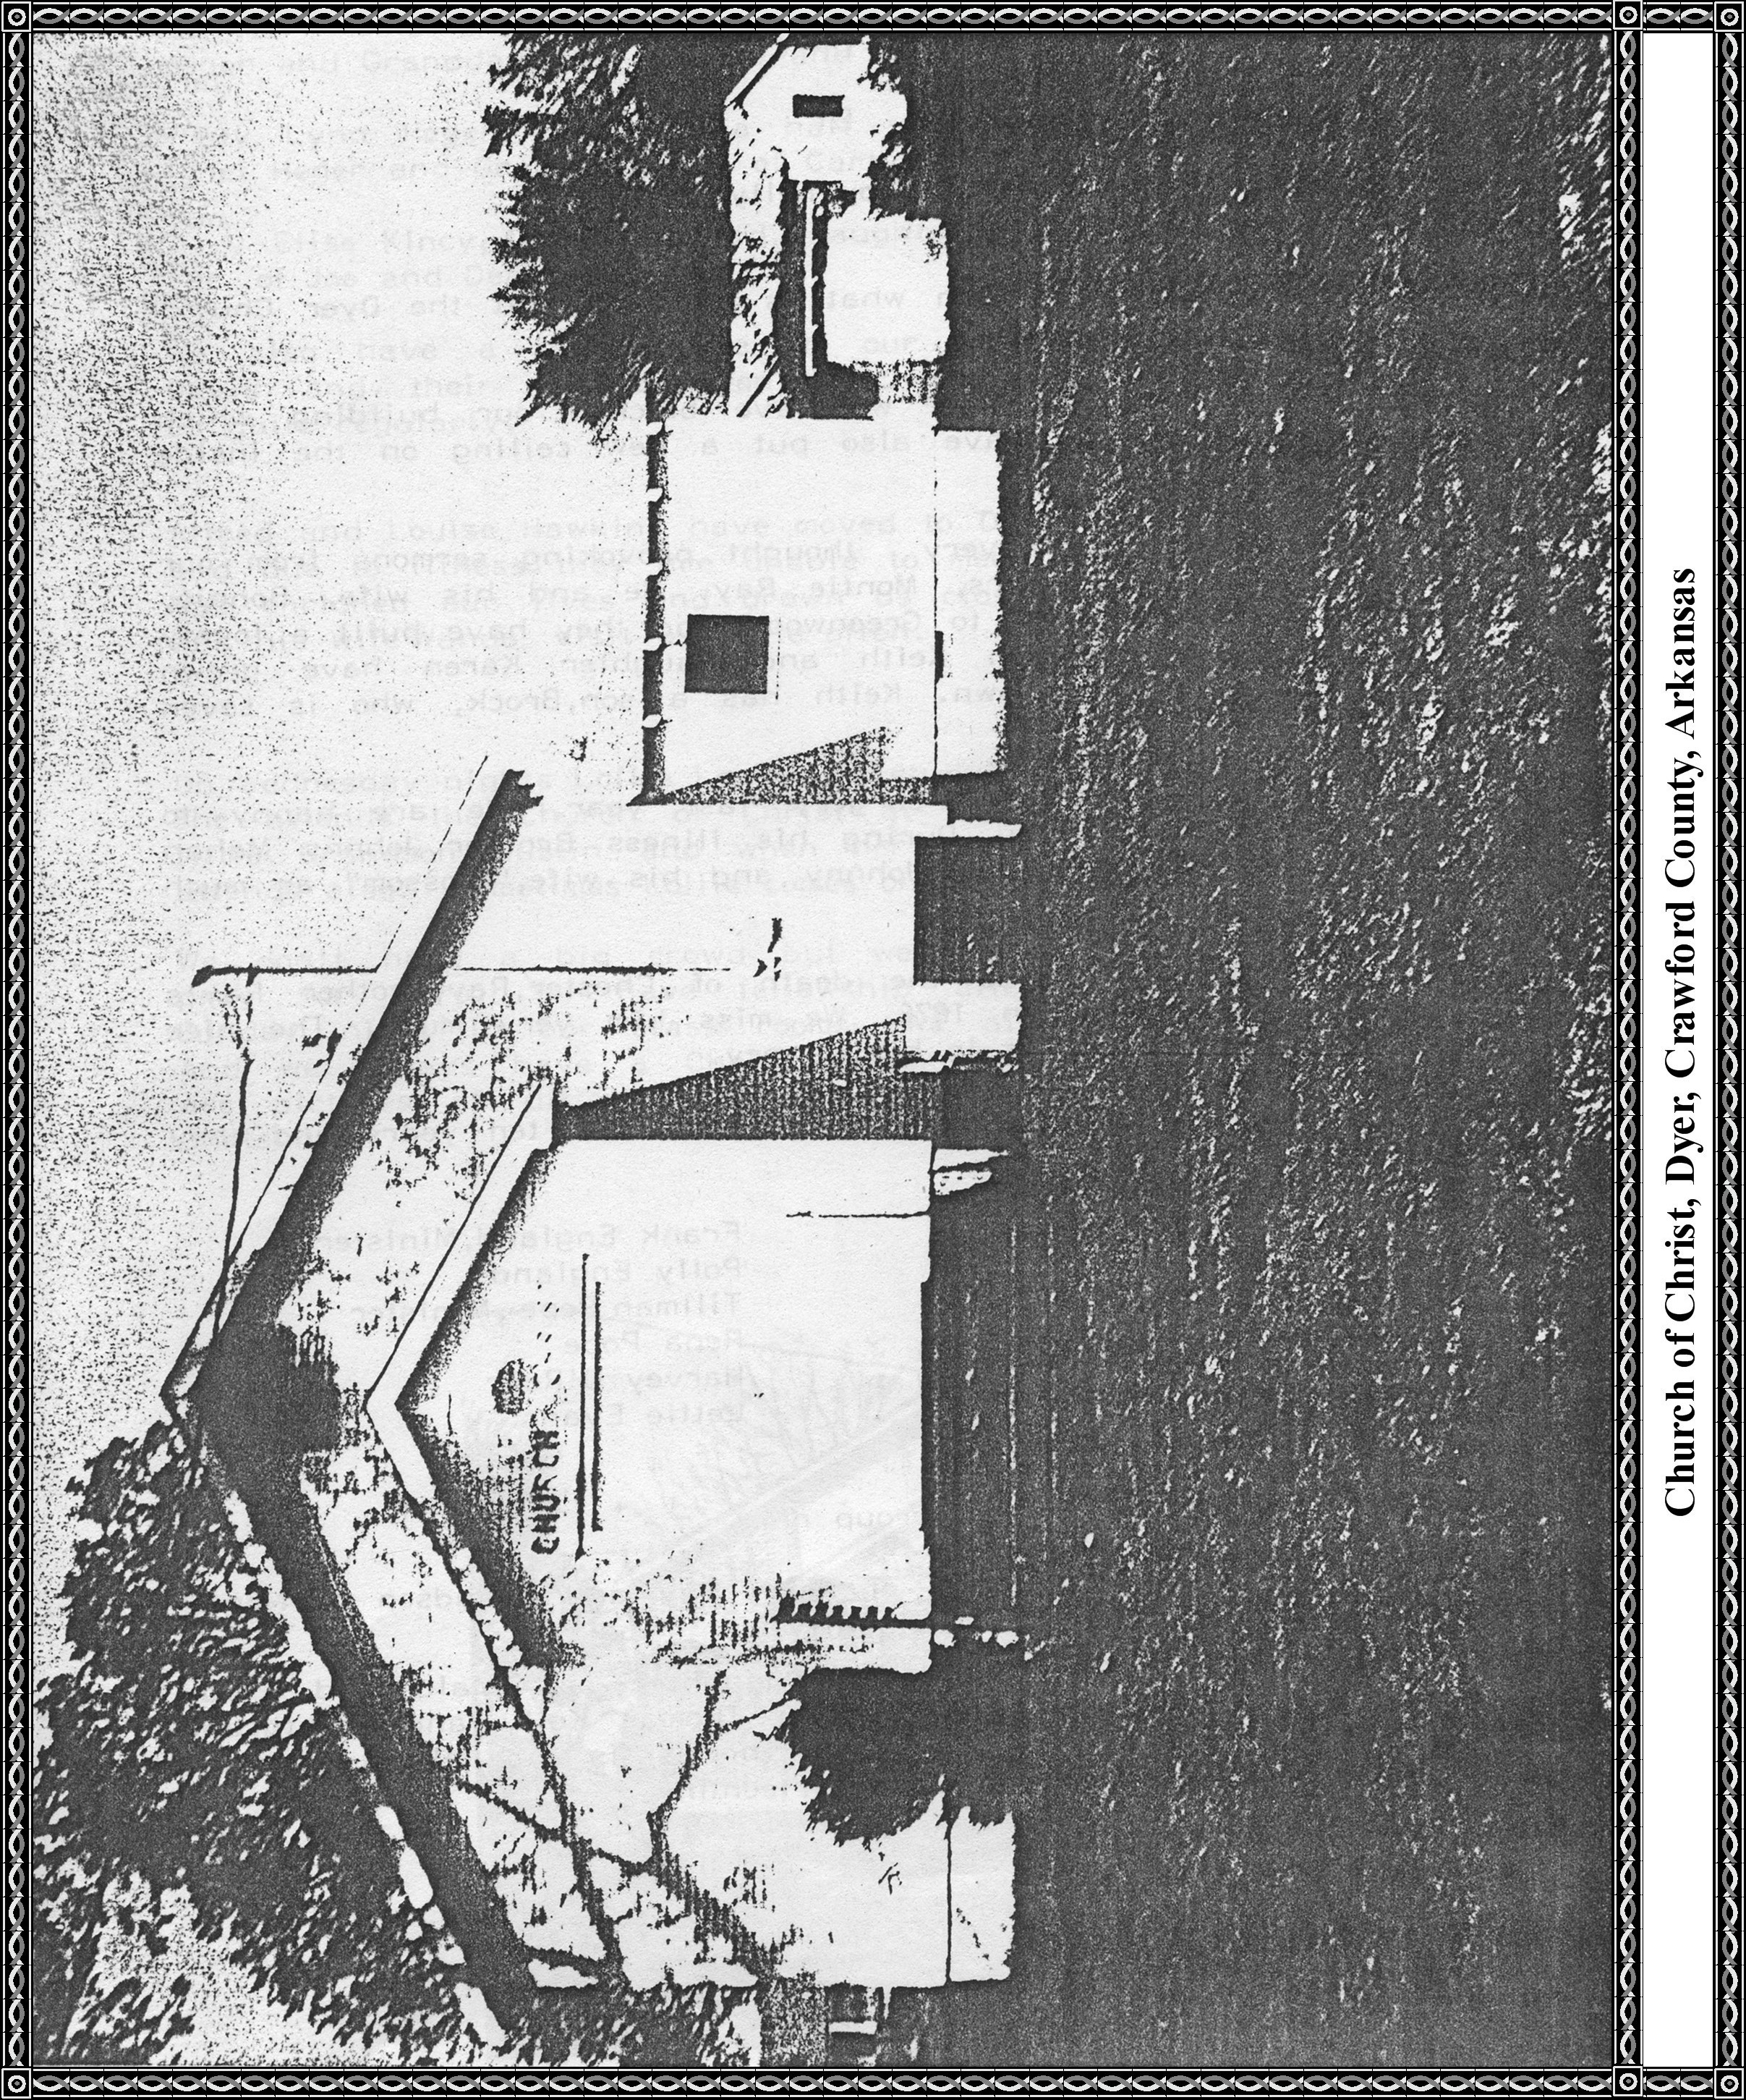

**CHURCH OF CHRIST**

By

Mary Lou Kelly

**1976 - 1986**. A new update on what is happening at the Dyer Church of Christ.

First of all, as you can see we have bricked our building which we are very proud. We have also put a new ceiling on the inside of the Church.

We are still hearing some very thought provoking sermons from our minister of twenty two years, Montie Ray. He and his wife, Bonnie, have moved from Fort Smith to Greenwood and they have built a lovely new home there. Their son Keith and daughter Karen have grown up with families of their own. Keith has a son, Brock, who is seven years of age.

Brother Ray had open heart surgery last year. We are happy to say that he looks good now. During his illness Brother Johnny Mahan preached for us. We still love Johnny and his wife, "Blossom," as much as ever.

One of the sad events was the death of Chester Ray, Brother Ray's father, who passed away in 1976. We miss him very much. The nice walk outside our Sanctuary is in his memory.

**We have lost several of our members in the last ten years and they are as follows:**

Chester Ray Frank England, Minister

Castle Winfrey Polly England

Mabel Morse Tillman Pope, Minister

Olin Campbell Rena Pope

Mary Campbell Harvey O'Rear

Mann Davis Lettie Evans

Ethel Wright

**We have some "little Ones" in our group now:**

Brock Davis Ray, seven year old son of Keith Ray and grandson of Montie and Bonnie Ray. He visits us occasionally.

Sherry Leann Jones, four years old, daughter of Gerald and Cindy Kelly Jones, granddaughter of Mary Lou Thomas Kelly and great-granddaughter of Lucy Nelson Thomas. Lucy Thomas is our eldest member. She will be ninety years old February thirteenth.

Amanda Marie Heger, four years old, daughter of David and Janet Heger and granddaughter of Carl and Alice Heger.

Misty Lynn Heger, two and a half years old, daughter of David and Janet Heger and granddaughter of Carl and Alice Heger.

Mary Elise Kincy, three years old, daughter of Kim Kincy and granddaughter of Joe and Dean Kincy.

**We also have a new couple in our Community:**

Darrell and Cindy Davis and their two children, Rachel and Mikey. They meet with us quite regularly.

Alfred and Louise Hawkins have moved to Dyer from the Jethro Community and due to illness they are unable to meet with us but their presence has enriched our lives and drawn us closer together. Their son Jerry and his wife Wanda visit us quite often.

On Wednesday, nights Lollie Leakey is studying the Bible with us. She attends the Church of Christ at Chastain. Often she brings her little grandson Dustin and when her mother Viva Sassie is able she attends also. Sometimes Lollie comes on Sunday nights too.

We don't have a big crowd but we are proud of all we have and pray for more. We have fellowship after Church on every second Sunday night in our class rooms. We also have cake on Birthdays and we always have a Christmas party in someone's home. Following are pictures of different occasions such as picnics, Halloween, and Christmas.

***[Editor's note: I'm not sure where the pictures, mentioned in the last sentence, are.]***

**Church of Christ, Dyer, Crawford County, Arkansas**

