**THE METHODIST EPISCOPAL CHURCH, SOUTH**

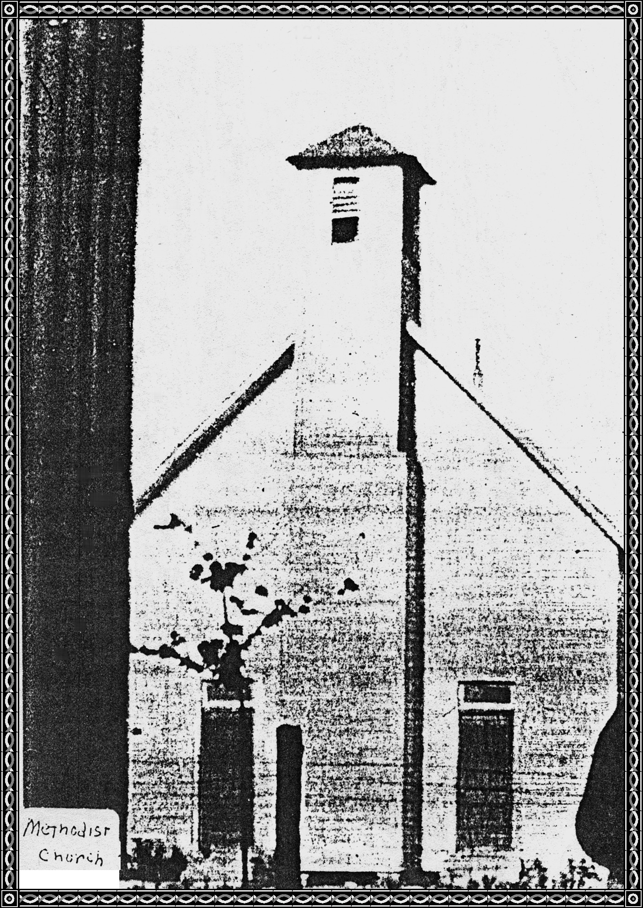

This Church was built by Floyd Loomis in 1892 and was the first Church in Dyer.

Mr. Shelton C. Chastain gave the land for the Church so that all Denominations could worship in the Church.

The Baptist Church was built a year later and built like this one with exception of the Belfry in front and their pulpit was in the East end of Church and Methodist was in the West end of Church.

**Dyer United Methodist Church, Dyer, Crawford County, Arkansas**

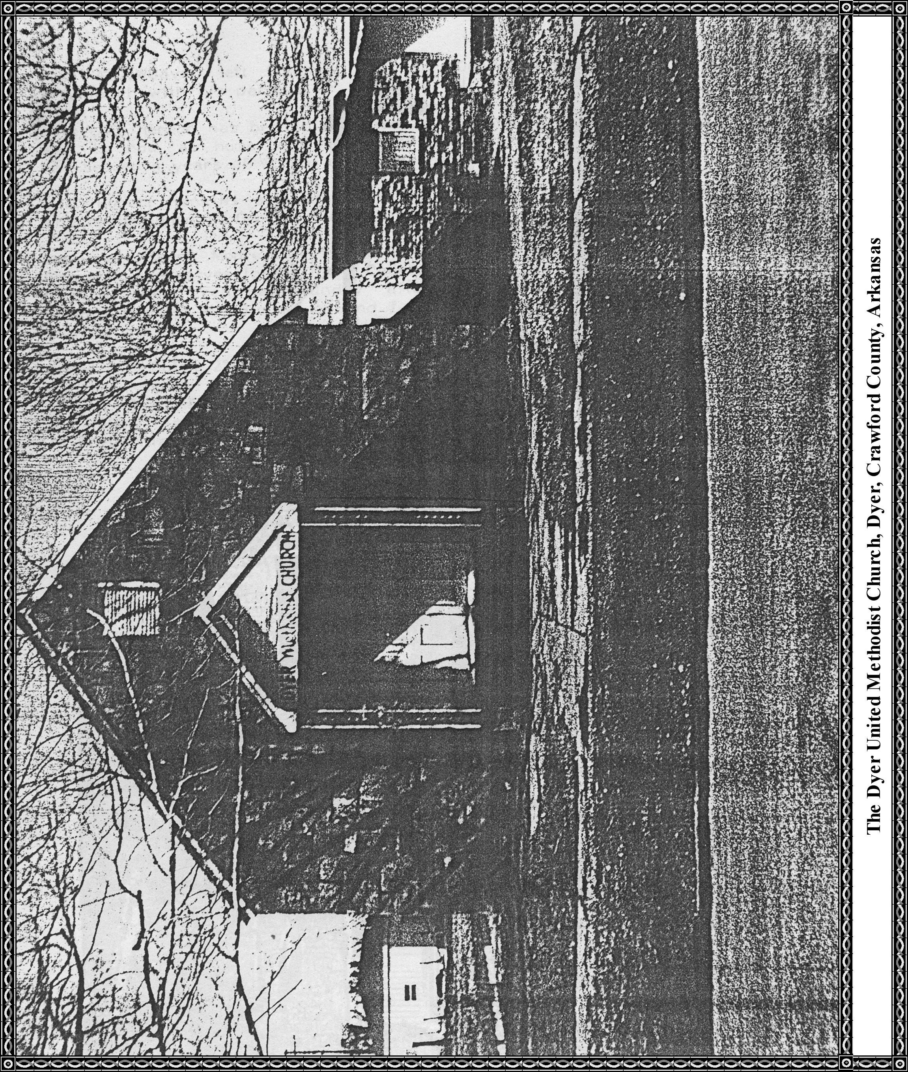

**DYER UNITED METHODIST CHURCH**

1986

By Martha Chitwood

I am coming to you with a report of things that have taken place at the Dyer United Methodist Church since our May 16, 1976, Bicentennial Year.

When we left you at that time Dorothy Collier was our pastor and Charles P. McDonald was our

District Superintendent. Dorothy left us in June 1976 and Nicholas and Carol Lascoro, a husband

and wife team, served us until June of 1977 with McDonald as District Superintendent. Then from June 1977 until November 1979 we had Kathy Fadick as our pastor with William Wilder as District Superintendent.

In January, February, and March 1979, when our pastor, Kathy Fadick, went away to school for three months, we had Glenn Daily, an Indian, for our speaker, and we enjoyed his wonderful sermons.

We had as pastor, William Sonneman, December 1979 till July 1980 when he left to go away to school, still with William Wilder as District Superintendent.

On August 10, 1980, W. Patrick Warrick came as our pastor. Wayne C. Jarvis was District Superintendent. Bro. Warrick stayed with us until June 1981.

In June 1981, Fern Cook came as our pastor and has been with us till this time 1986. She is pastor only at Dyer and is serving under Wayne C. Jarvis.

We as a Church enjoy at Easter time each year a Parish of six churches: Mountain View, Alma, Dyer, Kibler, Newberry Chapel, and Mulberry. The pastor of the churches are the speakers in one of the churches that is not their own. Our last Sunday night service on Easter is at Mulberry where we are served Communion. We have fellowship together after each session.

**We have only had three marriages in our church since 1976:**

Donald J. Glover of Van Buren and Melissa Claudette Hatley Alma, married 28 Mar 1981 by Rev. J. S. Edwards.

Eldon D. Davis of Dyer and Cynthia D. Bauer of Alma, married 20 Jun 1981 by Melford Gwaltney.

Dick Dewayne Hamlin of Greenwood and Deborah Ann Davis of Dyer, married 12 Apr 1985 by Melford Gwaltney.

**Funerals held in the Methodist Church have been:**

James O. Stephenson, age 95, born 10 Oct 1880, died 19 Jun 1976. Rev. Irl Scott Lancaster officiating. Buried in Dyer Cemetery.

Ida Mae Stephenson, age 92, born 05 Nov 1833, and died 04 Oct 1976. Rev Nicholas Lascoro officiating. Buried in Dyer Cemetery.

Maurice Lester Howard, age 81, born 08 Jan 1896 and died 18 Feb 1977. Rev. Nicholas Lascoro and Rev. Eddie Smith officiated. Burial in Dyer Cemetery.

Myrtle Morse, age 96, born 03 Feb 1881 and died 05 Apr 1977. Rev. Lester Nye and Rev. J. S. Edwards officiated. Buried in Dyer Cemetery.

Grace B. Williams, age 78, born 04 May 1902 and died 24 Oct 1980 with Rev. Patrick Warrick officiating. Burial in Dyer Cemetery.

Susie Bennett Tomlinson, age 95, born 28 Nov 1885 and died 01 Dec 1980. Rev. John Price and Rev. Uriah Smith officiated. Burial in Dyer Cemetery.

June Dyer Steele, age 62, born 16 Jun 1919 and died 29 Aug 1981. Rev Archie Boyd and J. Fred Patton officiated. Buried in Dyer Cemetery.

Fred Kamm, age 97, born 06 Feb 1885 and died 07 Jan 1983. Rev. Jim Brooks officiated. Buried in Dyer Cemetery.

Martin M. Kamm, age 95, born 06 Mar 1887 and died 23 Jan 1984. Rev. Fern Cook and Rev. H. J. Morris officiated. Buried in Dyer Cemetery.

Earl T. Morse, age 84, born 12 Feb 1900 and died 05 Aug 1984. Rev. Fern Cook and Rev. James Peters officiated. Burial in Dyer Cemetery.

**Improvements at the Dyer United Methodist Church since May 15, 1976**. May I say here that a lot of our improvements came from Memorials to our Church.

In May 1978 we bought cushions for the pews.

At time of the Bicentennial in 1976 we only had three of our stain glass windows and finally in July of 1978 the last six windows were installed.

In December 1978 we purchased a small strip of land that joined on the North the original land that the Methodist Church owned.

In September 1979 the Church and Educational building was painted.

In October 1982 a new roof was put on the Church by free labor.

In January 1983 a P. A. System was installed.

In August 1983 the walls were paneled and a new ceiling, new lights, and ceiling fans.

In December 1983 outside carpeting was laid on the porch of the Church.

In September 1984 a new sidewalk was poured in front of Church.

For all the nice things that have been done for the Dyer United Methodist Church in the last ten years we are grateful and thankful to all of you, for each one of you have been a great part of the

church. May our church go forward for the work of the Lord.

**The windows that have been installed since 1976 are:**

Martha Sue Moss In Memory

Seab and Susie Tomlinson In Memory and in Honor

Martin and Stella Kamm In Honor

John H and Emma B Warrick In Memory

Jewell and Martha Chitwood In Honor

Frank Porter and Myrtle Morse In Memory and in Honor

|  |  |  |  |
| --- | --- | --- | --- |
| Year | Pastor | District Superintendent | Bishop |
| 1916-1917  1933-1936  1936-1939  1950-1951 | Floyd G. Villions, Sr  J. B. Stewart  Floyd G. Villions, Sr  Floyd G. Villions, Sr | W. M. Shermon  H. H. Griffin  H. H. Griffin  Henry Goodloe | C. E. Morris  Moore  Moore  Paul Martin |