**World War II Veterans**

| **World War II Veterans** | | |
| --- | --- | --- |
| Acord, Ewell Dean  Acord, Hartsell  Acord, Herschel  Bell, Bill  Bell, Gerald  Belt, Hansel  Belt, Jasper  Belt, Thurman  Bennett, H. A.  Blevins, Willard  Brasher, W. N.  Casey, Warren  Chapen, Luther  Chapen, Cecil  Chitwood, Claude  Chitwood, Jack  Chitwood, Morgan  Collins, Bobby  Cottrell, Roe  Cottrell, Clay  Cottrell, Kenneth  Cottrell, James Lee  Cottrell, Loy  Coulter, Orvil  Cupp, Otis  Darr, John  Darr, William, Jr  Davis, Delmer  Davis, J. D.  Davis, Lloyd  Davis, Silas  Dyer, Jake  Eddings, Gordon  England, Frank  England, Haskell  England, Idas  England, John  England, T. J.  Evans, Bill  Gray, Malcolm  Gregory, Ples  Gregory, Albert  Gregory, G. G.  Gregory, Joe  Hall, Wayne  Hankins, Robert | Harris, Garland  Harris, Jewel  Harris, Lyle  Harris, Millage  Hatley, Claude  Hatley, Hess  Heard, Jack  Henson, Neal  Hill, Grady  Hood, Albert  Hood, Edward  Hood, Douglas  Hood, James  Hood, Robert  Hood, Roy  Hoyle, Jack  Hurd, Mitch  Isaack, Verden  Kennedy, Charles  Kennedy, June  Kennedy, Quentin  Kincy, John  Kincy, Olin  Koiser, Coy  Leakey, Oscar  Leakey, Ben  Leakey, Edgar  Leakey, Richard  Mason, Tom  McAdoo, Ray  McCain, Elbert  McCain, Edward  Morse, Dewey  Morse, Edgar  Morse, Herbert  Morse, Howell  Morse, Leslie  Morse, Merle  Morse, Paul  Morse, Selmer  Moss, Charlie  Moss, Robert  Peevy, Arland  Peevy, Jack  Peevy, Jim | Peevy, John  Peevy, Mason  Peevy, Roner  Peevy, Russell  Penson, Clyde  Porter, Frank  Porter, John  Porter, Herman  Porter, Stewart  Powell, W. B.  Powell, W. S.  Reed, Lester  Rhodes, Frank  Rich, Trumas  Roe, Jack  Slusher, Johnnie Ray  Summers, Gerald  Summers, Gordon  Swafford, Idus  Swafford, Roy  Swafford, Wiley  Wagner, Tommy  Weaver, R. G.  Weese, Bill  Weese, Ralph  Weese, Raymond  Weese, Scott  Weese, Jesse  Wells, Paul  Wells, Percy  Wells, Vernon  Whitlock, Fred  Whitlock, Hershel  Whitlock, Jerry  Whitlock, Louie  Wilcox, Clarence  Williams, Hershel  Wilson, Glebb  Wilson, H. G.  Wilson, John  Wilson, Robert  Wright, E. C.  Wright, Frank  Wright, Paul  Wright, Truman |

Staff Sergeant **Robert Arland Peevy**, 25 years old, was reported killed in Luxembourg, February 2. He was serving with a tank destroyer unit and had been awarded a bronze star for gallantry in action early in January. He had been overseas six months and in service three years. He is the son of Mr. and Mrs. Cal Peevy of Alma, Arkansas.

Killed: Private **Wiley J. Swafford** of Dyer died January 7 of wounds suffered in France one day earlier, the War Department has notified the parents. Pvt. Swafford died four days before his nineteenth birthday. He entered service April 17, 1944, and has been overseas a month. Mr. and Mrs. Swafford have another son, Private First Class, **Idus B. Swafford**, who is stationed at Camp Edwards, Massachusetts. Survivors include nine sisters.

**Dyer Private Killed In France:**

Private **John E. Peevy**, 20, was killed in action in France, August 2. His wife Mrs. Lois Mae Peevy of Dyer, Arkansas, has been notified by the War Department. The young soldier had been in service a year and overseas two months. He was the son of Mr. and Mrs. Claude Peevy of Alma, Arkansas.

**Dyer Man Missing Since December War Prisoner.**

**Reeves Porter**, husband of Mrs. Blanche Porter of Dyer and the son of Mr. and Mrs. Jess Porter of Dyer and Route 3 of Alma, is a prisoner of war in Germany, it was learned last week.

Porter, missing in Belgium since Christmas Eve, said in two communications of January 13 and January 24 that he was being held at Stalag Luft Camp 4-B, believed to be located at Mohlberg near Dresden, Germany. He said he was well and asked the Red Cross be contacted for instruction on forwarding "the most you can until the war is over."

Inducted November 3, 1943, Porter trained in the field artillery at Fort Sill, Oklahoma, and went overseas in April 1944. He was transferred to a tank destroyer battalion in October and has been with the first Army since beginning overseas service.

Mrs. Porter is the former Blanche Chitwood, and the couple has two small sons. Porter has never seen his youngest son who will soon be seven months old. He has three brothers in service: Pvt. First Class Frank Porter in New Guinea; Sergeant John Porter in Italy; and Mechanical Sergeant Stewart Porter, a radio instructor stationed at Sioux Falls, South Dakota.

**May 1969:**

PFC **Boyce D. Burgett**. Only boy to die in the Viet Nam War from Dyer. In just a month he would have been returned home. He was the son of Mr. and Mrs. Ward Burgett of Dyer.

**Dennis Davis**, Route 2, Mulberry, Arkansas, has been promoted to sergeant in the United States Air Force. He is the son of Mr. and Mrs. Dudgeon Davis and a 1971 graduate of Mulberry High School, Mulberry, Arkansas.

**Jimmy Cottrell,** who is stationed in Fort Knox, Kentucky, is spending his furlough with his parents, Mr. and Mrs. Mart Cottrell. He is to go overseas after his visit here.

His brother, **Paul Wesley Morse** is in Van Buren visiting their parents after serving 21 months in the Pacific area. Another brother, **Howell Morse,** is on duty in the Pacific.

**Former Dyer Girl Married**

Corporal **June Kennedy**, daughter of Mr. and Mrs. W. B. Kennedy, former residents of Dyer who now live in Tucson, Arizona, became the bride of Technical Sergeant **Wm. T. Moler** of California, December 18, her parents have announced.

The double ring ceremony was performed in the Presbyterian church at Salina, Saline County, Kansas, where both the bride and bridegroom are stationed at Smokey Hill Army Air Field. The bride wore a white wedding gown with finger tip veil and carried a bouquet of red roses. Her only attendant was Corporal Carmen Jordon of Baton Rouge, Louisiana. Staff Sergeant Joe Hudson was best man.

Mrs. Moler is a graduate of Alma High School, attended Central College at Edmund, Oklahoma. Before entering service she was employed as a receptionist in the Little Rock office of the United States Employment Service. Since joining the WAC, she has flown as Radio operator on a cargo ship.

Sergeant Moler attended Oakland Polytechnic College in California and has been stationed at Salina, Kansas, since 1943 as a weather forecaster. They are remaining at present at Salina, Kansas.

**HEADQUARTERS EIGHTH AIR FORCE**

**OFFICE OF THE COMMANDING GENERAL**

**AFO 634**

**STEWART PORTER**: 38294373, Technical Sergeant, Army Air Force, United States Army. For gallantry in action against the enemy while on a bombardment mission over Germany 29 May 1944. After "Bombs Away," the B-17 aircraft in which he was serving as Radio-Operator and Gunner was subjected to vicious attacks by a large number of enemy fighters. Sergeant Porter was painfully wounded and knocked down when a 20MM cannon shell exploded in the radio compartment. In spite of this, he courageously returned to his gun and assisted in warding off the repeated attacks. About fifteen minutes later he was wounded a second time by fragments of bursting cannon shell. With utter disregard for his wounds, Sergeant Porter remained at his gun and continued to fire at the attacking fighters. He refused first aid treatment until there was no longer a danger of further attacks. Sergeant Porter's gallantry, skill, and complete devotion to duty contributed in a large measure to the safe return of the aircraft and crew. He entered service from Arkansas.

**MERLE MORSE** FROM VAN BUREM REPORTED MISSING IN ACTION

**Merle Odell Morse**, Seaman First Class, was reported missing in action by the Navy Department, Tuesday, December 7, 1943. He is the son of Mrs. Ruby Morse, Van Buren, Arkansas.

Seaman Morse, 23 years old, was born in Mulberry and has been a resident of Van Buren for eight years. He graduated from High School 1941. On August 23, 1942, he enlisted in the Naval Reserve. He had been stationed in the Gilbert Island area, assigned to the USS Liscome Bay, CVE-56. The escort carrier was torpedoed by a Japanese submarine on 24 Nov 1943, with a catastrophic loss of life.

**The War Years**

World War II was a time of rationing, to save everything for our boys who were overseas and the war effort, but we also discovered that our boys did not get what we were rationed for, and sugar and other commodities were left to waste on the beaches. We had stamps for everything it seemed. Stamps for gasoline and you were allowed according to your war effort. Doctors and ministers were allowed all they needed. A B C was the code that placed you in categories and this told the Filling Station attendant how much gas you were allowed. A was unlimited amount. B was for workers in war industries. and everyone else was a C and allowed only so much gas. And tires was almost impossible to find, and women stood in line for hours hoping they would be able to purchase a pair of nylon hose, and men stood in line to buy cigarettes.

**Data On Our Soldier Boys**

**Dyer Corporal's Group Bombing Record:**

This was the bomb group to which Corporal Richard H. Leakey, Jr, son of Mr. and Mrs. Richard H. Leakey, of Dyer, was assigned. They set an Air Force record for bombing accuracy in September. This precision bombing record during one month was attained in 40 separate attacks while flying aerial support for the Allied drive in Northern Italy.

Corporal Leakey is serving as a truck driver and mechanic with the Veteran B-23 unit which has been cited by the President for distinguished service in battle.

**Dyer Man Wounded In Germany:**

Pvt. Loy O. Cottrell, son of Mrs. Elsie Cottrell, of Dyer, Arkansas, is in a hospital in England recovering from wounds received in action in Germany. He's O.K. he told in a recent letter to his mother who was notified by the War Secretary several days ago that he had been wounded. Pvt. Cottrell has been overseas two months and in the Arm Forces eight months.

Pvt. Loy Cottrell, a 20 year old infantryman who was seriously wounded September 20 in Germany, is visiting his Mother, Mrs. Elsie Cottrell at Dyer.

Pvt. Cottrell, who had been on the firing line two months when he was wounded, suffered shrapnel wounds to his feet and left leg. He will report to a hospital at Chickasha, Oklahoma, on February 20.

Mrs. Cottrell is being visited also by another son, Seaman First Class James Lee Cottrell, age 24. He will leave Friday for the West Coast to report for duty.

**Morse Prisoner Of Germans:**

Mr. and Mrs. Lee Morse has been notified that their son, Herbert Morse, who previously was reported missing in action in Germany is a prisoner of Germany.

Several days before the official notification, Mr. and Mrs. Morse had received a letter from their son written from a prison camp. The letter was dated October 10 and said he was well.

Morse's wife and two children live in Mulberry, he was overseas about two months when he was taken prisoner. He served in the infantry.

**Nine Soldiers From Fort Smith Area on Casualty List**

On an army-navy casualty list released Friday by the war department were the names of seven Western Arkansas and two Eastern Oklahoma men.

Next of kin has been notified in each instance. In case of divergence between this list and information sent to the next of kin, the last war or navy department telegram or letter to the next of kin is the appropriate authority.

**Army Dead in the Pacific:**

Private Elbie L. Eaton, husband of Mrs. Lillian E. Eaton, Pettigrew. Arkansas.

**Army Wounded in Europe:**

Leo B. Bogner, technician fifth grade, son of Mrs. Louisa Bogner, 2204 North Fifteenth Street. Fort Smith. Arkansas.

Pfc. Marion Bowerman, husband of Mrs. Betty L. Bowerman, route 3, Rogers, Arkansas.

Pfc. Louis L. Roberts, brother of Miss Evelyn Beason, Poteau. Oklahoma.

**Army Wounded In the Pacific:**

Private Clifford O. Barnes, husband of Mrs. Ruth Barnes, route 2, Gravette. Arkansas.

Pfc. Chalos C. McBride. son of Mrs. Katie McBride, Route 4, Fayetteville. Arkansas.

**Army Missing in Europe:**

Sergeant Harvey M. Whiteside, husband of Mrs. Lena R. Whiteside, route 2, Muldrow. Oklahoma.

**Army Prisoners of War In Germany:**

Private Herman R. Porter, husband of Mrs. Blanch E. Porter, of Dyer, Arkansas.

Pfc. James E. Robbins, son of Mrs. Rosa Lee Robbins, route 2, Dover, Arkansas.

**Additional Military News:**

Sgt. Dathan Molder has been transferred to an army air corps, and will be sent to an army air school.

Pvt. Herman R. Porter, F.N.R. T. C. is taking basic training at Fort Sill, Oklahoma. His wife and small son, Reeves, Jr, of Rt. 3, Alma, Arkansas, have gone to be with him until his departure overseas when he graduates from this field. Sgt. Porter and Molder are brothers-in-law.

**Herman R. Porter May Be Prisoner In German Camp**

Mrs. Reeves Porter has received word that her husband, Pvt. Herman R. (Bud) Porter may be a prisoner of war. This has not been confirmed but his name was given over an enemy propaganda broadcast as a prisoner of war. She also received letters from people all over the United States who had heard his name over short wave. Mrs. Porter and two sons live at Dyer, Arkansas.

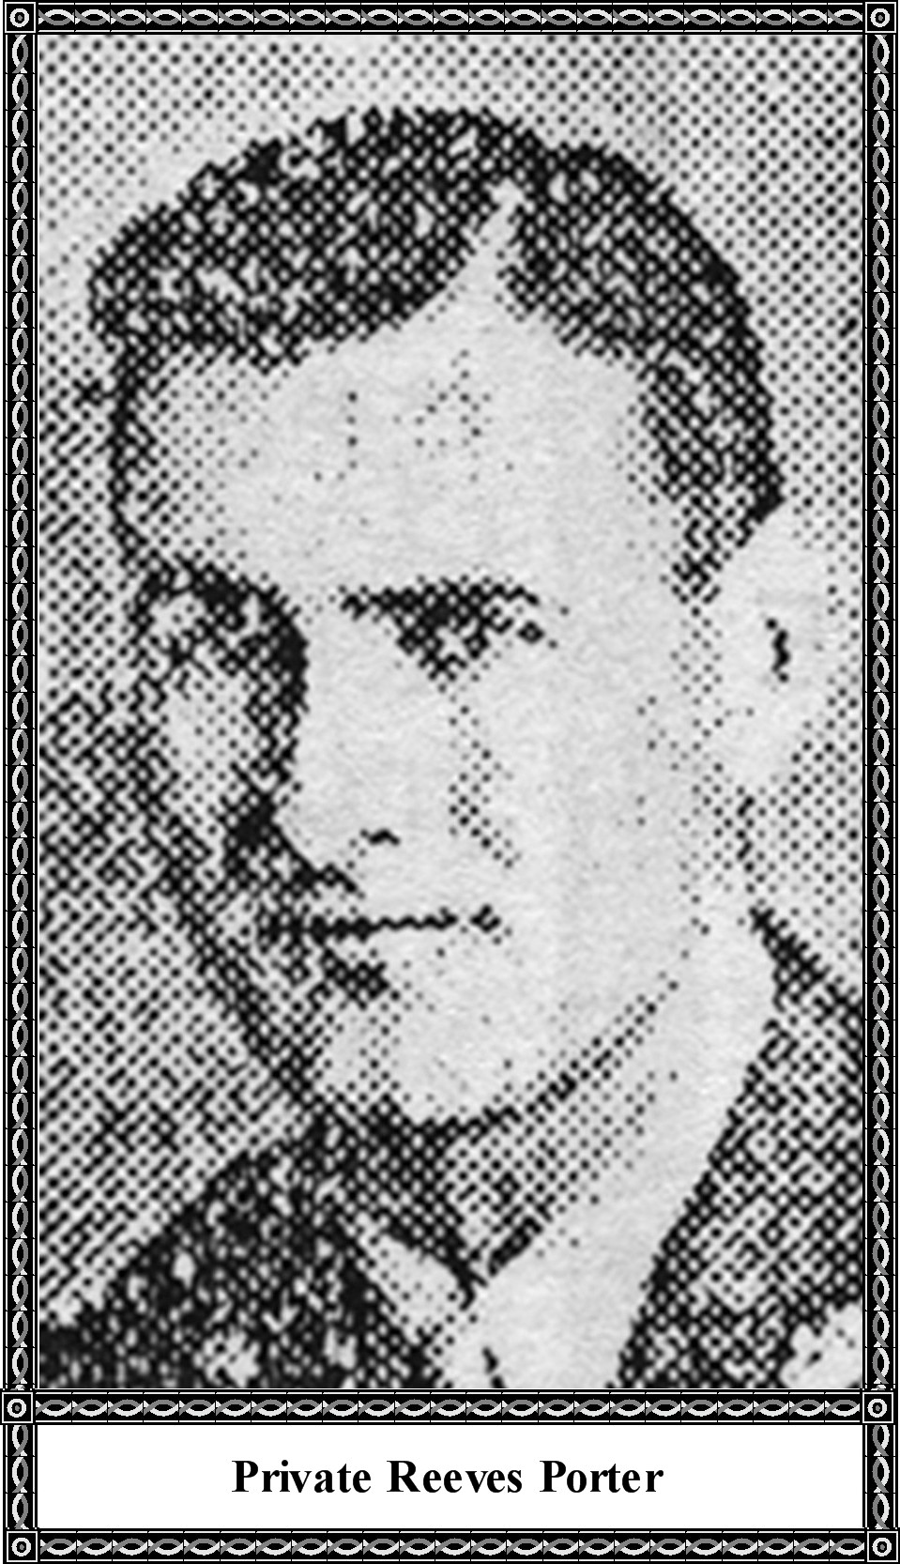

**Dyer Man, Missing Since December, War/Prisoner**

Dyer, Ark. - (Special) - Reeves Porter, husband of Mrs. Blanche Porter of Dyer and the son of Mr. and Mrs. Jess Porter of route 3, Alma, Arkansas, is a prisoner of war in Germany, it was learned last week.

Porter, missing in Belgium since Christmas Eve, said in two communications of January 13 and January 24 that he was being held at Stalag Luft camp B-4, believed to be located at Mohlberg near Dresden, Germany. He said he was well and asked the Red Cross be contacted for instructions on forwarding "the most you can until the war is over."

Inducted November 3, 1943, Porter trained in the field artillery at Fort Sill, Oklahoma, and went overseas in April, 1944. He was transferred to a tank destroyer battalion in October. He has been with the First army since beginning overseas service.

Mrs. Porter is the former Blanche Chitwood. The couple has two small sons. Porter has never seen his younger son who will be seven months old. He has three brothers in service: Private First Class Frank Porter in New Guinea; Sergeant John Porter in Italy; and Technical Sergeant Stewart Porter, a radio instructor stationed at Sioux Falls, South Dakota.

***[Editor's note: After checking the* Ancestors of Dyer, Volume I, 1838-1989 *obituary book compiled by my mother Alma Lorena Moss Lancaster, I discovered that these last two articles, one about Herman R. Porter and the second one about Reeves Porter, are one and the same man, namely, Herman Reeves "Bud" "Buddy" Porter, Sr, and his wife Blanche Chitwood Porter.]***

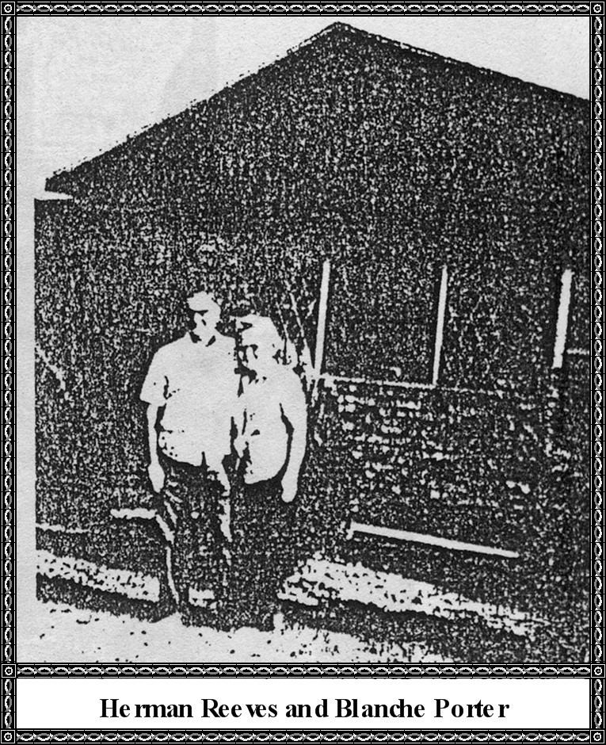

A-2c A. G. Weaver left Sunday night for Denver, Colorado, after spending a furlough with his parents, Mr. and Mrs. Alvis Weaver.

A-1c Lois Henson has been discharged at Andrews Air Force Base, Maryland, and is now at home with his parents, Mr. and Mrs. Thell Henson. Lois has served 4 years of which a part was spent in Bermuda.

Mrs. Robert Hankins and daughters left November 15 to join Sgt. Hankins who is stationed in Germany in the Army.

Seaman Albert Moore, who is stationed in Pensacola, Florida, and Sam Chastain, who serves in the Navy Cadets and also stationed in Pensacola, Florida. Both returned Sunday after spending a leave with their parents, Mr. and Mrs. Jim Moore and family and Mr. and Mrs. Jewel Chastain and son.

James B. McDuffie, age 22, son of Mr. and Mrs. Byron McDuffie, of route 2, Alma, Arkansas, recently was promoted to Corporal in Germany. He is a mechanic of the First Infantry Division, 63 Tank Battalion Corp. McDuffie entered the Army in April 1953, completed basic training at Camp Roberts in California and arrived in Europe during September 1953.

**UNCLE MACK'S FILLING STATION**

**WITH THE FRONT REMOVED**

