**Notes From Here And There**

Cumberland Presbyterian Church at Mulberry organized 21 May 1832. In the 1850s these names from Dyer were among the membership: Joel Dyer, Sarah Dyer, Stephen Dyer, George E. Dyer, Rebecca Dyer, Mary S. Dyer, Clem Dyer, James Heard, Martha Heard, Sarina Heard, Penelope Remey Dyer. This was taken from the original Church record.

Floyd Loomis left his hammer mark on our town:

He built the first house for Shelton Chastain which was beside the Moss store.

The James Selby two story home on Line Street.

Built the two story HOTEL for John William Moss.

Built the Methodist and Baptist churches.

The school house built 1885 in Dyer.

Bought 120 acres of wilderness South of Dyer.

Opened a street through some of his 40 acres east of Baptist Church which passed the brick school.

Street was named Loomis Street.

Sold an acre of land to the School Board for a playground.

A water fountain house was built on the West side of play ground.

Velta Fern Hopper Tillery sent me an old ledger containing the diary of the old Sharpe farm in the river bottoms of Dyer. It was called Clear Creek Plantation. It began 09 Mar 1885 and went through 18 Feb 1889. Uncle Joe Wright was listed at top of page for employees.

Sebe Tomlinson worked there as did Piety Fears later Wright. I carried the ledger with permission of Velta Fern to the Archives in Little Rock. Matt Hopper who was the Depot Agent for awhile was the father of Velta Fern.

Grandma Bounds moved to Alma from Dyer but returned to help usher in many a baby in our town. She was a midwife.

**Former Post Master Honored By Old Staff**

August 25, 1955

Early Thursday morning employees of the Alma Post Office inveigled W. D. Patton, he formerly lived at Dyer and was the cashier of the Bank of Dyer, retiring Post Master of Alma, into the office and presented him with a beautiful platform rocker as a token of their esteem and good wishes.

Walter Patton announced that he and Mrs. Patton were leaving on a fishing trip down to the Ouachita Mountains where they will be joined by their son, Walter, Jr, for several days on an outing.

**Mrs Mason And Mrs Hurst Get Cash Share**

Oklahoma City, Oklahoma, December 6

The Oklahoma Supreme Court today reversed its decision of a year ago on the $1,300,000.00 will of the late C. F. Meadors of Oklahoma City and gave the estate to a large group of relatives and a church, instead of two daughters alone.

The two daughters of the wealthy real estate dealer, who died in 1952 at the age of 79, are Mrs. Magnolia Mason and Mrs. Maude Hurst who lives near Magnolia, Arkansas.

The Court a year ago threw out the Meadors will and gave the estate to the two daughters. Today it upheld the will by a five-three decision and thus gave the estate to seven brothers and sisters of Meadors, l1 nieces and nephews, and the two daughters, and the First Baptist Church of Oklahoma City.

The daughters will receive 75,000 each under the will and the brothers and sisters will share equally.

**John C. Rogers Family**

I don't know where I picked up these data but wanted to include it in these notes.

John C. Rogers, a veteran of the War of 1812, ranged ahead of the travelcade coming from the State of Georgia and blazed a trail and selected camping sites where the pioneers could sleep and rest while allowing their teams and oxen to forage.

After many days of tiring travel, the travelers entered the area of the Arkansas Valley that is now Crawford County, Arkansas. After several days in the vicinity of Pleasant Hill on the banks of Little Mulberry Creek, a mile or so North of the present Mulberry, a scouting party was sent out to locate land for temporary home sites. The area West consisted of an elongated ridge, 3 miles wide by six miles long, was found available for homesteading.

One of the descendants, Mrs. Mary Meadors nee Rogers, has lived her entire life of 86 years in this new homeland, known as Georgia Ridge. John Rogers walked the entire distance from Georgia; Columbus Adams, Uriah Love, John O. Love, Jimmie Jones, Richard Hill, Joe and John Chitwood, the widow Powell, Wiley Taylor, Ned Chastain, Jim Lawson, Hardley White, and others.

The Ridge boasted four school houses: Chastain, Hill, Dean Springs, and Fine Springs. Church services were held at the school sites. Schools have consolidated now with Alma, Mulberry, and Dyer. The Hill school House was sold and moved. The Chastain school building has been converted into a Church building.

The Georgia Ridge Community lies in the foothills of the Boston range of mountains.

**The Dyer Family**

In march 1832, Ben and Martha Logue Dyer of North Carolina came to the Arkansas Territory and located on Frog Bayou Creek at the present site of Mountainburg. It was then a vast wilderness of virgin timber inhabited by Indians, wild animals, and plenty of wild game. In 1833 Ben Dyer's widowed mother, Mrs. Caleb Dyer of North Carolina and the other nine children started for Arkansas. Some of them traveled up the River in a flat boat. Some traveled across the country in wagons, driving the horses, mules, and cattle.

Caleb Dyer was of English descent, a soldier of the Revolutionary War, and a well-to-do stock raiser. He left Rebecca, his widow, and children well-fixed. His descendants today wonder if he didn't literally turn over in his grave when she started for Arkansas Territory in 1833. Rebecca Dyer was a remarkable pioneer woman. She and the nine children settled on Frog Bayou Creek in the wilderness next door to her son, Benjamin Dyer. In 1835 Benjamin Dyer died from exposure. She not only reared her own children but helped Martha Logue Dyer rear her children. Soon afterwards, Joel Dyer, Rebecca's and Caleb's second son, married Sarah Talkington whose parents had settled across the mountains on Little Mulberry Creek. The ridge of this mountain was entered as "the Narrows" at Van Buren, the County seat, by George Sater Dyer, Rebecca's and Caleb's third son.

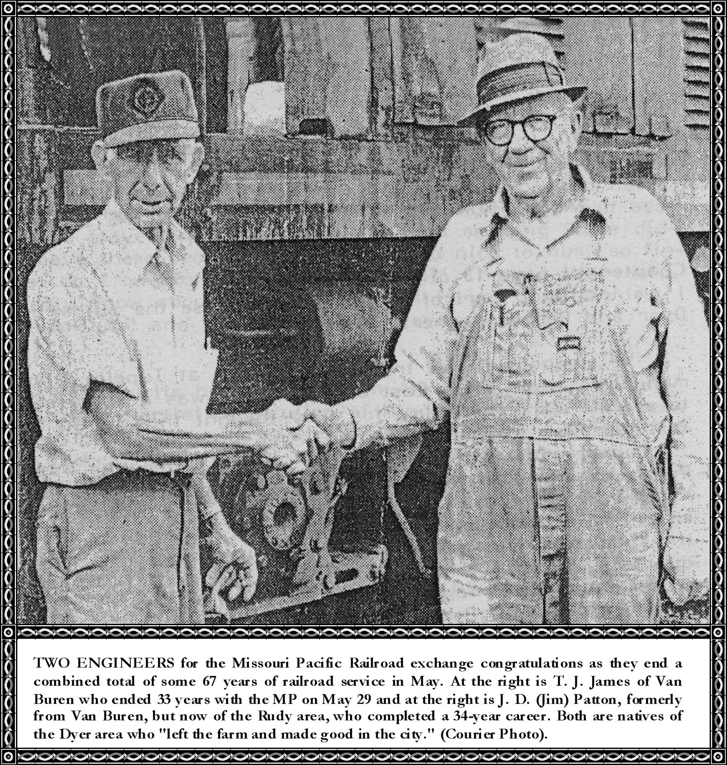

**William "Dockey" Brasher III ~ Debbie Davis**

