**AAC exhibition reflects artist's years in Ozarks**

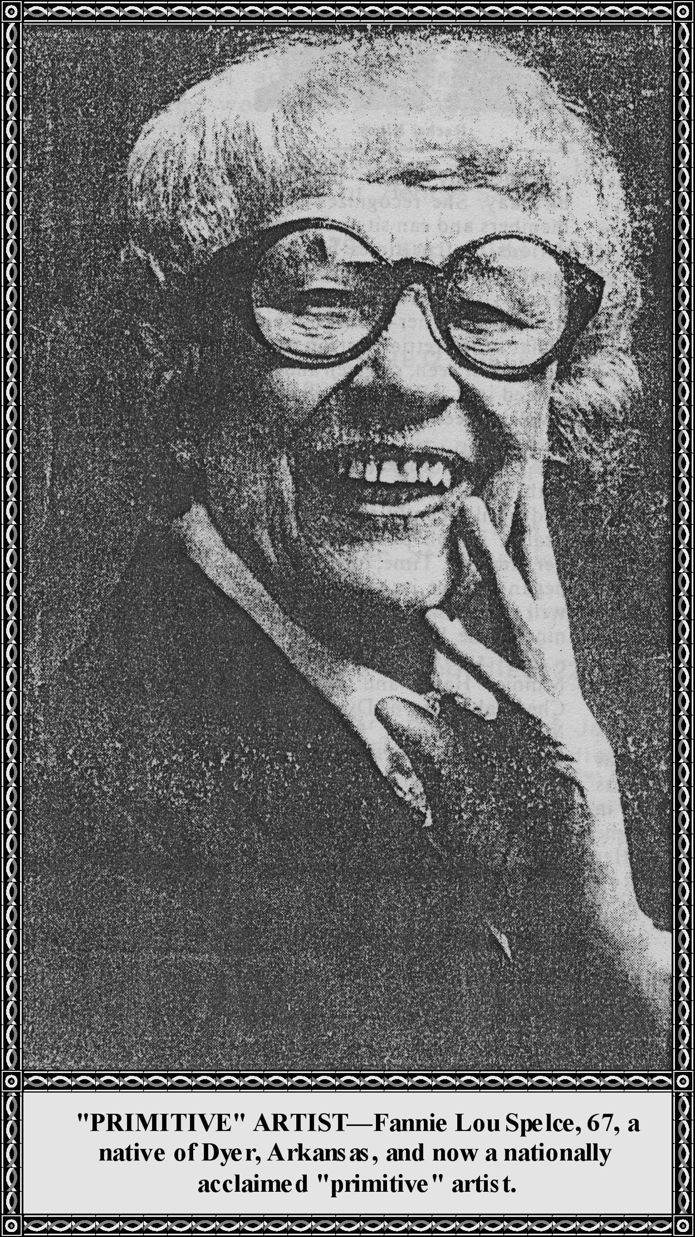

**Grandma's kitchen**



Ms. Spelce, 67 ***[Born 1908 + 67 = 1975]***, was born in Dyer, Arkansas, the oldest of five children of Arter and Florence Bennett.

She began painting at age 58 ***[Born 1908 + 58 = 1966],*** following a long career as a registered nurse.

Many of her paintings are of people that she grew up with.

**County Memorial Fair**

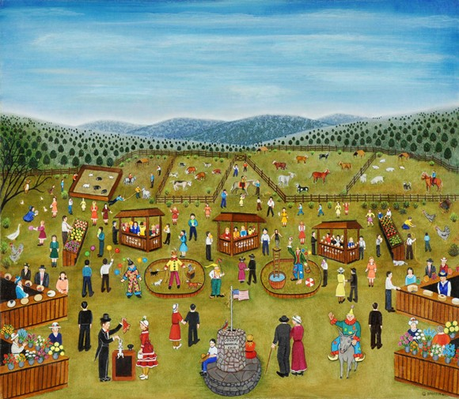

**Rachel Kincy celebrates 100th year**

|  |  |  |
| --- | --- | --- |
| Rachel Kincy  celebrates  100th year  (This article was written by Rachel Kincy's 79-ycar-old son, Olen Kincy, in honor of her 100th birthday.)  The weather on January 19 was beautiful, compared to the frigid temperatures this time a year ago, as 78 sons, daughters, grandchildren, nieces, nephews, and friends arrived at the American Legion Hall in Checotah, Oklahoma, for Rachel Kincy's 100th birthday celebration. They came from California, Texas, Missouri, Florida, Arkansas, and parts of Oklahoma.  The celebration began at 11 a.m. with her grandson, Joe Kincy, reading congratulatory letters from President and Nancy Reagan and Senator Boren from Oklahoma, then giving the Kincy family early-year history. Following, each attendee spoke, expressing their love for Rachel and praising her many virtues.  The group moved to the Green Country Restaurant's private dining room for an excellent meal and then returned to the legion hall for an afternoon of visiting, birthday cake and coffee.  Although Rachel was unable to attend the celebration, she was aware of the day's events as family members visited her in small groups at the nursing home throughout the | afternoon. Her health has deteriorated considerably since her 99th birthday. She recognizes family members and can sit up for short periods, but at times her mind wanders somewhat, for on a recent visit with her, she pointed to the wall of her room and said, "That's the prettiest cotton patch I have ever seen, so green and not a weed in it." Realizing what she must be seeing, I had to agree with her.  At 100, Mother has grown old with serenity, grace and dignity and until recently enjoyed good health, in full possession of all her faculties. Time, however, has began to take its toll on her, as well as her children, since only nine of the 12 survive today. The surviving children are Minnie, Hazel and Gladys of Checotah; Olen of Dyer; Leia of Mulberry; Claud, Pauline and Bessie May of California, and Alva of Missouri. Rachel has 30 grand, 65 great, 38 great-great-grandchildren and a great-great-great-grandson.  May God bless my mother.  ***[Different article in 3rd column.]*** | In March 1832, Ben and Martha (Logue) Dyer of North Carolina came to the Arkansas Territory and located on Frog Bayou Creek at the present site of Mountainburg. It was then a vast wilderness of virgin timber inhabited by Indians, wild animals, and all sorts of wild game.  In 1833 Ben Dyer's widowed mother, Mrs. Caleb Dyer, of North Carolina, and the other nine children, started for Arkansas. Some of them traveled up the Arkansas River in a flat-boat. Some of them traveled across the country in wagons, driving the horses, mules, and cattle. Caleb Dyer was of English descent, a soldier of the Revolutionary War, and a well-to-do stock-raiser. He left Rebecca, his widow, and the children well-fixed. His descendants today wonder if he didn't literally turn over in the grave when she started for the Arkansas territory in 1833.  Rebecca Dyer was a remarkable pioneer woman. She and the nine children settled on Frog Bayou Creek, in the wilderness, "next door" to Ben. In 1835 Ben died from exposure. She not only reared her own children but helped Martha rear hers.  Soon afterwards, Joel Dyer, Rebecca's and Caleb's second son, married Sarah Ann Talkington whose parents had settled across the mountain on Little Mulberry Creek.  The ridge of this mountain was so extremely narrow the place became properly known as "The Narrows," spoken "Narrs."  Joel and Sarah Ann Dyer established Dyer Station, now the town of Dyer, Arkansas. They reared six sons and six daughters. There was lots of traveling then, through "The Narrows," across to Big Frog Creek."  In 1845 the present site of Mountainburg was entered as "The Narrows" at Van Buren, the county-seat, by George Sater Dyer, Rebecca and Caleb's third son.  In 1848 a Federal Post Office was established at "The Narrows." Mail was delivered first by horseback and later by stagecoach from Fort Smith, Van Buren, and Fayetteville. The name continued until 1876. By that time there were so many "narrow" ridge-ways the name was confusing to postal authorities and settlers. It was changed to Mountain Burgh. The old English spelling of "Burgh" was used until 1893. Then the Post Office became officially Mountainburg.  A bit of the past history still lingers. The old folk say Mountain Burgh and the Star Route to Locke follows the same old "Narrs," the Narrows. |

In 1848 a Federal Post Office was established at "The Narrows." Mail was delivered first by horseback and later by stagecoach from Fort Smith, Van Buren, and Fayetteville. The name continued until 1876. By that time there were so many "narrow" ridge-ways the name was confusing to postal authorities and settlers. It was changed to Mountain Burgh. The old English spelling of "Burgh" was used until 1893. Then the Post Office became officially Mountainburg.

A bit of the past history still lingers. The old folk say Mountain Burgh and the Star Route to Locke follows the same old "Narrs," the Narrows.

**Taken From Benjamin Dyer's Diary**

Joel Dyer was born 1807 and died 1863, married Sarah Talkington in 1839. By 1850 this family was living at Dyer Station. They had 13 children.

Caleb Dyer was born 1778 and Rebecca Howard born about 1777. They married in 1820. Caleb was a grandson of Henry Sater.

Benjamin Dyer was born 1798 and died 1834 or 1835. He moved to the Arkansas Territory in 1832 and settled at Mountain Burgh, Arkansas, or the "Narrs."

Betsy Dyer, the oldest daughter, died 1832.She married William Mooney. Caleb Dyer died 1834, unmarried.

William Howard was the Post Master at "The Narrs."

1885 Walter A. Dyer was the Post Master at Dyer.

1886 Benjamin Dyer was Post Master at Red Top.

1888 Frank Dyer was Post Master at Graphic.

1876 Thomas J. Davidson was Post Master at Mine Prairie (Vine Prairie).

Samuel C. Morse was born 20 Jun **1843** and died 22 Feb 1879.

S. C. Morse was born **1848** and died 1879, husband of Jane Triech. ***[1843 vs 1848: Typo?]***

Jane Triech was born 18 Nov 1845 and died 01 Mar 1906, wife of S. C. Morse.

Benjamin Dyer was a member of the Clear Creek Masonic Lodge No. 33213, March 1874.

1872 Stephen Dyer and Elizabeth Alsobrook were married.

Mt Burg, Arkansas, was once homesteaded.

Grantors was the United States. James K. Polk was president

September 1848 to George Sater Dyer.

**Joe M. Malone**

We believe that Joe M. Malone sold his home place between the Heard and Lester homes west of Dyer about 1919-1920, and then he and Mrs. Malone moved to Seminole, Oklahoma. Their daughter Lula and son-in-law Horace Mason had moved to Oklahoma between 1915-1920 They

settled in Seminole and operated a grocery store for awhile.

Mr. and Mrs. Joe Malone bought a home in Seminole, Oklahoma, and lived there until 1927; he then sold his home and moved to Ozark and lived with Matt and Rose Hopper. Mattie Malone died July 10, 1930, at age 65 and was buried in Ozark. Joe Malone died of cancer on August 25, 1934, at age 72 and was buried at Ozark.

Mr. and Mrs. Joe Wright are buried in Highland Cemetery, Ozark, Arkansas. She died of a heart attack after suffering a broken hip on November 25, 1930, at age 84. Joe Wright died May 21, 1932. He was 72 years of age.

After living in Dyer for many years in the two story house on South Main Street they moved to Van Buren where they lived several years. Then moved to Altus to be near her son, Matt Hopper and family.

After the death of Piety, Joe lived in Ozark with the Hoppers until death in 1932. To Mr. and Mrs. Malone were born three children: Lula born 11 Oct 1884; Rose Belle born 29 Jul 1883; and Walter L. Malone. Lula married Horace Mason who was born 21 Mar 1883, and they had 5 children.

**Isaac Pounds Family**

Isaac Pounds lived in the Arkansas River bottoms, South of Mulberry on O'Bar farm about 5 or 6 miles from Mulberry. Leaving there and moving South of Dyer about six miles in the "Old Riverside" Community, residing there until the 1898 overflow at Riverside. There was a Methodist Church and a school and a steamboat landing. Steamboats plying the Arkansas River made regular stops at "Riverside Township" loading and unloading produce; at that time Riverside was the finest settlement in Crawford County. The school was called Gum Grove and the church was a large one room building named Riverside Methodist Church

Isaac Pounds farmed about 80 acres of cotton, corn, and raised stock. Frances, Lucinda, and Josie were probably born at Riverside, whereas Sam, Leroy, Leander, Katie, and Callie were born at Alma. The family moved to Gum Grove about 1877 and lived there until about 1882 when they moved to Charleston in Franklin County. From Charleston they moved to Logan County, near Roseville. Albert was born while they lived in Logan County. They were in the 1892 and 1898 overflows and the last one wiped them out. A whole crib of corn washed away.

From Logan County they returned to Gum Grove, and at one time they lived one mile East of Alma before they moved to Franklin County. Given to Clebourne Pounds by my father 1957-1958. Aunt Kate Cottrell told me that she remembered steamboats docking at Old Riverside and that one named "Miller Boy" was her favorite. About two miles from Gum Grove there was a school house located very near the river bank and it was Sharps Chapel. My father taught his first term of school there in 1898 at a salary of $25 per month. The school house is now gone and even its site is in the River channel.

The Isaac Pounds mentioned above was my grandfather and his second wife was my grandmother. She was Nancy Jane James born North of Ozark in Franklin County. She was the daughter of Jeremiah James and his first wife, Nancy Caroline Huggins. Nancy Jane James was born 23 Jun 1848 and died 21 Nov 1910. She and Isaac were married at Ozark, Arkansas, 05 Dec 1867.

**John Henry Manuel of Dyer, Arkansas**

He was born January 25, 1840, in Stokes County, North Carolina. The maiden name of the subject's mother was Nancy Manuel, daughter of John and Dicie Manuel of Stokes County, North Carolina. The subject was a farmer, a Democrat, a Baptist. He enlisted at Holly Springs, Mississippi. He served from March 1863 to the close of the war. He served with Company D, 33rd Regiment. He married Sarah Risher, daughter of Ben and Rebecca Risher on 28 Dec 1865 in Clark County, Mississippi. Children were:

1. Eddie Manuel Married Bill Drake, Dyer, Arkansas
2. Lillie Manuel Married Bob Thompson, Roland, Arkansas
3. Rosa Manuel Married Wilber Drake, Sallisaw, Oklahoma
4. Jessie Manuel Married Ben Campbell, Long, Illinois

***[Editor's note: Google.com did not find Long, Illinois, said Ben Campbell was born in Tennessee. ???]***

1. Gertrude Manuel Married Ed McCabe, Mulberry, Arkansas
2. Vilas Manuel Married Goldia Chastain, Dyer, Arkansas
3. Carl Manuel Married Stella Wright

**John Morse, Dyer, Arkansas**

He was born 1844 in Crawford County, Arkansas. He was the son of Preserved Morse of Crawford County, Arkansas, and his wife Annie Williams was the daughter of Dr. Williams of Franklin County, Arkansas. The subject was a Democrat. He enlisted in Crawford County, Arkansas, June 1865, and served to the close of the War with Company G, Arkansas Regiment. He married Polly Edwards, daughter of Cass Edwards (of Scott County, Arkansas) at Mulberry, Crawford County, Arkansas. Children were:

1. Jim Morse Died at Dyer, Arkansas
2. Preserved Morse Dead
3. Mary Morse Married Will Flanagan, Dyer, Arkansas
4. George Morse
5. Rebecca Morse
6. Alice Morse Married Columbus Medlin, Dyer, Arkansas
7. Bessie Morse

**John Osborn Love…**

…of Dyer, born 10 Feb 1833, in Cleveland County, North Carolina, son of John Love of the same place who lived in Gordon County, Georgia. He was the son of Charley Love of Cleveland County, North Carolina. The maiden name of the subject's mother was Rebecca Harden. The subject was educated in Gordon County, Georgia. He was a farmer, a Democrat, a Missionary Baptist, and a Mason. He was Captain of the Seventh District "Malicia" of Georgia. He served from May 1862-1865. He married Samantha C. Adams, daughter of Andrew Adams and his wife Caroline of Gordon County, Georgia, on December 22, 1854. Pickens Howell was the Captain of a company in the Mexican War. This man was my wife's uncle. Our children were:

1. F. Barto Love Married Bettie Trout, Mulberry, Arkansas
2. Mollie D. Love Married Will Stewart, Little Rock, Arkansas
3. Sallie Love
4. Tom Love Deceased
5. Nana Love Married Poley Wardlow, Lakeview, Texas
6. Ulama Love
7. John Love Married Ida Drake, Fort Smith, Arkansas
8. Alex Mayfield Love
9. Anna May Love
10. Frank Love

**James Monroe Pendergrass**

He was born 15 Oct 1842 in Marshall County, Alabama. He was the son of Jacob Pendergrass, who was a soldier in the Seminole War and lived in Alabama and Tennessee, who was the son of John Pendergrass who also lived in Alabama and Tennessee. The name of the subject's mother was Susan Carter, daughter of Jim Carter of Marshall County, Alabama. John Carter fought in the Seminole War. He was a farmer and enlisted in Franklin County, Arkansas, August 1862, and served until 1865 in Company I, 34th Arkansas Infantry. His wife's name is not listed. Their children were:

[**Sula Pendergrass** 1870-1930](http://records.ancestry.com/sula_pendergrass_records.ashx?pid=3175212) Lidge Hunter, Mulberry, Arkansas

[**Susan Miria Pendergrass** 1873-1939](http://records.ancestry.com/susan_miria_pendergrass_records.ashx?pid=3211843) Robert Lee Teague

[**http://records.ancestry.com/wilhelmena_m_pendergrass_records.ashx?pid=3171714**](http://records.ancestry.com/wilhelmena_m_pendergrass_records.ashx?pid=3171714)

[**Wilhelmena M Pendergrass** 1876-1938](http://records.ancestry.com/wilhelmena_m_pendergrass_records.ashx?pid=3171714) Tom Marlar

[**Lola Pendergrass** 1878-1963](http://records.ancestry.com/lola_pendergrass_records.ashx?pid=3174691) Colcett Wilson

**William Marshall Sutton**

He was born 10 May 1842 in Randolph County, Arkansas, and was the son of James Sutton of Meigs County, Tennessee, who lived in Fulton County, Arkansas, and he was the son of John Sutton of Knoxville, Tennessee. The maiden name of the subject's mother was Jennie Marshall, daughter of Thomas Marshall and Rosa Buster who lived in Lawrence County, Arkansas. John Sutton fought in the Revolutionary War. The subject was educated in Lawrence and Randolph Counties, Arkansas, by teachers: J. N. Hillhorse and Thomas Hynes. He was a farmer, a Justice of the Peace and Mayor of Dyer, a Democrat, a member of the Methodist Church, South, and a Mason. He enlisted in Lawrence County, Arkansas, 16 Jun 1861 and served until April 1865 in Company D, 7th Arkansas Regiment. He married Martha Wells, daughter of William Wells of Lawrence County, Arkansas, on 20 Feb 1867. Their children were:

James Robert Sutton Deceased, Holdenville, Oklahoma

William A. Sutton Married Lillie Wooten

Susan E. Sutton E. T. Mayland, **Blacklock**, Arkansas ***[Black Rock?]***

Laura E. Sutton Frank Weese, Alma, Arkansas

**Jacob Franklin Wells**

He was born 07 Jun 1842 in Newton County, Arkansas, and was the son of Jacob Wells of Crawford County, Arkansas, and Roseana Necome. He was educated in Crawford County, Arkansas, by teacher James Harrison. The subject was a blacksmith, a merchant, a Justice of the Peace for 21 years at Dyer, Arkansas. He was a Democrat, a Mason, a Hardshell Baptist. He enlisted for the Civil War in Crawford County, Arkansas, in June 1862 and served until 1865. He served in Company G, 22nd Arkansas Infantry and was paroled at Fort Smith. He married Delia F. Yearton, daughter of Jack and Malilde Yearton, on 25 Jul 1866 in Franklin County. Their children were:

Fannie E. Wells John J. Hutchinson, Smeadley, Arkansas

Andrew J. Wells Orena Stephenson, Fort Smith, Arkansas

Jacob F. Wells Sara Morton, Dyer, Arkansas

Joseph L. Wells Florence Selby, Dyer, Arkansas

Julius Quincy Wells Anna Chitwood, Dyer, Arkansas

Mary Lee Wells Asa Dyer