**People Of Dyer**

**1985**: Crawford County Historical Society honored five persons at the Annual award ceremony at the Alexander Christian Church on Sunday in Rena, Crawford County, Arkansas. Among those five was Mrs. Kincy, the mother of Ellis and Olin Kincy who live here. Of all the recipients of the Pioneer award, the life of Mrs. Kincy is probably the hardest; hers was not a story of notable accomplishments but is an example of true grit. Mrs. Kincy was in a Checotah, Oklahoma, Nursing home, and she was represented by her son Olin Kincy. Mrs. Kincy, whose Tennessee forerunners fought in the Civil War, had to work hard to survive, according to her grandson, Joe Kincy. She was married at age 15 to Cooper Kincy, who worked as a tenant farmer in Western Arkansas and eastern Oklahoma. At harvest time the family worked in the harvest from Georgia Ridge to the Arkansas River and from Checotah to Sallisaw, Oklahoma. When not cooking or cleaning in the house, she worked in the field along with her husband and children. In the winter when there were no crops to be harvested, the health and wealth of the family depended on the animal furs they could gather. But the family bonds are strong and, according to her grandson, Mrs. Kincy's happiest moment came recently when she saw her children together again as she celebrated her 99th birthday.

**Memories Of Bonnie Anderson**

Bonnie Anderson lives in Denver, Colorado, and wrote these memories to me. Your mother and mine with May and Annie Dyer always taught Sunday School classes and had charge of Christmas and Children Day programs.

Clyde Chastain and I were by the fireplace watching for Santa Claus, and somehow Santa lost his footing and tumbled out and scared us.

Children's Day a group of little girls wore pink cheesecloth dresses. Cloth had to be dyed. We sang and marched on stage, and my brother Doyle fell off stage and broke his nose.

I remember when your brother Tommy was a baby. I was allowed to push him up and down "Widow Street."

After my mother and grandfather, Lucy and Robert N. Anderson, died, we moved to the homestead farm about 1½ miles West of Dyer to live with my grandmother, her sister, Lois Fain, and my great aunt, Julia Anderson. They are all buried in our lot in the cemetery and I thank Jewel Chitwood for taking such good care of them.

I wished that we had had a Library when I was attending school in Dyer. I very well remember when we got the big dictionary that sat on a stand for the school. It was used by everyone as not many of us had dictionaries in our homes in those days.

When I was age 13 our home burned and all records and pictures were destroyed. I have eleven grandchildren. Keep the good work going in Dyer with the Dora Moss Library.

I have many fond memories of the Dyer school and the Methodist Church. Your mother and mine, Lucy Metheny Anderson were best friends.

**John Rogers…**

…was the wagon master of the caravan that left Walker County, Georgia, in the fall of 1843. They stopped in Washington County for several months and in 1844 they were in Crawford County.

John's father was Enoch Rogers and listed on the 1840 census. Edward Bruce Chastain was a son-in-law of John Rogers. Enoch died about 1840. He had a brother named John Rogers born in 1790 in North Carolina. Enoch married in 1790 a Catherine Teague, a half blood Cherokee. His son, John was born 1796 in Georgia.

John Rogers married Amy G. Adams 18 July 1814 in Jackson County, Georgia. She was a daughter of William Adams of Hancock County, Georgia. The will was probated February 1809. His wife was named Jane and a son named James, and daughters named Rebecca, Nancy, and Amy.

William Adams, son of James Adams, was a evolutionary soldier in South Carolina. James Adams will was probated 21 July 1706.

**Entrance To Dyer Cemetery**

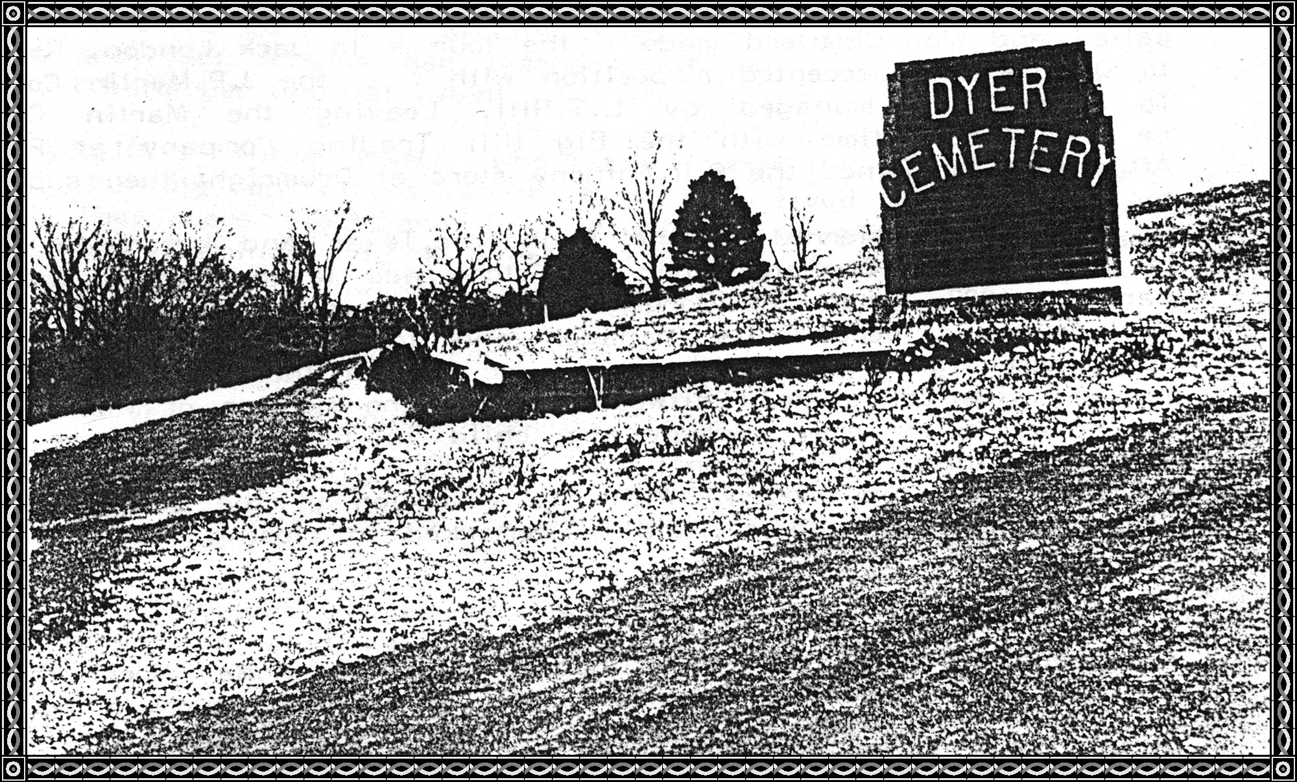

***[Editor's note: The above image is original with this book as compiled by Alma Lorena Moss Lancaster.***

***This next image was taken by Thomas Irl Lancaster on Friday, 07 May 2010.]***

**Entrance sign to Dyer Cemetery, Dyer, Crawford County, Arkansas**

**The Good Old Days**

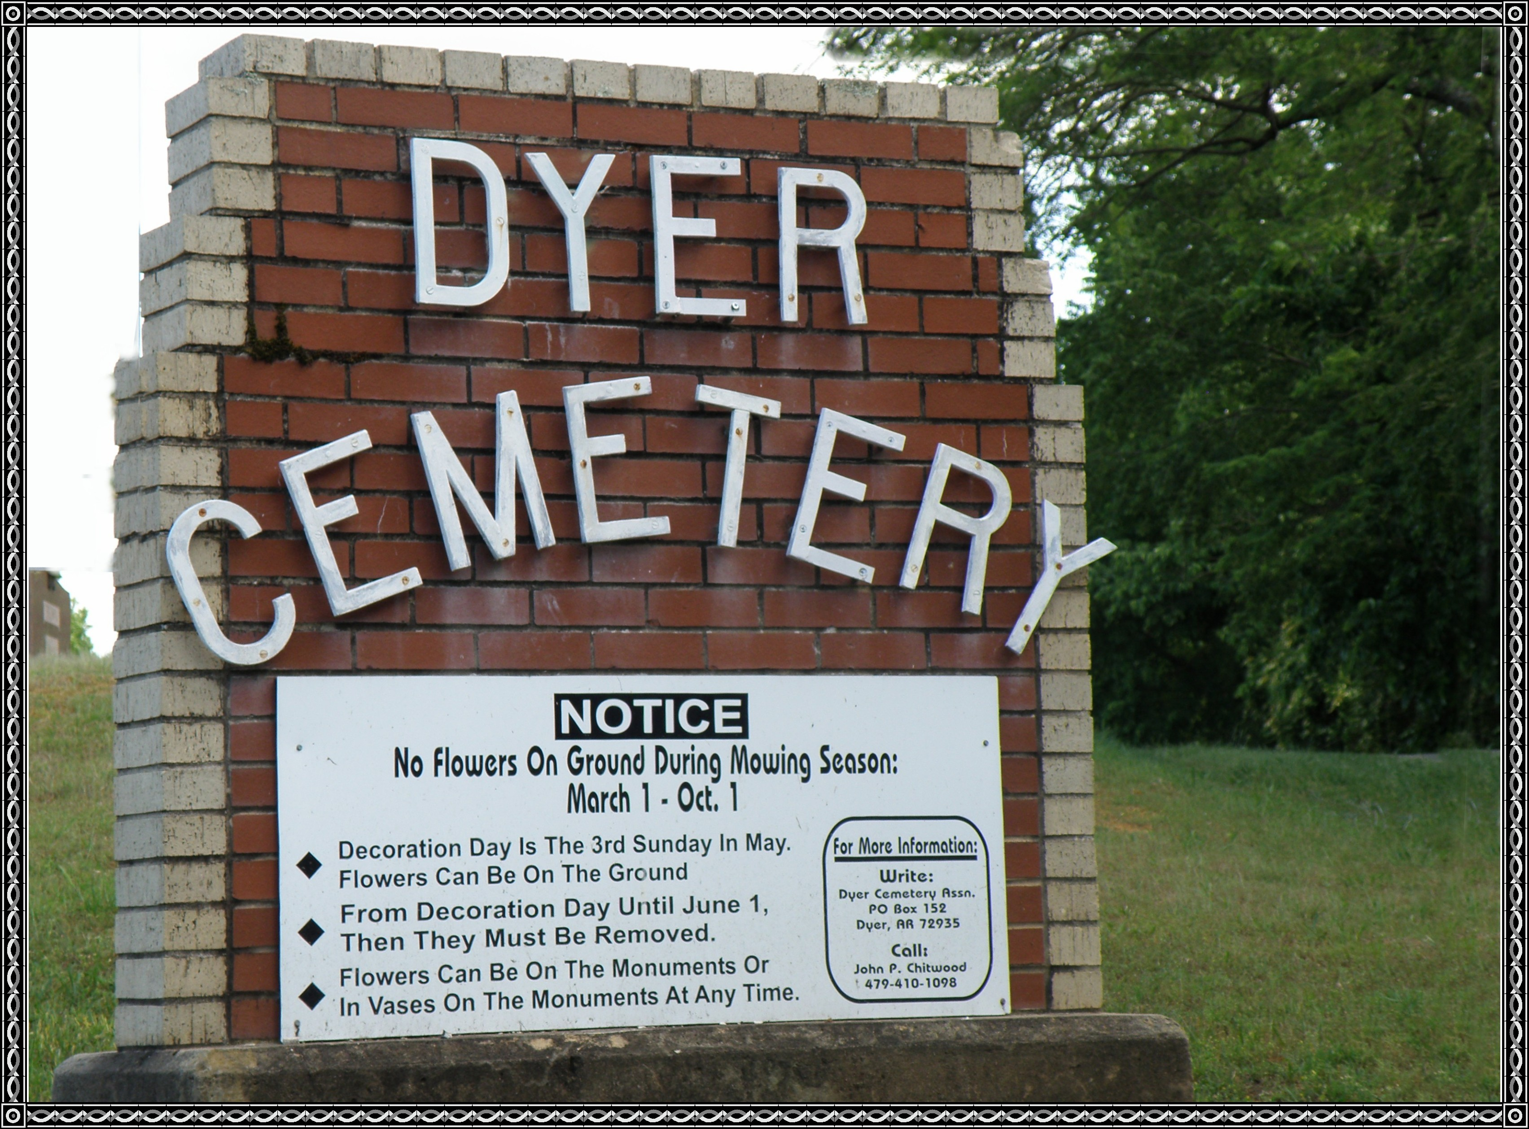

(This is taken from an article written by Jack Gulledge)

Lots of people are looking backward these days. Nostalgia is in. TV Programs, movies, Books recall a simpler time. What one of us hasn't uttered the poet's words:

Backward, turn backward,

O, Time in your flight,

Make me a child again

Just for tonight."

Everything seemed happier then. No locks on doors, food in the garden. Hand-me-down clothes for another year even if they didn't fit, and the radio entertained us with Kate Smith singing, "When the moon comes over the mountain." Major Boles Amateur Hour and the Lum and Abner at the Jot-Em-Down store.

With all the delights of nostalgia, the danger is being so sold on yesterday THAT we neglect to use today and PLAN for tomorrow.

**People Who Have Called Dyer Home**

**May 1, 1930: Paragraph Portrait No. III**

Mr. **Joe Chitwood**, manager of the L. T. Hill store at Borger, Texas, first saw the light of day at Dyer, Arkansas, on December 28, 1893. Dyer is about 20 miles Northeast of Fort Smith and Mr. Chitwood remained in that vicinity until young manhood. After completing the Public School system, he attended the Arkansas State Agricultural College at Russellville, Arkansas, for two years. Indeed it was not until he reached the age of twenty-one that he forsook his studies and emigrated into Oklahoma with his parents as merchants.

In 1916 he moved to Eufaula, Oklahoma, and entered the store for Dunlap Brothers and he also saw service in a store owned by this company in McAlester, Muskogee, and Cleveland. At that time California called, and Mr. Chitwood made the tour a la Jack London. Returning to Oklahoma he accepted a position with the J. P. Martin Company. To Hominy, Oklahoma, and managed by L. T. Hill. Leaving the Martin Company he was for a time with the Big Hill Trading Company at Fairfax, Osage County, Oklahoma. After that he joined the C. R. Anthony store at Drumright, Creek and Payne counties, Oklahoma, then supervised by L. T. Hill.

He was transferred to the Panhandle, Texas, and became a member of the L. T. Hill Company when the store was taken over in the early part of 1927. When the Borger store was opened a few months later, Mr. Chitwood became its manager and to quote his own words, "Is still there fighting then in the wonder city of the oil world." It would be an injustice to Mr. Chitwood to make no mention of the fact that he knows every man, woman, and child in Borger and there is not a one of them who doesn't call him "JOE". Incidentally, Joe can call them by name in return. With the exception of the Grand Jury, Mr. Chitwood has no hobbies...and he remarked in closing that he doesn't like dogs.

"Yes, Virginia, there are still honest people." Anna Morrison Bluff lost $220 dollars while shopping in Fort Smith. On returning home she received a call from Cuba Leakey of Dyer. She had found the money with name on the envelope and was calling to return it.

Some writer from Fayetteville came to Dyer a few years ago to locate kinfolk of Jim Renfroe to write a movie on him. They asked "Did he do all the things we have heard that he did?" The answer was, "Yes, and probably did more than you heard about."

Another time some writers came to Dyer hunting where Johnny Cash was born. This was a mistake for he was born at Dyess, Mississippi County, Arkansas, instead of Dyer, Arkansas.

Clay Cottrell of Dyer, Arkansas, belonged to the Fort Smith Twins Knot Hole   
Gang.

**1986**: Cottrell ran across his membership card for 1925 which has been 61 years ago.

The kids cheered for Twin victories in professional baseball at Andrews Field.

Members had to agree not to skip school to attend a game, attend no game against the wishes of parents or employer, uphold the principles of clean speech, sports and habits; stand with the rest of the Gang against cigarettes and profane language; and not engage in unruly conduct. The card was signed by Blake Harper, president.

**December 13, 1928: Mrs. T. W. Moss: *[aka Dora Belle Haydon Moss]***

Dear Mrs. Moss: Congratulations. Yours was the best story sent into the Christmas Seals, and we take pleasure in enclosing our check for $25.00. Your story will be run in the ***Arkansas Gazette*** and next fall we will reprint the story in leaflet form.

**Fannie Lou Bennett Spelce** of Austin, Texas, formerly of Dyer, Arkansas, has received National recognition for her primitive art style and is frequently compared to Grandma Moses. She is now 70 years old ***[Editor's note: born 1908 + 70 = 1978]*** and began her new career at age 59. Many of her Paintings are of her "growing up" days around Dyer, her home town. When she went to seek art lessons, her teacher told her to go home, lessons would just harm her unusual talent.

**October 25, 1979**: Three women who were born in Dyer were back visiting, hunting up places where they had lived, and seeing old friends. They were Viola and Lois Flemings, daughter of Boss and Abbie Loomis Flemings, and a cousin of theirs, Susie Flemings, who was a daughter of Will and Belle Johnson Flemings.

**1985**: Mr. and Mrs. Herman Porter of Dyer went back to Tennessee to help erect a marker of their ancestor's grave site after nearly one hundred years, Mary Louise McGimsey Porter.

**1859**: The Chitwoods, Hills, Taylors, and Rogers came to Georgia Ridge from Georgia and later moved to Dyer where their children attended school.

In **1888** Will Kurkendall lived in the house on the River Road south of the railroad on what we remember as the Sweeney or Sam Stephens home site.

Raymond Koiser has opened up a new business in Dyer. He has rented Roe Cottrell building formerly used as a barber shop.

In July a contest in dress making was held under the direction of Miss Gore. Prizes donated by merchants of Van Buren. Awards were as follows: Those from Dyer were: Best house dress, 2nd Mrs. H. A. Bennett, and 3rd was Mrs. D. C. Cottrell.

**October 1954**: Sunday is Layman's Day in the Methodist Church and the selected speaker at Dyer will be Charlie Moss of Fort Smith. He was born at Dyer, a former resident at Alma, as well as Superintendent of the Alma High School.

I received a letter from Tennessee Meadors Patrick who lives in Fort Smith and was born at Dyer. In her letter was a copy of Lifeline from the First Baptist Church located at 1400 NE Street. In the Bulletin was a picture of Tennessee and her husband, Carl Patrick under which said, "We thank God for Carl and Tennessee Patrick who have served Jesus Christ faithfully for 22 years as Directors and as workers in the preschool division." She added these words to the article: "Thought you might like this as you well know my church training was begun in the Methodist Church at Dyer at a very early age."

**1908: Hopper-Malone**

At the home of the bride's parents, Mr. and Mrs. J. M. Malone, near Dyer, on last Sunday evening at five o'clock, J. Matthew Hopper was married to Miss Rose Belle Malone. Rev. Horton, pastor of the M. E. Church at Mulberry, officiating ***[M. E. Church aka Methodist Episcopal Church].***

Mr. Hopper until recently had been engaged in the street car service at Fort Smith but will later have charge of the Depot office at Dyer. He is quite talented and is a nice Christian gentleman.

Miss Malone is a most affable young lady, possessing that trait of character that makes one feel better by having met her.

Quite a number of relatives and friends were present to which was served a most excellent supper.

This was one of the prettiest home weddings that has ever taken place in this neighborhood and was a real social feast.

**The Buffalo Club**

The Buffalo Club was organized June 1, 1913, with six charter members named as follows: Shelton Chastain, George Henson, Vance Moss, Garland Ayres, Raymond Wright, and Tommie Moss. A Constitution and By-Laws were drafted by a Committee and adopted. They had a password, signs, secret meetings, degrees, and the following officers: President, Garland Ayres; Vice President, Shelton Chastain; Secretary, George Henson; Treasurer, Vance Moss; Chaplain, Raymond Wright; Sergeant at Arms, Tommie Moss.

The aim of the organization, first, last, and always is the uplift of social conditions and a bright pure view of life, Exalted ideals to strive for, with the means being by reading, study, conversation, etc. Recreation shall be of the best order both in literature, music, dramatics, and physical culture. Have a questionnaire for membership.