**The Old Valley School House, Sketch of**

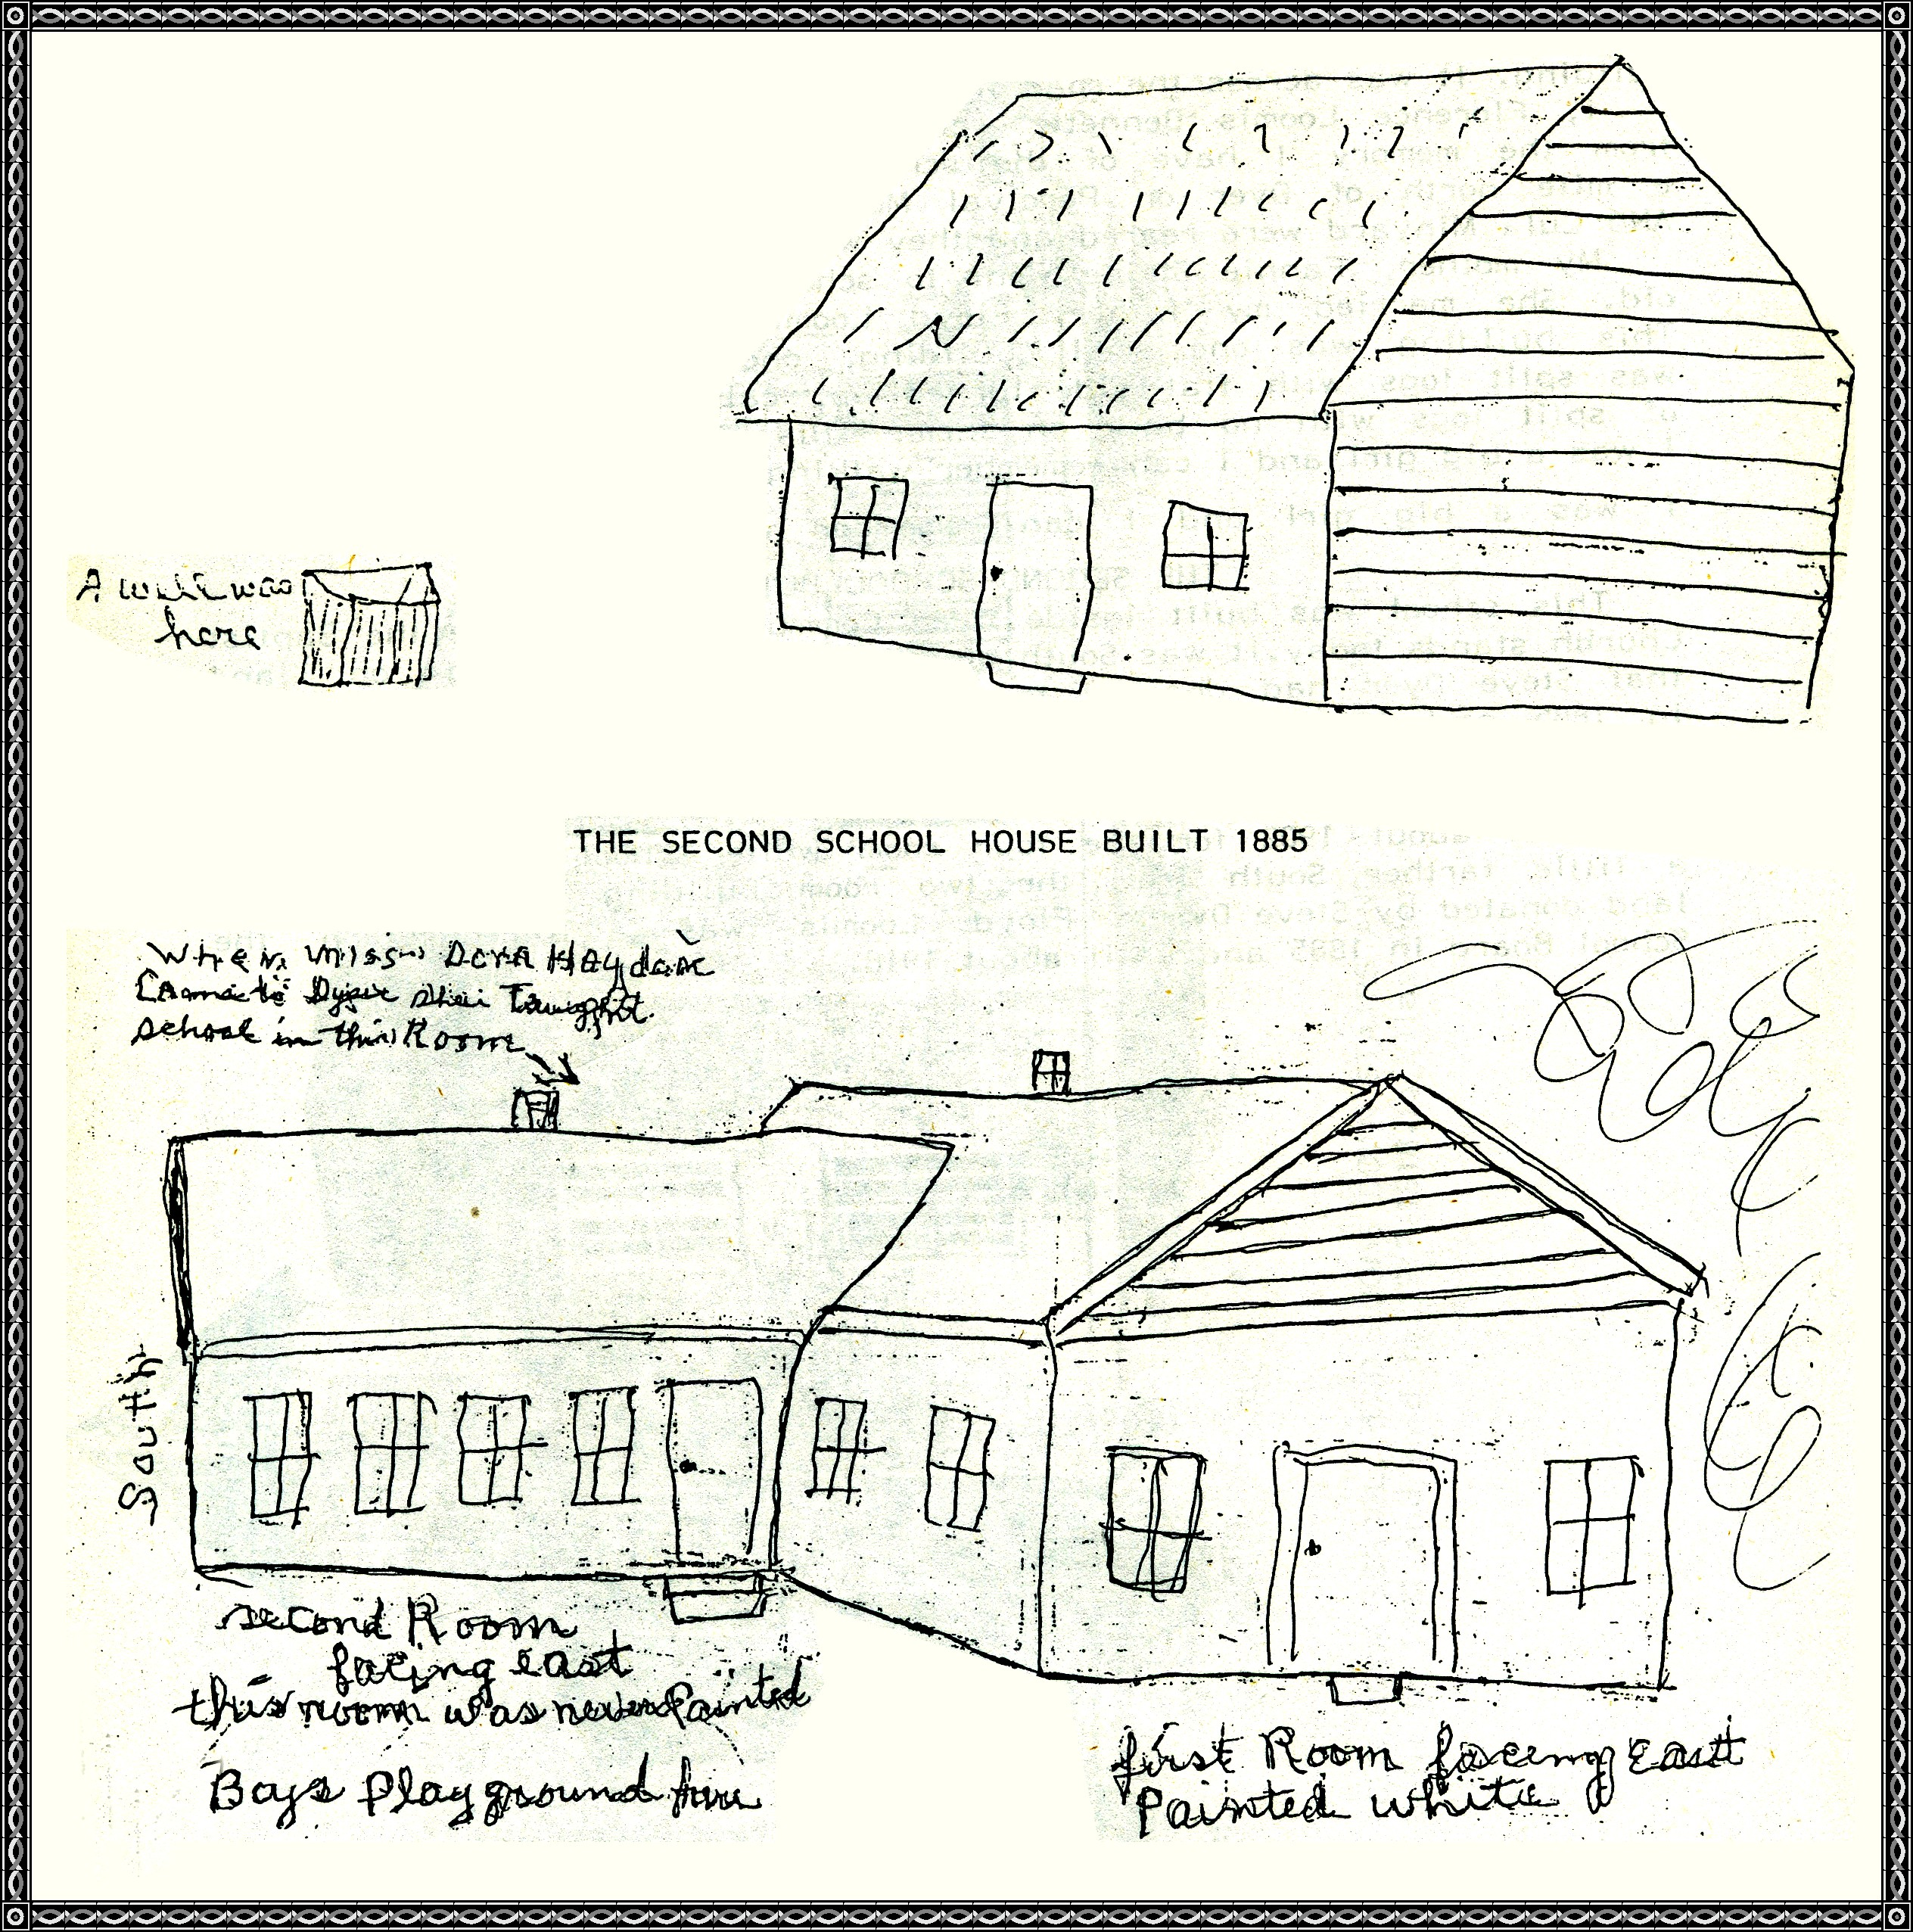

**Translations**: A well was here ~ When Miss Dora Haydon came to Dyer, she taught school in this room ~ South ~ Second room, facing East, this room was never painted ~ Boy's playground here ~ first Room facing East, painted white.

**This Is The Old Valley School House**

By Florence Loomis Bennett

This looks exactly as I remember when I saw it and walked in the building. It was across the road from the Perserved Morse home.

I, Florence Loomis Bennett, write this as my mother told me also from the memory I have of the school house. It was located 3/4 of a mile north of Dyer on the Percival Morse place where Lige, Dave, Sam, and Lula Minyard were reared, and they went to school here also.

My mother, Fannie Strine, went to school in 1867, she was 6 years old. She married my father, Floyd Loomis, from New York in 1879. This building was one small building, one room built of logs, floor was split logs with flat side turned up, called puncheon floor. Seats of split logs with no back on them. This building stood there until I was a big girl, and I can remember walking to this school.

**1885: The Second School Building**

This school was built inside the Dyer Community near where the Baptist Church stands today. It was South of the Church building on land that Steve Dyer had donated to the school and Church. It was built in 1885 and later another room was added to it on the South side of school. It was sold to Herbert Cravens, and he built the house that we know as the Tom James home.

**1902: The Four Room White School**

This was about 1902 for the four room white school which was built just a little farther South from the two room building but still on the land donated by Steve Dyer. Floyd Loomis was a Director on the School Board in 1885 and until about 1918.

**The Four Room School**

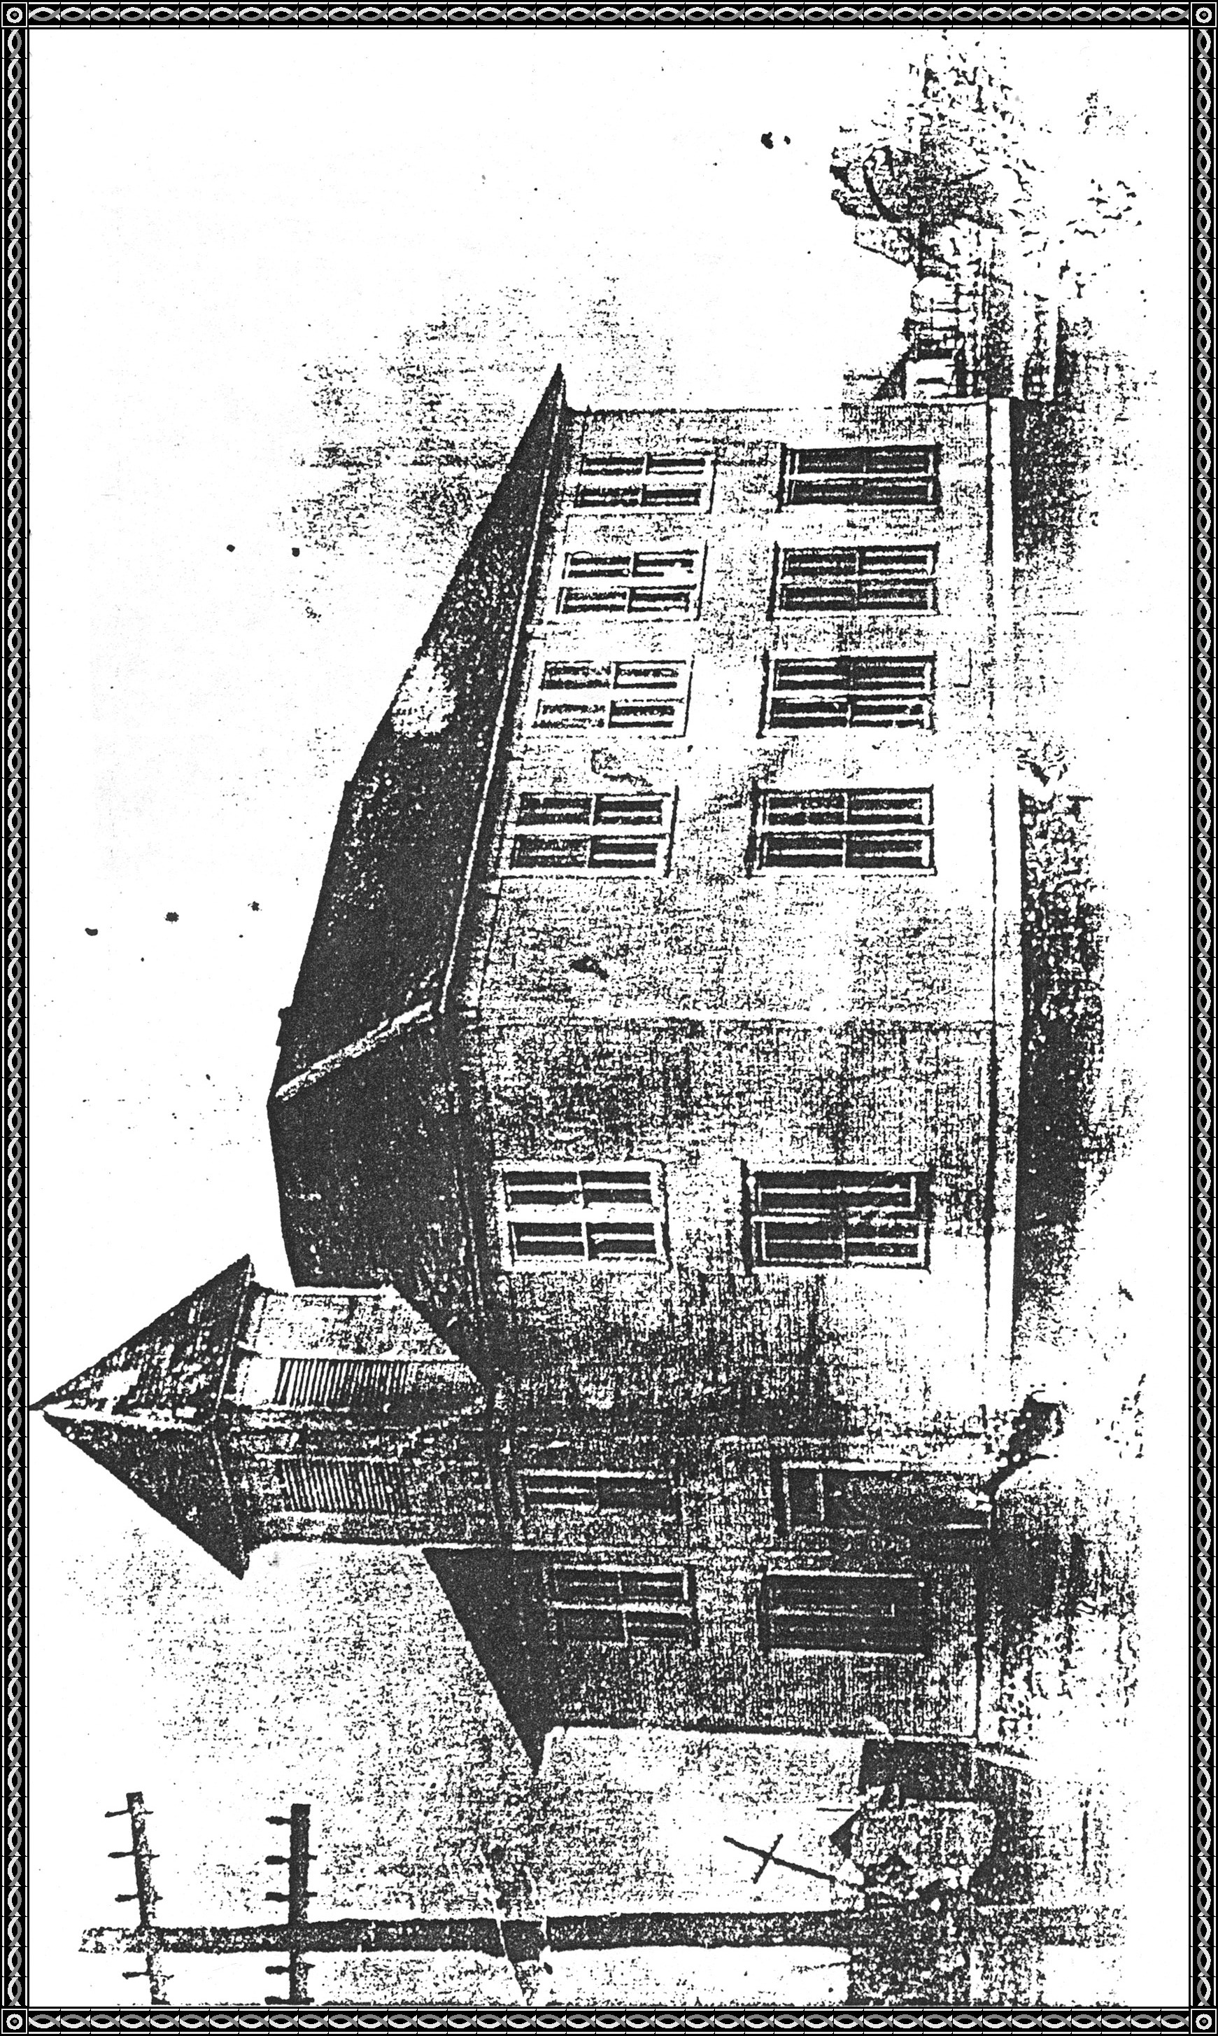

**THE FOUR ROOM SCHOOL, TWO ROOMS DOWN STAIRS AND TWO ROOMS, UP-STAIRS.**

**Built in 1902 and sold in 1917-1918 to Vilas Manuel.**

**1917: The Brick School House**

