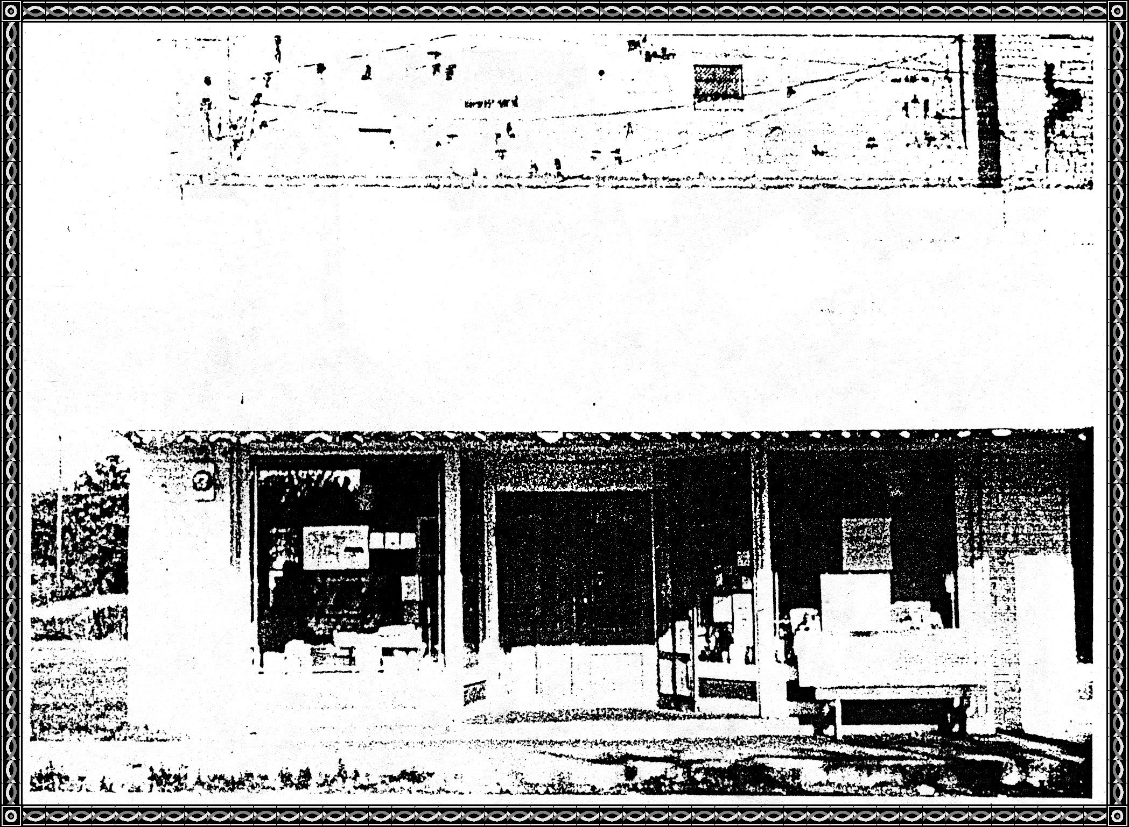

**Our Little Country Store**

This little country store of ours:

That stands in Dyer town;

Isn't just a quick run stop;

Or a place to fool around,

But it's a part of all of us;

And means so much more,

Than just a closer place to shop -

Or another Grocery Store!

Inside those double doors;

You'll find your choice of food;

You'll also find the nicest folks;

And they aren't ever rude!

They always have a pleasant word;

A smile, a hint of cheer;

Their special way of showing you

That they do really care!

Of all the places I have gone,

And all the folk that I have known

Non can compare in any way,

With that little store that stands today

"In the Heart of Dyer Town."

**Dedicated to: Rhodes Grocery in Dyer**

**News From Rhodes Grocery**

By

Virginia Rhodes

Ten years have passed and a lot of "fishing, gardening, farming, and tall tales" have taken place in the store. During this time we have had several emergency calls and will share one with you that ended great.

One cold morning Frank received a call from Judy Moore to come and help her get a new born calf from the bank of their pond. When he arrived he found Judy out in the pond holding the baby calf out of the water, and she was stuck in the mud. Frank rescued both Judy and the calf from the cold water.

Frank and I made history the past year by closing the store a few days so we both could be with our daughter, Jaynee, and family in Tampa, Florida. We have one granddaughter, Kristie, and two twin grandsons, Nicholas and Jeremy. At this time we would like to thank our customers for being so happy and understanding for us to visit our children.

Can you believe we have been in business for forty years? During this time, it has been a pleasure to see children grow up and now their children are our customers. When we look back we realize that we both are growing older. Jerry Moore was a young man when he helped us in the store and now his son, Jerry, is working for us.

In the last ten years we have lost and missed several of our loved senior citizens including my father known as Grandpa Kamm to everyone.

Mother, Stella Kamm, is 89 years old and is doing great. She cooks, bakes, and keeps house as always. Frank's mother, Bonnie Rhodes still stays busy doing needle work and growing flowers.

Again we want to say that we are thankful for our friends and out little Community. Also for old friends who take the time out to stop by the store and say, "Hello." The Lord has been good to us and we love you all.

May we see you again in three years for Dyer's 100th birthday in 1989.

Frank and Virginia Rhodes

**Let's Open The Door To The Country Store**

And look at what we might find in the shelves, on the counter, and sitting on the floor beside the counter in a old Country store.

There would be the cracker barrel that men thought nothing about of raising the lid and helping themselves or of slicing off a bite of cheese that lay on the counter in a big round hoop. "Now, why with so much would a merchant mind a little bite for me?"

Then there was the "White Mule" or "Sow Belly" that was used to season a pot of turnip greens and pinto beans. And coffee came in the bean which was carried home and run through the coffee mill that every woman had hanging on her kitchen wall. SUGAR in a barrel and later in a large sack that was scooped out to whatever pounds a person wanted.

Pickles also came in a barrel as late as 1916, and the store had a "vinegary" smell when you entered the store.

Lard was in a large can and was dipped up into the needs of the customer. Eggs that were taken in trade were kept in a large wooden box with compartments for eggs and then sold. I remember that the train men would jump off the train and run to Daddy store and buy several dozen of eggs. Butter that was churned and molded by the housewife was traded for groceries and then resold.

Coal oil or kerosene was in a barrel with a pump so the kerosene could be pumped out into the coal oil can that every family had, about a gallon size. This was a necessity for lamps and starting fires or when someone cut a foot then you ran to the kerosene can and poured some over the cut. The merchants would stick a Irish potato over the spout of the can so it would not spill.

Such brands as Red Fox coffee, Arbuckle coffee, Garrett, Honest and Rooster snuff. Bull Durham tobacco. Lydia E. Pinkham which was the woman's medicine and someone said that it guaranteed to have a baby in every bottle, Black Draught, Chill Tonic, Calomel, Quinine, castor oil, Senna tea Leaves. ***[Senna tea leaves >>>]***

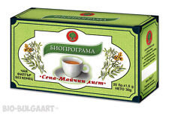

Nails in different sizes in nail kegs around a counter and later when kegs were empty they were used for the "loafers" to sit around the stove in the winter.

In show cases there would be Taffy Kisses, Licorice, Peppermint Candy sticks, Horehound sticks which was good for sore throats, Lemon Drops, and a hard candy that were colored and flavored in different flavors with designs on each piece, Penny Suckers, Jaw Breakers which were almost too large to hold in your mouth, and of course Chewing Gum.

In the clothing department you would find long black stockings and white ones for Sunday or summer. "Long Handle" underwear that were so difficult to put into those long stockings we wore or else you went to school with a "Goose egg" on the side of your leg High topped shoes that either laced or buttoned that you used a shoe button to fasten. And one must have overshoes for, in winter when it snowed or rained a lot, it would be MUDDY. Men stiff collars that were buttoned to the shirt. And handkerchiefs as we did not have Kleenex in those days; so at Christmas time one received a lot of handkerchiefs.

And the dry goods of percale, gingham, striped, and solid colors that mothers would buy in the fall to make up school clothes for the children. These materials sold for 10 cents a yard. Then there were ribbons to run through eyelets on camisoles, etc. Trimmings such as lace, bias tape, rick rack, elastic for garters to hold up those long stockings or put in legs of bloomers.

Curling irons to crimp the hair. Side and back combs to keep hair in place. White and black sewing threads, there were not many colors as we have today.

There was the five cent cigar, the 20 cent loaf of bread, and with the Prince Albert can of tobacco you were given a free package of cigarette papers and dried fruits in a wooden box with wax paper over the top and fruit was ladled out to the customer and those big chief tablets to write on in school and the cedar pencils and how big we felt when we were handed a nickel pencil. I read somewhere that the virgin forest were cut down to make the cedar pencils.

And also people could visit with their neighbors while shopping and learn who got "Hitched" and who had a baby and who had died.

Most of us can recall the store handling these products but then there are some that never saw the old country store.

***[Editor's note: At this point one or two sentences are so scrambled that I cannot translate correctly, to I am deleting these sentences.]***

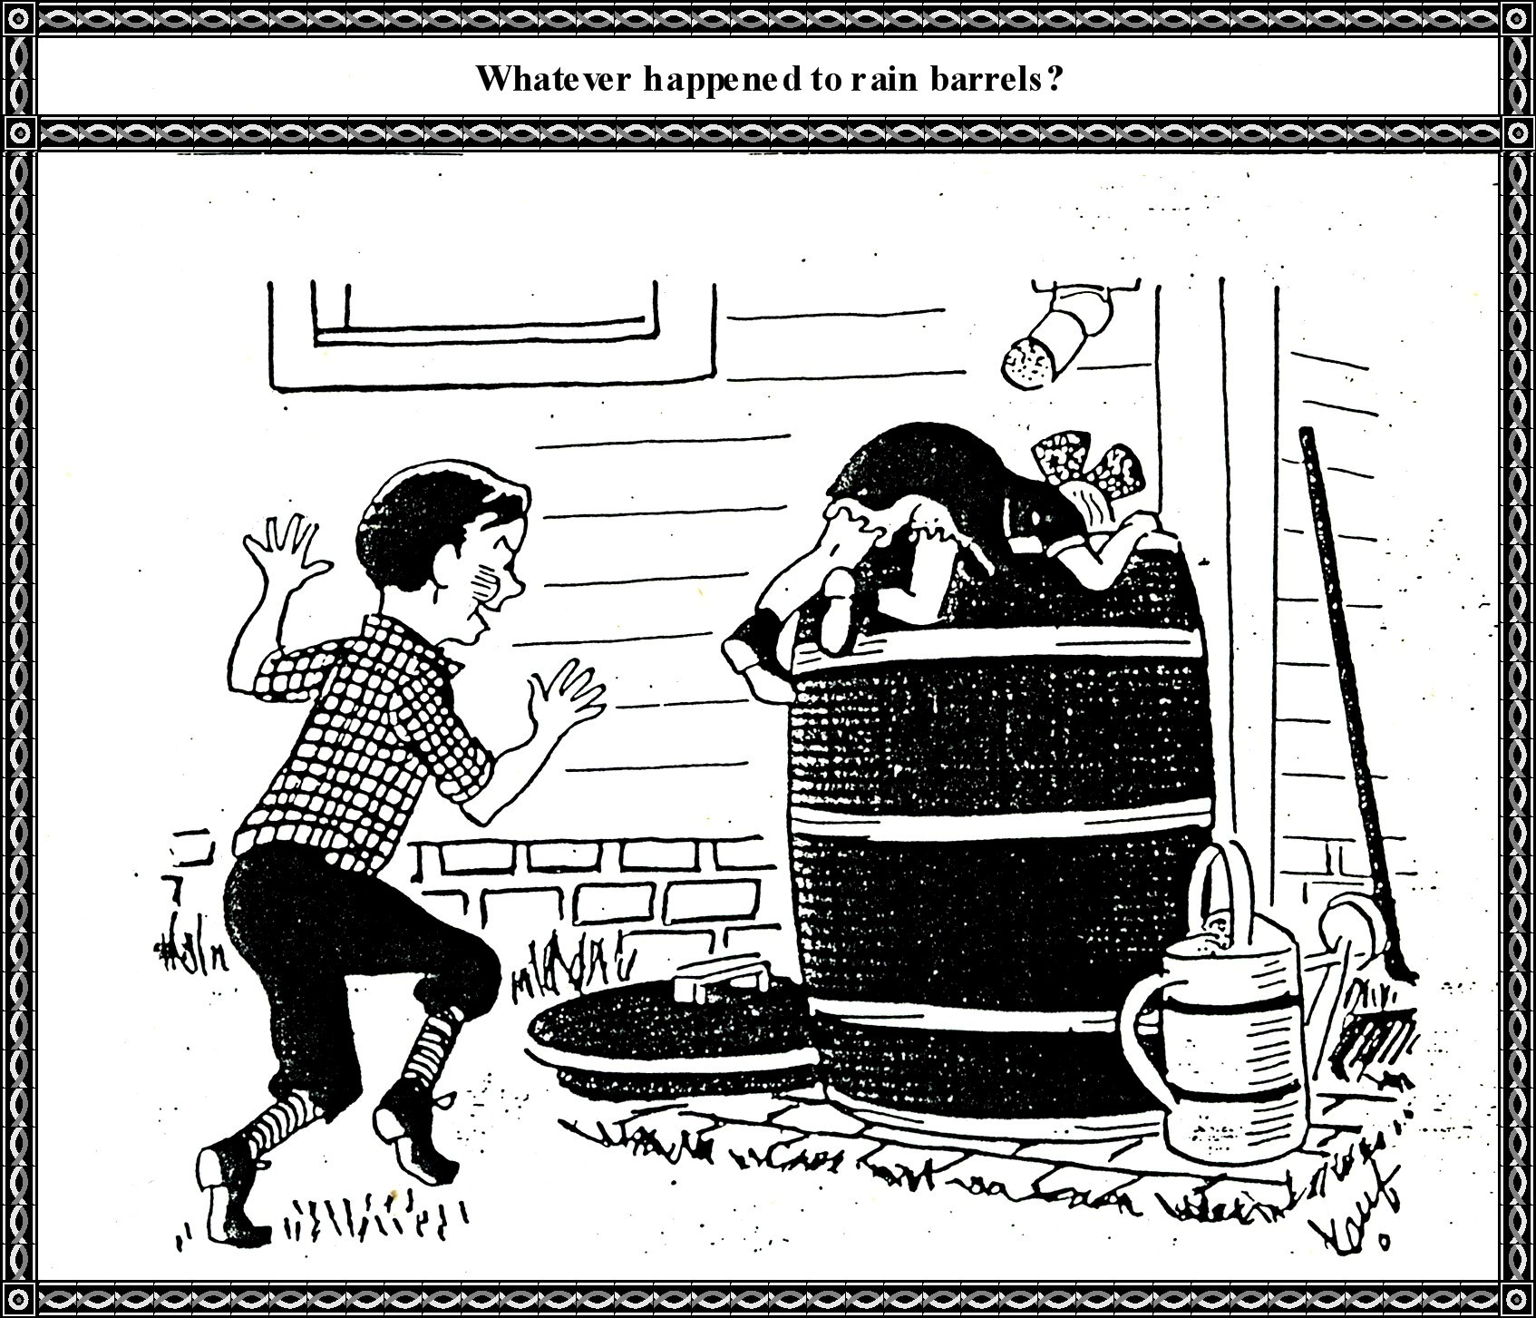

…that we liked to holler down in. "You can't holler down my rain barrel" so goes the song. Almost every family had one that sat under the downspout of the house. The water was used to wash clothes and your hair in for it was soft.

You could yell "Hoo-hooing" sounds and your voice would come back in a strange deep timbre.

**1927:** Thomas William Moss has returned to being a merchant after a few years out of the business, and he has a nice clean bill of goods. He has named his store, "The Economy Cash."

About **1930** Fred Arbuckle had a store in the middle store of the three still standing.

**1983:** Mary Lou Kelly put in a THRIFT STORE where Tuff Nelson's Barber Shop was located. Her slogan was:

"Bargains you will find and good clothes you will choose

When you shop with us at MARY LOU's."

**Bob Moss Weekly**

December 17, 1938 Moss Grocery Store

"DON'T BE ROBBED, SHOP WITH BOB"

Sockeye Salmon 24 cents Peanut Butter 25 cents

Sugar, 10 lbs 50 cents Great Northern Beans 5 cents a pound

Cranberries 16 cents per lbs Bacon 18 cents per lb.

Jell-O 5 cents Chops 35 cents a lb.

Oysters 11 cents

My! "How about them apples?" Thought you might like to look at these prices and compare prices of yesterday and today.

