WEATHER
March 12, 1914: Almost total eclipse of the moon at 12:20 P.M.
February 17, 1908: Arkansas River rising for the past 48 hours and may get high before it stops rising.
May 1928: The mail was brought to Mulberry and then carried across Little Mulberry in a small boat and picked up in a car and carried to Dyer. Van Duren was almost isolated and surrounded by water. Arkansas was the worst hit state in this flood. The St Francis, The Arkansas, and the Mississippi Rivers were the worst, and they inundated 6600 square acres of the state. 40,000 people were driven from their homes. 13% of the state was under water with a loss reported to be $14,936,00.
April 2, 1935: Arkansas River out its banks into cotton fields. Men are killing fish with clubs that have come in with the flood waters. Dick Leakey's son killed a 15 pound fish in Charley Moss's cotton field.
1943: River overflowed and flood washed out the South approach to the Van Buren bridge. After the rampaging river had subsided, the bridge stands isolated from the Highway which carries U. S. 71 and 64 North. After the raging waters had gouged out a hole 20 feet deep and more than 100 feet long, carrying out a long slab of pavement.
The Frisco railroad Bridge at Van Buren subsided into the Arkansas River late Friday after the flood washed out its support blocks and from Fort Smith side was also washed away.
Dyer Sustained Damages In Nation Wide Storm
March 1956: Dyer was a turmoil of excitement over the weekend as people and cars filled with sightseers milled in and out of the town continuously all Saturday and Sunday viewing the wreckage of the disaster which struck in the Community about midnight Friday the 24th. The storm which contained very little rain did its damage in hurry, sweeping a clean path Eastward.
The Hays Hurd home was destroyed before the eyes of the family who becoming frightened had gotten into their car to get out of the area. The wind twisted the car around into tree. neither they or the two children were hurt.
Just in front of the Hurd place stood the Assembly of God Church just completed last summer. J. S. Edwards who was pastor of the Church and who lives next door in the parsonage was preparing with his wife and children to go over into the new constructed building of concrete for more protection when the twister struck and blew IT apart. Rev Edwards said later, "The only reason I was not in the Church was that I could not find my shoes".
Another family who missed death and injury was that of Dewey Morse whose home is located East of the Assembly of God Church. He and eight persons were huddled in their home as the howling wind picked up and dropped the house off the foundation. They said the newly constructed room recently added to their home on the East side was what saved their lives.
Barns were destroyed and large trees were blown down, chicken houses scattered, and debris was strewn all over.
The home of Edd Isaac was raised about 3 inches of the foundation and the South side and dishes were broken, the deep freeze was picked up from the smoke house and moved to the yard.
The homes of Claude Hatley and Bob Hankins were badly damaged. The roof was blown from house of Fayette Peevy and part has not been found. A barn belonging to Rosson and one belonging to Roden.
The Fish Cove
Located On Highway 64
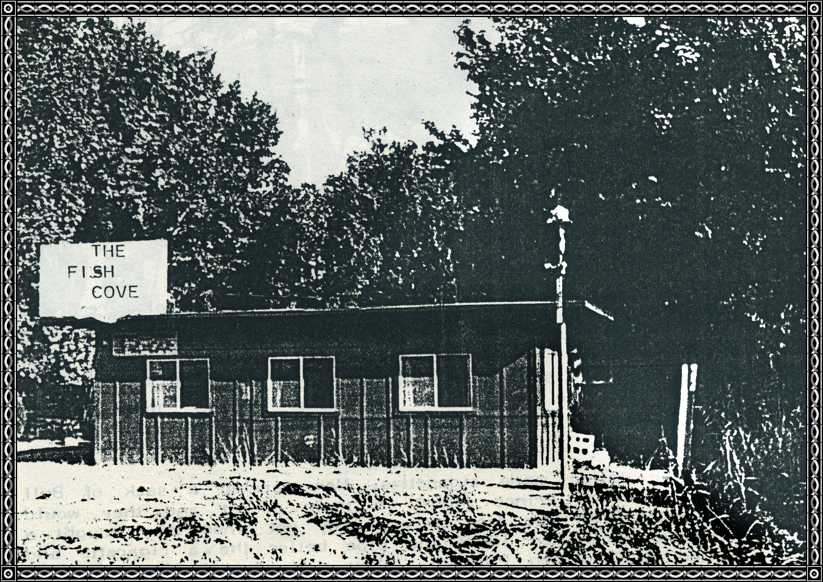
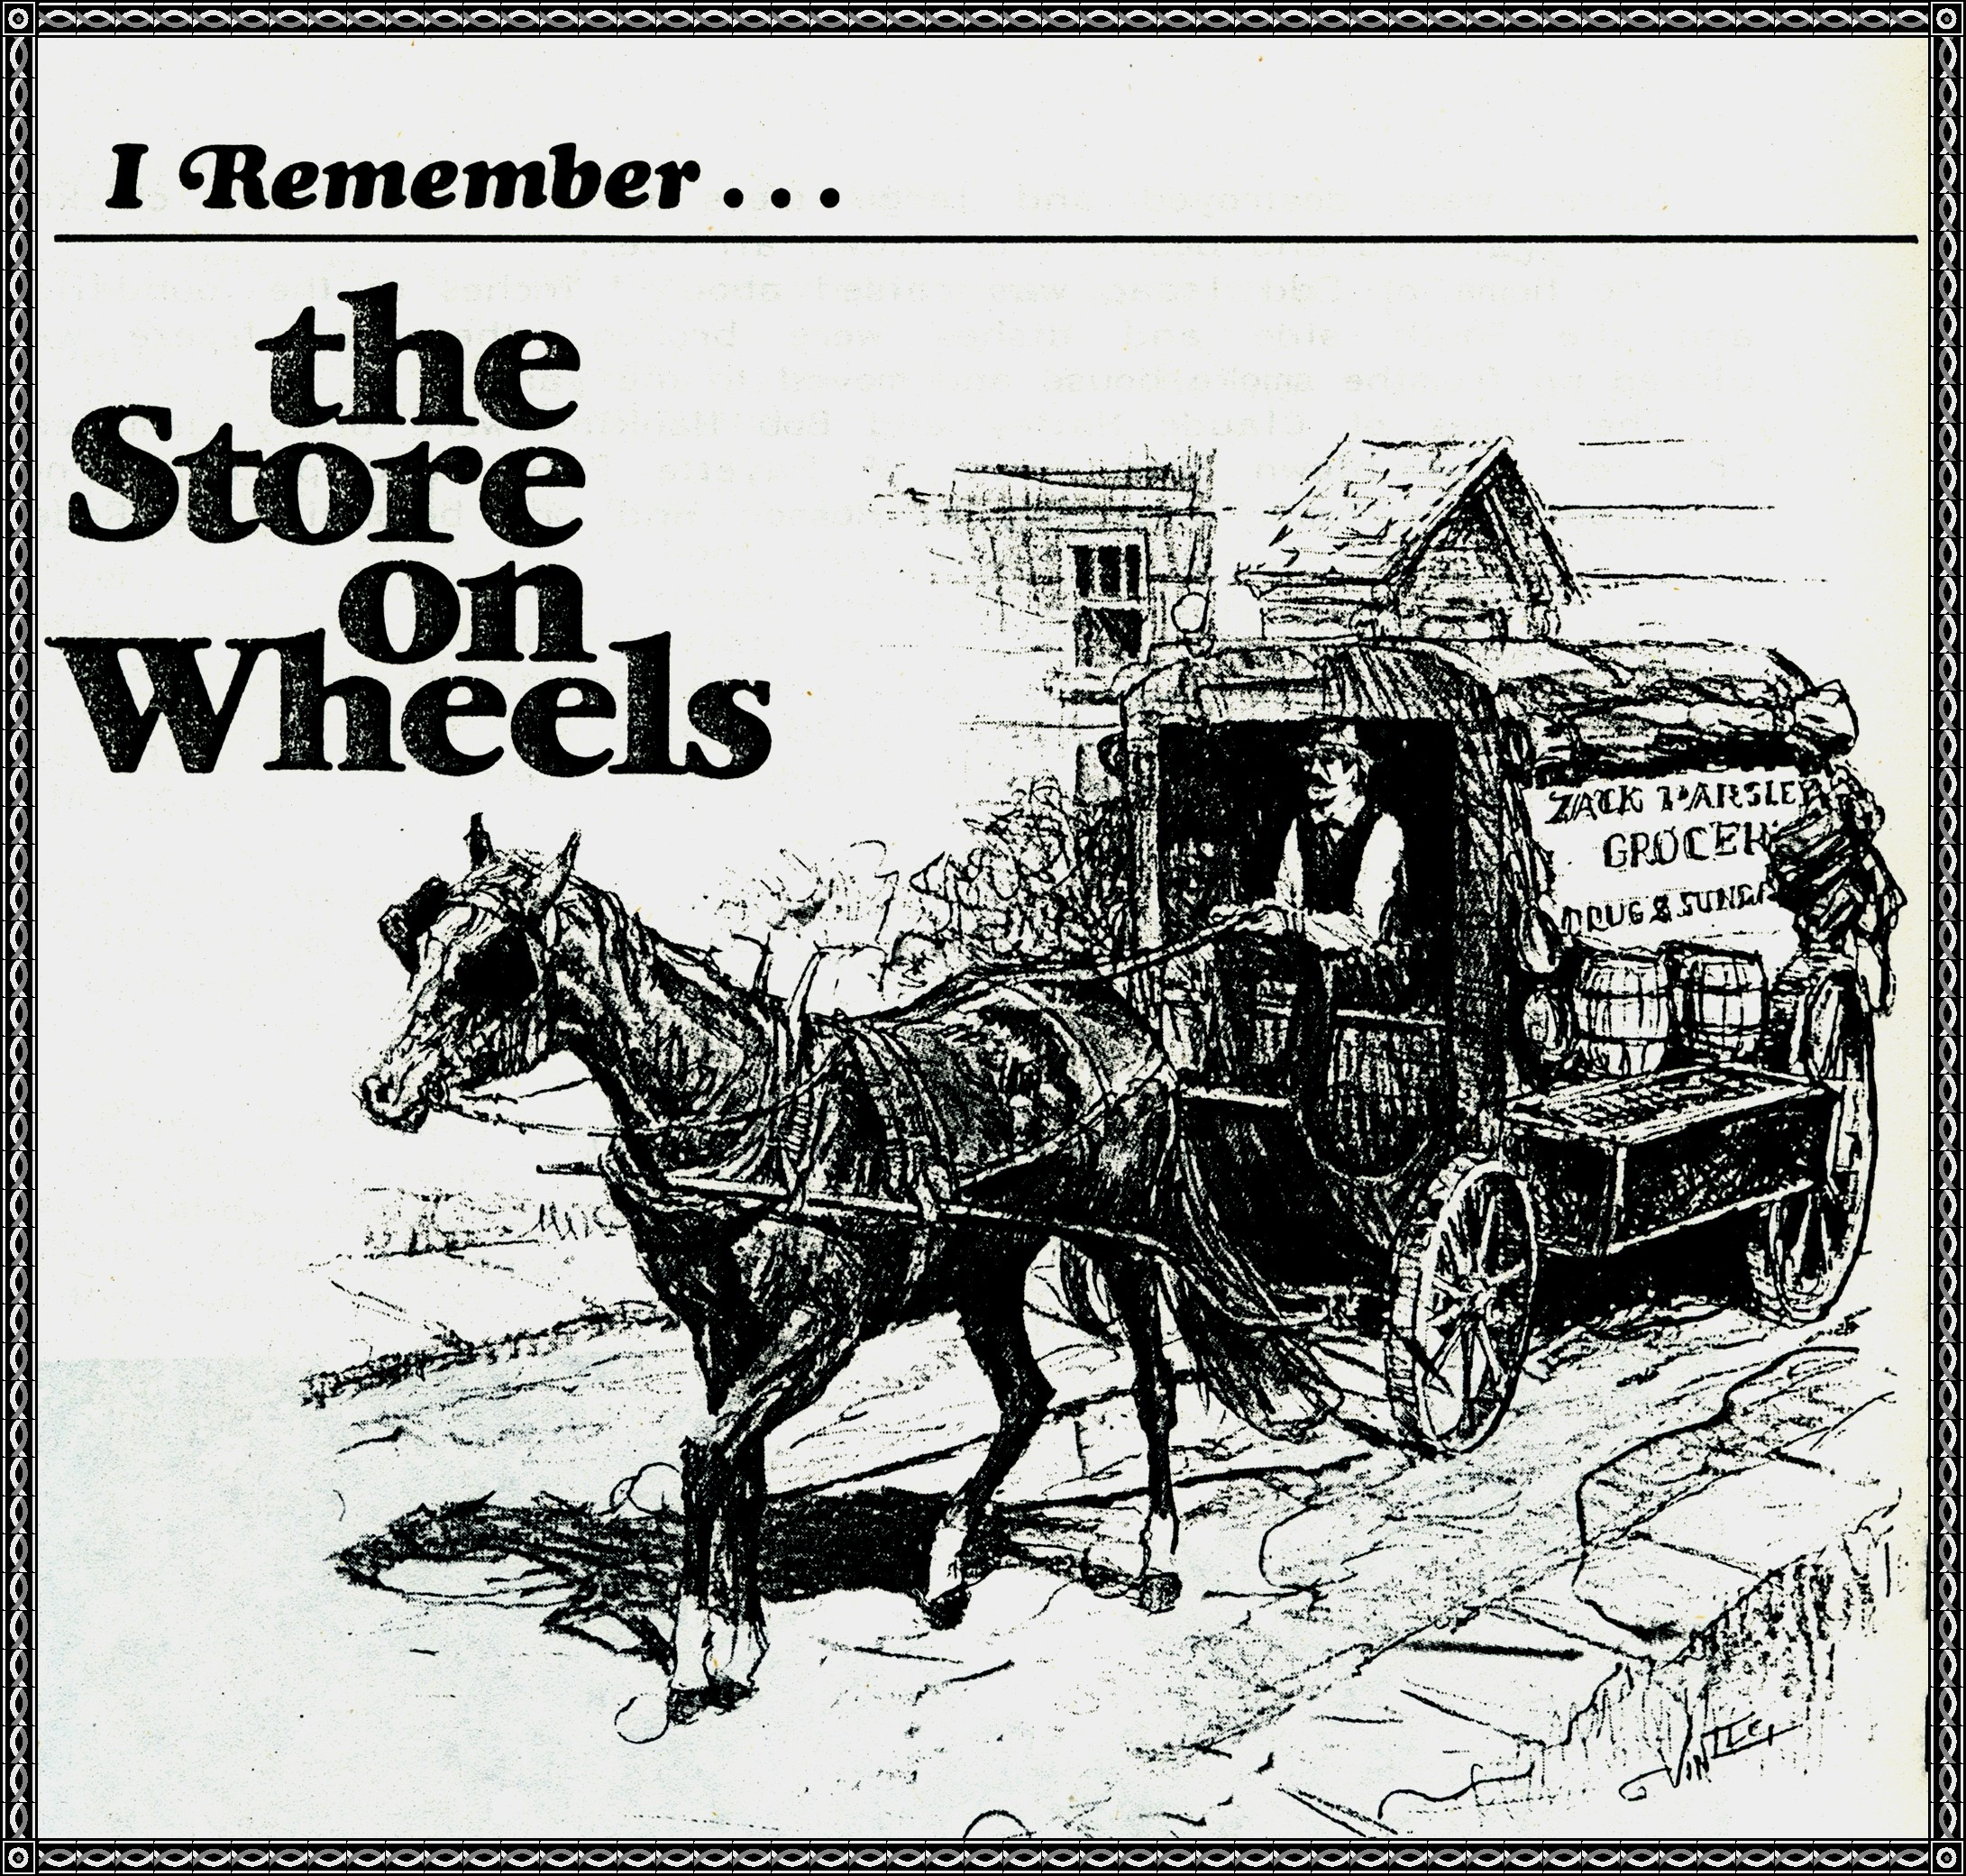
We did not have this store on wheels but it also reminded me of the men who came around with dress goods and pans and other household goods for people to buy.
THE BUGGY WHIP that stood within a holder on the front side of the buggy and the driver would give the horse a "tap" to make him pick up speed.
The Pipe
There were no tailor made cigarettes. Men carried a sack of Bull Durham or a can of Prince Albert in their pocket and they would roll a cigarette with the free papers they got when they bought a can of tobacco. Some men liked the pipe better than a cigarette, and many smoked a Corn Cob Pipe that they made for they could "toss" this pipe when it began to smell but they always had a Briar pipe for Best. And the young boys would slip out behind the barn and smoke: Corn silks, rabbit tobacco, or grape vine. Yep, I know about those. Old women sat in the corner and smoked a pipe.
John William Moss and Sons, General Merchandise
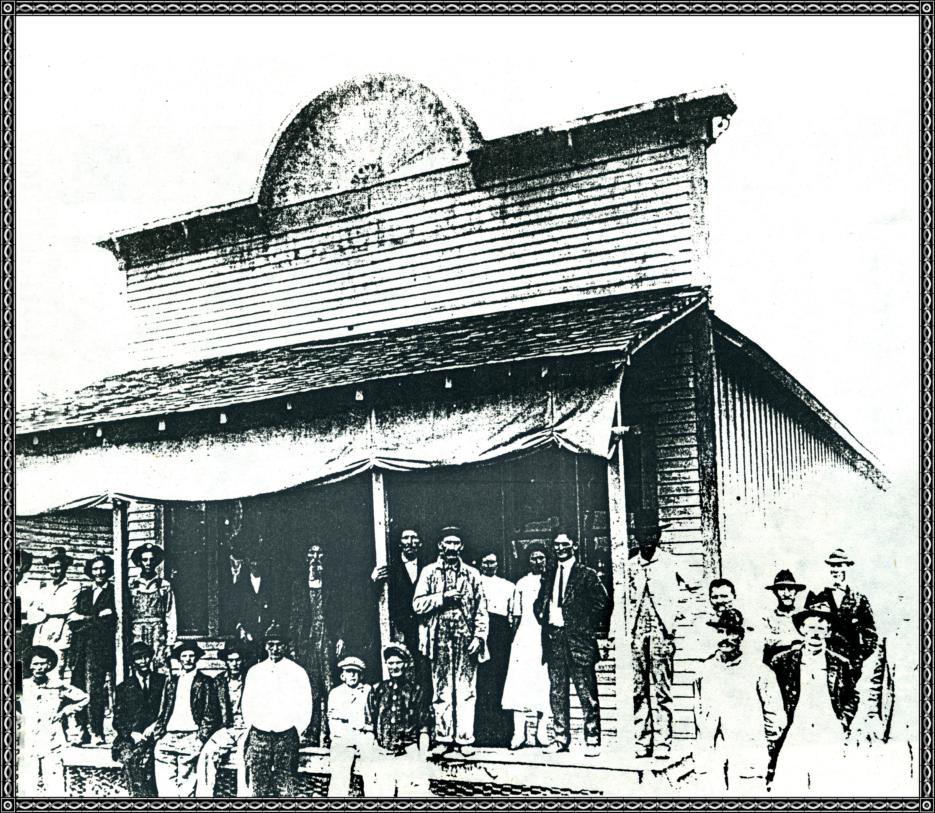

T. J. James, General Merchandise
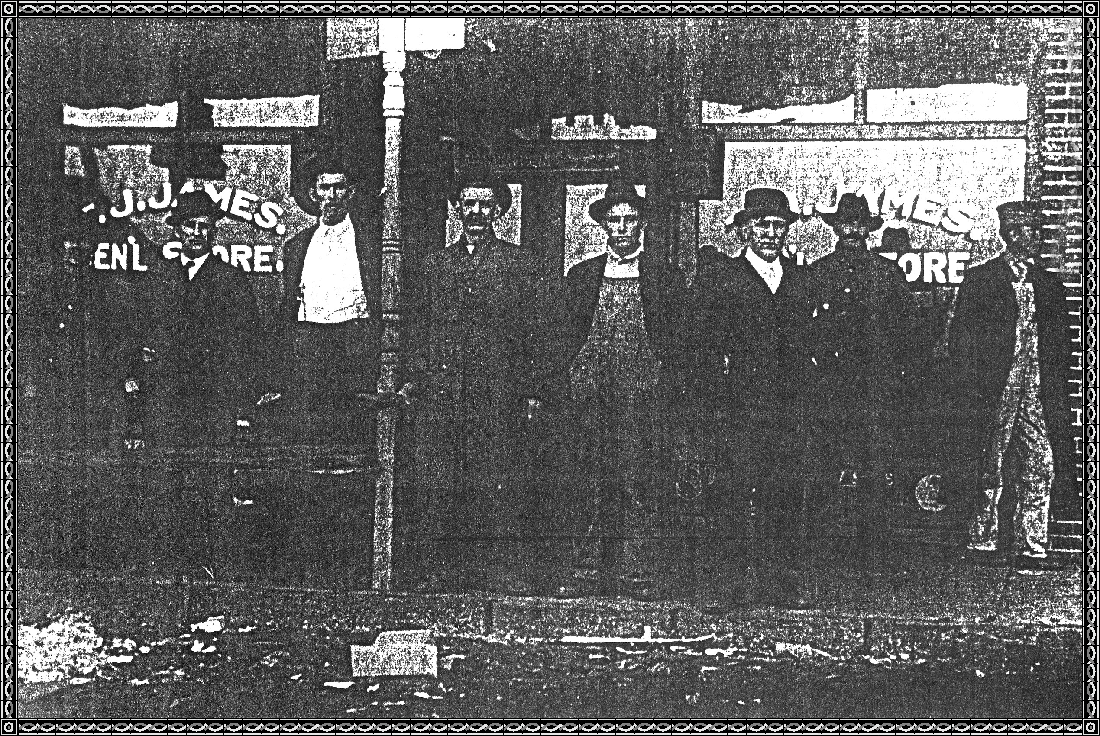

Marset Bennett Harve Chastain Dick Heard
Bill James Tom James Charlie Moss
Dick Wells

Willis Mason's Confectionary
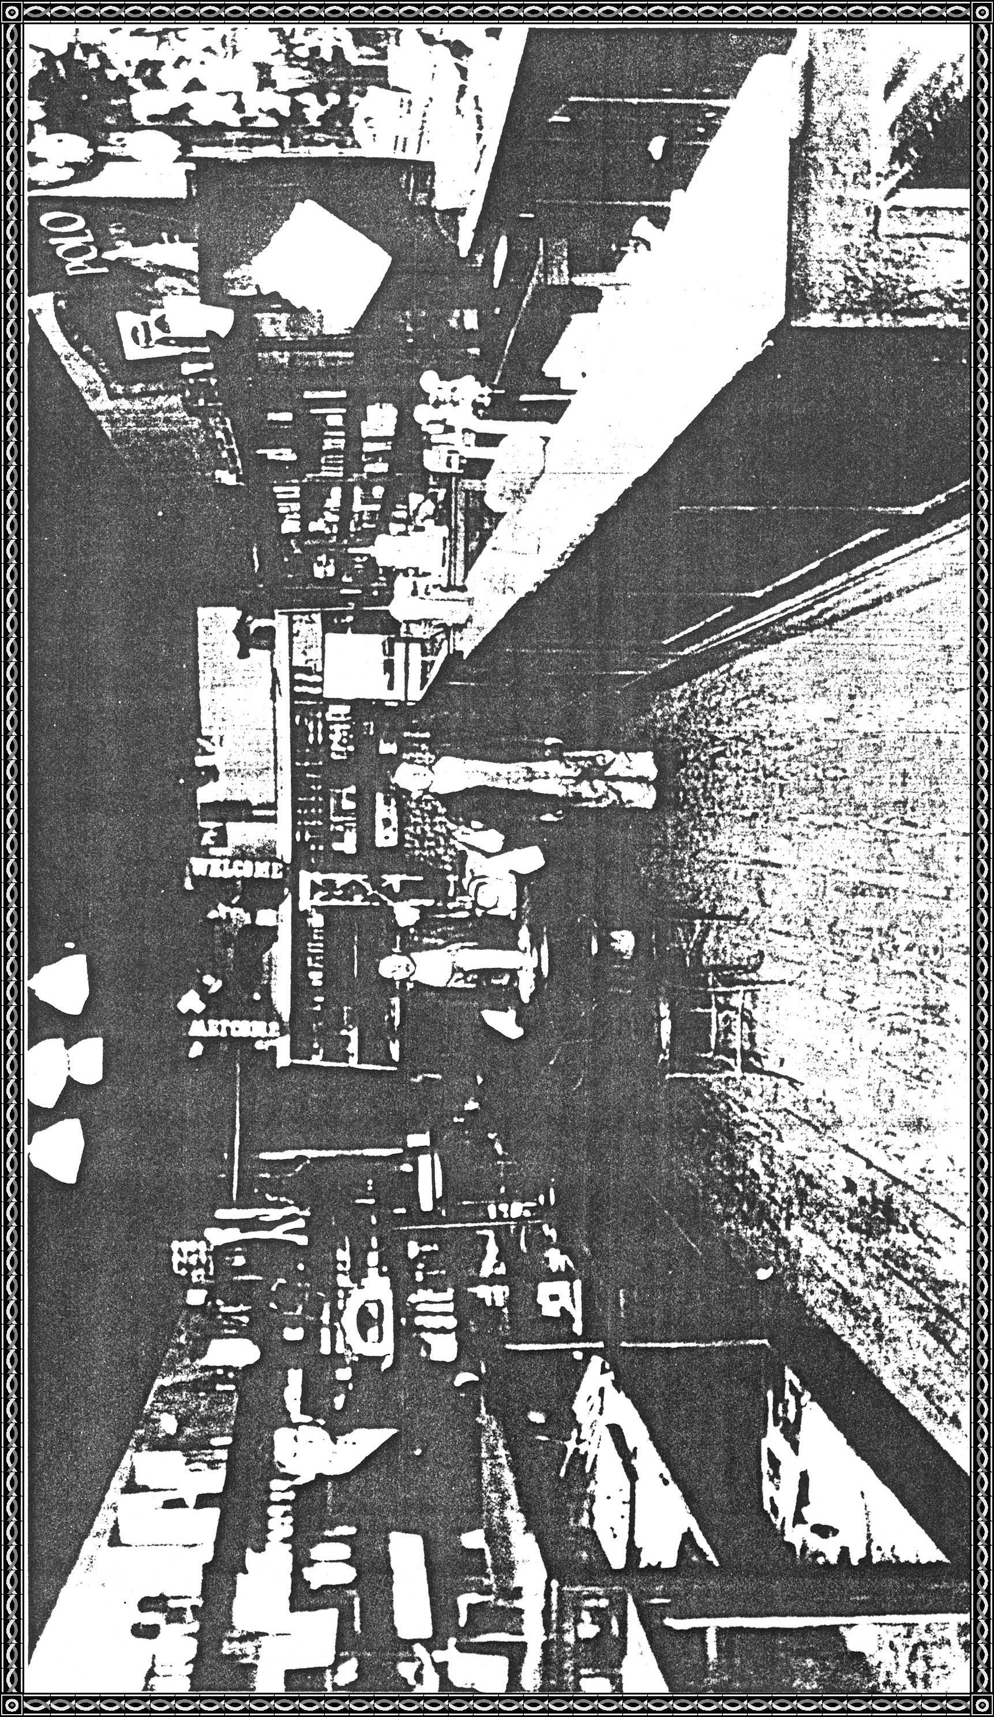

This store was to the East of Aldridge's home near the sidewalk. Mr. Mason is standing behind the counter. Wish we knew who the two boys were standing beside the table where you ate ice cream. The soda fountain was on the North side of the store.

