**WASHINGTON STREET, THE BUSINESS PART OF DYER**

In the past ten years I have done a lot of research and have added to some of the data that I had written up in "**Looking Back At Dyer**." I have included some drawings that people have given me as they remember our Community. So perhaps with your memory you can put the stores and businesses of Dyer in perspective.

Most agree that there were four stores on Railroad Streets facing the railroad. The merchants in these stores were Stephen Dyer and the Post office was located in his store with one of his sons, Walter Dyer acting as the Post Master. It seems that the first depot was across the street from his store on the North side of railway facing his store and two more of his sons were the agents and also had a small stock of groceries in the depot.

Merchants in the other three stores beside Stephen Dyer were John Nelson, Jacob Wells, W. N. Brashier, and J. R. Richardson. Now when the fire occurred in 1909, M. T. Rhodes had a drug store and Post Office in one of the stores. This note was taken from a newspaper.

J. N. Patton had a store on the East side of the Street and I can remember when there was a grist mill and uncle Jake Wells's office behind Patton store although someone else was operating it then. There was a walk down the south side of the buildings.

And across the railroad on the South side of Street were more stores. John William Moss had built a small store when he first went in business which became a feed store and the Post Office was in there for awhile. In the meantime Moss had built a larger store which most of us may remember. Across the street from his store was Jones shoe repair shop near the depot. Bill or Will is Mason Ice Cream Parlor and store that Uncle Shelton Chastain ran for awhile, also a Mr. Hines had a store in this building. Then South from that store and between store and Methodist Church was Cap Meadors's Blacksmith Shop. In my research I discovered that the Railroad Company built the shipping shed in 1903.

The Post Office was moved from store to store until Terrell Rhodes built the building where the Dora Moss Library is today. I was able to contact the Postal Department and get a list of all the Post Masters Dyer have had. They are listed by name and years in **Looking Back at Dyer**.

Willis Mason's youngest daughter, Callie Mason, sent these data on Mason store, saying that not only did he sell Ice cream and fountain drinks but he made his special chili and sold it there. And that there was a vacant lot between his store and the Depot where he set up a croquet set in trade for the big boys to keep the lot mowed, and this became the gathering place for the young people of Dyer.

John Smith always had a store when he was living here until he moved away about 1925. Someone told me that in the fall during cotton picking time he would gather up his stock and take it down to the Community of Riverside and after cotton picking was over he would move back to Dyer.

And I find that Addie Green who married a Price and moved to Mulberry. She had a millinery set up in one of the stores here.

**30 June 1909: FIRE AT DYER**

This article was taken from the Press Argus:

"The most destructive fire in the history of the town of Dyer occurred between 2 AM and 4 AM Thursday morning, destroying every business house on the North side of the Iron Mountain Railroad. It is believed that the fire was incendiary origin. The following stores were destroyed.

"J. R. Richardson, General merchandise and small insurance. J. F. Wells, grocery and no insurance. He is the Justice of the Peace for Dyer and had his office in the store room and all court records were destroyed. W. N. Brashier, General merchandise, $2000.00 insurance. M. T. Rhodes Drug Store and Post Office, no insurance. He saved the mail and office fixtures but lost his drug stock. Then there was a vacant store belonging to the Love estate."

**So The Business Places Are Rebuilt:**

W. N. Brashier had four buildings built to replace stores which were burned. The first one South became the Bank of Dyer, the second built was a large building and most of us remember when Seth Davidson ran a business there. Mr. Brasher started a store again in the third building, and the fourth was a small store and this was where Terrell Rhodes had the Drug Store and Post Office for several years. After Brasher went out of business, Fred Wagner operated the Dyer Trading Company buying eggs, cream, and butter. When Wagner moved to Mulberry, Bob Lester and Dan Harrison took over the Dyer Trading Company in 1914. Following was Tom James with a general merchandise store.

This article was also taken from paper:

**OPEN BRANCH STORE: MAY 11, 1913**

"Wednesday morning Shibley-Heard and Company of Van Buren, one of the largest dry goods stores in the County, will open a branch store at Dyer, Arkansas, carrying a full line of general merchandise. The store will be in charge of Bettis Heard, who for the past three years has been a popular clerk in the Van Buren store. Mr. Heard is well qualified for the position and no doubt will build up a good business."

**FRED WAGNER STABBED**

**Friday morning May 16, 1913:**

"Fred W. Wagner, manager of the Dyer Trading Company at Dyer, former Deputy Circuit Clerk of Crawford County, was severely cut in four places Wednesday night in front of the Trading Company by M. Hargroves. Hargroves was brought into Van Buren Thursday noon and charged with intent to kill. Hargroves brother owed Wagner a small bill. When Wagner "dunned" Hargroves, he told Wagner that the bill was not his but his brother Ed's. Wagner threw him out of the store and then he began cutting Wagner with a pocket knife. Hargroves was brought to Van Buren jail by Fayette Tippan, Deputy Sheriff at Dyer.

**TELEPHONE EXCHANGE OFFICE**

I believe that Mrs. Florence Bennett sent me this data: That the first and only telephone office in Dyer was a little two room building on the corner of Washington and Alma Streets where the Holcombe store was and today is the Alamo Foundations. Ira Griffin was the first operator; he and his wife and small son lived in the back room of the office and the next operator was George Allison in 1915 for a short time. I remember that Joe Jean and his wife lived in this building and he was the operator of the exchange. The rate for the telephone was one dollar a month if you owned your own telephone.

**Barber Shop:**

I have mentioned that Monroe Nelson had a Barber Shop in the back of John William Moss's store so sometime after 1910 he had a frame shop built beside the old Patton store where the Library is today, which I am sure this burned when Mr. Oxford's store burned about 1917. Also Uncle Jake Wells's grist mill and office burned at the same time. So Monroe had the barber Shop rebuilt with brick this time and it must have been before Terrell Rhodes built the building that housed the Post Office for many years.

Most "Dyerites" think that Pink Winfrey had the last three stores built about 1915. These three buildings stand today. Two of the stores housed Henry Burrough's Hardware store and a furniture store. Mrs. Sula Hunter had a millinery shop in the front of the furniture store. Virgil Rhodes has a grocery store in the last of the stores before he married. Farl Nichols from Ozark had a General merchandise and Etta Winfrey worked for him.

**Taken from the Press Argus:**

"**1927**: For rent. A brick building. 22x90 feet, glass front, concrete floor, steel ceiling, metal roofing, and shelves for hardware. See W. P. Winfrey."

**1920**: Wallace and Maude Winfrey had a ice cream store and soda fountain where Rhodes store is now. Olen Selby helped in the store.

**1920**: George Crowe ran a general merchandise store in the big store that was destroyed several years ago. He was followed by C. C. Fines, I believe, and then the building was used by the Church of Christ until they built their Church or perhaps they worshiped in Uncle Dan Chitwood's house and then built the Church there.

In early 1920's Virgil Davidson operated a store in the two story building and the Lodges of the Community and farmers Union met in the upstairs room of this building.

**1926**: Merchants were Guy Gray, Joe Mullens, Henry Mullens, Elsey Harris, Perry Acord, and C. C. Fines.

**February 1927**: Guy Gray packed up his drug stock and moved to the Rio Grande Valley in South Texas.

**1927**: Bill Cecil had a Harness shop in the old drug store. Shopshire also had a furniture repair shop and made swings, etc, in this store.

**MONROE NELSON'S BARBER SHOP**

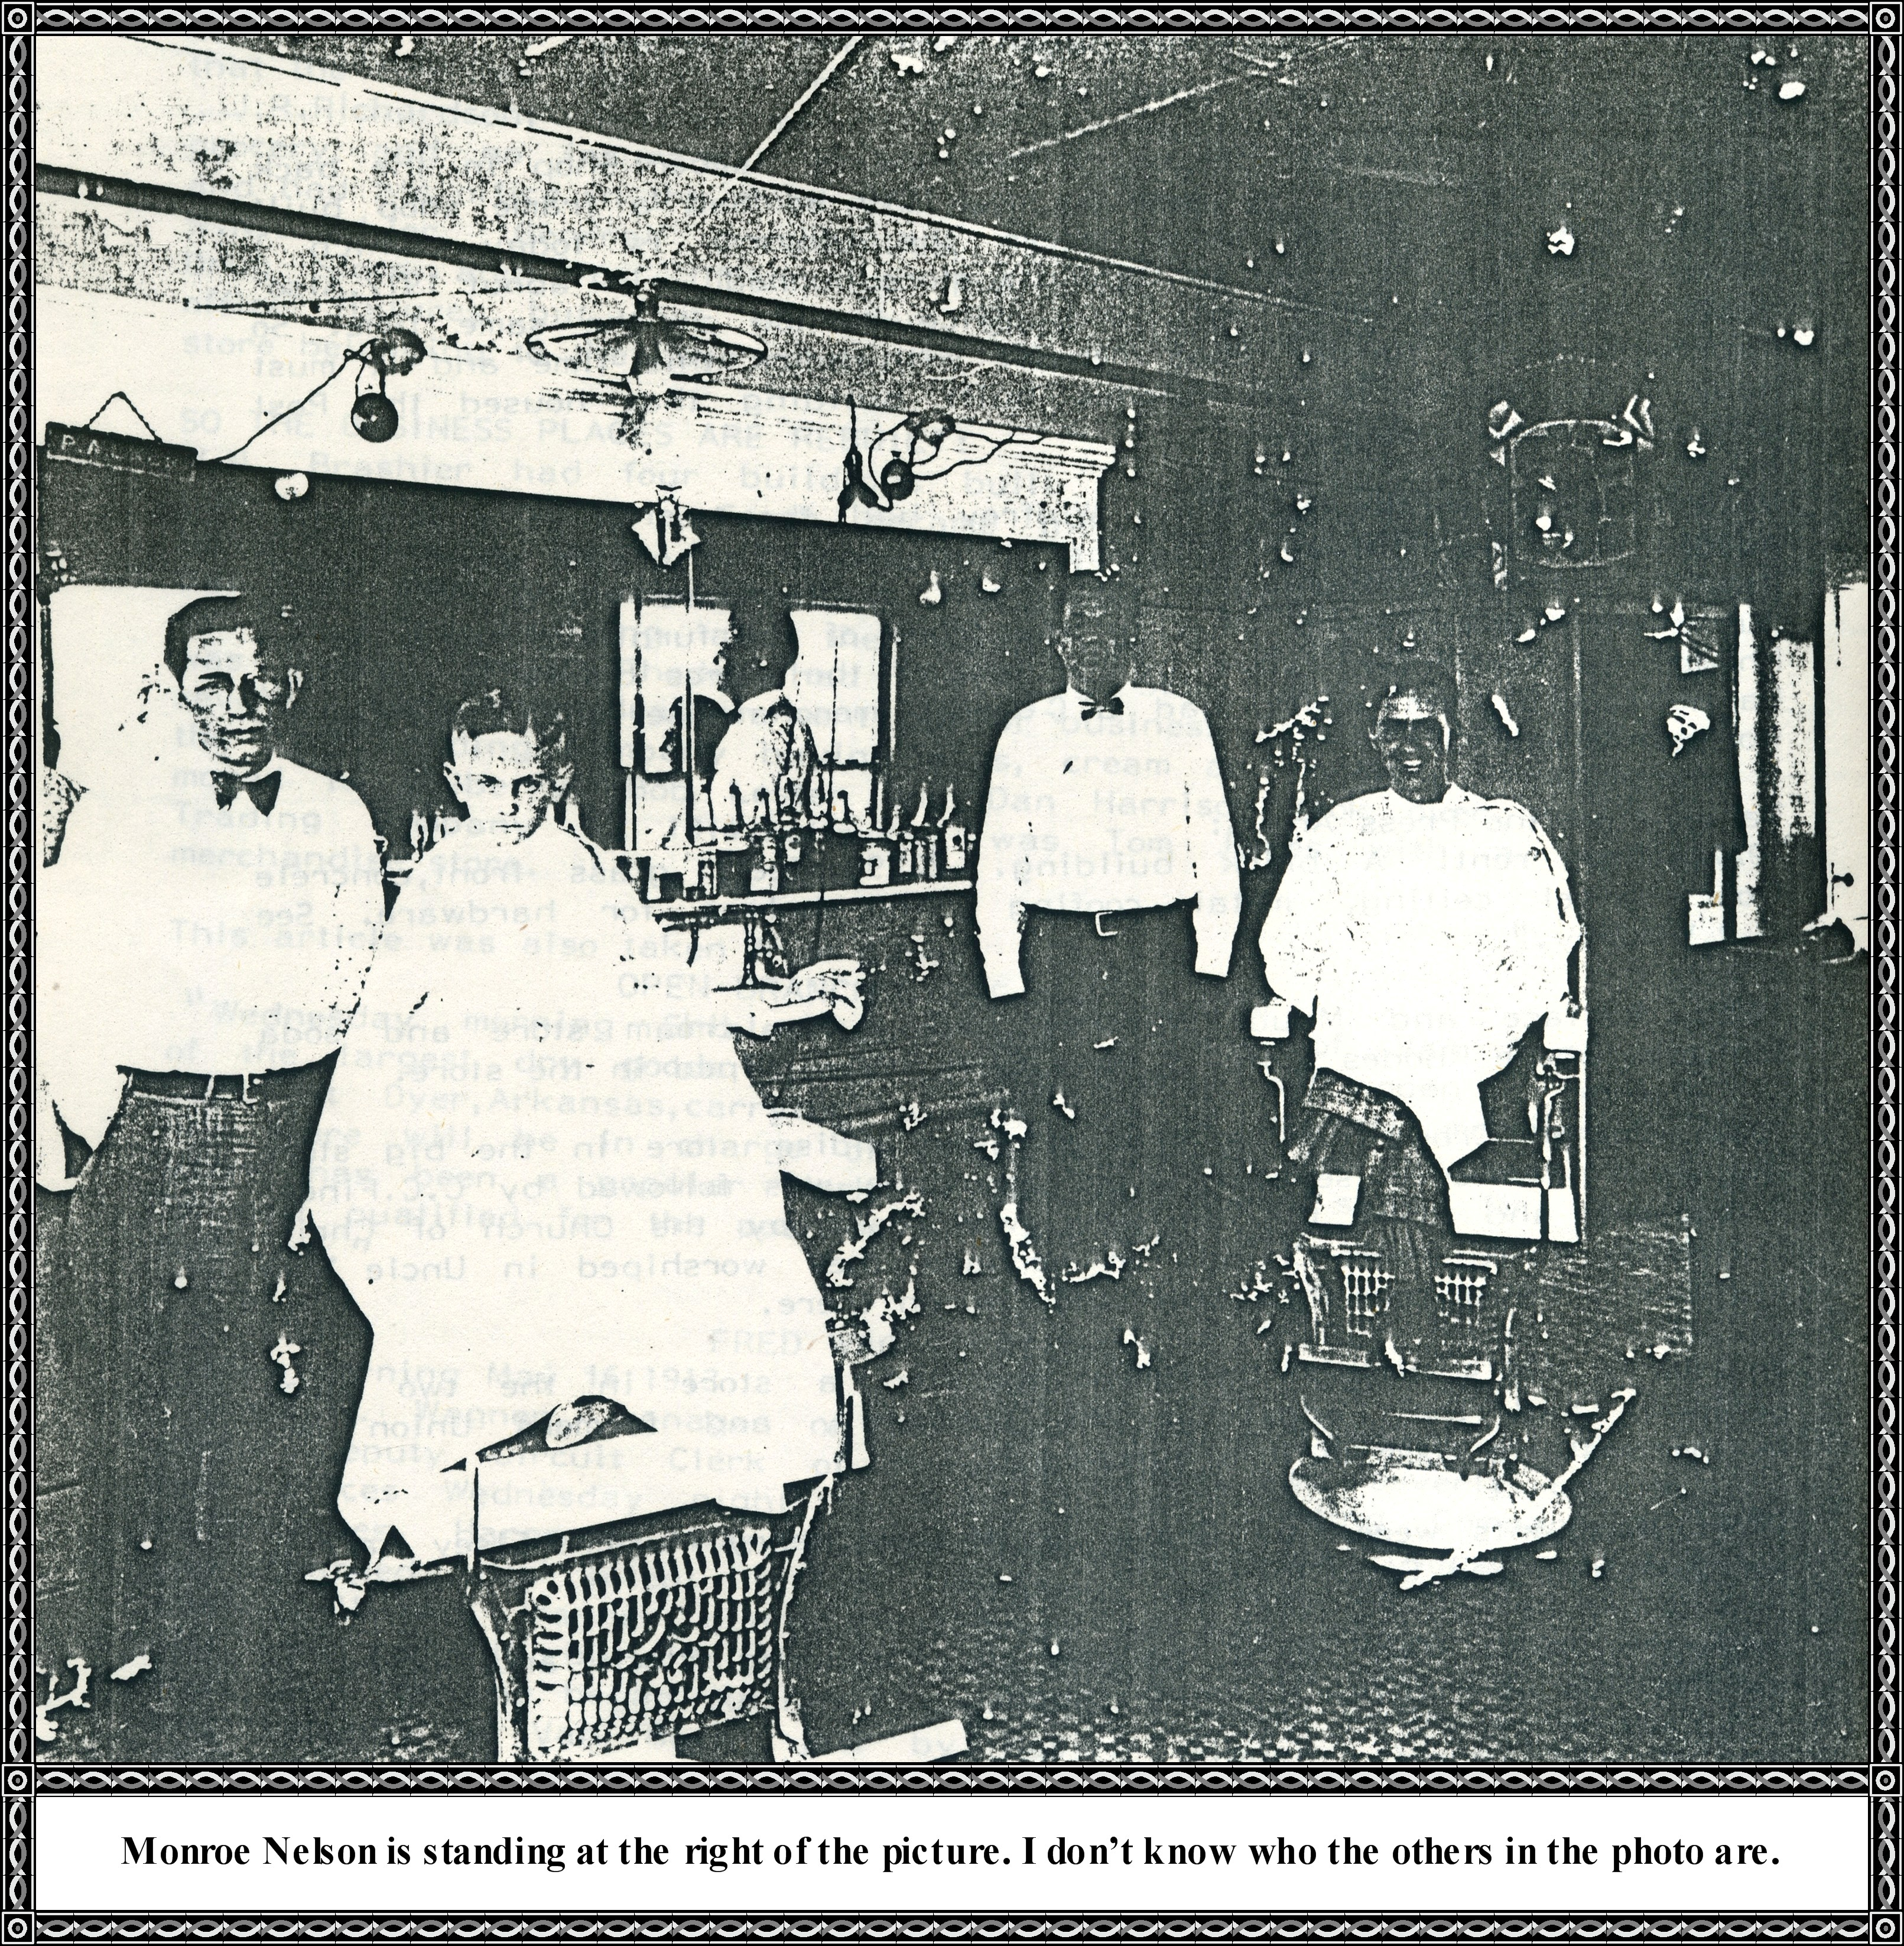

**1908 Dyer Business District by Ernest Cottrell**

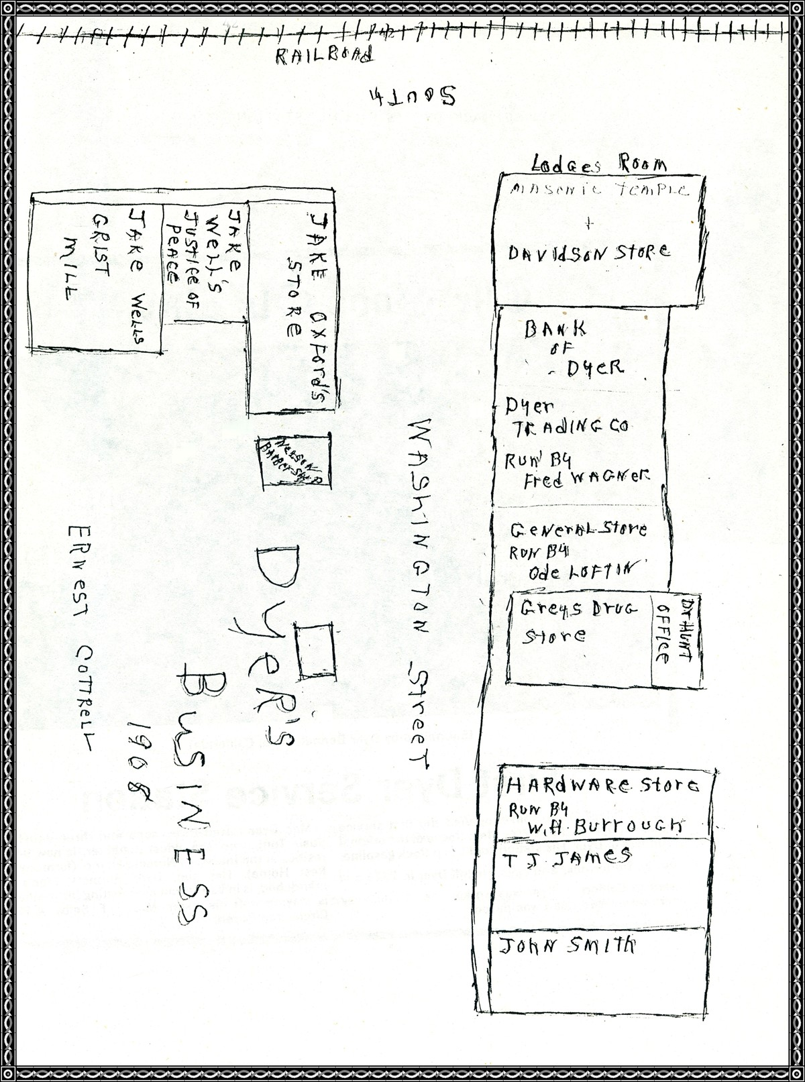

**UNCLE MACK DYER'S FILLING STATION**

Photo courtesy of Dyer Bennett, Brea, California

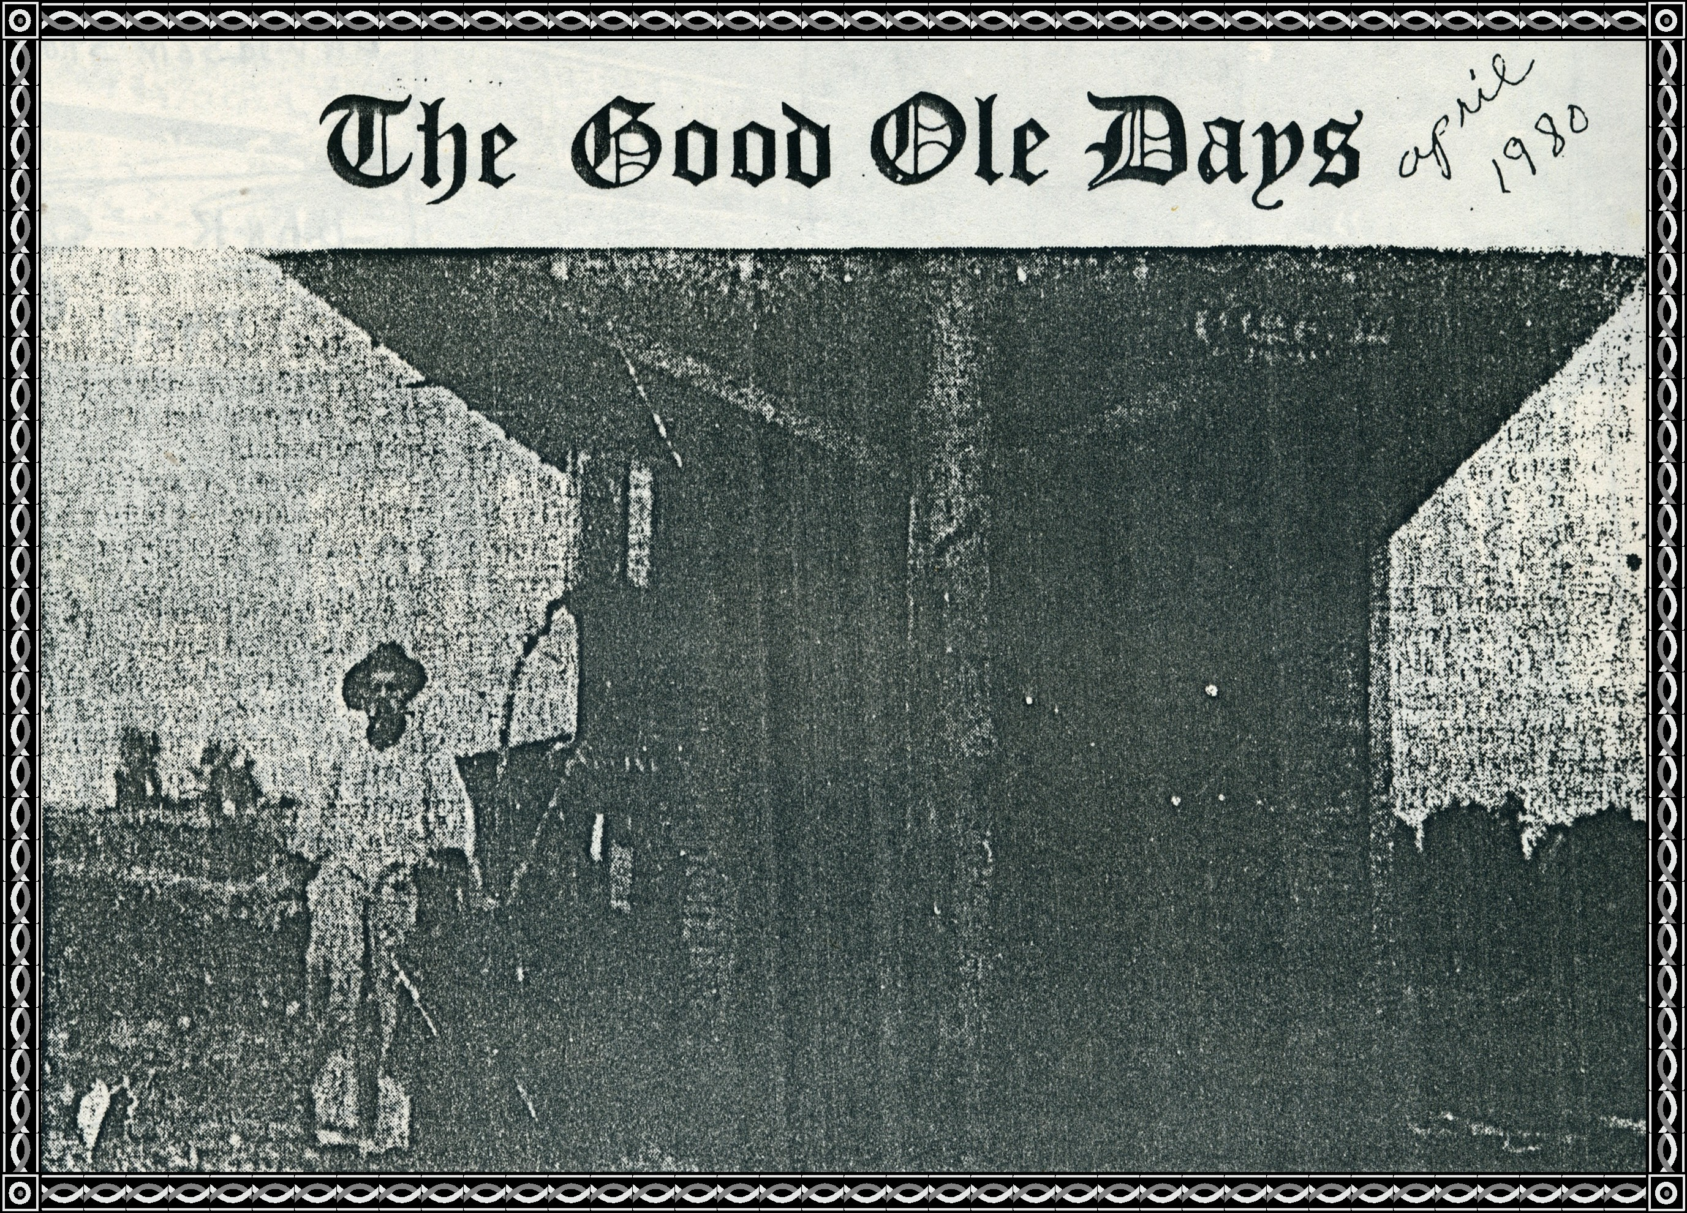

|  |  |
| --- | --- |
| **First Dyer Filling Station** | |
| J. M. "Mac" Dyer, above, opened the first service station in Dyer in the 1920's. He was one of the original founders of Dyer. His station sold Deep Rock gasoline, butter, buttermilk, and eggs. He left Dyer in 1926 and went to California. Dyer was working on the highway here when Wire Road was paved. | Mac Dyer raised three sons and three daughters. Susie Tomlinson, the oldest daughter, is now 94 and resides at the Intermed Nursing Home (formerly Cates Rest Home). Her son, Dyer Bennett, Mac's first grandchild, is in Van Buren now visiting his mother. He is staying with his sister, Mrs. J. F. Selby, of 4 Royale Circle, Van Buren. |