**THE DORA MOSS LIBRARY**

With the urging and urging, some more by Dora Moss, I finally decided to do what she wanted me to do and sent out letters for donations and books, and they began to roll in for it seemed everyone who had moved away from here would have given anything had there been a Library here when they were growing up. So on 29 October 1972 we held an open house at the City Hall sponsored by the Library Board consisting of Virginia Rhodes, Wanda Aldridge, Martha Chitwood, Lois Williams, Mary Lou Kelly, Irene Hurd, and Lorena Moss Lancaster.

Mother ***[Dora Belle Haydon Moss]*** had been taken up to the Library the night before so she could see it for she was 95 years old and couldn't attend at the Open House. We had a good crowd that day and I was sorry that Mother could not be present since Mrs. Walter Patton had been driven down and neither could she get out of the car.

Mother lived to know that the Town Council had named the Library for her, for her concern that all children have access to a library for reading and reference work. She had taught many years. They also gave her a plaque which now hangs in the Library.

I, Lorena Moss Lancaster, started the Library and have been the "free Gratis" Librarian these ten years and still glad that I can still open the doors each Saturday afternoon.

We soon outgrew the small room in the City Hall and, when the new Post Office was built, we began to make plans to see if we could buy the building, not only for a Library but to save the building that many of us saw in the erecting of it.

After the Bicentennial celebration at Dyer, plans were made to purchase the old Post Office and in July 1976 we paid half of the cost with monies donated by concerned people and shelving was built by Irl Scott Lancaster, and books were moved in, and we had our first day of checking out books from the new (old) library on February 12, 1977.

On October 31, 1976, before moving into the building we held an open house in the Post Office where the Library would be. 110 visitors registered and $247 dollars were donated for purchase of the post office for a library. Also the pictures that Thomas Irl Lancaster had made at the Bicentennial were shown in the albums which were placed in the library.

One of the projects to come out of the celebration of the Bicentennial was the organization of the Genealogical Society which we did and met in the Dora Moss Library for a year or two until the Crawford County Genealogical Society was organized with the beginning at Dyer (20 April 1977 organization). Until Octbber16,1979.

In January 1986 there are 12,000 books in the shelves. Which have been obtained through donation of books, buying at book sales, and buying new books for the Memorial shelf. When this project was begun in 1972, we never thought that it would become what it is today.

**Susi Tomlinson To Return Home To Dyer Today**

Susie Bennett Dyer Tomlinson is a Dyer. In fact, she is the daughter of Mack Dyer, one of the founders of that small Crawford County town of the same name.

She named her oldest son Dyer and raised him and her other two children in the town where she was born. In fact, she lived in Dyer until her second husband died.

Then she moved to Fort Smith. Then she was 87, she had an operation and has since lived at the Cate Nursing Home on Rudy Road.

Today at 92 she will be honored when her son, Dyer Bennett, presents to the Dora Moss Library in Dyer a collection of books. The books, an encyclopedia of animals, will be dedicated in her name and will be place on special display, Bennett said.

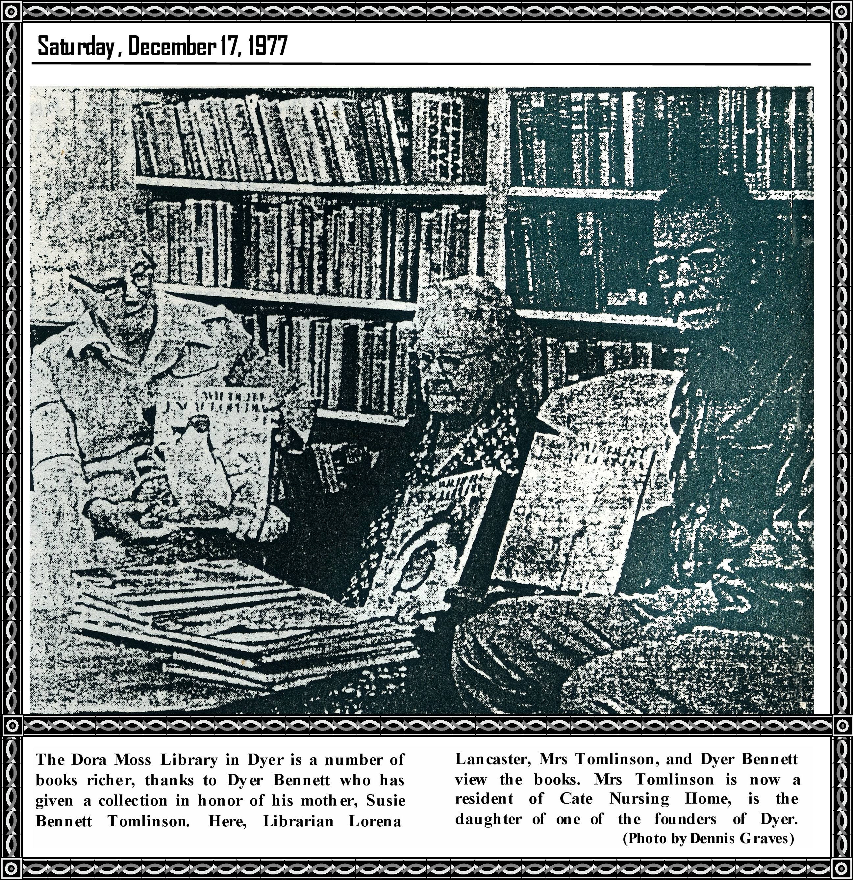

The lady will be on hand for the dedication and will no doubt be glad to visit her old home town.

The very spry and alert lady recalled Thursday: "There were fewer churches in Dyer when I lived there, just a Baptist and a Methodist. There was also a depot where people danced, but that is now gone."

There were four or five stores, among them T. J. James's dry goods store, a hardware store owned by Harry Burrough, a bank where W. D. Patton was a top official.

There used to be a constable and a justice of the peace in Dyer.

"It seems as if the town was smaller when I lived there. My father was a farmer and later a government worker. My Uncle Steve was the postmaster."

Today things must really be changed. There are lots of new houses, new churches, and certainly new people.

Lorena Lancaster, librarian at Dyer, said she would be pleased to receive the books.

Bennett has given books before, she added, and also a lamp.

**DYER COMMUNITY LIBRARY**

By

Dora Belle Haydon Moss

Have you ever been to Dyer-Town

In the State of Arkansas

Did you see the little Library

That grew up from the raw?

A retired preacher and family

Moved into this little town

Though retired, they were not broken down.

They weren't to be out and down.

His wife Lorena Moss Lancaster

Cast about for what she could do

To help in some way

Her dear community, too.

For she was born and lived here

All her growing up years

Then she met her Texas husband

and went away with him for years.

She knew the people of this town

Were voracious readers all

But couldn't have all the books they wanted

Their income was too small.

But this preachers wife wasn't daunted

She began to think what she could do

To make her Mother's dream come true

To have books for the Community too.

So off to good ole Van Buren

The source of so much sense

To learn how to start a Library

Without books, no room, and no finance.

She wrote placards by hand

And put them in the stores

Soon the Community was aware

Of the move and at once did more.

The City fathers offered the Town Hall

To place the Library in

People sent checks and cherished books

Soon came from afar and near at hand

The preacher, Rev. Irl Lancaster

Grabbed his hammer and his saw

And built shelves for the books

for the Library in Dyer, Arkansas.

We are happy and thankful

Mother, who is a young ninety-five

And I, who has not really retired

and just hope I'll stay alive.