**TOWNSHIPS OF CRAWFORD COUNTY**

|  |  |  |
| --- | --- | --- |
| NAMES OF TOWN AND COMMUNITIES | | |
| Alma  Aday  Bond Special  Bidville  Concord  Cedarville  Cove City  Cross Lanes  Chastain  Cain  Chester  Dyer  Dripping Springs  Dora  Dean Springs  Figure 5  Fine Springs  Georgia Ridge | Graphic  Gregory Chapel  Hobbstown  Haroldtown  Kenner Chapel  Kibler  Lone Elm  Lee's Creek  Lancaster  Locke  Leonardsville  Lillie Ford  Logtown  Meadors  MountainView  Mountain Grove  Mulberry  Maple Shade | Mountainburg  Natural Dam  Newton  Newbury Chapel  Oak Bower  Piney  Pennywit Springs  Pope  Red Hill  Rudy  Shaberg  Sulphur Springs  Turner  Vine Prairie  Van Buren  Union town  Yoestown |

**ALMA**

The land where Alma is located was brought from the Government between 1835 and 1840.

Previous to 1876 the business of Alma was done on what is now Main Street. Renfroe and James operated dry good stores. Brodie and Locke had dry good stores and groceries. Drug stores were run by Dr. G. W. Smith and George Bolling. George Hurst had a butcher shop. Doctors were: Black; Hughes; Wynne; and Cathey. Dr. King and William Bostick were hotel keepers.

The Post Office was established in 1871-1872. Up to that time, the Post Office was established in was called "Gum Town." In 1879 a Public Hall was built and used for school. In 1876 the Little Rock/Fort Smith railroad had the line completed to Alma.. Alma was Incorporated in 1887. In 1942, Alma had the largest Canning Plant in the world. It was one of the first towns to be supplied with natural gas in about 1915. Electricity was installed in 1903. Water was installed in 1936 from Fort Smith, supplied from Lake Fort Smith near Mt. Burg.

**CHASTAIN**

Was named in honor of John Shelton Chastain who came from Georgia and donated an acre of for school and church purposes.

**CHESTER**

Located in Township 12. First settlers settled there in 1850. Frisco railroad in 1884. I am including Chester as Miss Vesta Furlow was a teacher at Dyer in 1912. Tradition says there are number of mines in the vicinity, and one of its curiosities is the Rock House and has been made into a cold storage receptacle.

**GEORGIA RIDGE**

This section was settled after the Civil War between the States by a group of people coming to this County from the State of Georgia.

**LANCASTER**

When the Frisco Railroad was built through Crawford County the site of Lancaster was a booming lumber, farming, fruit, and cattle section. Judge Jesse Turner told them they had to have a name and suggested it be Lancaster as it reminded him of Lancaster, Pennsylvania, as his father described it and who was born there

**MOUNTAIN VIEW**

Named by the Lark family, who were pioneers of the County and built a Methodist Church on top of a mountain from where there is a grand view.

**MULBERRY**

In 1889 an act passed to change the boundary line between Crawford County and Franklin County, and Mulberry became a part of Crawford County.

It was born of a railway and drew largely from Old Pleasant Hill. A store was built in 1876 by Quesenbury. It was Incorporated in 1880

**MOUNTAIN BURG**

Seems Mountain Burg was in existence before the Frisco. The site of Mountainburg was bought from the government in 1848 by George Dyer.

The strip of bottom land between the mountains was originally known as "The Narrs." It is located on Highway 71. In 1879 Mr. Yoes built a store building.

**NATURAL DAM**

Is known as one of the most remarkable Natural curiosities The natural rock formation is located a few yards off highway 59 in Ozark's natural forest. The dam is formed by a solid bed of sandstone from 6 to 8 feet in diameter which runs across the Lees Creek making a natural barrier. It is the handiwork of God. Today this Community is a few miles South of the Dam on Highway 59. This was begun in 1870 and soon outgrew the Old Settlement which has passed away, and now the Dam is used for picnics and swimming. I also hear that perhaps there will be a Park there in the near future.

**RED HILL**

A small Community near Mountain Burg and received its name when a small group of people were standing and one looked up and said, "Look at that Red Hill." Mrs. Caroline Dyer Rhodes, mother of our Terrell and Orel Rhodes, also Phronia Chitwood and Savannah Burna who lived at Dyer. She was the one who suggested that the Community be named Red Hill

**VINE PRAIRIE**

So named because the prairie was covered with wild vines so the settlement naturally adopted the name of Vine Prairie. It was once called Mine Prairie.

**VAN BUREN**

This town is of interest to us as it is the County seat of Crawford County. It was Incorporated in 1845. The first mail to arrive in Van Buren came from Little Rock on the sixth of May 1823. Phillips Landing was established March 1831. Mail was delivered by horseback and took five days to arrive from Little Rock. When you received mail then, you paid the postage. No envelopes were used, the letters were folded and sealed with red seal, and this method was used until 1850.

|  |  |  |  |
| --- | --- | --- | --- |
| STREAMS IN CRAWFORD COUNTY | | | |
| Arkansas River  Cedar Creek  Cove Creek  Flat Rock  Frog Bayou | Hollis Lake  Lees Creek  Mill Creek  Ned Lake  Slack Creek | West Cedar  Webber Creek  Mayes Branch  Little Webber  Clear Creek | Foster Branch  Little Lees Creek  Little Mulberry  Big Mulberry  Mountain Fork |

Crawford County was named in honor of William Harris Crawford of Georgia who was Secretary of the Treasury under President Monroe.

The original Crawford County was organized in 1820 and extended from Point Remove to Fort Gibson all on the South side of the River. Our County as we know it today was Indian land until 1828 when by Treaty it was added to the original County.

The site of the first County seat was at the home of John Jay which was located about half way in the County.

The second site was at McLain Bottoms, now Roseville.

The third site was at Crawford old Court House on Arbuckle Island.

The fourth site was at the Whitson place, which is today the Beneau Farm.

The fifth site was at Crittenden on Little Mulberry Creek, now Pleasant Hill Community.

The sixth site it was moved to Van Buren and later the Court House which was built in 1838.

On the night of the 23 of March, the County Court House was destroyed by fire with nothing remaining but the walls. So the Court House was ordered to be built around the walls left standing after the fire, and this is our Court House today.

Natural Dam is the oldest settlement in our County.

Oldest road is from the Court House up by Frog Bayou on by Lees Creek and into Washington County.

**MULBERRY**

Mulberry Camp Ground took the name of Pleasant Hill. It was composed of the Church which was probably a Tabernacle with cabins built around it for the people to stay in while at the summer meetings.

Dr. Williams deeded the land to the Church before 1855, and he also operated the Post Office and the Station for the stage coach at Pleasant Hill, and his daughter who was a Mrs. Dyer also helped at the Station.

The Pleasant Hill Settlement on Mulberry Creek was the oldest approach to a Community between the Arkansas River and the White River before 1818 and the only approach which continued through the Cherokee occupation 1818 to 1828.

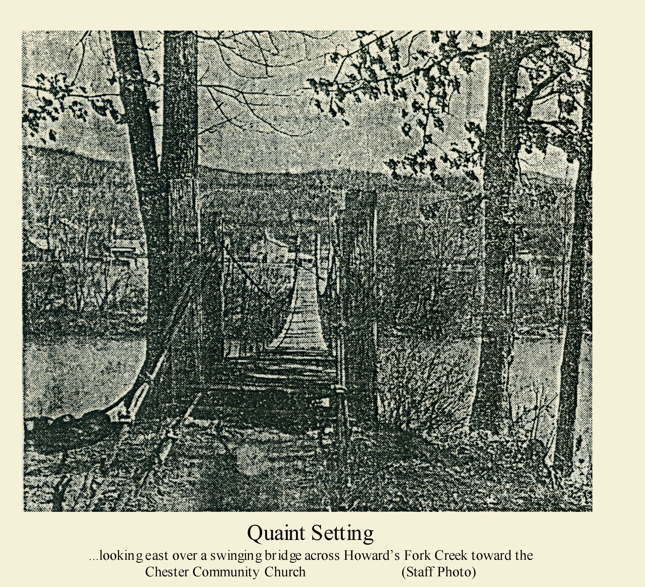

This is the bridge that crossed Howard Creek going to Chester, and, when we went up that way on Fourth of July on a picnic, we would walk across this bridge.

Everyone has deep in their heart the old home town where they first went barefoot, got their first whipping, traded their first pocket knife, grew up and went away, thinking they were too big for that little burg, BUT THAT IS WHERE YOUR HEART IS. This is your heritage.

***Will Rogers***

If you see a couple walking along the street and the man walks on while the woman pauses to look in the shop window, it is a sure sign that they are married.

**THE OLD SPRING DOWN BY THE GIN**

Who remembers the Spring? It was located on land that belonged to the Lipscombe, the Nelsons, and was east of the Gin on Line Street. It was down in the Northwest corner of the lot and had a large flow of water, and around 1910 and 1912 the women carried their wash and wash pot down there to do their washing. The children would climb over the rafters in the old saw mill that was standing there not in use any more even in those days.