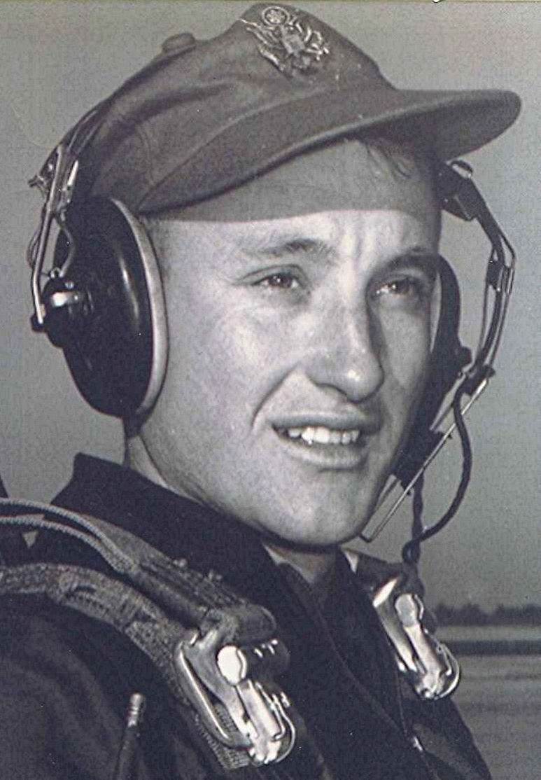
The Long and Winding Road
Dyer, Crawford County, Arkansas, USA
May 23, 2000
Some time back we took a side trip while on an overnight stay in Arkadelphia. To Sparkman, Holly Springs, Princeton, Manning, and Shady Grove; including places that it had been over fifty years since I was last there. It is next to impossible to express the feelings one experiences when returning to these places that are so laden with memories; yet in many ways so different from that I knew back when. The passage of fifty plus years had erased or altered many of the objects of my teenage recollections.
Thinking about all that and what it means as we travel down the trail toward our ultimate destiny often brings more questions than answers. I keep remembering what it was like back then when we were kids and our parents were closer to the ages we are now. Back then, a teenager's world and the time available in which to experience it seemed to stretch forth in an unending stream. But now I know that was only an illusion. It has always been a fact that the long and winding road had an end somewhere out there beyond the green vistas and purple hills that obscure that last mile.

Editor's note: see the Richard Boyd Dodson 004 ~ The Long and Winding Road file for a slightly different memory.

