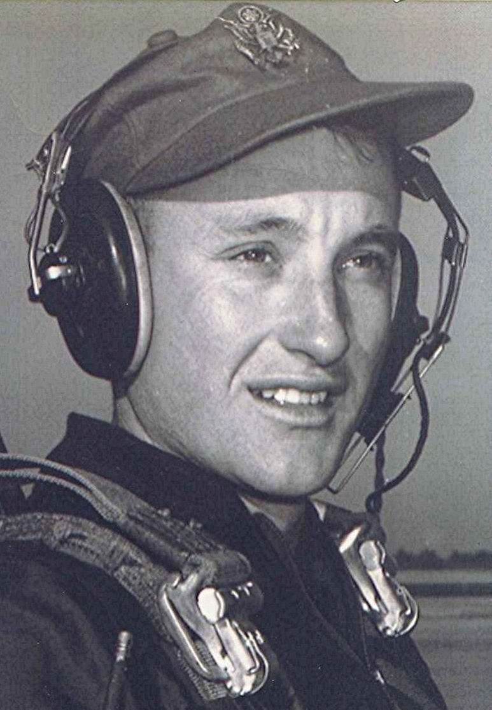
Sunrise, Sunset
Dyer, Crawford County, Arkansas, USA
May 23, 2000
Sunrise, when the world awakens to a dewy landscape; where the songbird's early calling announces the arrival of the new day. Then later we witness its ending: the heat from the early summer sun slowly receding as the shadows lengthen and a dusty tiredness settles over the land.
We are surrounded by life's symbolism and that just mentioned, in many ways represents this journey on earth. In the beginning we have a new day, a blank book upon which to write, with many paths before us from which to choose. Then comes the sunset of our lives. Our choices irretrievably having been made; the roads taken, the bridges crossed. The book now nearing its final chapter.
As the quiet of the even tide enwraps the world, I look westward and think of home as I contemplate my destiny beyond time and space and sunsets.
~ Richard Boyd Dodson

~ SHS Alumni newsletter, Spring 2004

Editor's note: see the Richard Boyd Dodson 006 ~ Sunrise, Sunset file for a slightly different memory.

