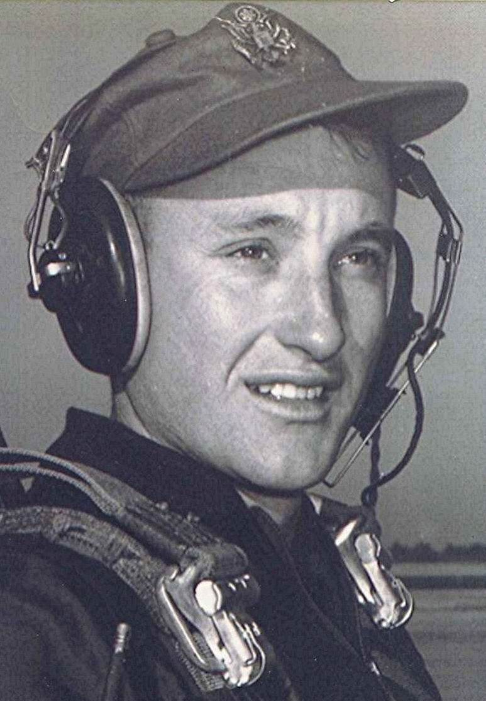
Memories of Dallas County
Notes and Other Unsubstantiated Opinions
Ben Few Campground
Date unknown
As evidenced by the recitation above,¹ the prospect of fall brings with it an outbreak of the nostalgic fevers, mostly held in check till now. Won't be many more days until we will be congregating at the Iron Mountain Marina again. Speaking of which, since I have been appointed to bring beef for the hamburgers, I have stumbled onto a great bargain. Found some Hudson Frozen Hamburger Patties on sale real cheap. Fellow mentioned something about a recall. I gathered he was trying to recall how much he paid for them. Anyway, I couldn't turn the deal down. Looking forward to sharing them with you. Now if I can locate some buttermilk and green onions, we'll be all set.
While on the subject of buttermilk and green onions; I remember maybe the last time I was ever at Ben Few Campground near Princeton for a revival meeting. That was nearly fifty years ago. An old-time Methodist preacher, Brother Roscoe Walsh, had the sermon that Sunday afternoon, immediately after "dinner on the ground." Those who remember Brother Walsh will recall him being a giant of a man, who resembled Charles De Gaulle in several ways. Tall and bald headed, he towered over the podium. He had the reputation of livening up conversations as well as sermons with an endless repertoire of humorous stories and one-liners.
As he stood in the pulpit that Sunday afternoon right after lunch. Brother Walsh paused for a moment while looking out over the congregation , then said "If you have ever eaten buttermilk and green onions and then tried to go and plow a new-ground², you will know how I feel."
That moment has remained with me for all these years, probably because it epitomized his humorous outlook on things.
Speaking of Ben Few Campground, Don [Mann] writes that the 100th anniversary camp meeting will be held next August. I plan to be there if I can. Say that every year, but am determined to make it work next time.
Went to the Franklin County fair over at Ozark³ a few days back. The thing that enticed me there was the display of restored farm tractors. Had a collection of twenty five or more. If anything will bring back memories, it's the sight of a restored replica of the first tractor we ever owned. In the late forties, we bought a used John Deere Model "H" with complete equipment for $1200. No lights, no starter, nothing but a fly wheel to crank the cantankerous, un-crankable thing. Was almost enough to make my daddy who never swore, swear. Cotton crops were so bad that it took several years to pay off that $1200 debt with twenty-eight cent cotton.
On the way back from Ozark, got to wondering why the increasing interest in restoring old farm tractors. The obvious question is whether or not it is something new, or whether each generation goes through such a phase. I believe what we are seeing is unique, not only the restoration of old tractors from the forties and fifties, but a burgeoning business in nostalgia-related music and even a revival in clothing from that period.
Someday, if not already, the fifties will be looked back upon as the golden age of the United States. How fortunate to have been part of that era.
Warmest regards,
Boyd
1 ~ Editor's note: see Richard Boyd Dodson 149 ~ dd mmm yyyy ~ where doctors made house calls file for more information.
2 ~ Hope that not many of you have to explain to someone else what "new ground" means. Or how a nervous horse feared being jerked to a sudden halt when the plow hit a stump. Or how the roots pulled forward by the plow point suddenly broke, whacking leg or bare foot. And how the plow handle slapped into the ribs when the plow struck a root with a glancing blow.
3 ~ Editor's note: Ozark is a city in Franklin County, Arkansas, USA.

